# ABAP Statements

## Create the program

* Go to Tools -> ABAP Workbench -> Development SE38 – ABAP Editor

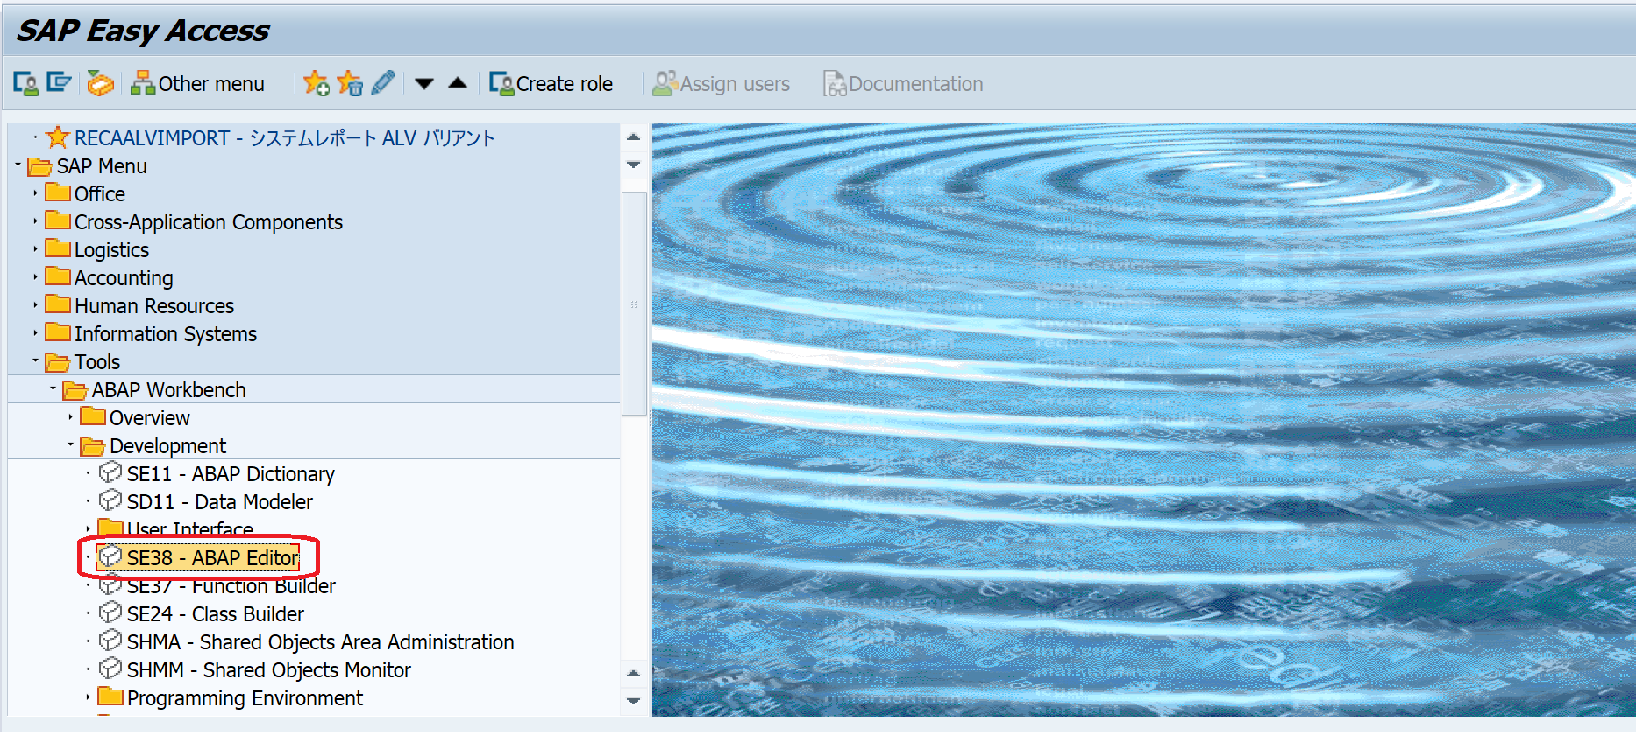

* Or we can search SE38 straight in the search box and we will see this window appear

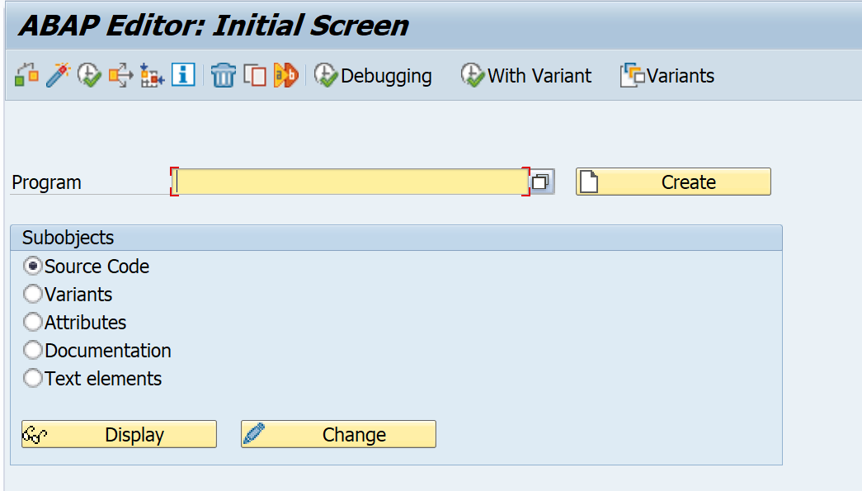

## Intro to WRITE statement

* Let’s begin with WRITE statement with some indentation

**REPORT** zalvgrid_v0.

**DATA**: text **TYPE** string **VALUE** '0123456789ABCDEF',

col **TYPE** i **VALUE** **25**,

len **TYPE** i **VALUE** **5**.

**WRITE** text. "write full text

**WRITE** /**5**(**10**) text. "write indent 5 with len of 10

**WRITE** **AT** col(len) text. "same same but if with pre-defined variables

Typically, if you want to output something out to the screen, speaking of classical report, we need to write the screen so WRITE statement will be the best option among thousands

## Data (Variable) declaring

Let consider this variable declaring in Python

x = **5**

y = "John"

Now, let put it in the ABAP context, we will have this below

**DATA**: x **TYPE** i **VALUE** **5**,

y **TYPE** STRING **VALUE** "John".

## Constant declaring

CONSTANT con1 **TYPE** p **DECIMALS** **1** **VALUE** '6.6'.

## String concatenate

**DATA**: t1 **TYPE** c **LENGTH** **10** **VALUE** 'We',

t2 **TYPE** c **LENGTH** **10** **VALUE** 'have',

t3 **TYPE** c **LENGTH** **10** **VALUE** 'all',

t4 **TYPE** c **LENGTH** **10** **VALUE** 'the',

t5 **TYPE** c **LENGTH** **10** **VALUE** 'time',

t6 **TYPE** c **LENGTH** **10** **VALUE** 'in',

t7 **TYPE** c **LENGTH** **10** **VALUE** 'the',

t8 **TYPE** c **LENGTH** **10** **VALUE** 'world',

space.

**CONCATENATE** t1 t2 t3 t4 t5 t6 t7 t8

**INTO** **DATA**(result).

**CONCATENATE** t1 t2 t3 t4 t5 t6 t7 t8

**INTO** result **SEPARATED BY** space.

## Condense

**DATA**: **BEGIN OF** sentence,

word1 **TYPE** c **LENGTH** **30** **VALUE** 'She',

word2 **TYPE** c **LENGTH** **30** **VALUE** 'feeds',

word3 **TYPE** c **LENGTH** **30** **VALUE** 'you',

word4 **TYPE** c **LENGTH** **30** **VALUE** 'tea',

word5 **TYPE** c **LENGTH** **30** **VALUE** 'and',

word6 **TYPE** c **LENGTH** **30** **VALUE** 'oranges',

**END OF** sentence,

text **TYPE** string.

text = sentence.

**CONDENSE** text.

## References

* Internal table: https://www.guru99.com/all-about-sap-internal-tables.html#:~:text=Work%20areas%20are%20single%20rows,one%20line%20at%20a%20time.