# DATA DICTIONARY (ABAP DICTIONARY)

Welcome to my ABAP note, this is the first section that we will discuss about. Let’s run straight into it…

## Create your first table

To create a table in SAP, we need to gain access to T-code SE11. Enter SE11 into search box and we will see this screen

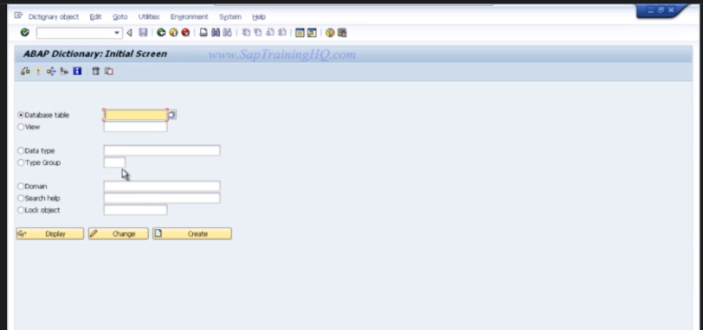

As you may see in the initial screen of se11, there are some objects we need to take a look at

* **Database** **table**: place to create independent, transparent tables or we can input an existing table names.
* **Views**: logical views on more than one table. The structure of the view is defined in the ABAP Dictionary.
* **Data Types** (data elements, structures, table types): structure of a type can be defined globally in ABAP programs.
* **Domains**
* **Search helps**: list of possible input values
* **F1 Helps**: documentation about the field
* **Lock objects:** synchronize access to the same data by more than one user

But let’s continue making the table first of all. Then, we have to ensure that the input table name is user-defined which means it should start with Z and Y, for example “ZEMPLOYEE”, let talk little bit about the letter Z and Y

* **"Z" Programs**: Programs that start with the letter "Z" are generally used for custom developments that are specific to an organization's needs
* **"Y" Programs**: Programs that start with the letter "Y" are typically used for temporary developments or prototyping. "Y" programs are often used for testing or experimental purposes and are not intended for long-term usage or deployment in a production environment

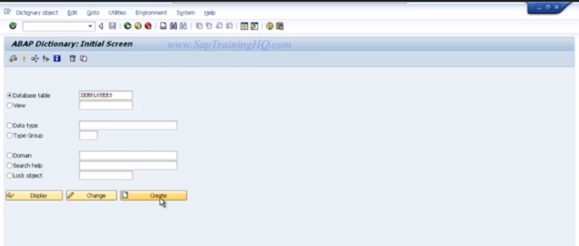

Click CREATE, we will see this screen below here

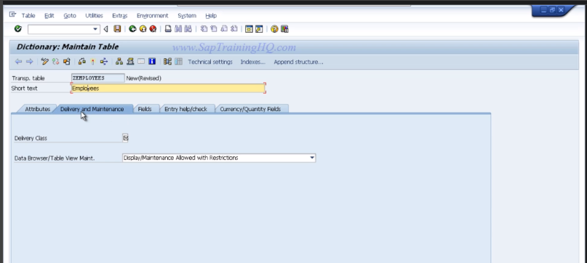

**Do not forget to input the short text for our data table.**

Let’s go deep into the options in this screen, we have to input into Delivery Class and Data Browser for maintenance

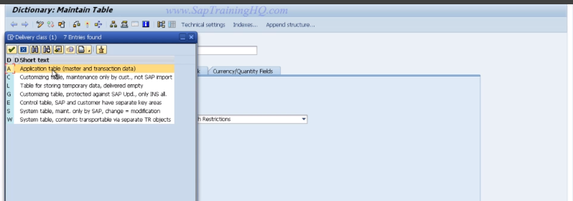

Select Application table – A in the Delivery Class

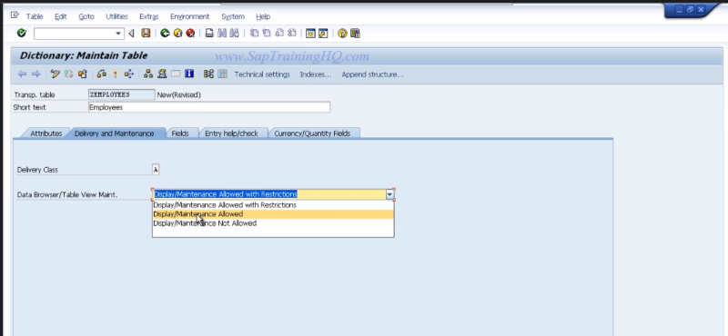

Select Maintenance allowed in the Data Browser

Then, we click on **Save** button, we will see the screen below

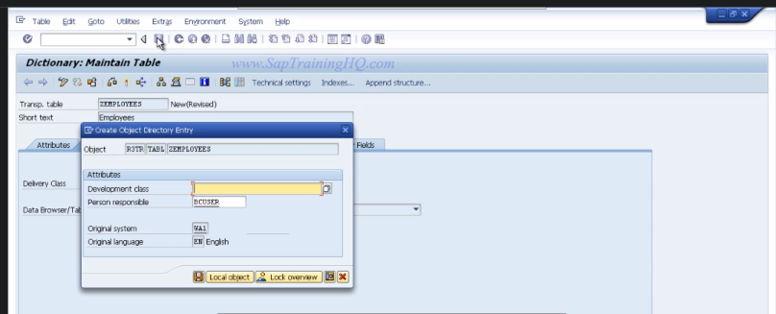

“Create Object Directory Entry” is what we will see. The one thing we can see is Development class and so on, there are many options for us which means we need to move on our development to the other systems such as Test System and Production system but in our scenario, we just click on LOCAL OBJECT and continue

But in case you want to select the Object Directory, you can go to GOTO and select it

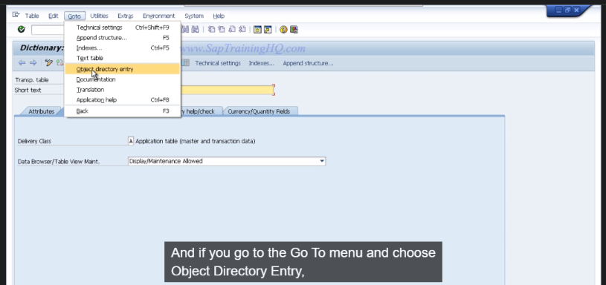

If you are at this step, you are all set and ready to edit the table.

## Create fields

To do so, click on tab Fields, you will see the page as below

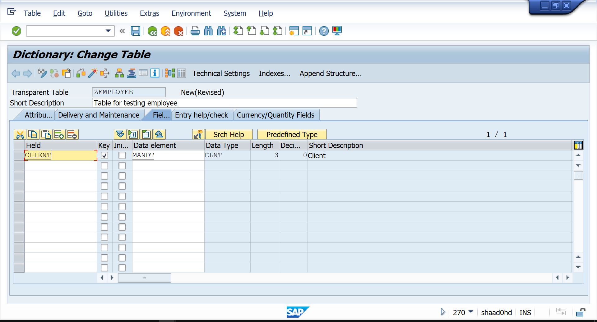

In this part here, we need to keep in mind that we need to field -> then Data element -> then Domain

Now consider this table below:

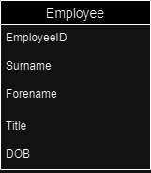

I will just create 1 field with the formula above (Field->D.E->Domain) and repeat the steps for the other fields

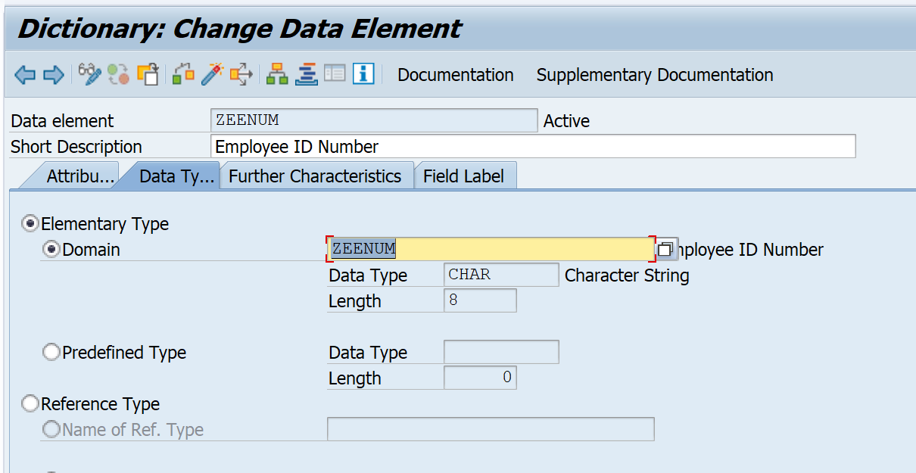

SAP GUI refers double clicking so whenever you create something, double click on it, for example: to create domain, please double click on ZEENUM, you will see below

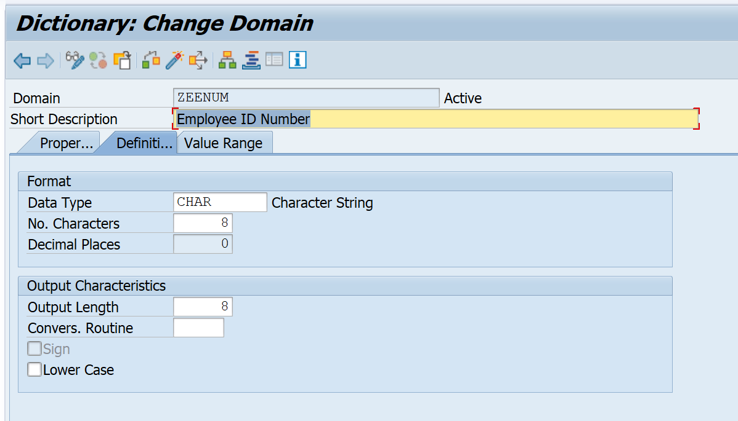

Don’t forget to activate the domain (DOMA) first then activate the Data Element (DTEL), wherever you create DOMA or DTEL, please activate them straight away.

Now, let’s repeat the steps for the other fields. The info that will appear on the transparent table is the info we get from creating Data Element, we will see below:  
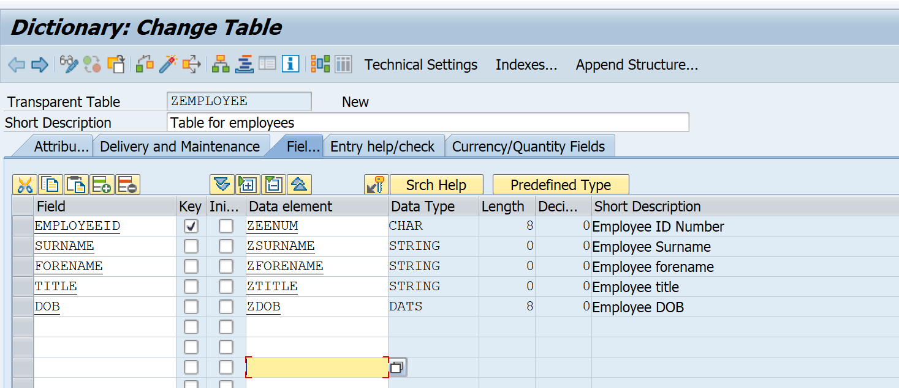

At last you need to activate the whole table, we will see the option below – Maintain Technical Settings

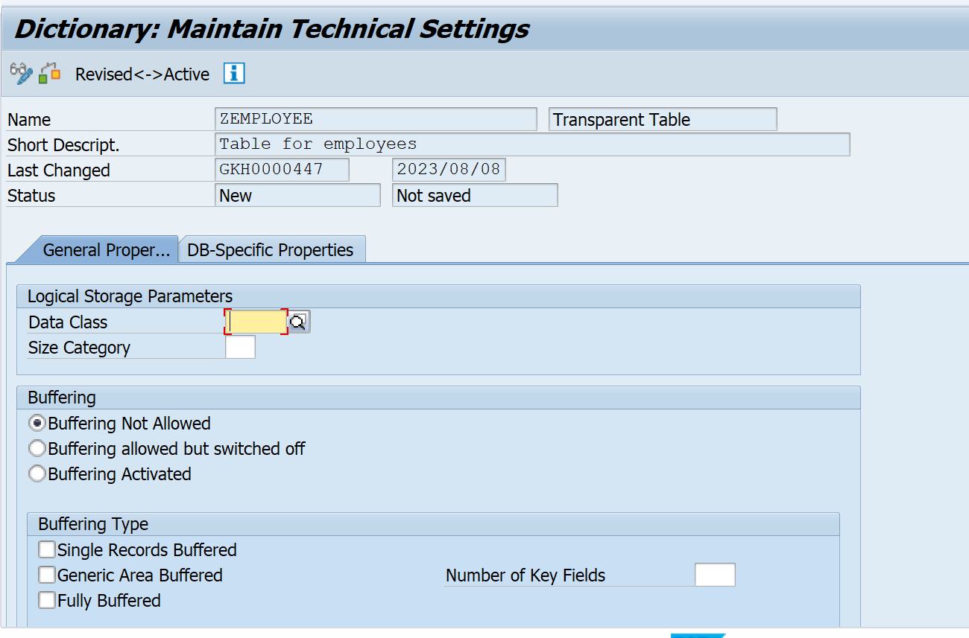

Then we have insert Data Class (in this case we enter APPL0) and Size Category (You can pick any number that you want to)

## Input data into the data table

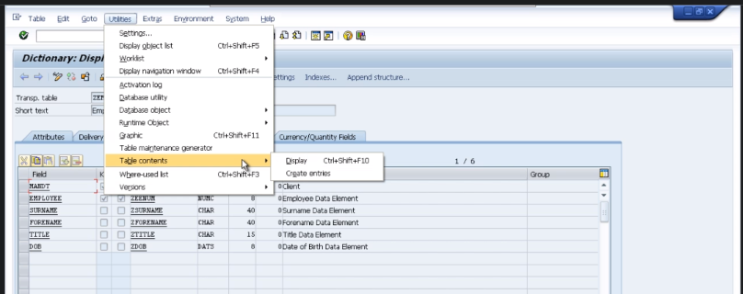

From Ultilities -> Table Contents -> Create entries

## View data from data table

There are 2 ways to do this

* Using SE11, go to table -> Ultilities -> Table contents -> Display 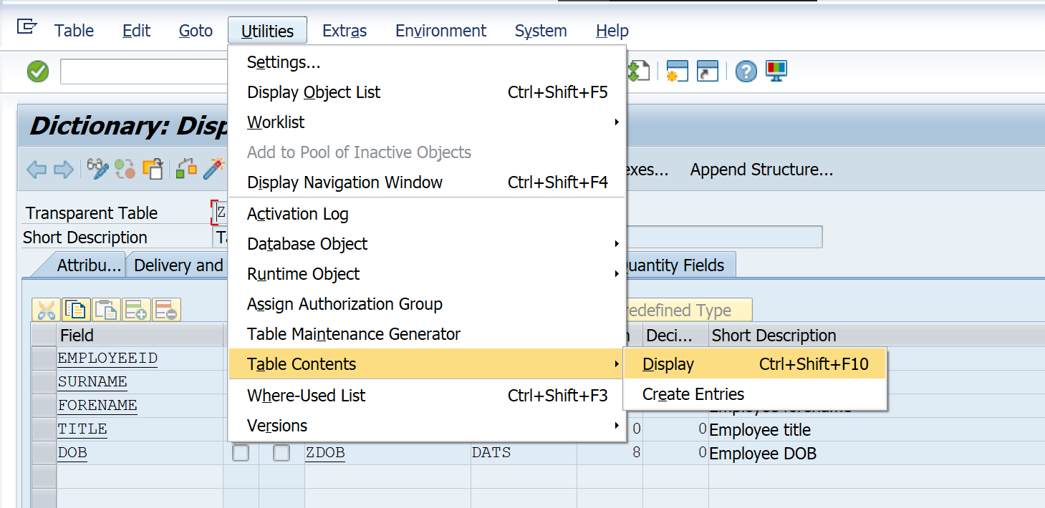
* Using SE16, go to table then click on clock symbol.