DESIGN AND ANALYSIS OF ALGORITHMS
LAB 02: ANALYSIS OF RECURSIVE ALGORITHMS

Designing and analyzing recursive algorithms

Iterative | recursive
Locate basic operations  Identify the worst case  Count the number of basic operations in the worst case => T(N)  3.1 Determine Big Theta/Big-O notation of T(N) | Locate basic operations  Build recurrence relation by Counting the number of basic operations => T(N)  Solve the recurrence relation  3.1 Determine Big Theta/Big-O notation of T(N)

A sample

- Finding maximum value in an array
- Input: Array A (A[1], A[2], . . . , A[n])
- Output: Largest element in the array.
- Algorithm:
- Findlargest(A[1:n])
  - 1. If n = 1, then return A[1].
  - 2. Else,
    - 3. let m = Findlargest(A[1 : n − 1]).
    - 4. If m > A[n], then return m
    - 5. Else return A[n].
- Basic operations:
comparison in line 1
assignment in line 3
comparision in line 4

- Recurrence relation

$$T\left(n\right)=\left\{\begin{aligned}T\left(n-1\right)+3, if n>1 \\ 1 , if n=1\end{aligned}\right.$$
- Solving the recurrence relation

T(n) = T(n−1)+3
T(n−1) = T(n−2)+3
T(n−2) = T(n−3)+ 3
···
T(2) = T(1) + 3
-----------------------
T(n) = T(1) + 3(n-1) = 3n -2
$$T\left(n\right)∈Θ(n)$$

Exercises:

- Design (pseudocode), implement (Python) and analyze (complexity) a recursive(a) algorithm and an iterative(b) algorithm for computing the k-th power of 2( for $k=3$, we have $2^{3}=8$)
- Design, implement and analyze a recursive(a) algorithm and an iterative(b) algorithm for finding maximum value in an array
- Design, implement and analyze a recursive(a) algorithm and an iterative(b) algorithm for finding a value in a sorted array

Recurrence Relation

Samples
To analyze the complexity of the recurrence relation, we might solve by the iterative method or Master theorem.

Sample Solutions with Master theorem
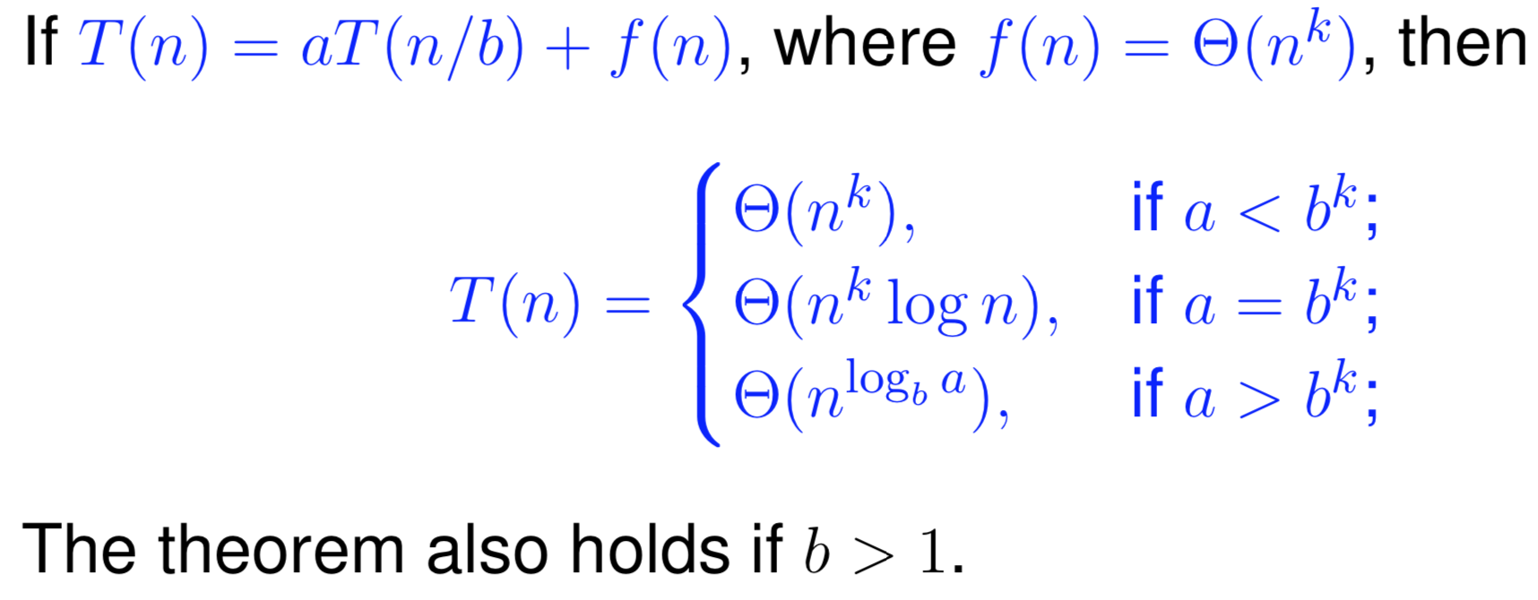
Sample 1
C (N) = C (2N/3) + 1 2N/3 = N / (3/2)
$$a=1, b=\frac{3}{2}, f\left(N\right)=1 and f\left(n\right)∈Θ\left(n^{k}\right), therefore k=0$$
$$⇒a=1=b^{k}={\left(\frac{3}{2}\right)}^{0}$$
$$⇒C\left(N\right)∈Θ\left(N^{k}logN\right)=Θ\left(logN\right)$$
Sample 2:
T(n) = 2T(n/2) + cn
A = 2, b = 2, k = 1, b^k = 2=> a = b^k => $T\left(n\right)∈Θ(nlogn)$

A sample solution with iteration

Given the following recurrence relation

$C\left(n\right)=2C\left(n/2\right)+n-1$ with $n>1, C\left(1\right)=0$

Applying the reverse method, we have:
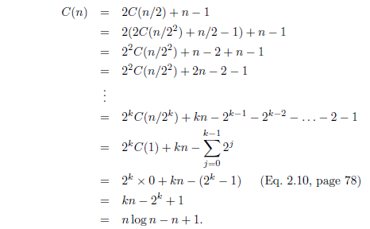
So $C(n)∈Θ(nlgn)$

Given another recurrence relation
C_{N} = c_{N-1} + N. With n ≥ 2, C₁ = 1
C_{N-1} = c_{N-2} + N-1
C_{N-2} = c_{N-3} + N-2
…
C₂ = C₁ + 2
C_{N} = C₁ + 2 + 3 + … + N = 1 + 2 + 3 + … + N = N(N+1)/2 $∈Θ(N^{2})$

Exercises
Solve the following recurrence relations with the iterative method
- C_{N} = C_{N/2} + 1000 with N ≥2, C₁ = 0
- C_{N} = 3C_{N/2} + N with n≥ 2, C₁ = 0
- C (N) = 2C (N/2) + 1. With N ≥2, C (1) = 0
Solve the following recurrence relations with Master theorem
- C_{N} = C_{N/2} + 1000 with N ≥2, C₁ = 0
- C_{N} = 3C_{N/2} + N with n≥ 2, C₁ = 0
- C (N) = 2C (N/2) + 1. With N ≥2, C (1) = 0
- C_{N} = 4c_{N/2} + N. With n ≥2, C₁ = 1
- C (N) = 9C (N/3) + N
- C (N) = C (2N/3) + 1
- C (N) = 3C (N/4) + NlgN
- $T(n)=T(n/3)+2T(n/3)+n$
------

