DESIGN AND ANALYSIS OF ALGORITHMS
LAB 03: DIVIDE-AND-CONQUER

I. Divide-and-Conquer Paradigm

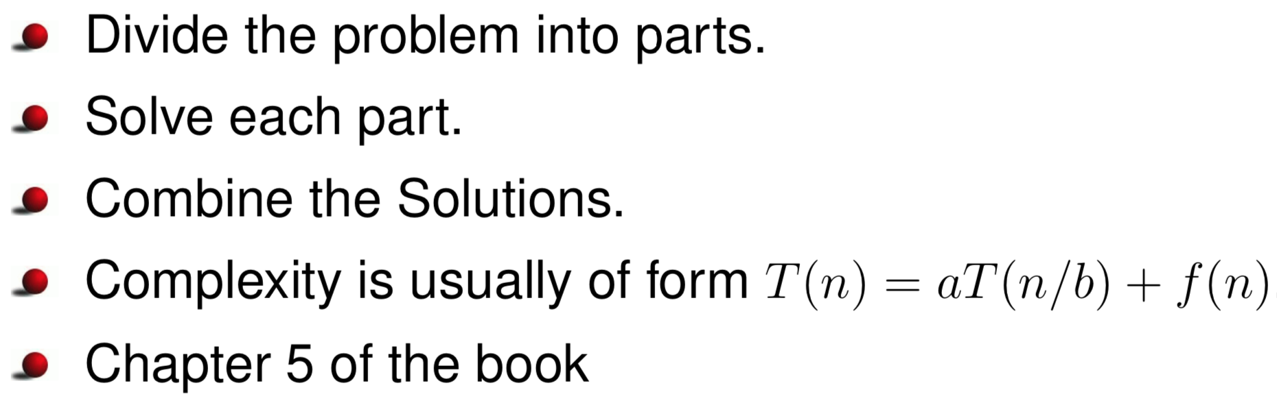

II. Sample
Pseudocode of MergeSort algorithm is given as follows:
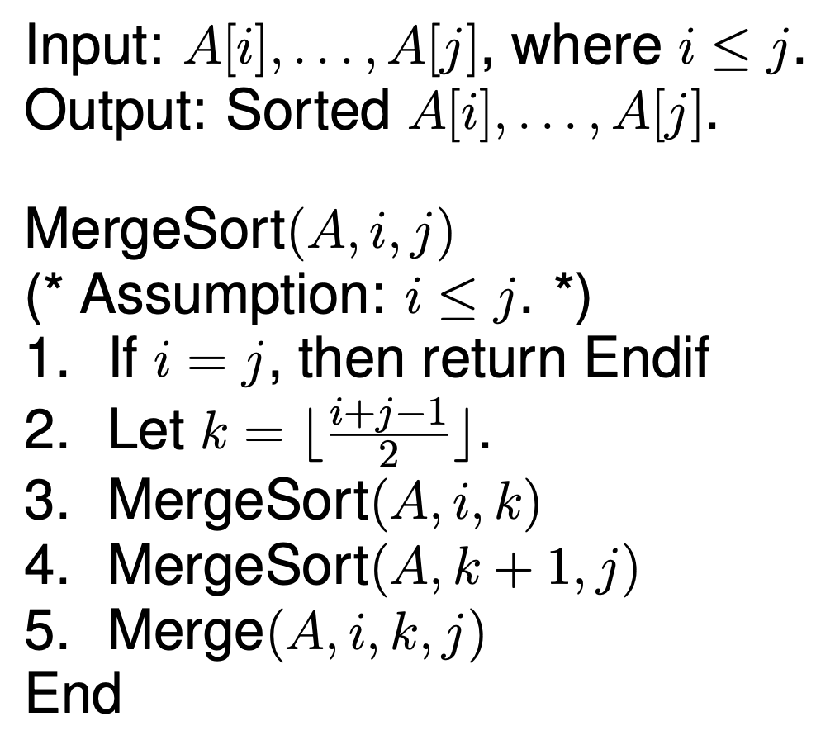
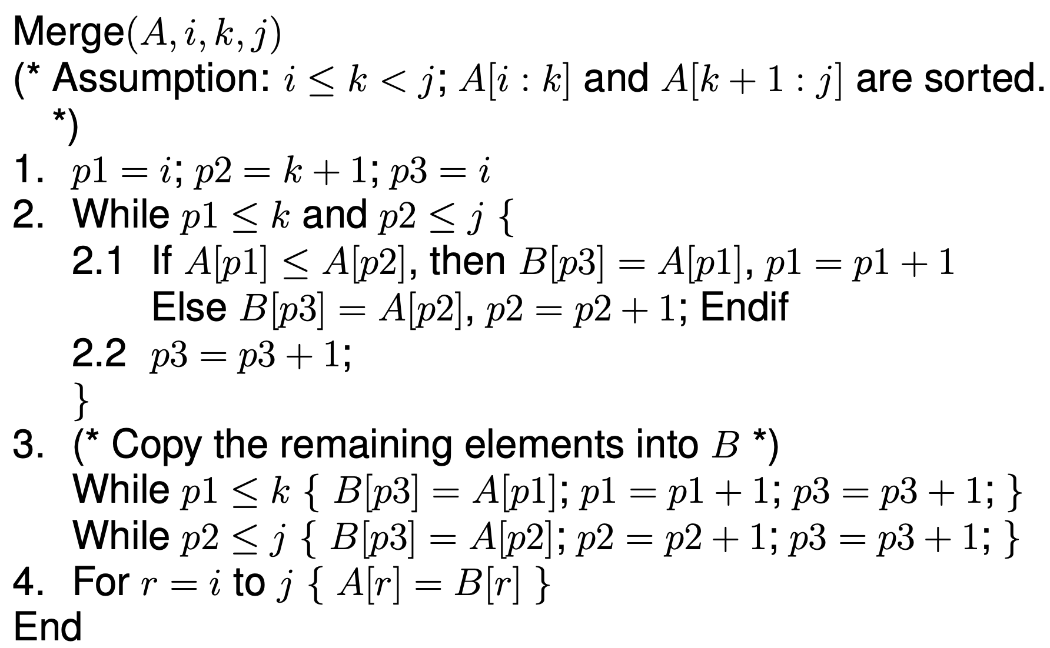
The MergeSort algorithm is analyzed as follows
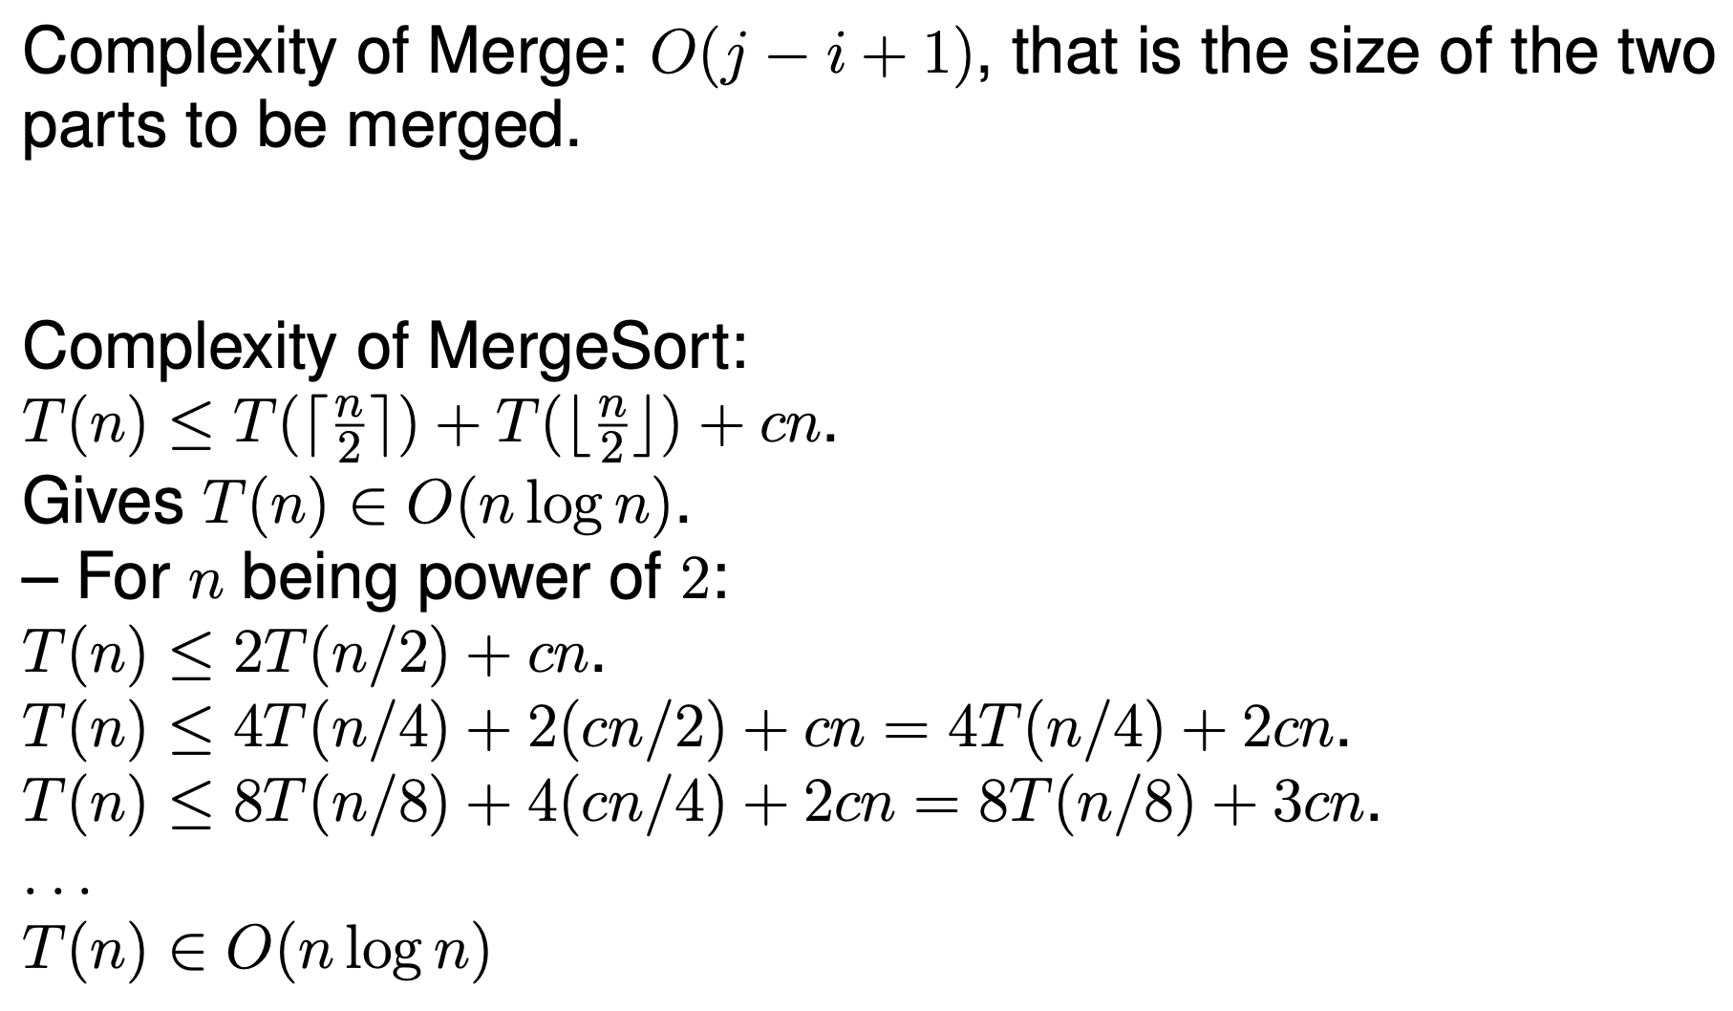
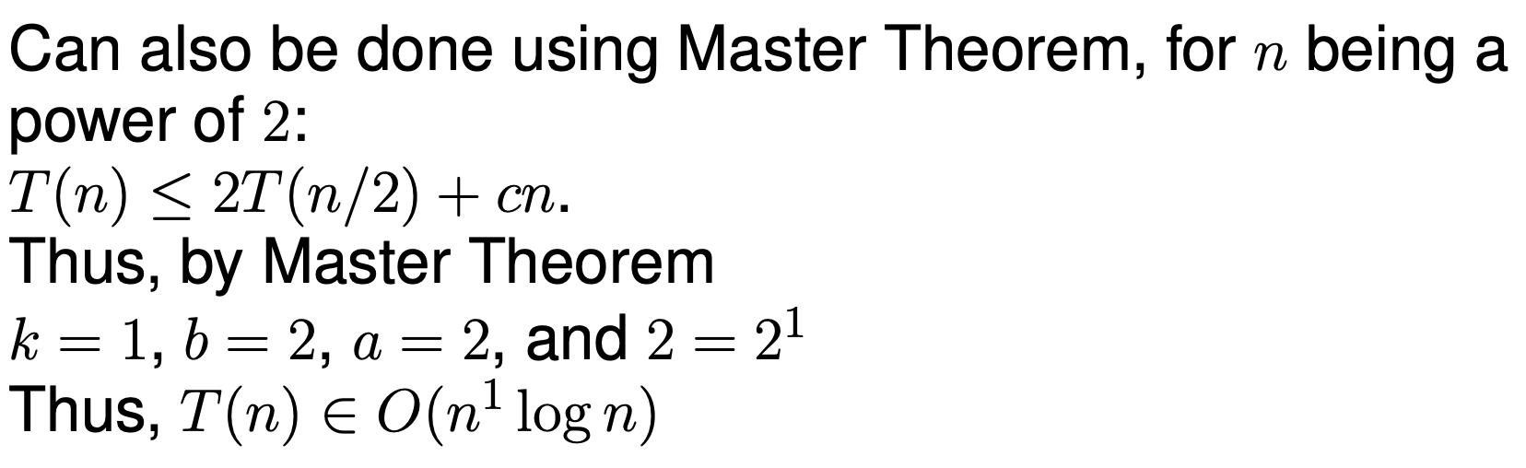
Implementation of MergeSort in Python is presented as follows
import timeit
from random import shuffle

def mergesort(A, i, j):
if i == j: return None
k = (i + j)//2
mergesort(A,i,k)
mergesort(A,k+1,j)
merge(A, i, k, j)

def merge(A,i,k,j):
B = [0]*len(A)
p1, p2, p3 = i, k+1, i
while p1 <= k and p2 <= j:
if A[p1] < A[p2]:
B[p3] = A[p1]
p1 += 1
else:
B[p3] = A[p2]
p2 += 1
p3 += 1
while p1 <= k:
B[p3] = A[p1]
p3 += 1
p1 += 1
while p2 <= j:
B[p3] = A[p2]
p3 += 1
p2 += 1
for r in range(i, j+1):
A[r] = B[r]

x = list(range(400))
shuffle(x)
print(x)
start = timeit.default_timer()
mergesort(x,0, len(x) - 1)
stop = timeit.default_timer()
print(x)
print('Time: ', stop - start)

III. Exercises
1. Design, implement and analyze a recursive algorithm with divide-and-conquer approach to calculate the number $a^{n}(a, n≥0)$
$$a^{n}=\left\{\begin{aligned}1 if n=0 \\ a*a*…*a if n>0\end{aligned}\right.$$
A(n) = A(n-1) * a
2. Design, implement and analyze a recursive algorithm with divide-and-conquer approach to calculate the number $x (a, n≥0)$
$$x=\left\{\begin{aligned}a if n=0 \\ a*(a+1)*…*(a+n) if n>0\end{aligned}\right.$$
X(n) = X(n-1) * (a + n)????
3. Design, implement and analyze a recursive algorithm with divide-and-conquer approach for:
a. Calculating Height of a binary tree
b. Traversing a binary tree in Pre-order, Post-order, In-order.
Node = (value, Left, Right)
Node = (1, None, None)
Node0 = (1, Node, None)

4. Implement and analyze the worst case of QuickSort algorithm using Python programming language. Then compare the program with the presented above MergeSort program on random datasets as large as possible.
5. Design, analyze and implement an algorithm in the divide and conquer approach to find an element in an ascending sorted array.

