DESIGN AND ANALYSIS OF ALGORITHMS
LAB 06-07: GREEDY ALGORITHMS

I. Greedy Paradigm
The greedy algorithm makes a locally optimal solution. In some cases, this is enough to get a globally optimal solution.
- The choice at each step must be feasible: satisfy the requirements.
- Each step reduces the problem to a smaller problem.
- Locally optimal: Each step is Greedy and tries local optimization, that is, chooses best among local choices based on some metric.
- Short-sighted.
- Easy to construct, simple to implement
- Irrevocable: once choice is made, there is no going back.
- May or may not give optimal (best) solution.

II. Visualization Example
import pylab
pylab.plot([1,2,3],[4,6,3],'o-')

III. Runtime
import time
start_time = time.time()
main()
print("--- %s seconds ---" % (time.time() - start_time))

IV. Input Generation
Import random
S = random.sample(range(100), 6)
print(S)

V. Programming Exercises
- Implement a greedy algorithm for the Coin Changing Problem in Python programming language and draw the running time of a program as a function of the size of its input, having generated different inputs.

The Coin Changing Problem is described as follows
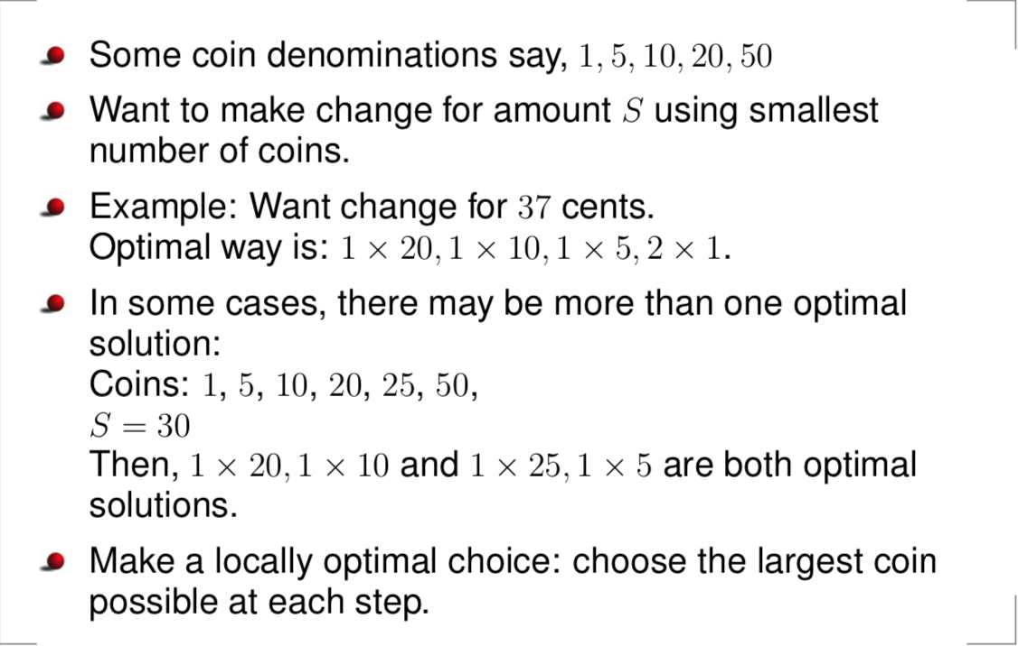

The greedy algorithm to solve The Coin Changing Problem is as follows
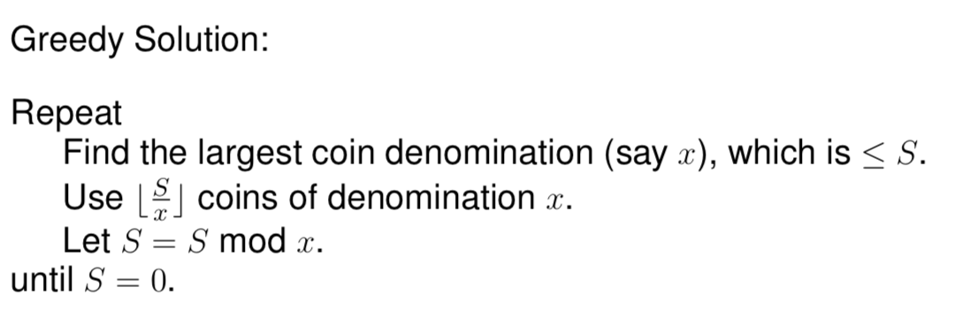
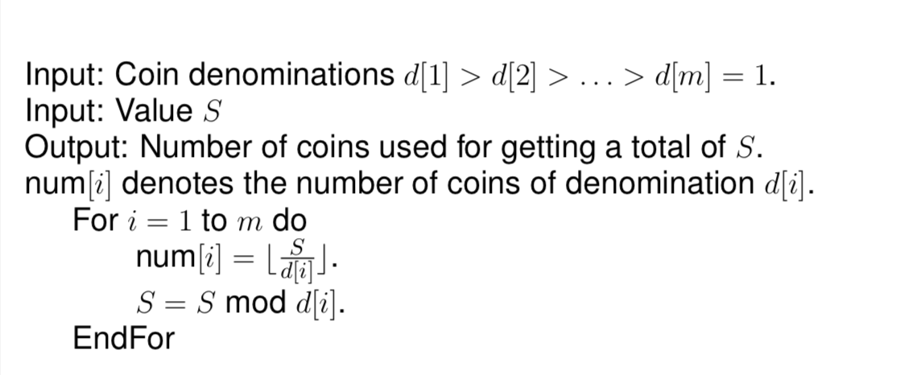

- Implement a greedy algorithm for the Fractional Knapsack Problem in Python programming language and draw the running time of a program as a function of the size of its input, having generated different inputs.

The Fractional Knapsack Problem is described as follows
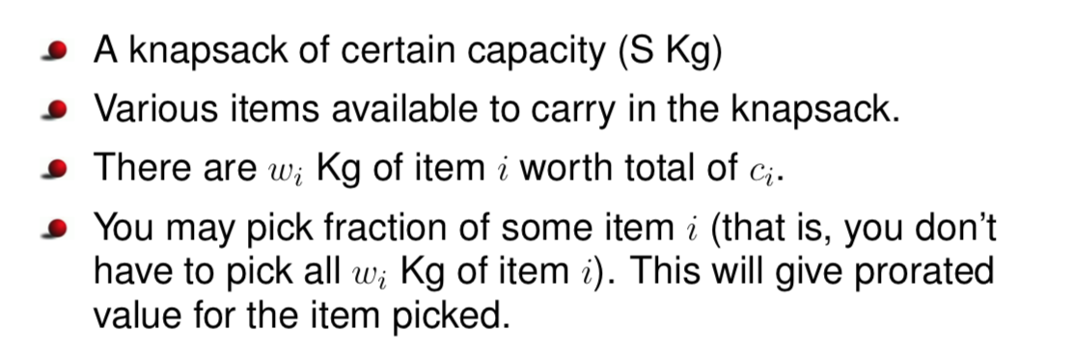

The greedy algorithm to solve the Fractional Knapsack Problem is as follows

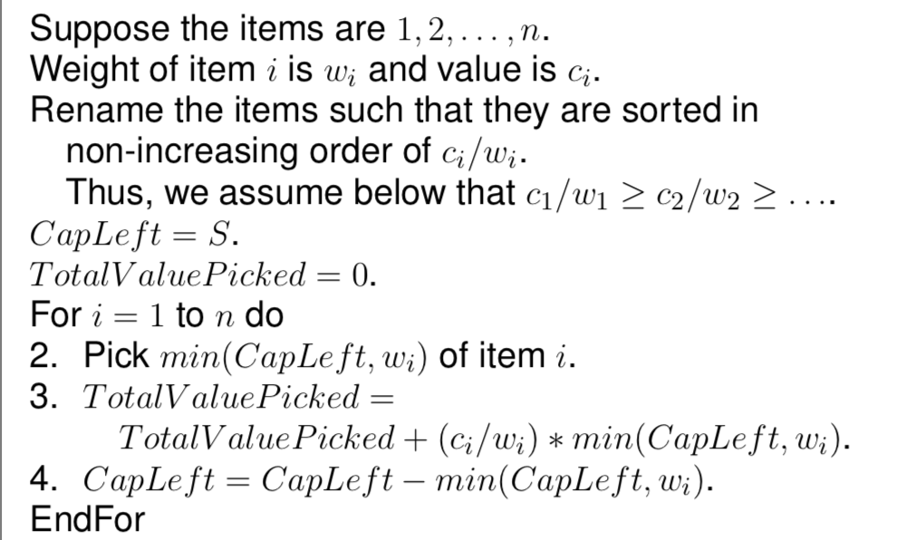

Hint: For the following exercises related to graph, we can represent a edge as a tuple of three elements

>>> (1,5,4)
(1, 5, 4)
>>> x = (4,1,5)
>>> x[0]
4
>>> x[1]
1
>>> x[2]
5
>>> y = (2,3,4)
>>> z = [x,y]
>>> z
[(4, 1, 5), (2, 3, 4)]
>>> sorted(z)
[(2, 3, 4), (4, 1, 5)]

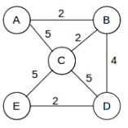

G = {'A':[(2,'B'), (5, 'C')],'B':[(2,'A'),(2,'C'), (4,'D')]}
>>> G['A']
[(2, 'B'), (5, 'C')]
>>> G['A'][0]
(2, 'B')

G = {'A':{'B':2, 'C':5},'B':{'A':2, 'C':2, 'D':4}}

>>> G = {'A':{'B':2, 'C':5},'B':{'A':2, 'C':2, 'D':4}}
>>> G['A']['C']
5

- Implement a greedy algorithm for the Single Source Shortest Paths Problem in Python programming language and draw the running time of a program as a function of the size of its input, having generated different inputs.

The Single Source Shortest Paths Problem is described as follows
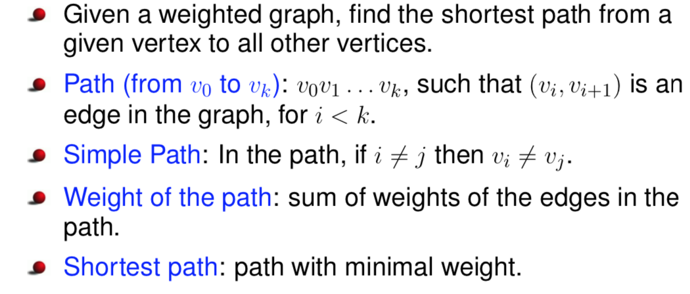
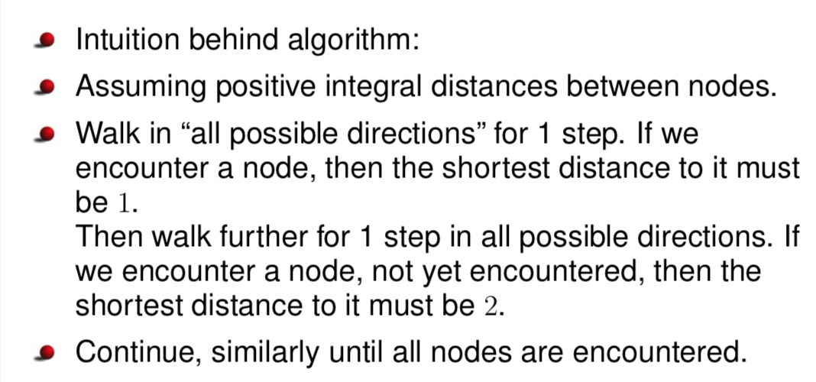
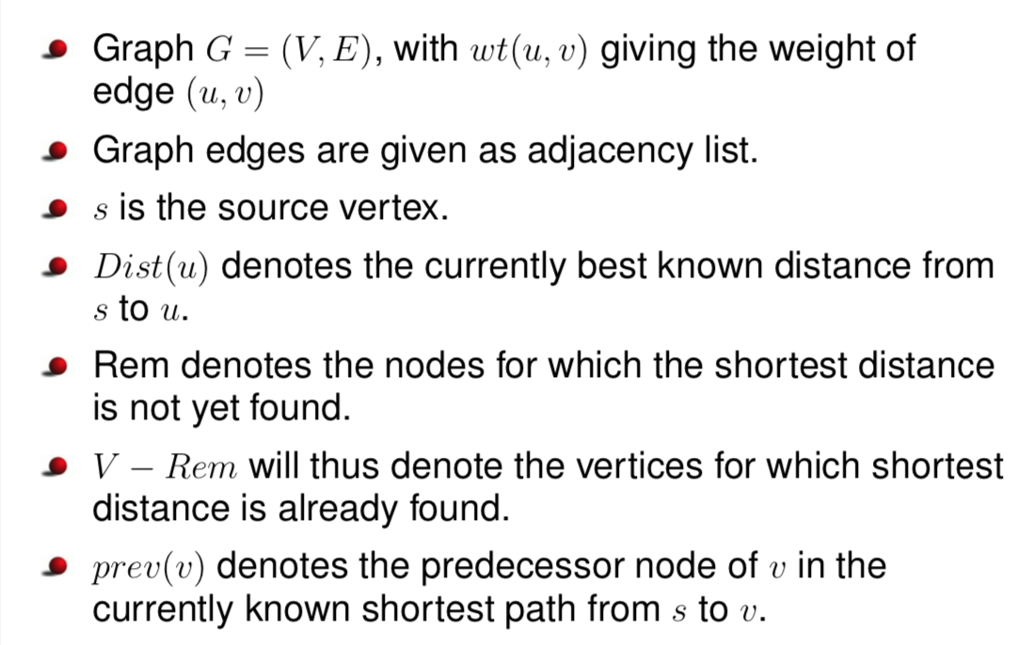
The greedy algorithm (Dijkstra’s Algorithm) to solve the Single Source Shortest Paths Problem is as follows
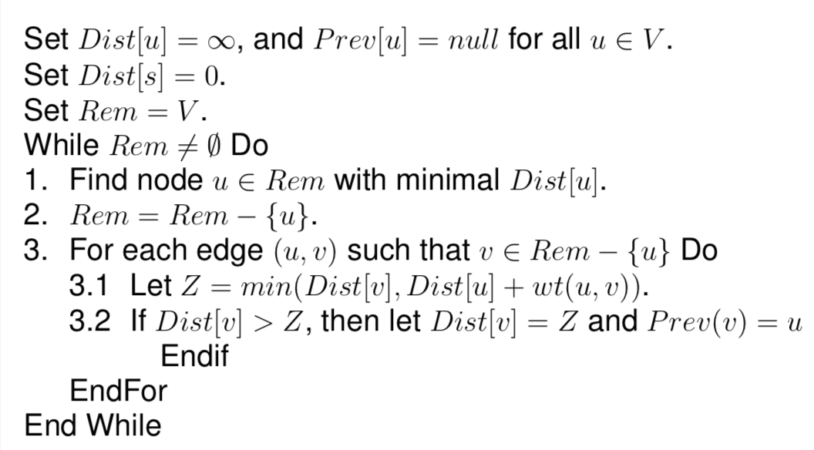
- Implement Prim’s Algorithm for finding a Minimal spanning tree in Python programming language and draw the running time of a program as a function of the size of its input, having generated different inputs.

The Minimal spanning tree Problem is described as follows

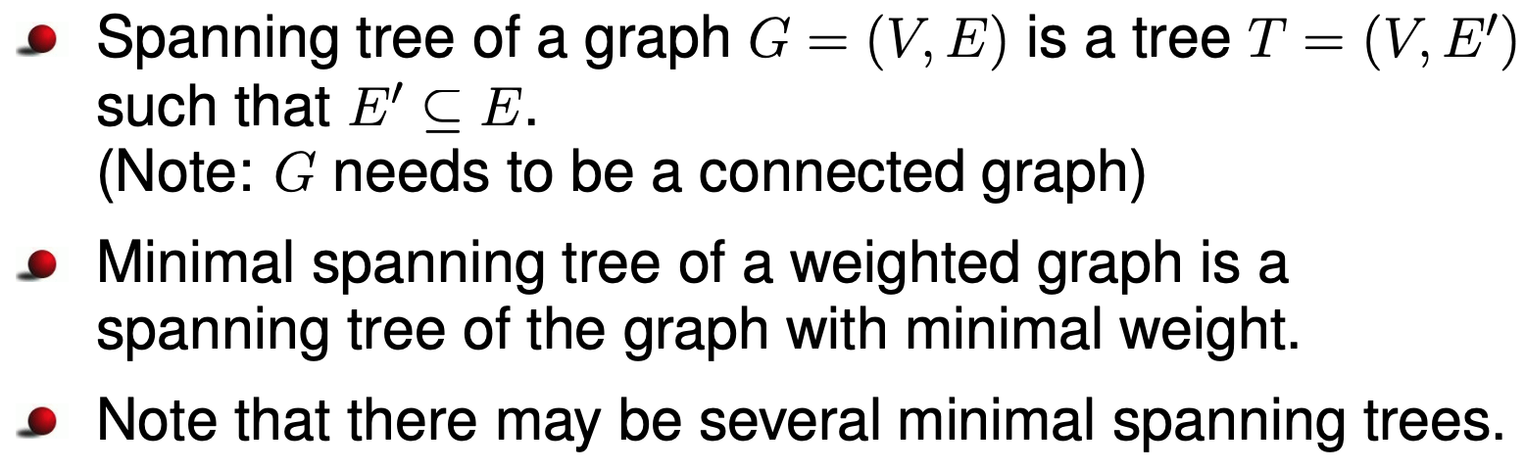

The intuition to find MST:

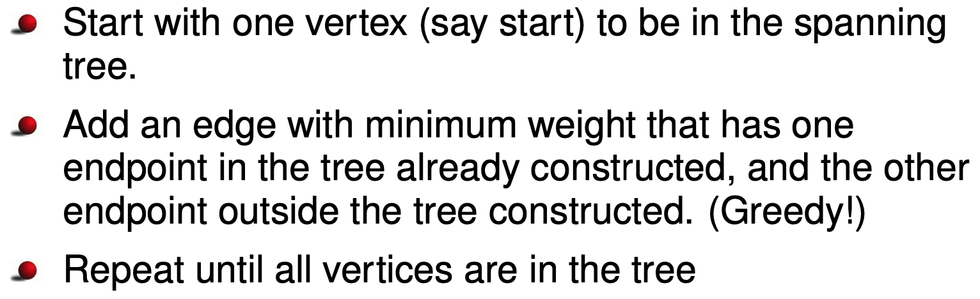
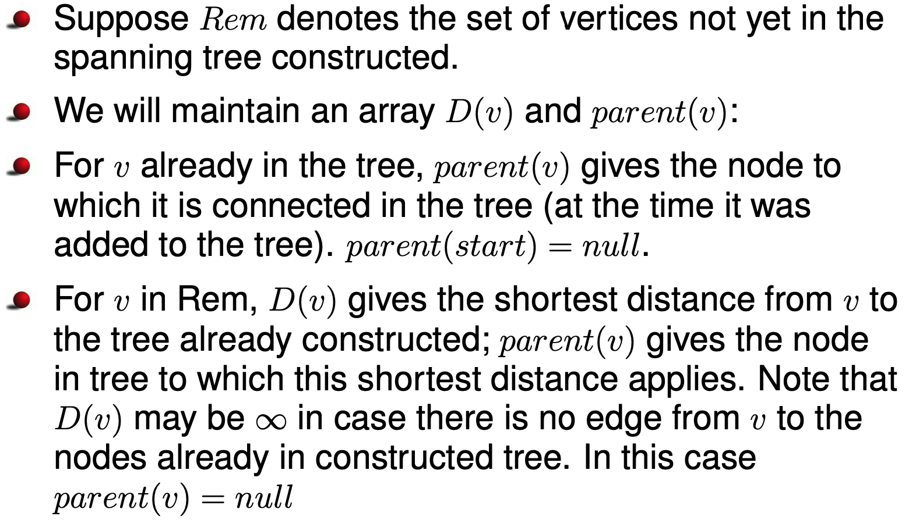
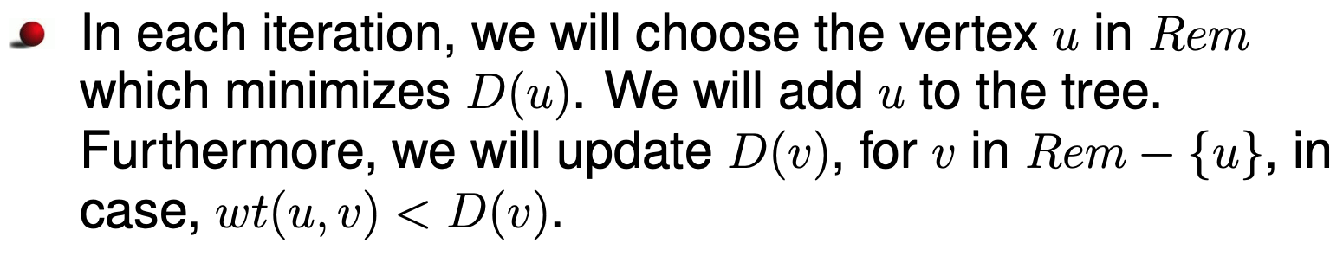
The Prim’s Algorithm for finding a Minimal spanning tree is as follows
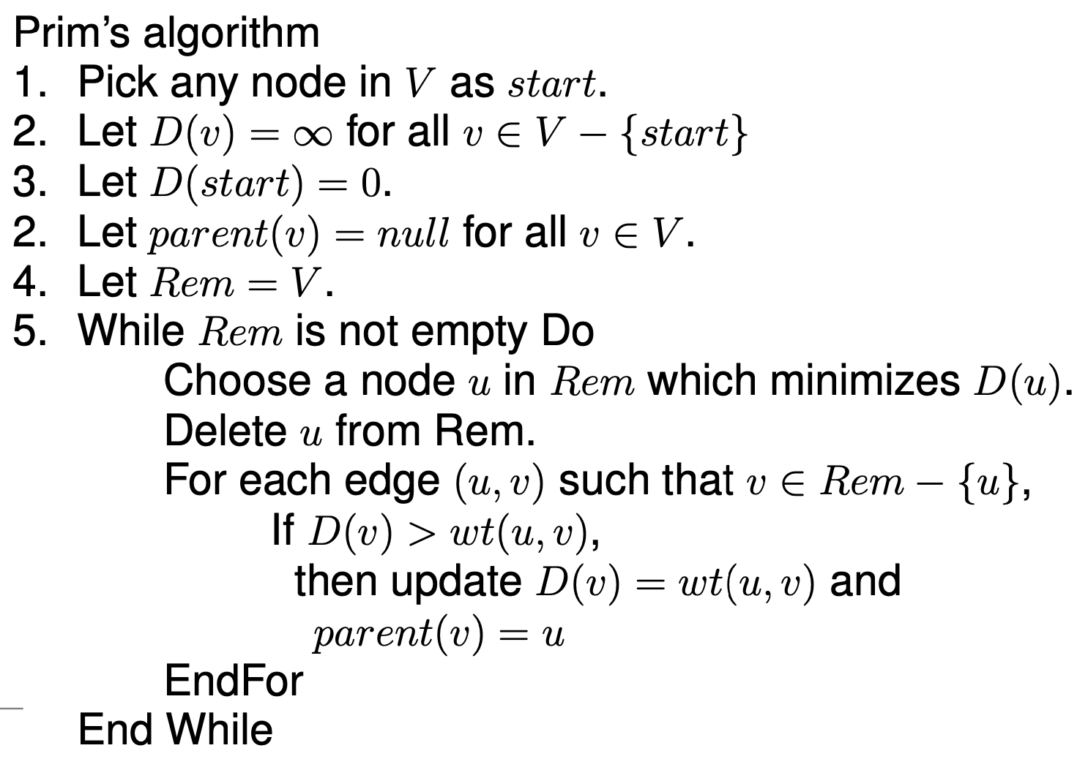
- Implement Kruskal’s Algorithm for finding a Minimal spanning tree in Python programming language and draw the running time of a program as a function of the size of its input, having generated different inputs.

The intuition of Kruskal’s Algorithm:

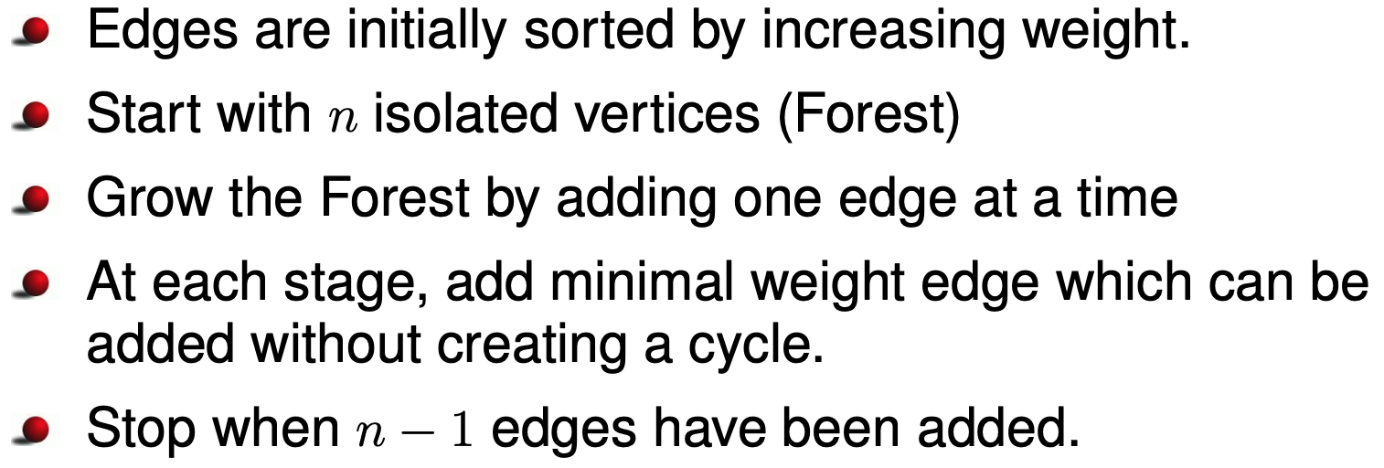

The Kruskal’s Algorithm for finding a Minimal spanning tree is as follows

