DESIGN AND ANALYSIS OF ALGORITHMS
LAB 08: Dynamic Programming

Dynamic Programming Idea

“Programming” relates to planning/use of tables, rather than computer programming.

Solve smaller problems first, record solutions in a table; use solutions of smaller problems to get solutions for bigger problems.

Differs from Divide and Conquer in that it stores the solutions, and subproblems are “overlapping”

Programming Exercises

A. Requirements for all problems:
- Implement a Dynamic Programming algorithm to solve problem in Python programming language
- Implement a Divide-and-Conquer algorithm (in the form of a recursive algorithm) to solve problem in Python programming language
- Generate different inputs of different size
- Draw the running time of each program as a function of input size

B. Problems
- Calculate Fibonacci Numbers
Fibonacci Numbers are described as follows
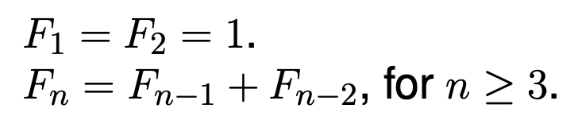
Def F(n):
If n <= 1:
Return 1
Return F(n-1) + F(n-2)

The Dynamic Programming algorithm to calculate Fibonacci Numbers is presented as follows
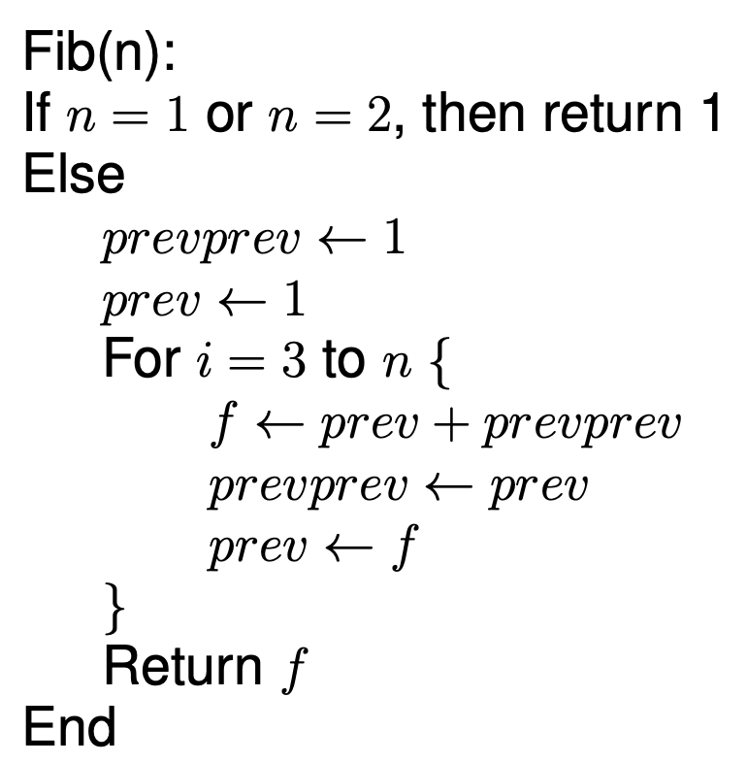

- Solve 0/1 knapsack problem
The 0/1 knapsack problem is described as follows
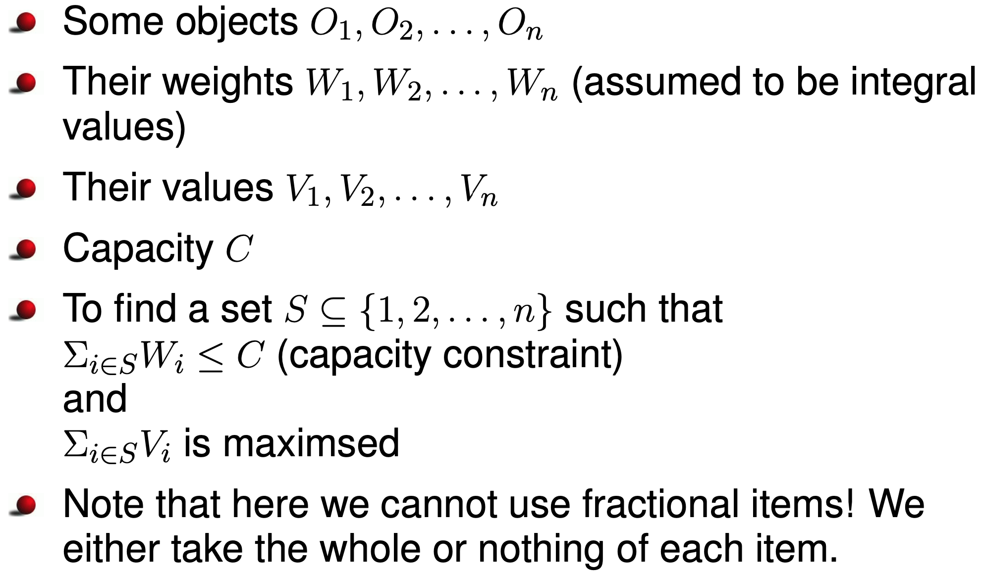
Intuition of Dynamic programming

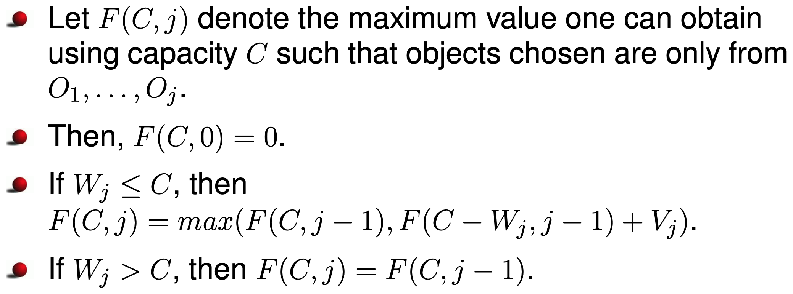

The Dynamic Programming algorithm to solve 0/1 knapsack problem
is presented as follows

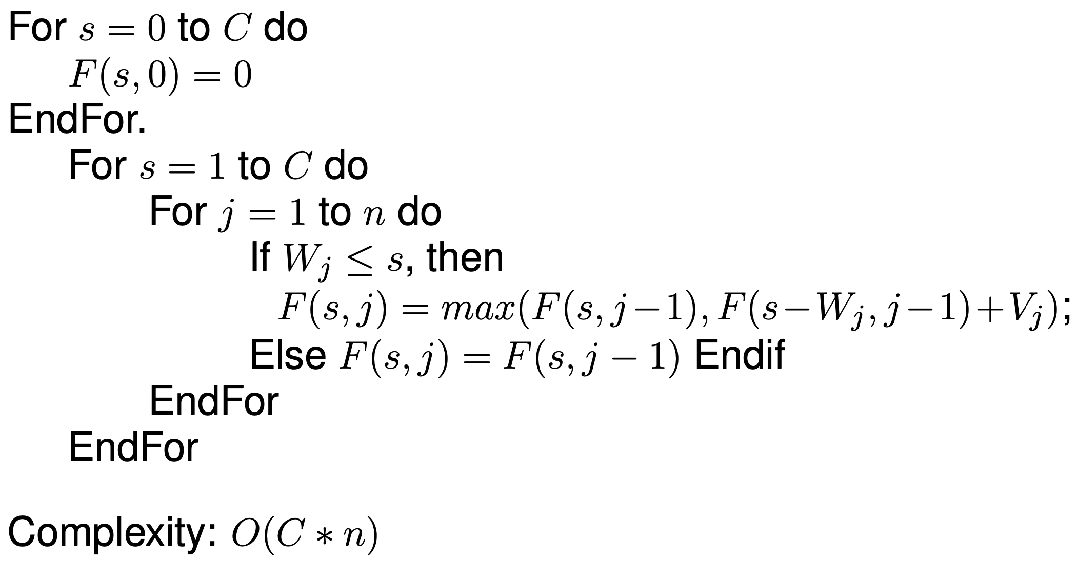

If we want to see which objects are chosen, apply the following algorithm
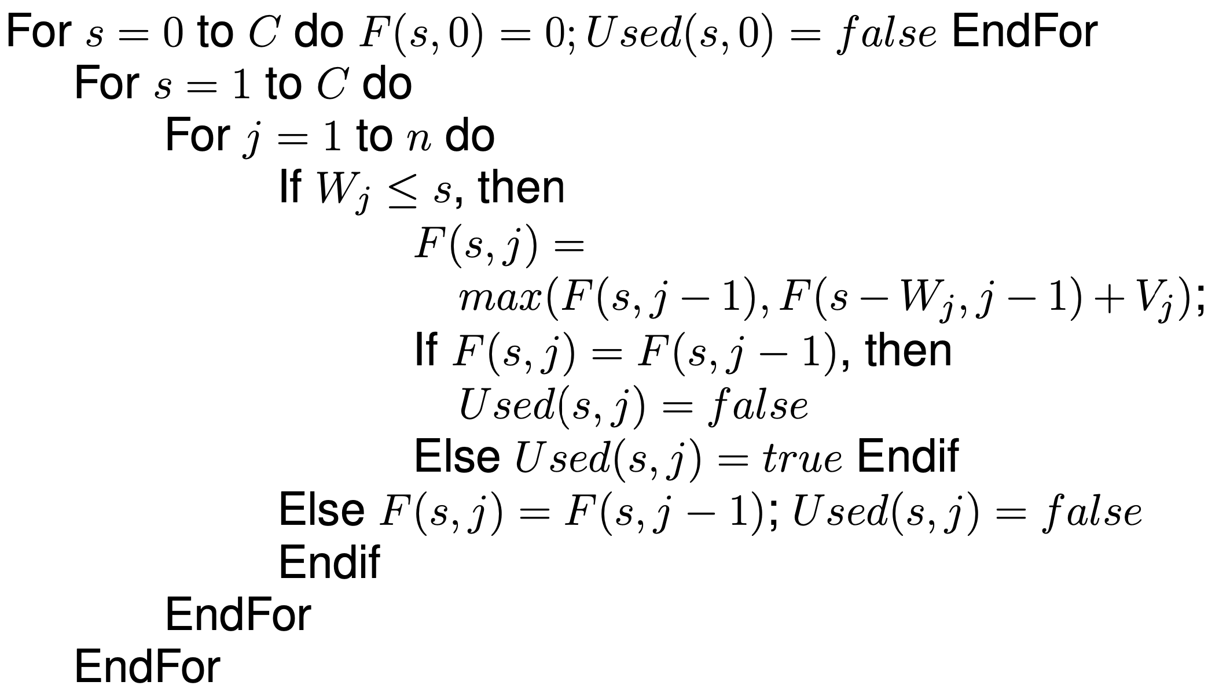
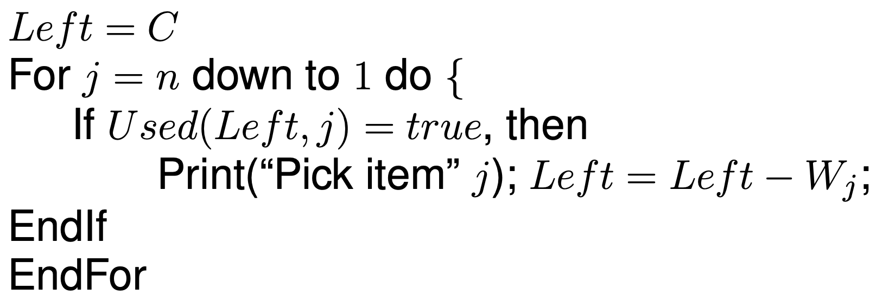

- Solve coin changing problem
The problem is described as follows

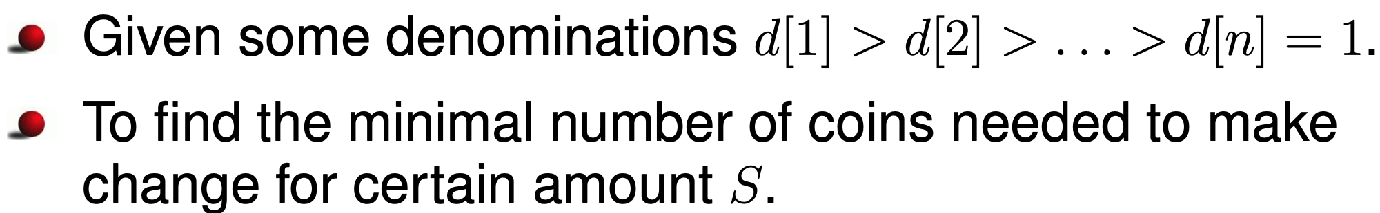

Intuition of Dynamic programming to solve the problem

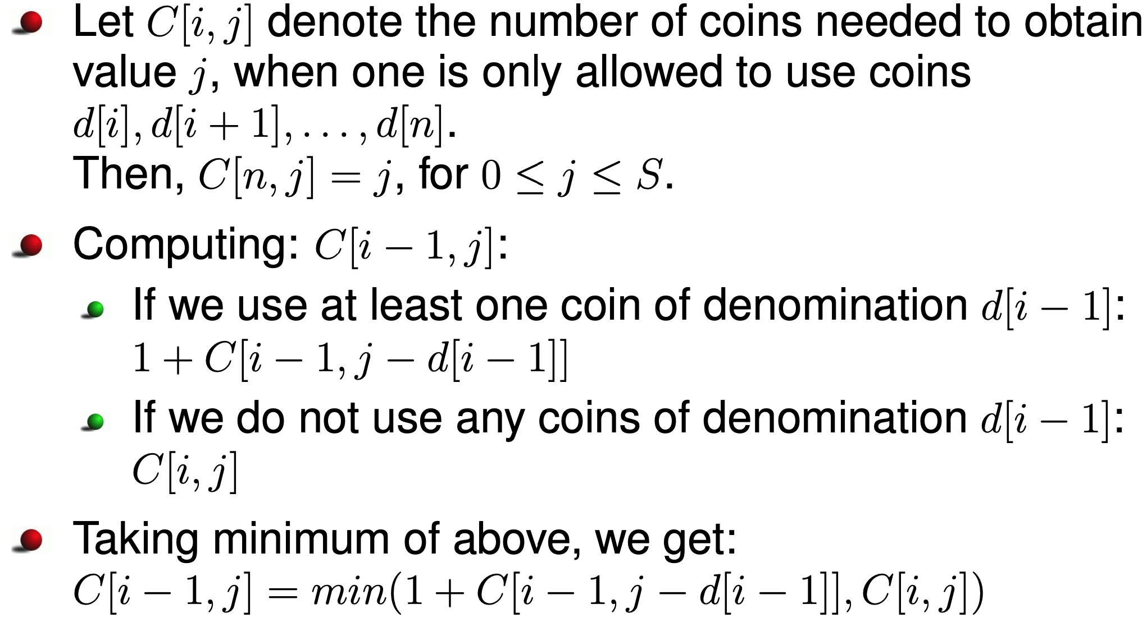

The Dynamic Programming algorithm to solve the problem
is presented as follows

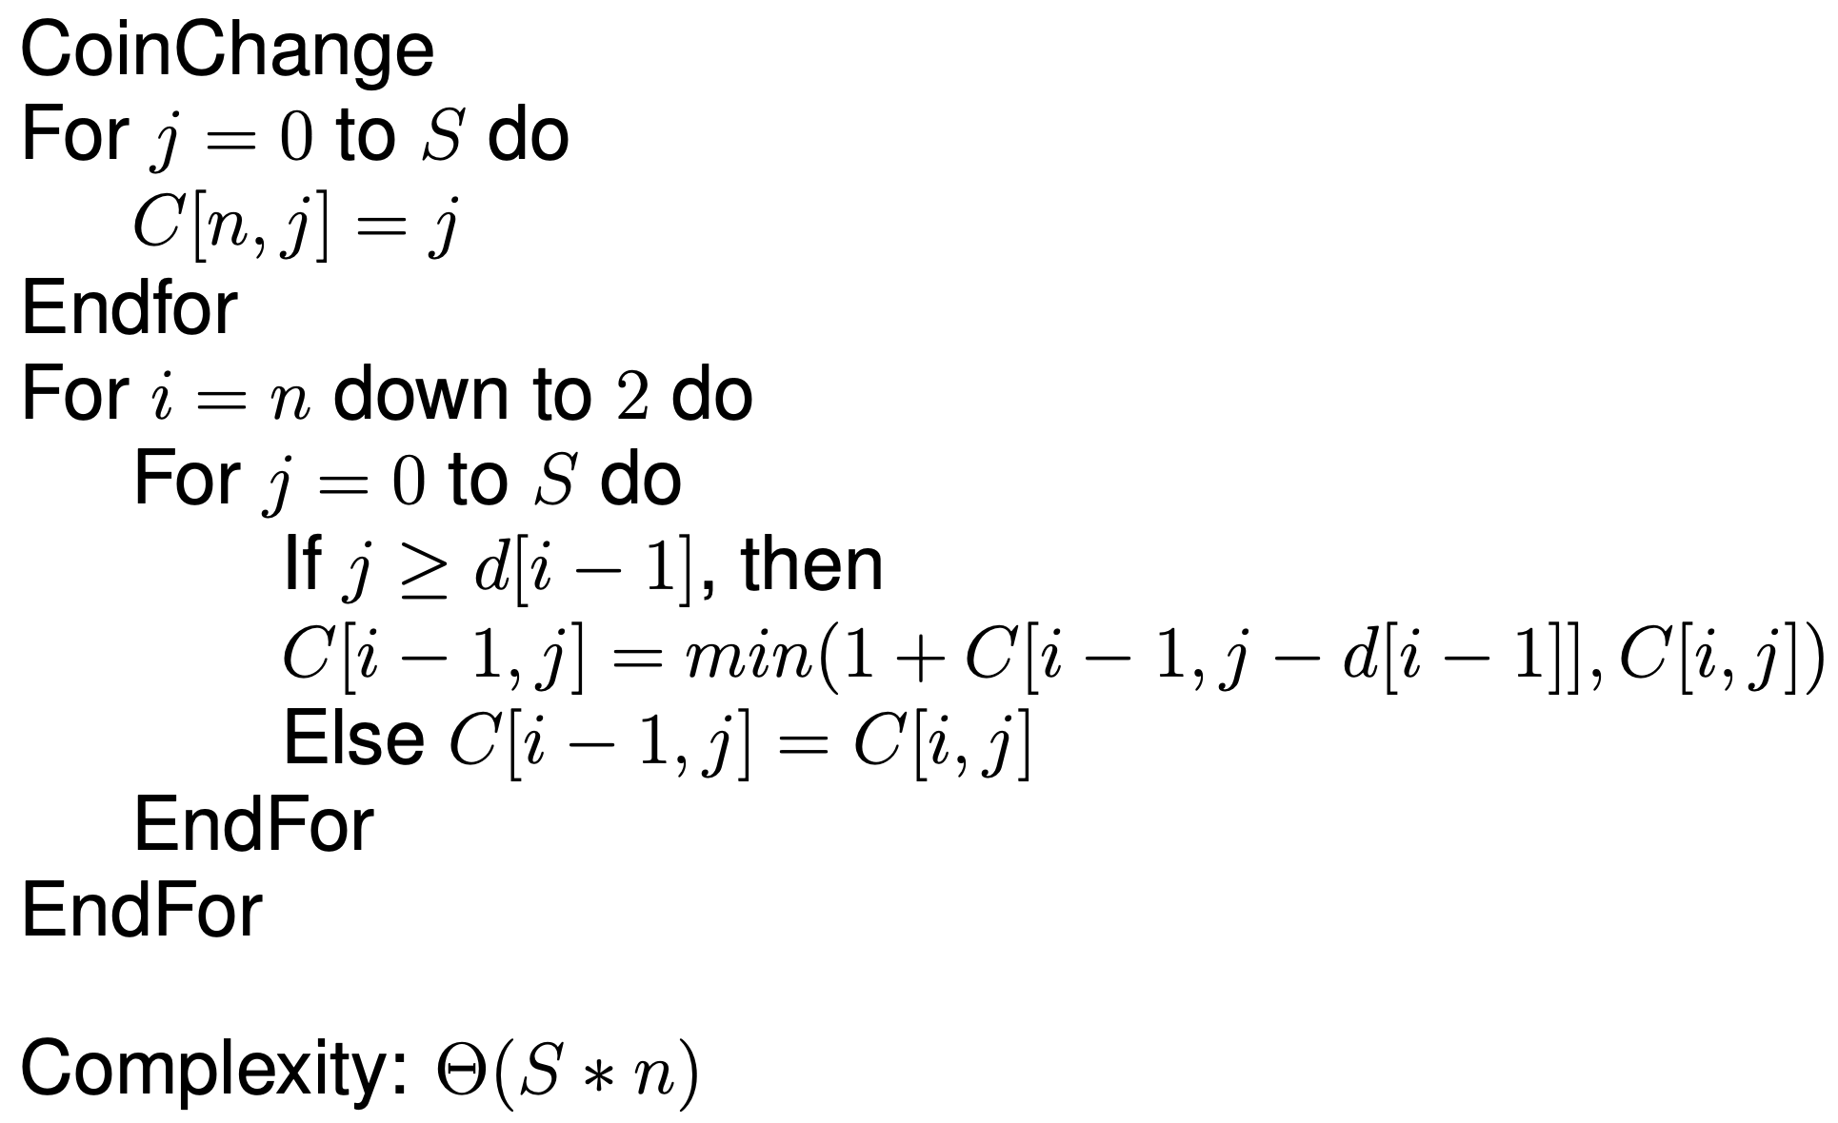

To give coins used:
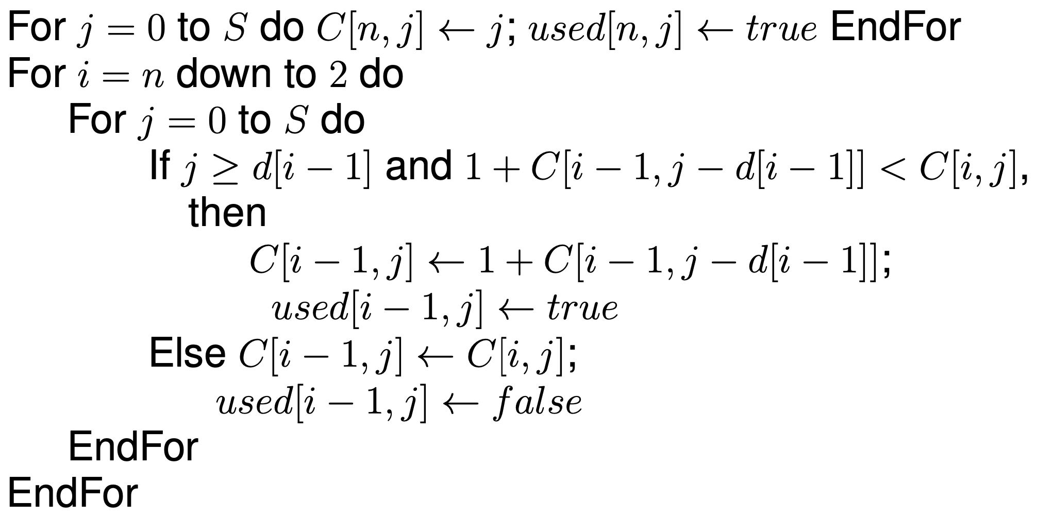

- Calculate Binomial Coefficients.

The Binomial Coefficients problem is described as follows

