**Name: Nguyen Minh Nhut – 518H0545**

**Exercise 1:**

Based on your experience with a bank ATM, draw an sequence diagram that models the data processing involved when a customer withdraws cash from the machine

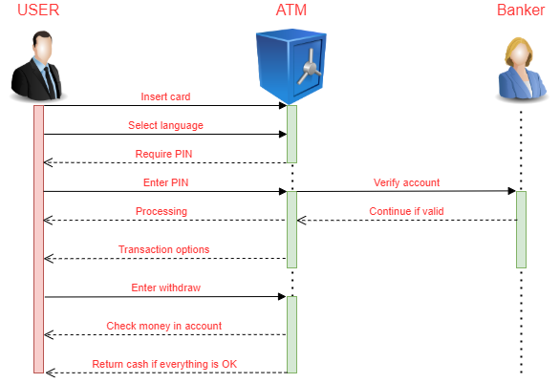

**Exercise 2:**

Develop a sequence diagram showing the interactions involved when a student registers for a course in a university.

Courses may have limited enrollment, so the registration process must include checks that places are available.

Assume that the student accesses an electronic course catalog to find out about available courses

