UML:

|  |
| --- |
| diff |
| -ui:diff  +level:QString |
| +ondiffClose():void  +sendlevel(int):void  +on_pushButton_clicled():void |

|  |
| --- |
| Hit |
| -time:int  -tp:int  -sd:int |
| +move():void  +style():void  +settime(int t):void  +gettime():int  +returntype():int |

|  |
| --- |
| Inrtroduction |
| -ui:Inrtroduction* |
| +intclose():void  +on_pushButton_clicked():void |

|  |
| --- |
| MainWindow |
| -ui:MainWindow*  -mainwindow2:MainWindow2*  -rank1:rank*  -option1:option*  -intr:Inrtroduction*  -movie:QMovie*  -music:QMediaPlayer* |
| +senddata(int): void  +on_start_clicked():void  +on_rank_clicked():void  +rankClose():void  +on_option_clicked():void  +getlevel(int a):void  +on_introduction_clicked():void  +misicon():void  +misicoff():void  +on_Exit_clicked():void  *+mouseMoveEvent*(QMouseEvent *e): void |

|  |
| --- |
| MainWindow2 |
| -Ui:MainWindow2 *  -tt:QTimer *;  -cc:QTimer *  -totaltime:int  -scene:QGraphicsScene*  -view:QGraphicsView*  -n_note:hit*  -note:QVector<hit*>  -scores:int  -dif:QString  -iterator ath:QVector<hit*>  -iterator cur:QVector<hit*>  -sc:score*  - music1:QMediaPlayer* |
| +add_hits():void  +timeend():void  +onMainClosed():void  +countscore(int c,int d): void  +setlevel(QString lv):void  +timecount():void  +resultshow():void  -hitdelete():void  -gamestart():void  -mainshow():void  -*keyPressEvent*(QKeyEvent *event):void |

|  |
| --- |
| music |
| -- ui:music * |
| +onmusic(int):void  +offmusic(int):void  +itclose():void  -on_pushButton_clicked():void |

|  |
| --- |
| option |
| -ui:option *  -diff1:diff *  -music12:music *  -di:int  -om:int |
| +onoptionClosed():void  +sendlevel(int): void  +mison():void  +misoff():void  -on_pushButton_clicked():void  -musicon(int c): void  -musicoff(int b): void  -on_pushButton_2_clicked():void  -getlevel(int a): void  -on_pushButton_3_clicked():void |

|  |
| --- |
| rank |
| -ui:rank* |
| +onRankClose():void  +on_pushButton_clicked():void |

|  |
| --- |
| score |
| -ui:score*  +aa:QString  +bb:QString |
| +setscore(QString a):void  +on_pushButton_3_clicked():void  +on_pushButton_2_clicked():void  +on_pushButton_clicked():void  +closes():void  +newgame():void  +ok():void |

遊戲架構

遊戲有三個難度,可以從選項中選擇難度,遊戲進到畫面有背景音樂及動態圖片當你移到開始鍵時,動態圖片停止,在選項中你也可以選擇背景樂的開啟或關閉,進入遊戲後有遊戲音樂,然後當遊戲結束之後可以輸入姓名依照分數有排行榜,也可以重新遊戲或離開,主畫面還有遊戲說明

遊戲說明

在主畫面中,點開introduction便有,不同顏色的有不同的分數,紅色分數最低,白色分數最高

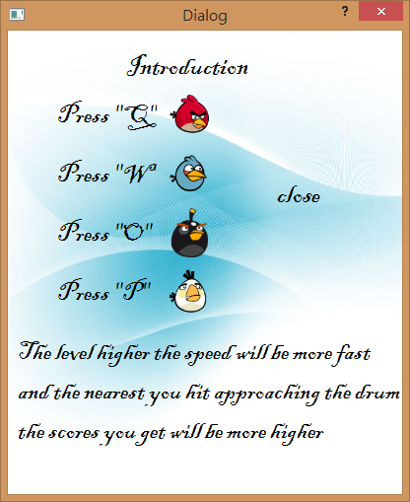

遊戲畫面:

