**INTI International College Penang School of Engineering and Technology**

**3+0 Bachelor of Science (Hons) in Computer Science, in collaboration with Coventry University, UK**

**3+0 Bachelor of Science (Hons) in Computing, in collaboration with Coventry University, UK**

**Coursework cover sheet**

**Section A - To be completed by the student**

|  |  |
| --- | --- |
| Full Name: Lim Ni Feih | |
| CU Student ID Number: 12672774 | |
| Semester:2 | |
| Session:  **April 2022** | |
| Lecturer:  **Nadhrah Abdul Hadi (nadhrah.abdulhadi@newinti.edu.my)** | |
| Module Code and Title:  **4067CEM Software Design** | |
| Assignment No. / Title:  **Continuous Assessment** | % of Module Mark:  **50** |
| Hand out Date:  **22nd April 2022** | Due Date:  **Task 1: 13 May 2022, by 11.59pm**  **Task 2: 1 July 2022, by 11.59pm**  **Task 3: 17 June 2022, by 11.59pm.**  **Task 4: 17 June 2022, by 11.59pm.**  **Task 5: 17 June 2022, by 11.59pm.** |
| Penalties: No late work will be accepted. If you are unable to submit coursework on time due to extenuating circumstances, you may be eligible for an extension. Please consult the lecturer. | |
| Declaration: I/we the undersigned confirm that I/we have read and agree to abide by the University regulations on plagiarism and cheating and Faculty coursework policies and procedures. I/we confirm that this piece of work is my/our own. I/we consent to appropriate storage of our work for plagiarism checking.  Signature(s): __________LNF___________ | |

**Section B - To be completed by the module leader**

|  |  |  |
| --- | --- | --- |
| Intended learning outcomes assessed by this work:  1. Understand and apply appropriate concepts, tools and techniques to each stage of the software development  2. Understand and apply design patterns to software components in developing new software  3. Demonstrate an understanding of project planning and working to agreed deadlines, along with professional, interpersonal skills and effective communication required for software production  5. Demonstrate an awareness of, and ability to apply, social, professional, legal and ethical standards as documented in relevant laws and professional codes of conduct such as that of the Malaysian National Computer Confederation. | | |
| Marking scheme | Max | Mark |
| 1. User Story Mapping 2. Setting up a GitHub Repository 3. Creating a Class diagram and design pattern selection 4. Creating a Prototype User Interface and Usability Testing 5. Discuss the ethical issue related to the software | 20  10  30  20  20 |  |
| Total | 100 |  |

**Vision**

Currently, college event organizers do not have a proper platform to promote and share the details of their events. Not only that, college students are not properly updated about the events held in the college as the marketing of events are scattered through emails, social media, notice boards, and word-of-mouth. This is due to different event organizers using different platforms to promote their events.

With the problem at hand, an all-in-one application is built so that the students will be able to keep track and receive information about the events without going through social media and emails. Besides, the organizers will also be able to promote and share their events with the students easily.

**Survey Questionnaire for College Event System User Story Mapping**

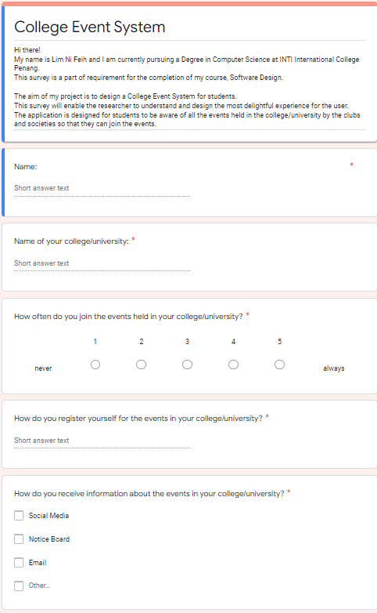

*Figure 1: Survey form (Page 1)*

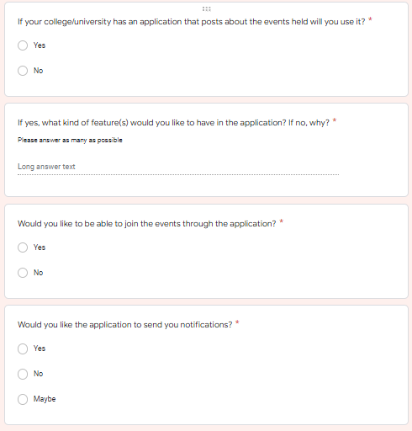

*Figure 2: Survey Form (Page2)*

**Responses for the Survey Questionnaire**

**Question 1:**

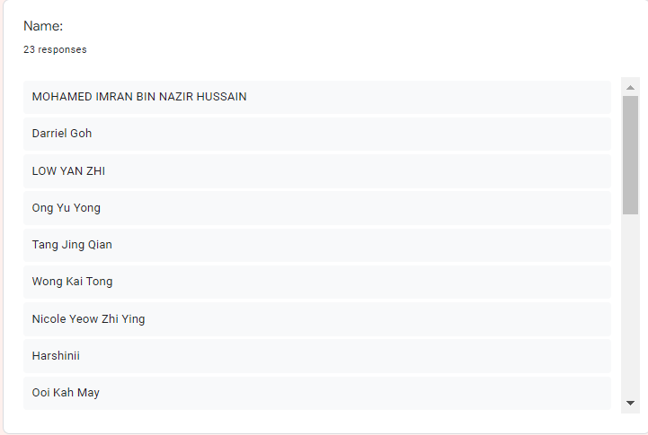

*Figure 3: Response for Survey Form (Name) (Page1)*

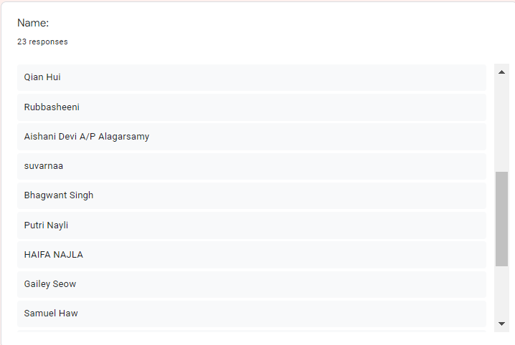

*Figure 4: Response to Survey Form (Name) (Page2)*

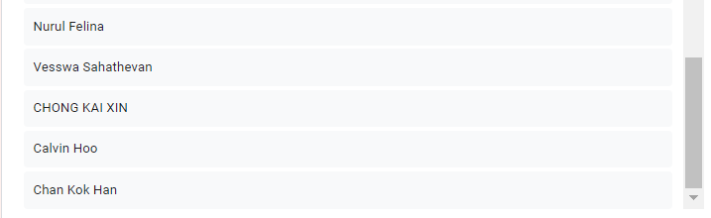

*Figure 4: Response to Survey Form (Name) (Page3)*

**Question 2:** 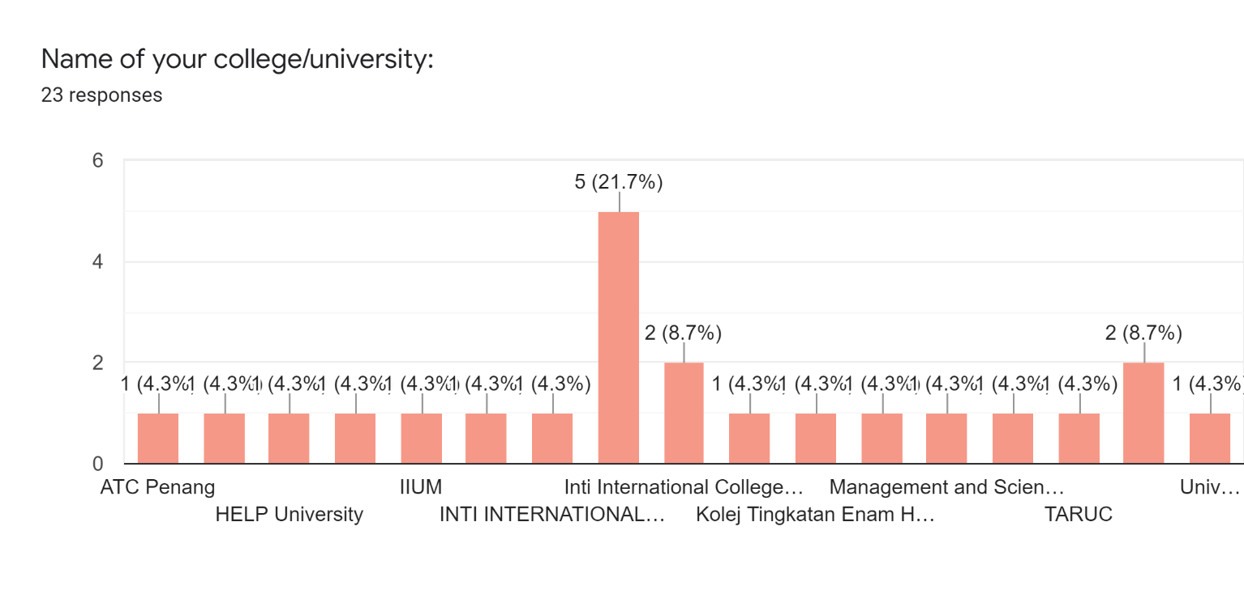

*Figure 6: Response to Survey Form (Name of your college/University)*

Summary:

Management and Science University -1

Swinburne University of Technology -1

TARUC - 1

USM - 2

UPM - 1

ATC - 1

DISTED - 1

HELP University - 1

IICP - 11

IIUM - 1

Kolej Tingkatan Enam Haji Zainul Abidin – 1

Kolej Yayasan UEM – 1

**Question 3:**

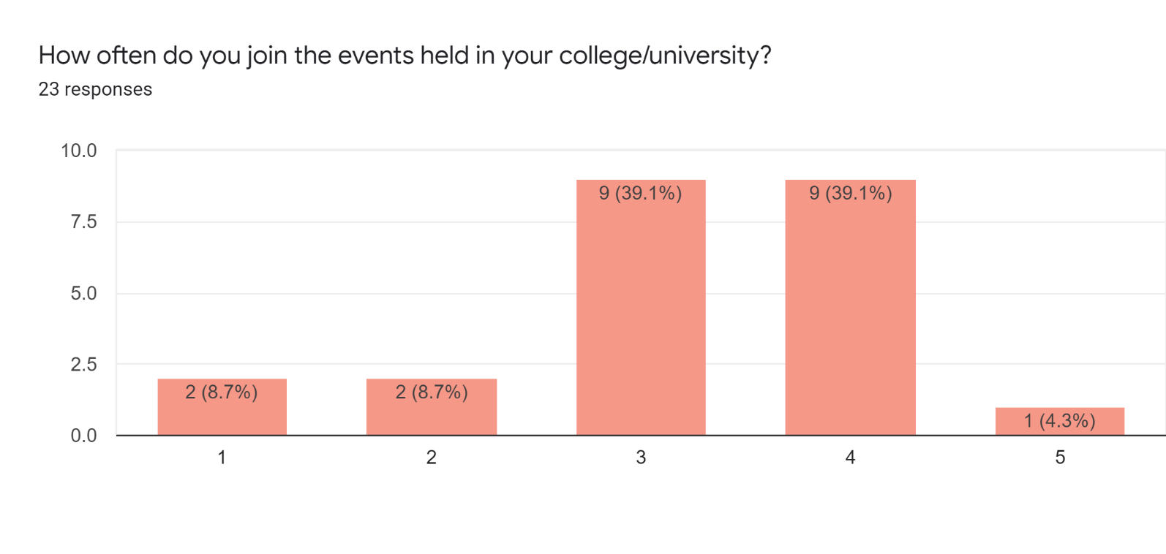

*Figure 7: Response to Survey Form (How often do you join the events held in your college/university?)*

**Question 4:** 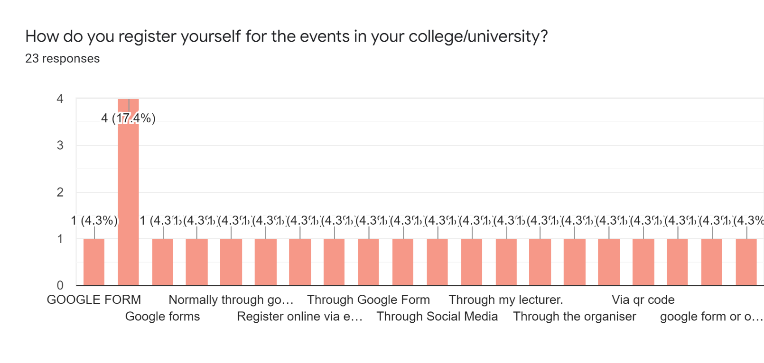

*Figure 8: Response to survey form (How do you register yourself for the events in your college/university)*

Summary (Some of them answered more than one method):

Social Media - 3

Through Lecturer – 1

Through organiser – 2

Google Form – 14

Never – 1

Qr code – 3

Email - 1

**Question 5:**

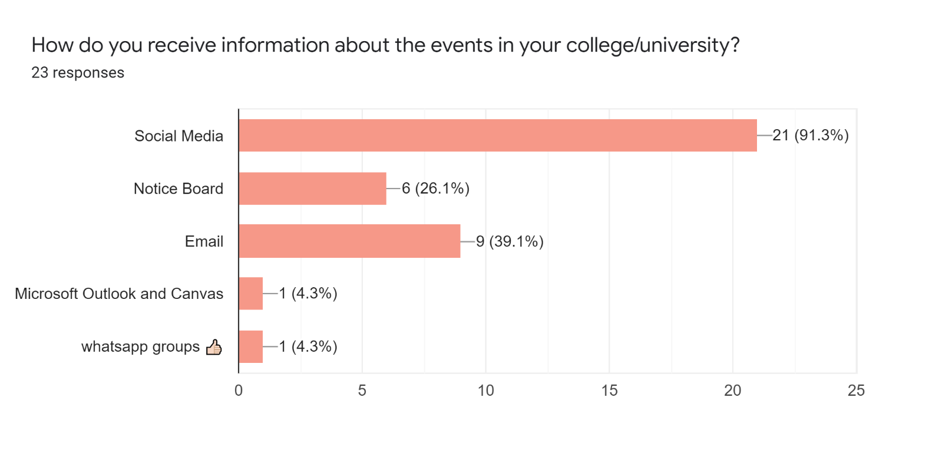

*Figure 9: Response to survey form (How do you receive information about the events in your college/university)*

**Question 6:**

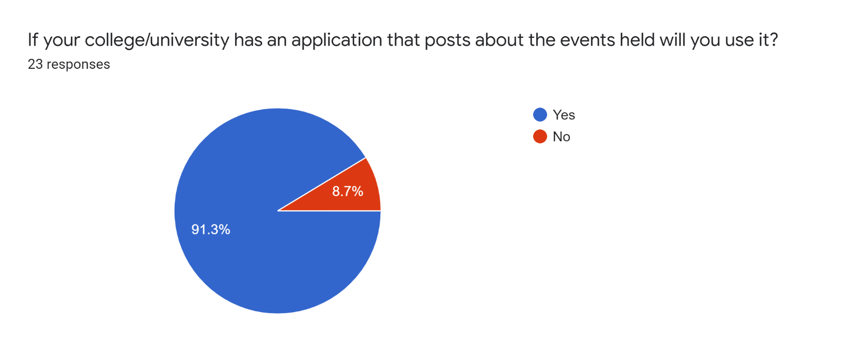

*Figure 10: Response to survey form (If your college/university has an application that posts about the events held will you use it?)*

Summary:

Yes – 21

No – 2

**Question 7:**

For yes:

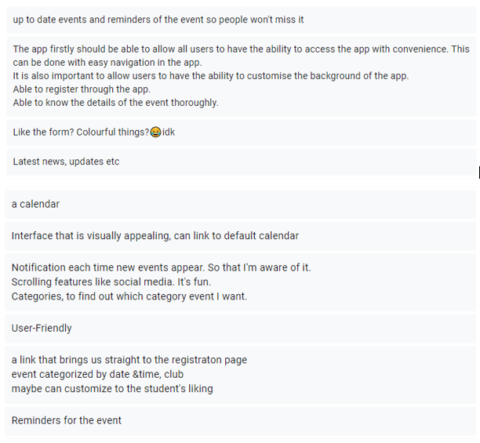

*Figure 11: Response to survey form (If yes, what kind of features would you like to have in the application? If no, why?)-Yes (Page1)*

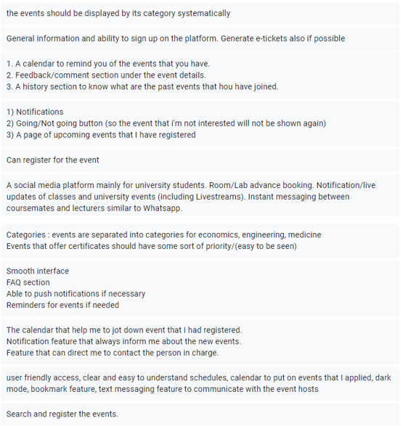

*Figure 12: Response to survey form (If yes, what kind of features would you like to have in the application? If no, why?)-Yes(Page2)*

For no :

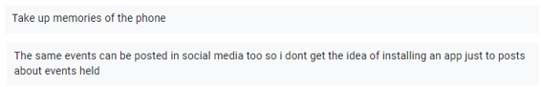

*Figure 12: Response to survey form (If yes, what kind of features would you like to have in the application? If no, why?)-No*

**Question 8:**

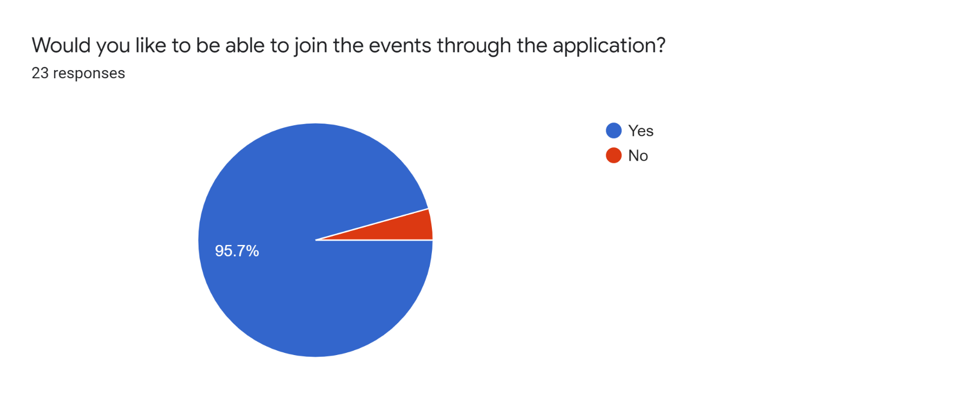

*Figure 14: Response to survey form (Would you like to be able to join the events through the application?)*

Summary:

Yes - 22

No – 1

**Question 9:** 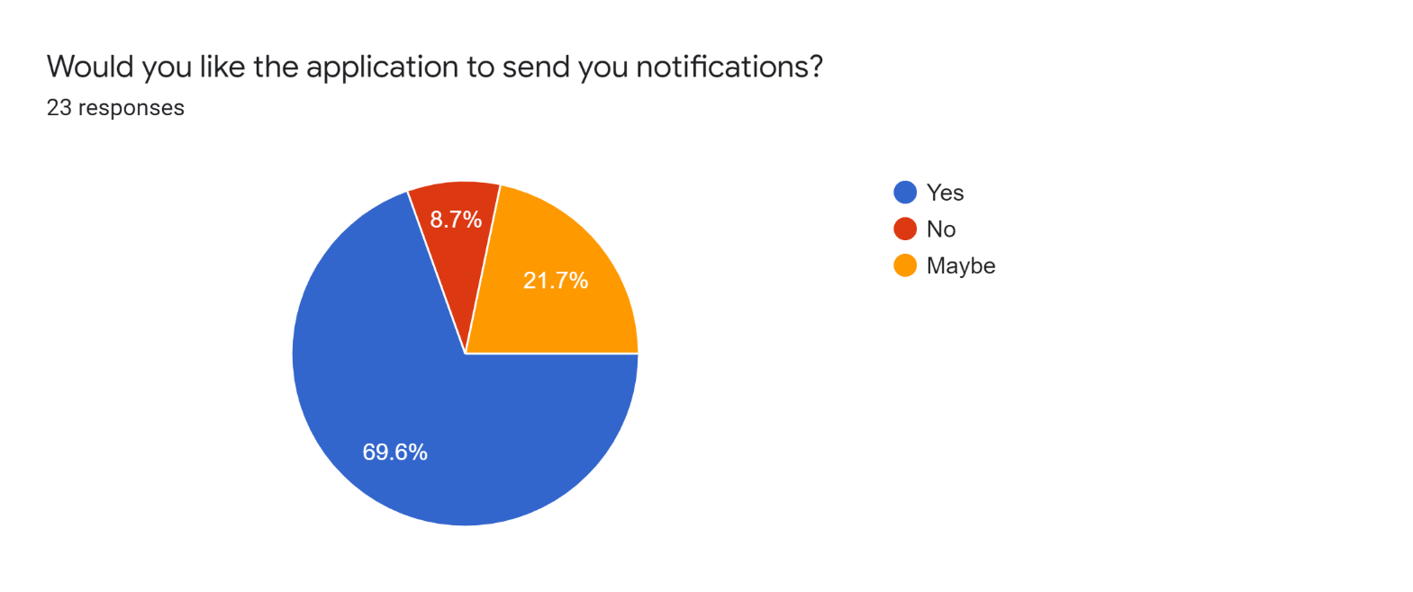

*Figure 15: Response to survey form (Would you like the application to send you notifications?)*

Summary:

Yes - 16

No – 2

Maybe - 5

**User Story Mapping (Miro)**

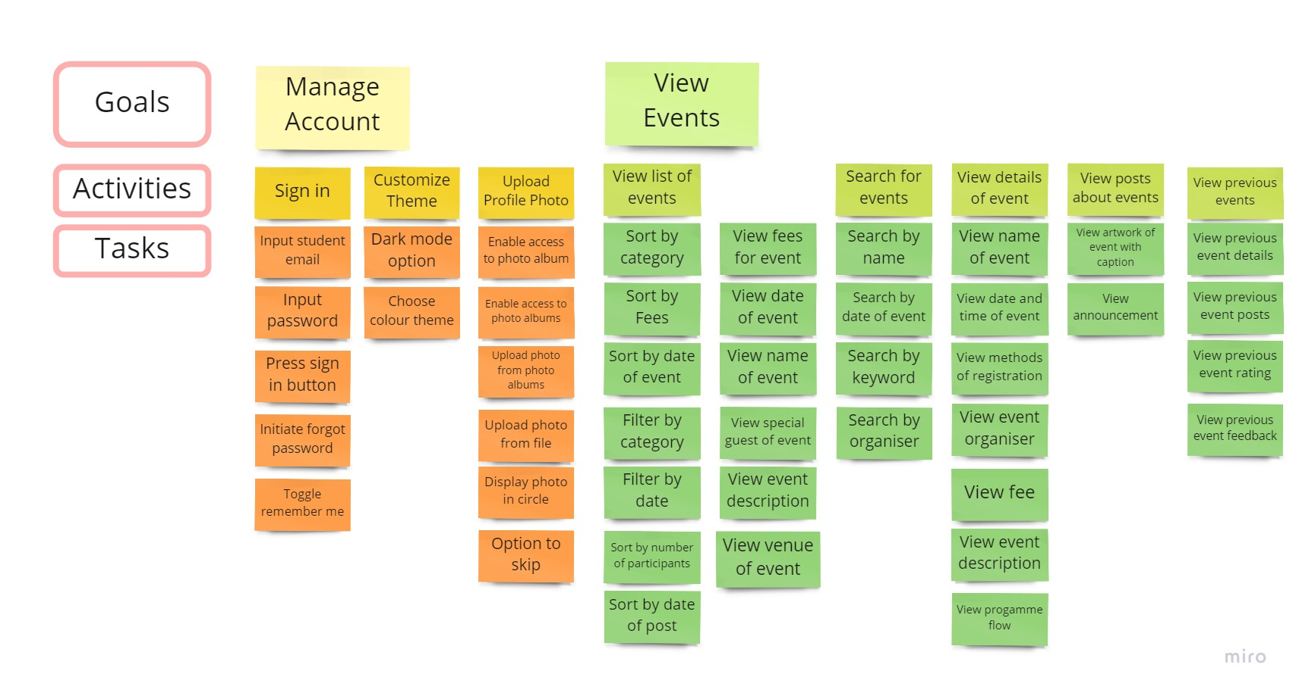

*Figure 16: User Story Mapping for College Event System (User is Students)(Part1)*

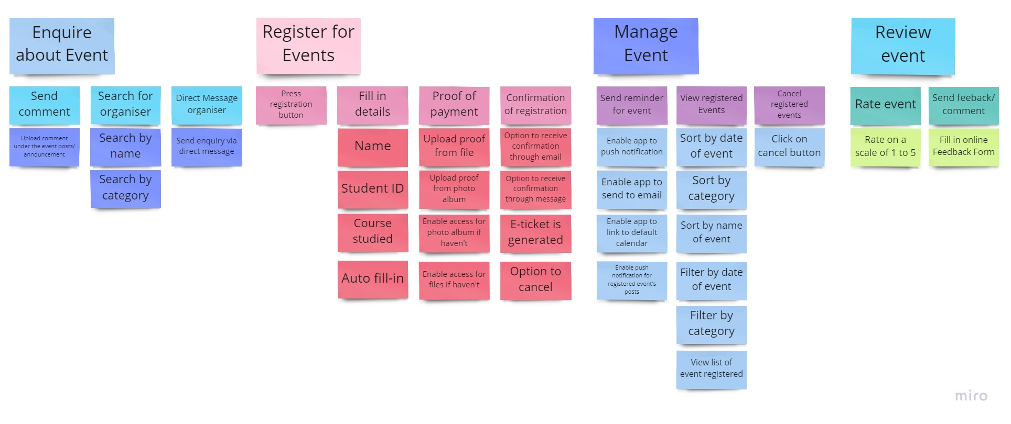

*Figure 17: User Story Mapping for College Event System (User is Students)(Part2)*

Figure 16 & Figure 17 is one User Story Mapping but separated into two pictures due to its contents not being readable when put into word document.