

**Thursday**

**Monday Tuesday Wednesday**

**The Zone Huddersfield**

**£4 extra per child**

**We will leave the club at 9:30 and be back for 1:00pm**

**10am-12:30pm**

**£3 Extra per child**

**Price includes a drink and sweets**

**Easter activities at the club**

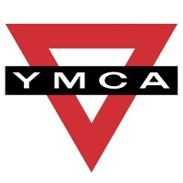 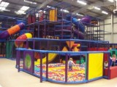

**2-3:00pm £3 Extra per child**

**The children will be going rollerblading at the YMCA**



**Week One 30th March- 2nd of April**

**Contact Hebble Harlequins 07773 645596, Gail 07772933851 or Jason 07766831194 for more information.**

**Please can you send your child with a healthy packed lunch. It is helpful if this is in a back pack so if we are on an outing the children can carry their own bags while safely holding their partners hand. Children also need a waterproof coat and suitable footwear for walking and playing out. Children are also welcome to bring slippers to wear inside the club.**

**Tuesday Wednesday Thursday Friday**

** **

**Easter egg hunt and Picnic at Mannor Heath Easter activities at the club 10-12:30pm £3 extra**

**crafts at the club park. 10-1pm £1 each**

**for an ice cream**

**Week two 7th -10th April**

**Contact Hebble Harlequins 07773 645596, Gail 07772933851 or Jason 07766831194 for more information.**

**Please can you send your child with a healthy packed lunch. It is helpful if this is in a back pack so if we are on an outing the children can carry their own bags while safely holding their partners hand. Children also need a waterproof coat and suitable footwear for walking and playing out. Children are also welcome to bring slippers to wear inside the club.**