Titel: Labor Multi Area OSPF

Klasse: 4BHIF

Name: Haiden

Gruppe: 01

Aufgabe: 04.05.2021 Abgabe: 18.05.2021

Inhaltsverzeichnis

1 Theorie-Teil 1

1.1 Link State Advertisment 1

1.1.1 Allgemeines 1

1.1.2 Typen 1

1.1.3 Router Rollen 2

2 Multi Area OSPF 3

2.1 Aufbau 3

2.2 Adressen & DHCP Konfiguration 3

2.2.1 Eisenstadt 3

2.2.1.1 DHCP Test 4

2.2.2 Graz 4

2.2.2.1 DHCP Test 5

2.2.3 Wien 5

2.2.3.1 DHCP Test 6

2.2.4 St. Pölten 6

2.2.4.1 DHCP Test 7

2.2.5 Krems 7

2.2.5.1 DHCP Test 8

2.2.5.2 ISP Netzwerk 8

2.2.6 ISP Router 8

2.3 Area10-OSPF-Einrichtung 8

2.3.1 Eisenstadt 8

2.3.2 Graz 8

2.3.3 Wien 9

2.4 Area0-OSPF-Einrichtung 9

2.4.1 Wien 9

2.4.2 St.Pölten 9

2.5 Area20-OSPF-Einrichtung 9

2.5.1 St.Pölten 9

2.5.2 Krems 9

2.6 Metrik zw. Eisenstadt & Krems 10

2.6.1 Eisenstadt 10

2.6.2 Krems 10

2.6.3 Berechnung 11

2.7 Das Problem mit Metriken 11

2.8 Richten Sie am Router Krems eine Defaultroute (statische Route) ein. 11

2.9 Anzeigen von ASR / ASBR 11

2.10 LSD – Link State Database 11

2.10.1 LSA (Link State Advertisment) Typen 11

2.10.2 Anzeigen für Area0 12

2.10.2.1 Type 1 12

2.10.2.2 Type 2 12

2.10.2.3 Type 3 12

2.10.3 Area 10 13

2.10.3.1 Type 1 13

2.10.3.2 Type 2 13

2.10.3.3 Type 3 13

2.10.3.4 Type 4 13

2.10.4 Area 20 14

2.10.4.1 Type 1 14

2.10.4.2 Type 2 14

2.10.4.3 Type 3 14

3 Router Config Dump 15

3.1 Eisenstadt 15

3.2 Graz 18

3.3 Wien 21

3.4 St.Pölten 24

3.5 Krems 27

3.6 ISP Router 30

# Theorie-Teil

https://en.wikipedia.org/wiki/Link-state_advertisement

## Link State Advertisment

### Allgemeines

The link-state advertisement (LSA) is a basic communication means of the OSPF routing protocol for the Internet Protocol (IP). It communicates the router's local routing topology to all other local routers in the same OSPF area. OSPF is designed for scalability, so some LSAs are not flooded out on all interfaces, but only on those that belong to the appropriate area. In this way detailed information can be kept localized, while summary information is flooded to the rest of the network. The original IPv4-only OSPFv2 and the newer IPv6-compatible OSPFv3 have broadly similar LSA types.

### Typen

The LSA types defined in OSPF are as follows:

* Type 1 – Router LSA – the router announces its presence and lists the links to other routers or networks in the same area, together with the metrics to them. Type 1 LSAs are flooded across their own area only. The link-state ID of the type 1 LSA is the originating router ID.
* Type 2 – Network LSA – the designated router (DR) on a broadcast segment (e.g. Ethernet) lists which routers are joined together by the segment. Type 2 LSAs are flooded across their own area only. The link-state ID of the type 2 LSA is the IP interface address of the DR.
* Type 3 – Summary LSA – an Area Border Router (ABR) takes information it has learned on one of its attached areas and summarizes it before sending it out on other areas it is connected to. This summarization helps provide scalability by removing detailed topology information for other areas, because their routing information is summarized into just an address prefix and metric. The summarization process can also be configured to remove a lot of detailed address prefixes and replace them with a single summary prefix, helping scalability.
* Type 4 – ASBR-Summary LSA – this is needed because Type 5 External LSAs are flooded to all areas with the source as the Autonomous System Boundary Router's (ASBR) router ID, but router IDs are not advertised between areas. This is solved by an Area Border Router flooding the information of the ASBR where the type 5 originated. The link-state ID is the router ID of the described ASBR for type 4 LSAs.
* Type 5 – External LSA – these LSAs contain information imported into OSPF from other routing processes. They are flooded to all areas unchanged (except stub and NSSA areas). For "External Metric Type 1" LSAs the metric sent is the cost from the ASBR to the External destination network and must be added to the OSPF cost to the ASBR advertising the Type 5, while for "External Type 2" LSAs routing decisions are made using the Type 1 metric cost sent as the total cost to get to the external destination including the cost to the ASBR. The link-state ID of the type 5 LSA is the external network number.[1]
* Type 6 – Group Membership LSA (Only supported on a few routers) – this was defined for Multicast extensions to OSPF (MOSPF),[2] a multicast OSPF routing protocol which was not in general use. MOSPF has been deprecated since OSPFv3[3] and is not currently used. It may be reassigned in the future.
* Type 7 – Routers in a Not-so-stubby-area (NSSA) do not receive external LSAs from Area Border Routers, but are allowed to send external routing information for redistribution. They use type 7 LSAs to tell the ABRs about these external routes, which the Area Border Router then translates to type 5 external LSAs and floods as normal to the rest of the OSPF network.
* Type 8 – A link-local only LSA for OSPFv3. A Type 8 LSA is used to give information about link-local addresses and a list of IPv6 addresses on the link. In OSPFv2, however, the Type 8 was originally intended to be used as a so-called External-Attributes-LSA for transit autonomous systems where OSPFv2 could replace the internal Border Gateway Protocol (iBGP). In these networks, the BGP destinations would be carried in LSA Type 5 while their BGP attributes would be inserted into LSA Type 8. Most OSPFv2 implementations never supported this feature, and it was never standardised for OSPFv2.
* Type 9 – a link-local "opaque" LSA (defined by RFC2370) in OSPFv2 and the Intra-Area-Prefix LSA in OSPFv3. It is the OSPFv3 LSA that contains prefixes for stub and transit networks in the link-state ID. It is also used for IETF NSF (Non-Stop Forwarding).
* Type 10 – an area-local "opaque" LSA as defined by RFC2370. Opaque LSAs contain information which should be flooded by other routers even if the router is not able to understand the extended information itself. Typically type 10 LSAs are used for traffic engineering (MPLS-TE) extensions to OSPF for creating the Traffic Engineering Database (TED), by flooding extra information about links beyond just their metric, such as link bandwidth and color.
* Type 11 – an AS "opaque" LSA defined by RFC 5250, which is flooded everywhere except stub areas. This is the opaque equivalent of the type 5 external LSA.[4]

### Router Rollen

<https://www.geeksforgeeks.org/link-state-advertisement-lsa/>

* Backbone router – The area 0 is known as backbone area and the routers in area 0 are known as backbone routers.
* Internal router – An internal router is a router which have all of its interfaces in a single area.
* Area Boundary Router (ABR) – The router which connects backbone area with another area is called Area Boundary Router. The ABRs therefore maintain multiple link-state databases that describe both the backbone topology and the topology of the other areas.
* Area Summary Border Router (ASBR) – When an OSPF router is connected to a different protocol like EIGRP, or Border Gateway Protocol, or any other routing protocol then it is known as AS. The router which connects two different AS (in which one of the interface is operating OSPF in area 0) is known as Area Summary Border Router. These routers perform redistribution. ASBRs run both OSPF and another routing protocol, such as RIP or BGP.

# Multi Area OSPF

## Aufbau

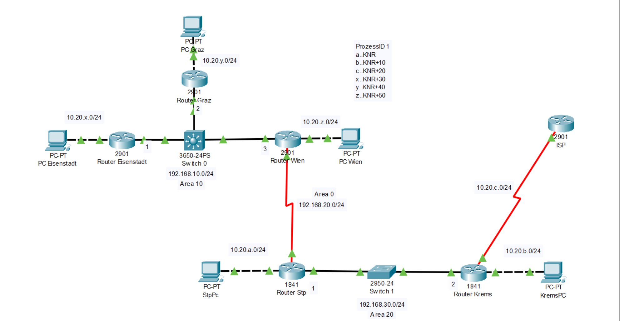

## Adressen & DHCP Konfiguration

### Eisenstadt

Eisenstadt(config)#int g0/0

Eisenstadt(config-if)#ip address 10.20.36.254 255.255.255.0

Eisenstadt(config-if)#no shut

Eisenstadt(config-if)#int g0/1

Eisenstadt(config-if)#ip address 192.168.10.1 255.255.255.0

Eisenstadt(config-if)#exit

Eisenstadt(config)#ip dhcp pool internaleisenstadt

Eisenstadt(dhcp-config)#network 10.20.36.0 255.255.255.0

Eisenstadt(dhcp-config)#default-router 10.20.36.254

Eisenstadt(dhcp-config)#exit

#### DHCP Test

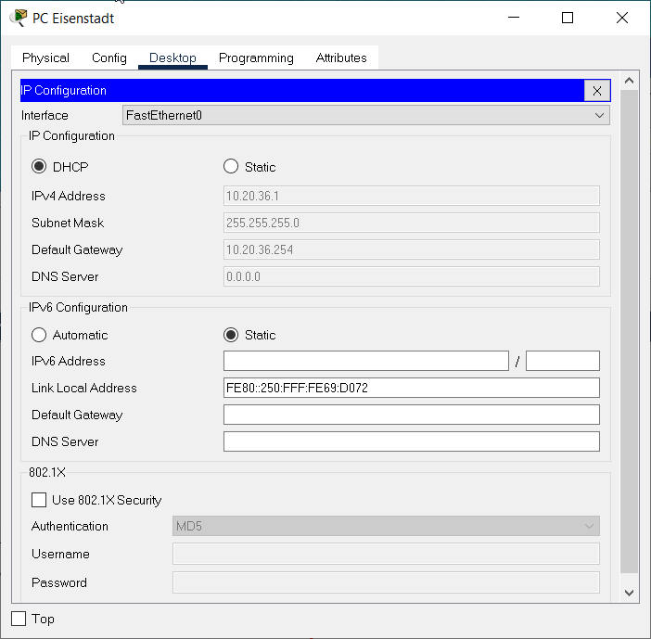

### Graz

Graz(config)#int g0/0

Graz(config-if)#ip addr 10.20.46.254 255.255.255.0

Graz(config-if)#no shut

Graz(config-if)#int g0/1

Graz(config-if)#ip addr 192.168.10.2 255.255.255.0

Graz(config-if)#exit

Graz(config)#ip dhcp pool internalgraz

Graz(dhcp-config)#network 10.20.46.0 255.255.255.0

Graz(dhcp-config)#default-router 10.20.46.254

Graz(dhcp-config)#exit

#### DHCP Test

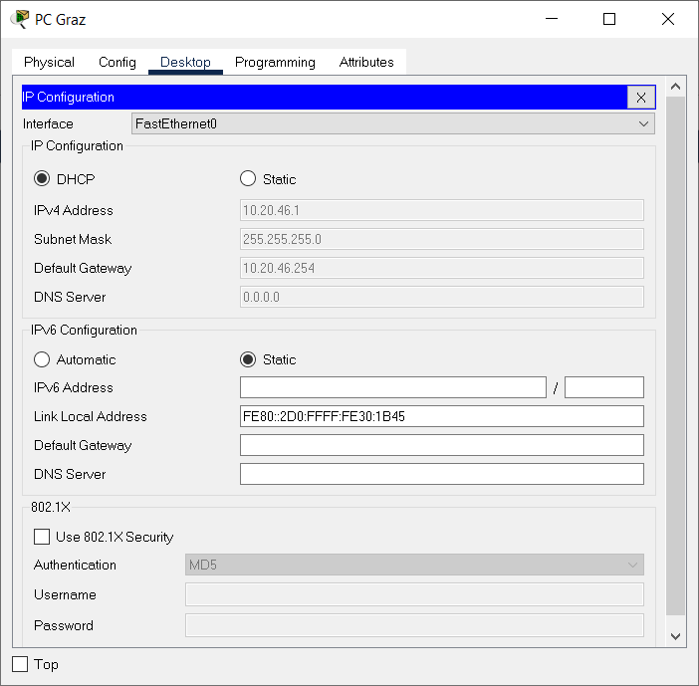

### Wien

Wien(config)#int g0/0

Wien(config-if)#ip addr 10.20.56.254 255.255.255.0

Wien(config-if)#no shut

Wien(config-if)#int g0/1

Wien(config-if)#ip addr 192.168.10.3 255.255.255.0

Wien(config-if)#exit

Wien(config)#ip dhcp pool internalwien

Wien(dhcp-config)#network 10.20.56.0 255.255.255.0

Wien(dhcp-config)#default-router 10.20.56.254

Wien(dhcp-config)#exit

Wien(config)#

Serial Interface Konfiguration:

Wien(config)#int s0/0/0

Wien(config-if)#ip addr 192.168.20.1 255.255.255.0

Wien(config-if)#no shut

Wien(config-if)#exit

#### DHCP Test

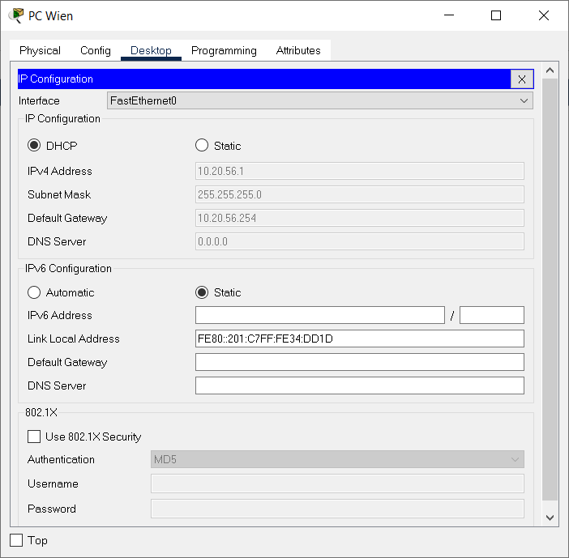

### St. Pölten

StP(config)#int f0/0

StP(config-if)#ip addr 10.20.6.254 255.255.255.0

StP(config-if)#no shut

StP(config-if)#int f0/1

StP(config-if)#ip addr 192.168.30.1 255.255.255.0

StP(config-if)#no shut

StP(config-if)#exit

StP(config)#ip dhcp pool internalstp

StP(dhcp-config)#network 10.20.6.0 255.255.255.0

StP(dhcp-config)#default-router 10.20.6.254

StP(dhcp-config)#

Serial Interface:

StP(config)#int s0/0/0

StP(config-if)#ip addr 192.168.20.2 255.255.255.0

StP(config-if)#no shut

#### DHCP Test

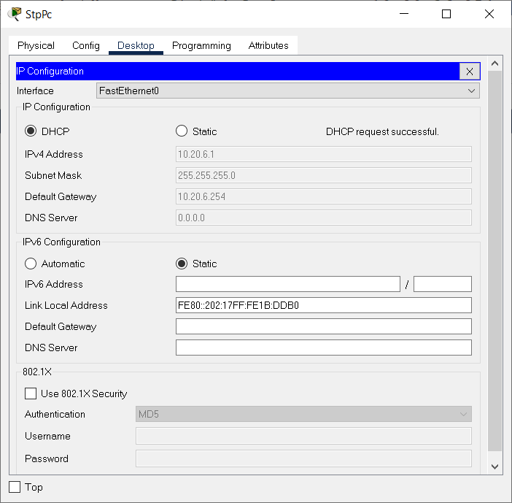

### Krems

Router(config)#int f0/0

Router(config-if)#ip addr 10.20.16.254 255.255.255.0

Router(config-if)#no shut

Router(config-if)#exit

Router(config)#int f0/1

Router(config-if)#ip addr 192.168.30.2 255.255.255.0

Router(config-if)#exit

Router(config)#ip dhcp pool internalkrems

Router(dhcp-config)#network 10.20.16.0 255.255.255.0

Router(dhcp-config)#default-router 10.20.16.254

Router(dhcp-config)#exit

Router(config)#int f0/1

Router(config-if)#no shut

#### DHCP Test

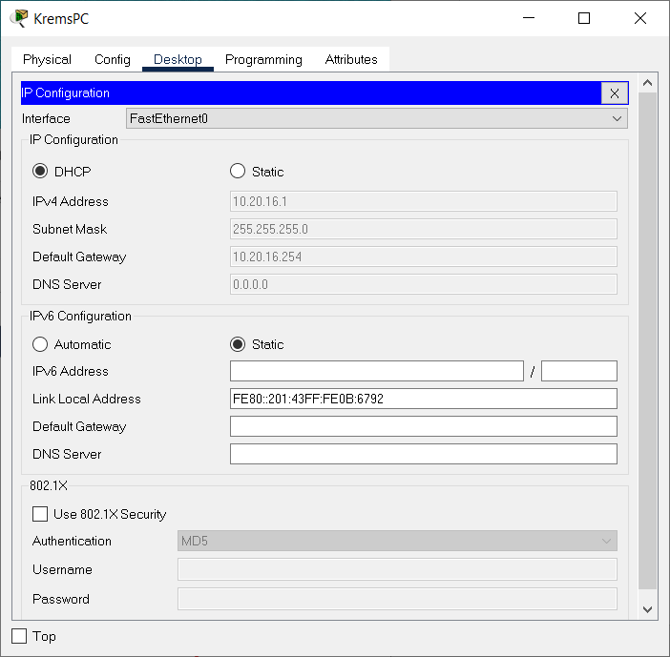

#### ISP Netzwerk

Router(config)#int s0/0/0

Router(config-if)#ip address 10.20.26.1 255.255.255.0

Router(config-if)#exit

### ISP Router

Router(config)#int s0/0/0

Router(config-if)#ip addr 10.20.26.254 255.255.255.0

Router(config-if)#exit

Router(config)#int s0/0/0

Router(config-if)#no shut

Router(config-if)#

## Area10-OSPF-Einrichtung

### Eisenstadt

Eisenstadt(config)#router ospf 1

Eisenstadt(config-router)#router-id 1.1.1.1

Eisenstadt(config-router)#network 10.20.36.0 0.0.0.255 area 10

Eisenstadt(config-router)#network 192.168.10.0 0.0.0.255 area 10

### Graz

Graz(config)#router ospf 1

Graz(config-router)#router-id 2.2.2.2

Graz(config-router)#network 10.20.46.0 0.0.0.255 area 10

Graz(config-router)#network 192.168.10.0 0.0.0.255 area 10

### Wien

Wien(config)#router ospf 1

Wien(config-router)#router-id 3.3.3.3

Wien(config-router)#network 10.20.56.0 0.0.0.255 area 10

Wien(config-router)#network 192.168.10.0 0.0.0.255 area 10

## Area0-OSPF-Einrichtung

### Wien

Wien(config)#router ospf 1

Wien(config-router)#network 192.168.20.0 0.0.0.255 area 0

Wien(config-router)#exit

### St.Pölten

StP(config)#router ospf 1

StP(config-router)#router-id 4.4.4.4

StP(config-router)#network 192.168.20.0 0.0.0.255 area 0

StP(config-router)#exit

## Area20-OSPF-Einrichtung

### St.Pölten

StP(config)#router ospf 1

StP(config-router)#network 10.20.6.0 0.0.0.255 area 20

StP(config-router)#network 192.168.30.0 0.0.0.255 area 20

StP(config-router)#exit

### Krems

Router(config)#router ospf 1

Router(config-router)#router-id 5.5.5.5

Router(config-router)#network 10.20.16.0 0.0.0.255 area 20

Router(config-router)#network 192.168.30.0 0.0.0.255 area 20

Router(config-router)#exit

## Metrik zw. Eisenstadt & Krems

### Eisenstadt

Eisenstadt>show int g0/1

GigabitEthernet0/1 is up, line protocol is up (connected)

Hardware is CN Gigabit Ethernet, address is 0010.115d.2502 (bia 0010.115d.2502)

Internet address is 192.168.10.1/24

MTU 1500 bytes, **BW 1000000 Kbit**, DLY 10 usec,

### Krems

Router#show ip route

Codes: C - connected, S - static, I - IGRP, R - RIP, M - mobile, B - BGP

D - EIGRP, EX - EIGRP external, O - OSPF, IA - OSPF inter area

N1 - OSPF NSSA external type 1, N2 - OSPF NSSA external type 2

E1 - OSPF external type 1, E2 - OSPF external type 2, E - EGP

i - IS-IS, L1 - IS-IS level-1, L2 - IS-IS level-2, ia - IS-IS inter area

* - candidate default, U - per-user static route, o - ODR

P - periodic downloaded static route

Gateway of last resort is not set

10.0.0.0/24 is subnetted, 6 subnets

O 10.20.6.0 [110/2] via 192.168.30.1, 00:02:07, FastEthernet0/1

C 10.20.16.0 is directly connected, FastEthernet0/0

C 10.20.26.0 is directly connected, Serial0/0/0

O IA 10.20.36.0 [110/67] via 192.168.30.1, 00:02:07, FastEthernet0/1

O IA 10.20.46.0 [110/67] via 192.168.30.1, 00:02:07, FastEthernet0/1

O IA 10.20.56.0 [110/66] via 192.168.30.1, 00:02:07, FastEthernet0/1

**O IA 192.168.10.0/24 [110/66] via 192.168.30.1, 00:02:07, FastEthernet0/1**

O IA 192.168.20.0/24 [110/65] via 192.168.30.1, 00:02:07, FastEthernet0/1

C 192.168.30.0/24 is directly connected, FastEthernet0/1

### Berechnung

Metrik = 108 : 1 Million * 1000 => 100 000

Die Metrik stimmt nicht überein.

## Das Problem mit Metriken

Die Metrik für OSPF orientiert sich an den Bandbreiten, die für spezifische Interfaces konfiguriert sind bzw. wurden. Allerdings kann diese Bandbreite abweichen, daher muss man die Bandbreite manuell beim Interface einstellen.

## Richten Sie am Router Krems eine Defaultroute (statische Route) ein.

Eintragen am ISP:

Router(config)#ip route 0.0.0.0 0.0.0.0 10.20.26.1

Setzen der Route in OSPF auf dem Krems Router:

Router(config)#router ospf 1

Router(config-router)#default-information originate

Router(config-router)#exit

## Anzeigen von ASR / ASBR

Dafür kann man folgendes Kommando nutzen: sh ip ospf border-rout

StP>sh ip ospf border-rout

OSPF Process 1 internal Routing Table

Codes: i - Intra-area route, I - Inter-area route

i 3.3.3.3 [64] via 192.168.20.1, Serial0/0/0, **ABR**, Area 0, SPF 64

i 5.5.5.5 [1] via 192.168.30.2, FastEthernet0/1, **ASBR**, Area 20, SPF 1

Krems ist ASBR, Wien ist ABR.

## LSD – Link State Database

### LSA (Link State Advertisment) Typen

• LSA Type 1: Router LSA

• LSA Type 2: Network LSA

• LSA Type 3: Summary LSA

• LSA Type 4: Summary ASBR LSA

• LSA Type 5: Autonomous system external LSA

### Anzeigen für Area0

Wien>show ip ospf dat

OSPF Router with ID (3.3.3.3) (Process ID 1)

Router Link States (Area 0)

Link ID ADV Router Age Seq# Checksum Link count

**3.3.3.3 3.3.3.3 397 0x80000005 0x004954 2**

**4.4.4.4 4.4.4.4 397 0x80000007 0x00e4b1 2**

Summary Net Link States (Area 0)

Link ID ADV Router Age Seq# Checksum

**192.168.10.0 3.3.3.3 557 0x80000009 0x0009cd**

**10.20.56.0 3.3.3.3 557 0x8000000a 0x0049a9**

**10.20.46.0 3.3.3.3 557 0x8000000b 0x00c03a**

**10.20.36.0 3.3.3.3 557 0x8000000c 0x002cd7**

**10.20.6.0 4.4.4.4 392 0x8000000a 0x0053cd**

**192.168.30.0 4.4.4.4 392 0x8000000b 0x000ab2**

**10.20.16.0 4.4.4.4 336 0x8000000c 0x00ea29**

**Summary ASB Link States (Area 0)**

**Link ID ADV Router Age Seq# Checksum**

**5.5.5.5 4.4.4.4 885 0x80000009 0x00161b LSA Type 1**

#### Type 1

3.3.3.3 = Wien

4.4.4.4 = St. Pölten

#### Type 2

3.3.3.3 = Wien

4.4.4.4 = St.Pölten

#### Type 3

4.4.4.4 = St.Pölten

### Area 10

Router Link States (Area 10)

Link ID ADV Router Age Seq# Checksum Link count

**3.3.3.3 3.3.3.3 562 0x80000006 0x0031b3 2**

**2.2.2.2 2.2.2.2 794 0x80000005 0x0008f1 2**

**1.1.1.1 1.1.1.1 794 0x80000005 0x00df2d 2**

Net Link States (Area 10)

Link ID ADV Router Age Seq# Checksum

**192.168.10.1 1.1.1.1 731 0x80000004 0x00b5f2**

Summary Net Link States (Area 10)

Link ID ADV Router Age Seq# Checksum

**192.168.20.0 3.3.3.3 557 0x8000000a 0x00117b**

**10.20.6.0 3.3.3.3 424 0x8000000b 0x00f1f1**

**192.168.30.0 3.3.3.3 424 0x8000000c 0x00a8d6**

**10.20.16.0 3.3.3.3 330 0x8000000d 0x00894d**

Summary ASB Link States (Area 10)

Link ID ADV Router Age Seq# Checksum

**5.5.5.5 3.3.3.3 885 0x80000009 0x003401**

#### Type 1

* + - 1. = Eisenstadt

2.2.2.2 = Graz

3.3.3.3 = Wien

#### Type 2

* + - 1. = Eisenstadt

#### Type 3

3.3.3.3 = Wien

#### Type 4

3.3.3.3 = Wien

### Area 20

StP#show ip ospf dat

…

Router Link States (Area 20)

Link ID ADV Router Age Seq# Checksum Link count

**4.4.4.4 4.4.4.4 847 0x80000006 0x008860 2**

**5.5.5.5 5.5.5.5 1398 0x80000005 0x00b520 2**

Net Link States (Area 20)

Link ID ADV Router Age Seq# Checksum

**192.168.30.1 4.4.4.4 847 0x80000003 0x0088a0**

Summary Net Link States (Area 20)

Link ID ADV Router Age Seq# Checksum

**192.168.20.0 4.4.4.4 899 0x80000010 0x00e69b**

**192.168.10.0 4.4.4.4 899 0x80000011 0x005d2d**

**10.20.56.0 4.4.4.4 899 0x80000012 0x009d09**

**10.20.46.0 4.4.4.4 899 0x80000013 0x00149a**

**10.20.36.0 4.4.4.4 899 0x80000014 0x008037**

#### Type 1

4.4.4.4 = St.Pölten

5.5.5.5 = Krems

#### Type 2

4.4.4.4 = St.Pölten

#### Type 3

4.4.4.4 = St.Pölten

# Router Config Dump

## Eisenstadt

!

version 15.1

no service timestamps log datetime msec

no service timestamps debug datetime msec

no service password-encryption

!

hostname Eisenstadt

!

!

!

!

!

ip dhcp pool internaleisenstadt

network 10.20.36.0 255.255.255.0

default-router 10.20.36.254

!

!

!

no ip cef

no ipv6 cef

!

!

!

!

license udi pid CISCO2901/K9 sn FTX15245UO8

!

!

!

!

!

!

!

!

!

!

!

spanning-tree mode pvst

!

!

!

!

!

!

interface GigabitEthernet0/0

ip address 10.20.36.254 255.255.255.0

duplex auto

speed auto

!

interface GigabitEthernet0/1

ip address 192.168.10.1 255.255.255.0

duplex auto

speed auto

!

interface Serial0/0/0

no ip address

clock rate 2000000

shutdown

!

interface Serial0/0/1

no ip address

clock rate 2000000

shutdown

!

interface Vlan1

no ip address

shutdown

!

router ospf 1

router-id 1.1.1.1

log-adjacency-changes

network 10.20.36.0 0.0.0.255 area 10

network 192.168.10.0 0.0.0.255 area 10

!

ip classless

!

ip flow-export version 9

!

!

!

!

!

!

!

!

line con 0

!

line aux 0

!

line vty 0 4

login

!

!

!

end

## Graz

version 15.1

no service timestamps log datetime msec

no service timestamps debug datetime msec

no service password-encryption

!

hostname Graz

!

!

!

!

!

ip dhcp pool internalgraz

network 10.20.46.0 255.255.255.0

default-router 10.20.46.254

!

!

!

ip cef

no ipv6 cef

!

!

!

!

license udi pid CISCO2901/K9 sn FTX1524U96A

!

!

!

!

!

!

!

!

!

!

!

spanning-tree mode pvst

!

!

!

!

!

!

interface GigabitEthernet0/0

ip address 10.20.46.254 255.255.255.0

duplex auto

speed auto

!

interface GigabitEthernet0/1

ip address 192.168.10.2 255.255.255.0

duplex auto

speed auto

!

interface Serial0/0/0

no ip address

clock rate 2000000

shutdown

!

interface Serial0/0/1

no ip address

clock rate 2000000

shutdown

!

interface Vlan1

no ip address

shutdown

!

router ospf 1

router-id 2.2.2.2

log-adjacency-changes

network 10.20.46.0 0.0.0.255 area 10

network 192.168.10.0 0.0.0.255 area 10

!

ip classless

!

ip flow-export version 9

!

!

!

!

!

!

!

!

line con 0

!

line aux 0

!

line vty 0 4

login

!

!

!

end

## Wien

!

version 15.1

no service timestamps log datetime msec

no service timestamps debug datetime msec

no service password-encryption

!

hostname Wien

!

!

!

!

!

ip dhcp pool internalwien

network 10.20.56.0 255.255.255.0

default-router 10.20.56.254

!

!

!

ip cef

no ipv6 cef

!

!

!

!

license udi pid CISCO2901/K9 sn FTX152438U0

!

!

!

!

!

!

!

!

!

!

!

spanning-tree mode pvst

!

!

!

!

!

!

interface GigabitEthernet0/0

ip address 10.20.56.254 255.255.255.0

duplex auto

speed auto

!

interface GigabitEthernet0/1

ip address 192.168.10.3 255.255.255.0

duplex auto

speed auto

!

interface Serial0/0/0

ip address 192.168.20.1 255.255.255.0

!

interface Serial0/0/1

no ip address

clock rate 2000000

shutdown

!

interface Vlan1

no ip address

shutdown

!

router ospf 1

router-id 3.3.3.3

log-adjacency-changes

network 192.168.20.0 0.0.0.255 area 0

network 10.20.56.0 0.0.0.255 area 10

network 192.168.10.0 0.0.0.255 area 10

!

ip classless

!

ip flow-export version 9

!

!

!

!

!

!

!

!

line con 0

!

line aux 0

!

line vty 0 4

login

!

!

!

end

## St.Pölten

!

version 12.4

no service timestamps log datetime msec

no service timestamps debug datetime msec

no service password-encryption

!

hostname StP

!

!

!

!

!

ip dhcp pool internalstp

network 10.20.6.0 255.255.255.0

default-router 10.20.6.254

!

!

!

ip cef

no ipv6 cef

!

!

!

!

!

!

!

!

!

!

!

!

spanning-tree mode pvst

!

!

!

!

!

!

interface FastEthernet0/0

ip address 10.20.6.254 255.255.255.0

duplex auto

speed auto

!

interface FastEthernet0/1

ip address 192.168.30.1 255.255.255.0

duplex auto

speed auto

!

interface Serial0/0/0

ip address 192.168.20.2 255.255.255.0

clock rate 2000000

!

interface Serial0/0/1

no ip address

clock rate 2000000

shutdown

!

interface Vlan1

no ip address

shutdown

!

router ospf 1

router-id 4.4.4.4

log-adjacency-changes

network 192.168.20.0 0.0.0.255 area 0

network 10.20.6.0 0.0.0.255 area 20

network 192.168.30.0 0.0.0.255 area 20

!

ip classless

!

ip flow-export version 9

!

!

!

!

!

!

!

!

line con 0

!

line aux 0

!

line vty 0 4

login

!

!

!

end

## Krems

!

version 12.4

no service timestamps log datetime msec

no service timestamps debug datetime msec

no service password-encryption

!

hostname Router

!

!

!

!

!

ip dhcp pool internalkrems

network 10.20.16.0 255.255.255.0

default-router 10.20.16.254

!

!

!

ip cef

no ipv6 cef

!

!

!

!

!

!

!

!

!

!

!

!

spanning-tree mode pvst

!

!

!

!

!

!

interface FastEthernet0/0

ip address 10.20.16.254 255.255.255.0

duplex auto

speed auto

!

interface FastEthernet0/1

ip address 192.168.30.2 255.255.255.0

duplex auto

speed auto

!

interface Serial0/0/0

ip address 10.20.26.1 255.255.255.0

clock rate 2000000

!

interface Serial0/0/1

no ip address

clock rate 2000000

shutdown

!

interface Vlan1

no ip address

shutdown

!

router ospf 1

router-id 5.5.5.5

log-adjacency-changes

network 10.20.16.0 0.0.0.255 area 20

network 192.168.30.0 0.0.0.255 area 20

default-information originate

!

ip classless

!

ip flow-export version 9

!

!

!

no cdp run

!

!

!

!

!

!

line con 0

!

line aux 0

!

line vty 0 4

login

!

!

!

end

## ISP Router

!

version 15.1

no service timestamps log datetime msec

no service timestamps debug datetime msec

no service password-encryption

!

hostname Router

!

!

!

!

!

!

!

!

no ip cef

no ipv6 cef

!

!

!

!

license udi pid CISCO2901/K9 sn FTX15244URR

!

!

!

!

!

!

!

!

!

!

!

spanning-tree mode pvst

!

!

!

!

!

!

interface GigabitEthernet0/0

no ip address

duplex auto

speed auto

shutdown

!

interface GigabitEthernet0/1

no ip address

duplex auto

speed auto

shutdown

!

interface Serial0/0/0

ip address 10.20.26.254 255.255.255.0

!

interface Serial0/0/1

no ip address

clock rate 2000000

shutdown

!

interface Vlan1

no ip address

shutdown

!

ip classless

ip route 0.0.0.0 0.0.0.0 10.20.26.1

!

ip flow-export version 9

!

!

!

!

!

!

!

!

line con 0

!

line aux 0

!

line vty 0 4

login

!

!

!

end