**The Evolution from Traditional Programming to ML**

Traditionally, machines were "taught" or programmed using explicit instructions written by humans. This process, known as rule-based programming, involves defining a clear set of rules or instructions that the computer follows to achieve a specific outcome.

In contrast, Machine Learning and especially Deep Learning have shifted this paradigm towards data-driven decision making, where machines learn the rules from the data itself(where we provide the input and the desired output, and let the system learn the rules), allowing them to adapt and improve over time without being explicitly programmed for every possible scenario.

**Deep Learning:**

Deep Learning, a subset of ML, shines in scenarios that traditionally would either be too complex or dynamic for conventional programming:

**Handling Complex Problems:** It excels in environments with intricate, hard-to-define rules.

**Adapting to Changes:** DL algorithms thrive in ever-changing environments, continually learning from new data.

**Unearthing Insights:** With the capability to analyze vast datasets, DL helps in discovering patterns and insights previously out of reach.

**Limitations of Deep Learning**

However, DL isn't a one-size-fits-all solution. It has its caveats:

**Explainability Issues**: If your application demands clear, understandable decision-making processes, DL might not be the ideal choice due to its "black-box" nature.

**When Simplicity Works Best:** Sometimes, a traditional approach might solve the problem more efficiently than a complex DL model.

**Zero Tolerance for Errors:** In critical applications where errors can have significant consequences, the reliability of DL can be a concern.

**Data Requirements:** DL requires substantial amounts of data to learn effectively, which might not always be available.

**ML vs. DL in Data Handling**

A key differentiator between ML and DL lies in their handling of data types:

**Structured Data:** ML models are adept at working with structured data, where relationships between elements are clearly defined.

**Unstructured Data:** DL comes into its own with unstructured data, such as images, text, and sound, learning complex patterns within the data.

**Neural Networks**

At the heart of DL lies the neural network, inspired by the human brain's architecture. These networks learn and make intelligent decisions, evolving with each piece of new information, mirroring the way we accumulate knowledge and experience.

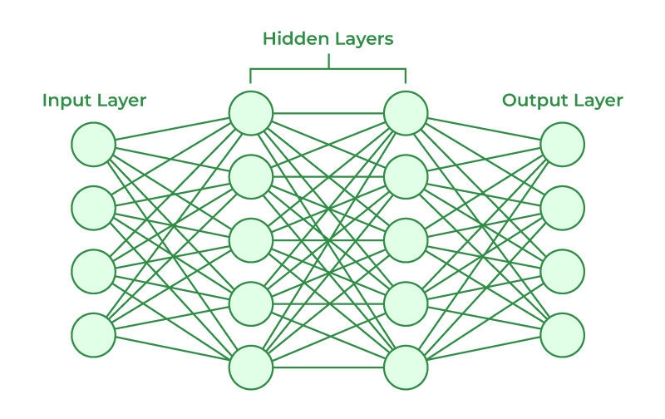

Neural Network and its types :- [Neural Network and its types](https://www.analyticsvidhya.com/blog/2020/02/cnn-vs-rnn-vs-mlp-analyzing-3-types-of-neural-networks-in-deep-learning/)

For more watch video on YouTube :- [Neural Network](https://youtu.be/aircAruvnKk?si=aM8JGX7Ybl-oC7oJ)

**Types of learning:**

**Supervised Learning:** This is a type of machine learning where the model is trained on a labeled dataset, meaning that each training example is paired with an output label. The model learns to map inputs to outputs based on this data. It's called "supervised" because the process of an algorithm learning from the training dataset can be thought of as a teacher supervising the learning process. We know the correct answers, the algorithm iteratively makes predictions on the training data and is corrected by the teacher. Supervised learning is used for tasks like regression (predicting values) and classification (predicting categories).

**Unsupervised Learning:** Unlike supervised learning, unsupervised learning involves training models on data without labeled responses. The system tries to learn without explicit instructions. It’s left on its own to find structure in the input data. Unsupervised learning can discover hidden patterns or data clustering without the need for human intervention. It's used for clustering, association, and dimensionality reduction problems, such as identifying customer segments in the marketing field or detecting anomalies in network traffic.

**Transfer Learning:** This is a research problem in machine learning that focuses on storing knowledge gained while solving one problem and applying it to a different but related problem. For example, knowledge gained while learning to recognize cars could apply when trying to recognize trucks. Transfer learning is useful when we have a lot of data for the problem we're transferring from and not much data for the problem we're transferring to. It allows us to leverage pre-trained models as the starting point on computer vision and natural language processing tasks, given the immense size and computational expense of training models from scratch.

**Reinforcement Learning:** In this type of learning, an agent learns to make decisions by taking actions in an environment to achieve some goals. The agent receives rewards by performing correctly and penalties for performing incorrectly. The agent learns without intervention from a human by maximizing its reward and minimizing its penalties. Reinforcement learning is used in various applications where decision-making is sequential and the goal is long-term, such as in game playing, robotics for navigation, and in trading systems where investment decisions are to be made.

**What is deep learning actually used for?**

* Recommendation
* Translation
* Speech Recognition
* Computer Vision
* NLP