**Thêm thuộc tính vào csdl**

* Model: thêm class mới



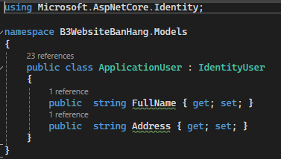

* ApplicationDBContext: thêm lớp thừa kế **IdentityDbContext<ApplicationUser>**

* Program.cs: thay đổi builder



//builder.Services.AddIdentity<IdentityUser, //IdentityRole>().AddDefaultTokenProviders().AddDefaultUI().AddEntityFrameworkSto//res<ApplicationDbContext>();

**builder.Services.AddIdentity<ApplicationUser, IdentityRole>().AddDefaultTokenProviders().AddDefaultUI().AddEntityFrameworkStores<ApplicationDbContext>();**

-PMC:

+ **add-migration v1**

+ **update-database**

* Thay đổi trong _LoginPartial.schtm

thay

@* @inject SignInManager<IdentityUser> SignInManager

@inject UserManager<IdentityUser> UserManager *@

Bằng

**@inject SignInManager<ApplicationUser> SignInManager**

**@inject UserManager<ApplicationUser> UserManager**

-Thêm biến ở **Register.cshtml**

* Lấy phần ký đưa vào csdl - **Register.cshtml**

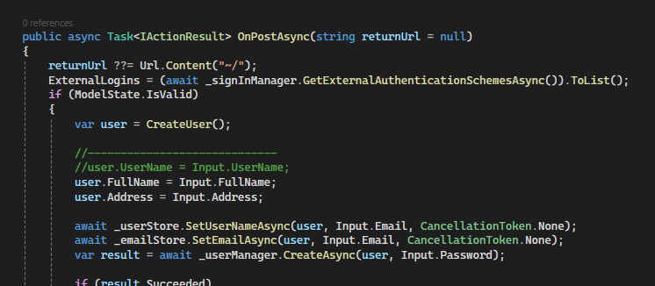

* Thêm chỗ đăng ký ở form - **Register.cshtml.cs**

**THÊM ẢNH**

**TÌM KIẾM**

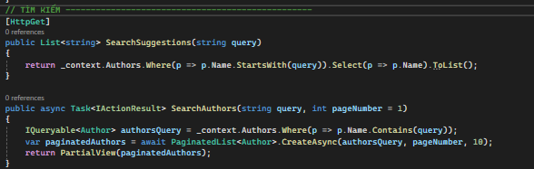

**PHÂN TRANG**

**Thêm giỏ hàng**