Prompt Engineering for Project Management

Student's name

Course name

Professor's name

Institution

Date

Prompt Engineering for Project Management
Task 1: Prompt Engineering Basics Exercise
A. Scenario a – Project Charter for E-commerce App
Original Prompt:
"Outline a project charter for launching a new e-commerce app in a startup, including objectives, stakeholders, and a high-level timeline."
Original Prompt Analysis
The initial request is a generic one and demands the fundamental components of a project charter. Although it is effective in terms of providing a plain output, it is not specific enough with regards to the perception of the elements with the PMBOK guidelines and it does not explain clearly the anticipated output pattern, which makes it somewhat harder to convert it outright into actionable information to the stakeholders.
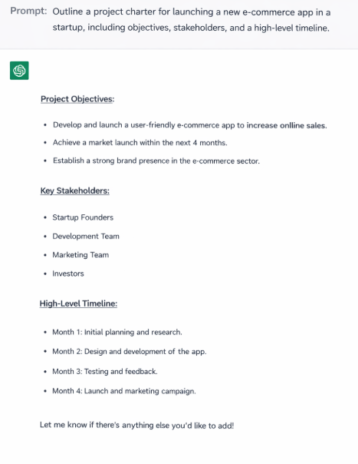
Original Prompt Output
Refined Prompt:
"Act as a PMP-certified project manager. Write a project charter to start an e-commerce application in a startup. Add objectives that are related to PMBOK, establish essential stakeholders, and give an overview date of time. Write out the charter by parts: 1. Objectives, 2. Stakeholders, 3. Timeline, and 4. Key Assumptions."
Refined Prompt Analysis:
Role-playing is applied in the refined prompt as the AI is instructed to play a project manager with PMP credentials, so the output is based on professional standards (Samamé et al., 2025). The prompt mandates alignment to PMBOK ensuring that the produced project charter contains the appropriate PMBOK best practices including project definition, stakeholder identification, and a timeline (Wang et al., 2025). This framework promotes clarity and relevance of the output, useful to the start-up phase of the project and aligns best practices in communicating with project stakeholders (PMI, 2023).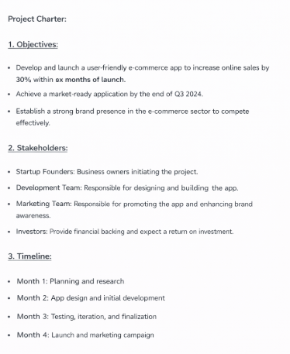
Refined Prompt Output
Analysis
The refinement added PMBOK language and a structured output (i.e. sections of goals, stakeholders, schedule) (Paterek, 2025). These refinements resulted in a more professionalized, clearer project charter, and even more purpose-focused on the instructions of PMBOK, making it more useful to the startup planning process (Project Management Institute, 2023).
B. Scenario b – Risks for a Remote Software Development Project
Original Prompt:
"List 5–7 risks for a remote software development project."
Original Prompt Analysis:
This prompt is clear and easy, but it is not predetermined and formal. Its risks could be general and not classified under the PMBOK areas of knowledge and so it is more difficult to incorporate them into a project risk register or to use them in a risk management development plan.
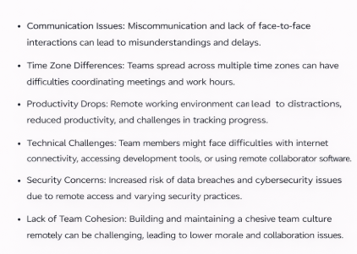
Refined Prompt:
"Act as a PMP-certified project manager. List 5–7 risks for a remote software development project, categorized by PMBOK knowledge areas such as scope, time, cost, and communication. Output as a bullet list."
Refined Prompt Analysis:
This enhanced trigger integrates PMBOK knowledge bases in classifying the risks to bring the output within the formalized risk management methods (PMI, 2023). Individually requesting a bullet list makes the output simple to read and useful in executing actual risk management. This approach will make sure that the risks are grouped and applicable to the specific project management areas and is more implementable to project teams (Zhong, 2025). Role-based prompting is also incorporated in the refinement to professionally meet the output.
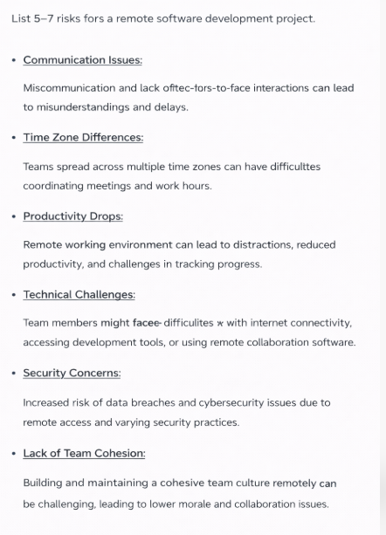
Analysis
The refined prompt leads to a more coherent and detailed list of risks by defining PMBOK categories of risk (scope, time, cost, communication). It also enhances the ease with which these risks can be implemented in a project risk register, which enhances the practice of project risk management.
C. Scenario c – Compare Projects, Programs, and Portfolios
Original Prompt:
"Compare projects, programs, and portfolios."
Original Prompt Analysis:
This is a simple request, which demands to compare three important issues in project management: projects, programs, and portfolios. Nevertheless, it is not context or criterion based and this can result into a generalized or a simplistic answer. No direct mentions to real-life examples or industry-related applications, which might assist the stakeholders in getting the idea of how the differences can be seen in the real world (Wang et al., 2025).

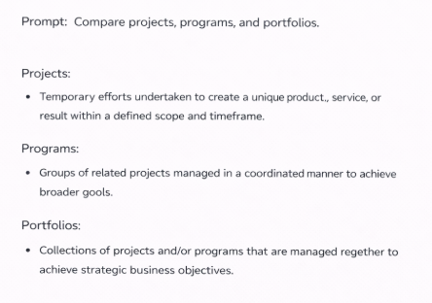
Original Prompt Output
Refined Prompt:
"Act as a PMP-certified project manager. Compare projects, programs, and portfolios, providing two real-world examples each from the tech and construction industries. Output in a table format."
Refined Prompt Analysis:
In the refined prompt, I provided real-life examples of the tech and construction sectors, which are applicable and effective to illustrate the PM principles in practice. The table format the request conforms to assists in sorting the comparison so that the stakeholders can simply absorb and implement the knowledge in their respective projects. The version is more consistent with the stakeholder communication practices, providing the industry context and providing an organized output (Wang et al., 2025). Another element is role-playing as a certified PMP manager, which makes the reply more credible and consistent with professional criteria.
Refined Prompt Output
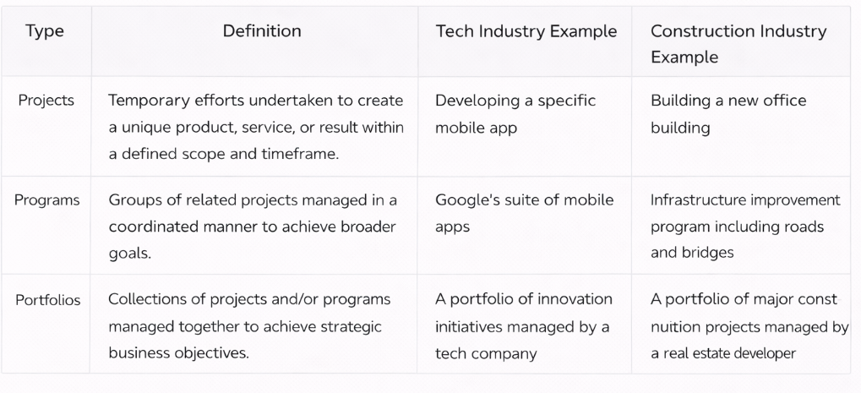
Analysis
The refined prompt will also improve relevance by asking real-world examples of particular industries and the comparisons between projects and programs as well as portfolios will be feasible and industry-focused. The table format enhances readability and makes the stakeholders to perceive differences effortlessly, enhancing communication in the PM process.
Task 2: Application to PM Challenges
Scenario: Delayed Marketing Campaign
You have been assigned the project of a postponed marketing campaign, the budget is $200,000, 3 weeks delayed because of the problems with vendors and hybrid group of 10 people. The project should be launched within Q2. You are requested to develop a chain of thought prompt and come up with 3-5 mitigation strategies and the output should be in table format with columns Strategy, Steps, Timeline, and Risks. This is an illustration of a very critical situation in project management, as intervention and decision making are important in restoring the project to path.
Full Prompt Analysis
The initial request requires the AI to generate mitigation plans to address the postponed marketing campaign with the aim of keeping the project on track with the schedule to launch in Q2 despite the 3-week delay. The prompt contains critical information of the $ 200,000 budget, a budget delay of the vendor, and hybrid team, all essential elements of the context that must be considered in the decision-making process. The presented prompt establishes a premise of further AI-assisted decision-making as it demands comprehensive step-by-step mitigation measures that may possibly solve the problems with the project. The anticipated output form, a table, is practical and clear as the project manager can conveniently evaluate the strategies and their effects.
Evaluation of the LLM Output
SMART Goals Alignment
The output of AI is usually organized in accordance with the SMART goals framework and comes up with strategies that would be Specific, Measurable, Achievable, Relevant and Time-bound (Atalay et al., 2025). Every mitigation plan is explicitly stated, with concrete steps to combat the delay, e.g., re-observing contracts with the vendors or improving communications with the stakeholders. The incorporation of quantifiable components, which include modifying the schedule and the communication procedures, makes the mitigation plans measurable and monitored. Also, the suggested measures can be implemented using the project resources, with the primary emphasis being on enhancing internal communication and re-examining vendor relations, which a project manager can control.
The strategy has included a timeline of every strategy to ascertain that they are time espoused and also prioritize actions that could have an immediate impact on the campaign delivery. Nevertheless, over-optimism exists in certain plans, which might include aggressive timelines (e.g. 1-week shorter delay) proposed without adequate weight on the complexity of the vendor problems and time required to bring together the team. This causes unrealistic expectations that may occur particularly when considering the dynamics of vendor negotiations as well as the existence of external dependencies.
Bias and Gaps in the Output
One overall bias of the AI output is it being highly optimistic about the timeline reduction. The proposal to cut the delay to a single week might not be viable considering how the vendor delays and the communication difficulties with the hybrid team. AI tends to model an ideal future situation without taking into account that external forces such as reliability of suppliers and supply chain interruptions are usually out of the direct control of the project team (Wang et al., 2025). This over-positive bias might result in excessive expectations and confrontation with stakeholders who might lack knowledge of the realities of the situation.
The other gap is that each strategy is not estimated in terms of its costs. As an example, improving the communication or redistributing resources might update the delays, but the strategies might also imply more expenses that should be considered in the budget at the cost of $200,000. Output failed to deal with this financial implication adequately and this is a sensitive area of project cost management. The PMBOK standards of PMI (2023) indicate that every strategy must be scrutinized through the lens of its real-world cost-effectiveness so that it does not surpass the budgeted funds or impose any economic burden.
Suggested Prompt Tweaks
- Add Vendor Risk Analysis: The initial prompt may be enhanced by adding a request to provide a vendor risk analysis. This would make sure that the strategies take into account the vendor performance and suggest the contingency plan to address delays caused by the vendor. A modified prompt could be: “In every strategy, add an evaluation of the reliability of the vendor and recommend mitigation measures in dealing with future vendor delays”.
- Request for Cost Impact Analysis: a request to cost impact analysis should be included in the prompt in order to verify that the project will be financially viable. This would enable the AI to offer fiscally viable steps that will not surpass the budget (Tan et al., 2025). An improved form of the prompt might be: “Under each mitigation strategy, determine the cost implications of the strategy and compare it with the leftover budget to make sure that the strategy is viable within the budget of $200,000”.
Ethical Concerns of AI outputs.
The moral aspects of AI-generated project management strategies are critical. As Hagendorff (2020) explains, AI systems may be biased, especially in their recommendations, especially when they are trained on best-case data or when they are not informed of all complexities of the real world. The over-optimism bias that the AI has suggested in the case may be providing false suggestions to the project managers and this may lead to the failure to meet expectations and the dissatisfaction of the stakeholders (Tan et al., 2025). The results of AI should be critically reviewed, and it is essential that the solutions provided make sense, are practical, and consistent with practical obligations (Nikiforova et al., 2025). The AI should also be induced to be aware of resource constraints and third-party requirements that do not necessarily translate into its decision-making (PMI, 2023).
Task 3: Ethical Reflection and Shareable Prompt Template
Part A – Ethical Reflection
The AI systems are effective in poster management but a bad prompt usage might lead to biased output of AI which can result in unfair distribution of resources, miscommunication or fact-free decisions. To provide some illustration, a vague or over-optimistic prompt can lead to the development of mitigation strategies that fail to capture factors which are resource-intensive that translate into unrealistic budget or schedule. It can lead to a lack of correspondence between the recommendations that are made by AI and reality in the project affecting the stakeholder trust and project success (Nikiforova et al., 2025). According to Hagendorff (2020), biases in AI may be introduced accidentally with erroneous instructions that fail to address the diversity and risks that are contextually specific or even lead to the already present inequities or even create new ones. In order to contain these risks, project managers must align the outputs of AI with established ethical guidelines (such as PMI ethics) and regularly test a variety of prompts to ensure that AI considers all potential possibilities, such as diversity, equity, and practical constraints. In that case, AI can be used in a more responsible manner and ensure that no inaccurate, unbalanced, and unfair information can be used to make any decision.
Part B – Shareable Prompt Template
To come up with a reusable prompt template and tailor it according to other kinds of projects and team structure the prompt should be created such that it has a modular structure. As an illustration, the following template can be used in stakeholder analysis in various projects: "Act as [Role]. In a [Project type] and [Team size] members, study the stakeholders by determining which ones have influence, interest, communication requirements and ethical concerns. Output in a matrix format." The template is generic and can be changed to suit any kind of project by changing the parameters to incorporate the role, the nature of the project as well as the size of the team. This is aimed at making sure that the AI generates outputs that are all-encompassing and specific to the needs of the project. As an example, the application of this prompt to a construction project with 12-member team might have the following form:
"Act as a PMP-certified project manager. For a construction project with 12 members, analyze stakeholders by identifying their influence, interest, communication needs, and diversity inclusion. Output as a stakeholder matrix." This output must present a matrix with distinctly discussed rows per stakeholder and columns with the need to influence, interest, and communicate of each, as well as another column of diversity.
Stakeholder Matrix Output
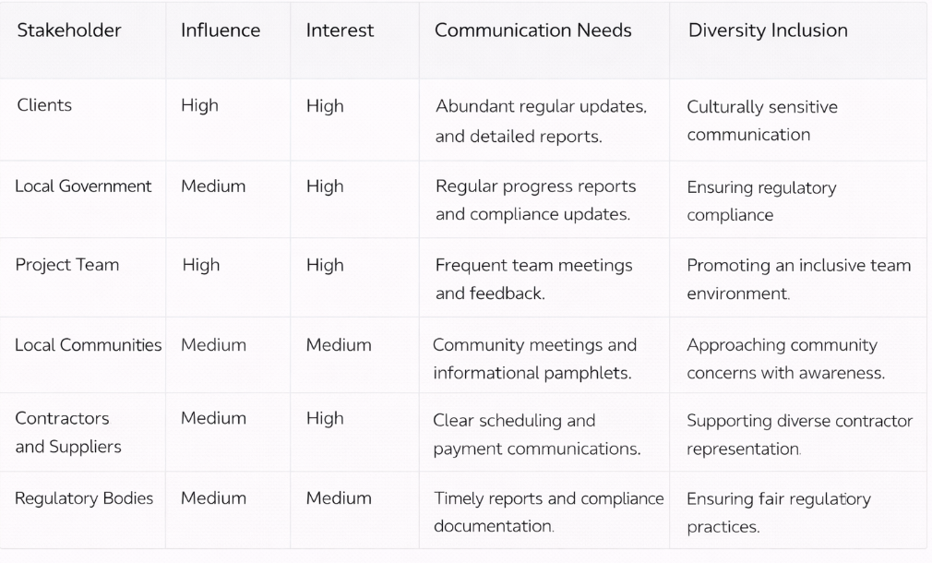

References
Atalay, A. S., Öztin, Ö., & Kanak, A. (2025). AI4SWEng manifest: Empowering the future of software engineering with advanced trustworthy artificial intelligence. Open Research Europe, 5, 352. https://open-research-europe.ec.europa.eu/articles/5-352/pdf
Hagendorff, T. (2020). The ethics of AI ethics: An evaluation of guidelines. Minds and Machines, 30(1), 99–120. https://doi.org/10.1007/s11023-020-09517-8
Nikiforova, O., Bobkovs, R., Miļūne, M. K., & Babris, K. (2025). MAPS-AI–A tool for AI-assisted model-driven generation of IT project plan and scope. In Product-Focused Software Process Improvement (pp. 455–471). Springer. https://link.springer.com/chapter/10.1007/978-3-032-12089-2_34
Paterek, P. (2025). Prompt engineering language in the agile product backlog refinement process. ResearchGate. https://www.researchgate.net/publication/398369402_Prompt_Engineering_Language_in_The_Agile_Product_Backlog_Refinement_Process
Project Management Institute. (2023). Talking to the machine: Prompt engineering essentials for project professionals. PMI. https://www.pmi.org/-/media/pmi/documents/public/pdf/learning/thought-leadership/talking-to-the-machine.pdf
Samamé, C., Sapaico, D., & Santisteban, J. (2025). SCOPE: A system for customized and optimized project enhancement for IT project management. Engineering, Technology & Applied Science Research, 15(2), 123–131. https://etasr.com/index.php/ETASR/article/download/13853/5890
Tan, P. X., Kamioka, E., & Nguyen, V. (2025). Beyond prompting: AI safety education in the generative AI era. ResearchGate. https://www.researchgate.net/publication/396693363_Beyond_Prompting_AI_Safety_Education_in_the_Generative_AI_Era
Wang, R., Xiao, L., Li, B., Shen, G. Q., Gao, B., & Zhou, J. X. (2025). RAG-based stakeholder agent construction for cross-regional collaboration in the construction industry: A case study of the Guangdong–Hong Kong–Macao area. In Proceedings of the 2025 International Conference on Digitalization of the Construction Industry. https://ascelibrary.org/doi/abs/10.1061/9780784486627.103
Zhong, Y. (2025). Leveraging large language models for intelligent construction management systems (Doctoral dissertation, University of Toronto). ProQuest Dissertations Publishing. https://utoronto.scholaris.ca/bitstreams/2fc84298-70b4-4827-b42b-469e9ccc6177/download

