Singapore Stock Exchange (SGX)
Executive Summary
The present report builds and analyzes two 1,000,000 equity portfolios of 10 Straits times Index (STI) constituents between 16 March and 10 April 2026. The passive portfolio uses a market capitalization weighting approach to mimic benchmark risk-return properties, with the highest weights of DBS (S$163.4B), OCBC (S$102.7B) and UOB (S$61.7B), and hence tracking error is minimized. The active portfolio, by contrast, picks six stocks on the basis of macroeconomic factors, sector prospects and company-level financial achievements, overweighting the banking and industrial companies likely to gain in the stable interest rates and infrastructure demand, and underweighting the poorer consumer groups. According to the LSEG Workspace performance evaluation, the passive portfolio followed the STI with a very small deviation whereas the active portfolio generated a small positive active return, which was mainly due to the stock selection effect in financial and the allocation effect in industrial, though with higher volatility and tracking error. Risk-adjusted indicators, such as Sharpe and Treynor ratios, indicate that active strategy increased returns but did not proportionately reduce the increased risk.
Introduction
Background
Portfolio Management is the act of strategically allocating capital on financial assets so as to attain particular goals on investments and also risk management (Reilly et al., 2019). There are two major strategies: passive and active management. Passive portfolio management aims to track the performance of a benchmark index like the Straits Times Index (STI) through replication of its composition and weighting to keep tracking errors and transaction costs to a minimum. Active management, by contrast, entails selective picking of stock and sector allocation to beat the benchmark by superior information, analysis and timing. The STI, which includes major Singapore listed companies, like DBS, OCBC and UOB, is an important benchmark, as it reflects the overall performance of the market and will act as a reference point in determining portfolio returns and risk.
Investment Objectives
The main aim of the passive portfolio is to most closely represent the returns and risk measures of the STI through the use of a market capitalization weighting strategy (Singapore Exchange, 2026). This means giving more weight to big companies like DBS (S$163.4B) and OCBC (S$102.7B) to make sure that it is consistent with the index structure (DBS Group Holdings Ltd, 2025). On the other hand, the active portfolio tries to beat the STI through a strategic selection of six stocks out of the available ten stocks depending on the macroeconomic trends, sector outlook and the financial performance of the firm. This involves defining overweight positions in industries likely to be advantaged by economic environment like banking and industrials and underweighting or eliminating companies with poor growth potential or extra risk.
Scope of the Report
This report evaluates a portfolio that is based on ten Singapore Exchange (SGX)-listed companies in various industries such as financials, consumer, and industries, that is, DBS, OCBC, UOB, DFI Retail, Genting Singapore, Wilmar International, ST Engineering, Sembcorp Industries, Keppel Ltd and Yangzijiang Shipbuilding (Yahoo Finance, 2026). Six companies out of this universe are chosen to be the active portfolio, through a careful financial, sectoral, and macroeconomic analysis. The two portfolios; passive and active have a starting investment of $1,000,000 and are analyzed between 16 March and 10 April 2026. Using return, risk and attribution analysis, performance is measured against the STI, to ascertain the efficiency of every investment strategy.
Passive Portfolio Management
Strategy Overview
Passive portfolio uses a complete replication approach that is meant to replicate the movements of the Straits Times Index (STI) by investing capital based on the market capitalization weight of the ten stocks that make up the market (Singapore Exchange, 2026). This practice will guarantee that companies with a greater share of the index movements like DBS (S$163.4B), OCBC (S$102.7B) and UOB (S$61.7B), are given proportionate distributions (DBS Group Holdings Ltd, 2025). The portfolio breaks down the systematic risk and returns profile of the STI by investing the portfolio of the $1,000,000 in each of the firms in the correct proportion to the relative market value. The main aim is not to outperform but to reduce tracking error with portfolio returns moving closely in line with benchmark performance.
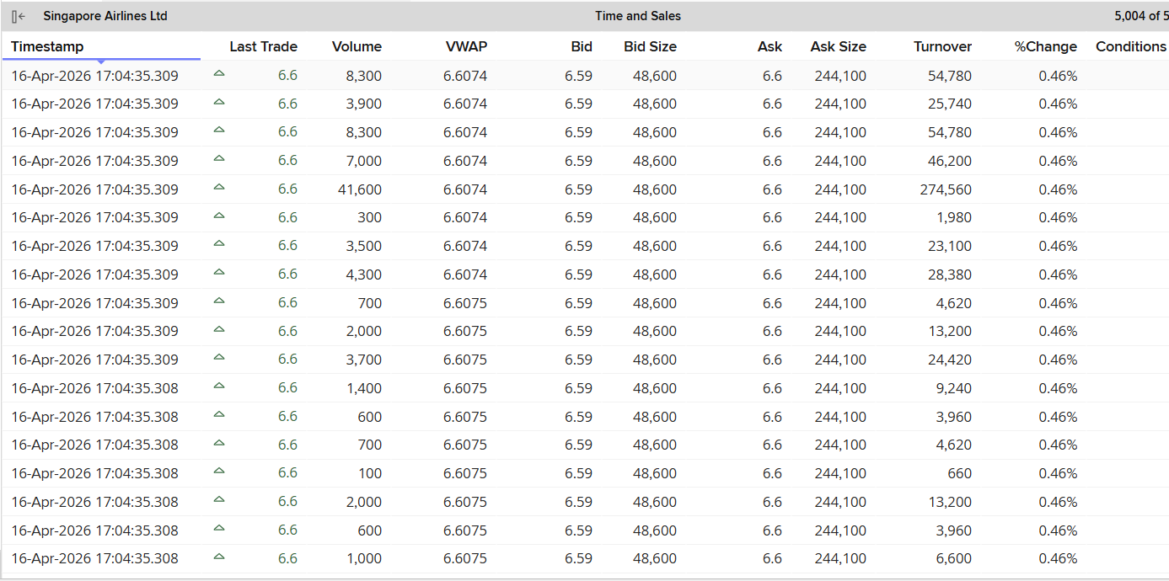
Portfolio Construction
The passive portfolio is determined by determining the weight of each company within the total market capitalization of the ten firms, after which the investment of the $1,000,000 is invested. The market capitalization of the firms used amounts to about S$514.8 billion with the biggest weight of 31.7% given to DBS then 19.9% to OCBC and 12.0% to UOB (Singapore Exchange, 2026). The weights determine the dollar amount and the number of shares to be bought depending on the prevailing market prices. An example would be that DBS will be allocated about $317,000, which translates to about 5,503 shares at a price of $57.60.
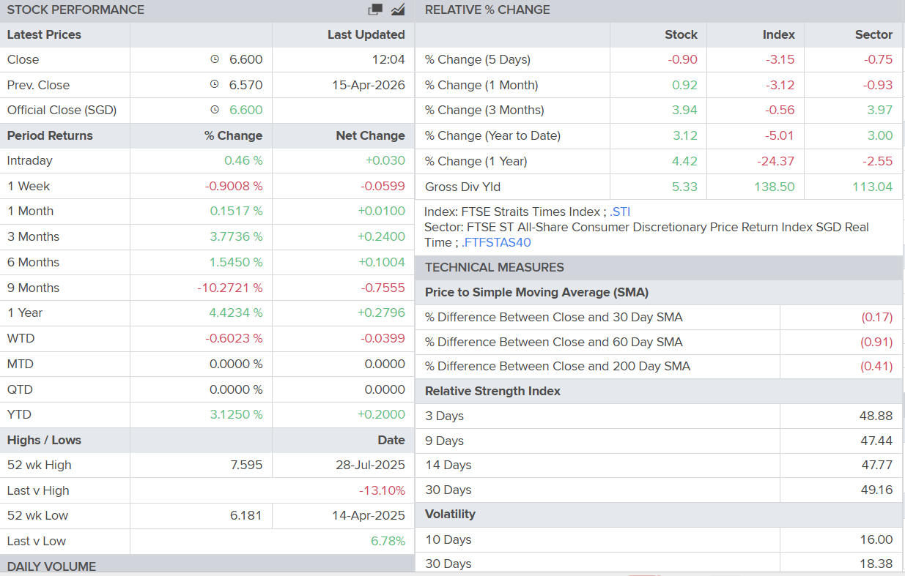
Expected Performance
The passive portfolio should closely track the performance of the STI because it replicates the index's weights and composition. Since the allocation follows the reference point, any fluctuation in the stock prices, especially of the heavily weighted companies like DBS, OCBC, and UOB, will likewise impact the portfolio in the same way as that of the index. Consequently, tracking error is not expected to be high, and only small deviations caused by rounding share quantities or transaction constraints. The risk profile of the portfolio will also be very similar to that of the STI, indicating general market trends and not company specific anomalies (Singapore Exchange, 2026). As a result, the actively managed portfolio is well measured on the basis of its passive strategy, which gives consistent and predictable performance.

Active Portfolio Management
Macroeconomic Analysis
The macroeconomic and Singaporean setting of the period under analysis was described by the moderate inflation levels and comparatively stabilized interest rates, as Singapore GDP is expected to rise between 2-3% in 2026, which represents a consistent but uncertain economic growth. Central banks were in a restraining position and interest rates were higher than those before the pandemic and this favored the banking institutions by enhancing net interest margins. Financial stocks like DBS, OCBC and UOB find this environment especially favorable since much of their earnings are earned through lending (OCBC, 2025). On the other hand, industrial companies like Keppel and Sembcorp are directly correlated with economic cycle, with stable growth underpinning infrastructure and energy needs. Nonetheless, the continuing global uncertainty such as geopolitical risks, decelerating external demand, and others provide downside risks especially to export-driven industries.
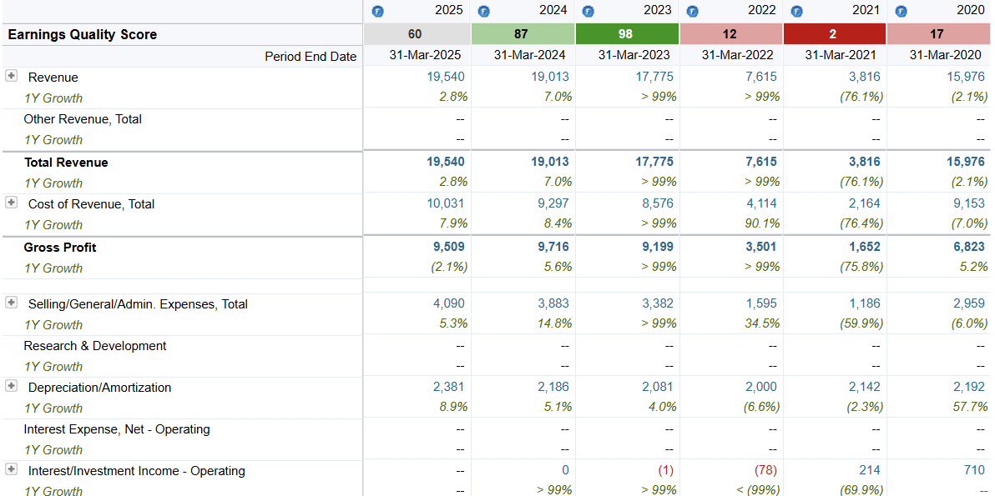
Industry & Sector Analysis
DBS, OCBC, and UOB dominate the financial sector, which is highly resilient due to the high rate of interest and capital adequacy, a fact that puts the banks in a position of expanding their earnings further. Conversely, the industrial industry, such as Keppel, Sembcorp and Yangzijiang Shipbuilding, is advantaged by trends in infrastructure investment and energy transition, but is vulnerable to global business cycles and commodity price swings (Sembcorp Industries Ltd, 2025). Consumer prospects are uncertain; whereas Wilmar enjoys the advantage of steady demand of basic goods, competitors like DFI Retail and Genting Singapore are struggling with a poor consumer mood and discretionary pressures on expenditure (Wilmar International Limited, 2025). In general, the growth prospects of financials and chosen industrials are better, and consumer-facing companies have greater uncertainty and demand-side risks, which will affect the sector allocation choice in the active portfolio.
Company-Level Financial Analysis
The analysis of all ten companies in the last three years shows that there are definite disparities in the profitability, efficiency, and leverage. Banks like DBS, OCBC and UOB have been recording high returns on equity (ROE) of 12-18%, indicating good profitability and stable asset turnover and moderate debt forms characteristic of financial institutions. Sembcorp and Keppel are examples of industrial companies that have shown increasing efficiency and profitability as a result of restructuring and energy transition efforts, albeit at fairly high leverage levels (Sembcorp Industries Ltd, 2025). Conversely, consumer firms like DFI Retail have poorer margins and efficiency implying that they are difficult to operate. Wilmar has constant margins but is exposed to commodity prices.

Stock Selection (Active Portfolio)
Selected 6 Companies
DBS (D05)
- Strong ROE (~15%) that reflects high profitability.
- Benefits directly from elevated interest rates
- Leading market share in Singapore banking.
- Stable growth in earnings and dividend.
OCBC (O39)
- Diverse sources of income (banking and insurance)
- Sound asset quality and capital sufficiency.
- Favorable exposure to interest rate environment.
- Less volatility compared to peers.
UOB (U11)
- Good regional expansion (ASEAN markets)
- High profitability and cost effectiveness.
- Receives regional economic growth.
- Risk aversion in the context of uncertainties.
Sembcorp (U96)
- Good standing in the energy transition industry.
- Increasing operational efficiency and profitability.
- Riding on the global sustainability trends.
- Infrastructure demand assistance in the long run.
Keppel (BN4)
- Restructuring to an asset-light model.
- Exposure to infrastructure and energy sectors
- Enhanced financial performance and margins.
- Positive forecast based on globally spread investment trends (Reilly et al., 2019).
ST Engineering (S63)
- Defence and engineering contracts with stable incomes.
- Good order book with visibility of revenue.
- Diversified global operations
- Defensive industrial exposure
Rejected 4 Companies
DFI Retail (D01)
- Poor profitability and decreasing margins.
- Exposure to competitive retail environment (DFI Retail Group Holdings Ltd, 2025).
- Low growth outlook
- Inefficient asset utilization
Genting Singapore (G13)
- Very reliant on consumer expenditure.
- Economically susceptible.
- Earnings volatility
- Sluggish post-pandemic recovery trend.
Wilmar (F34)
- Volatile commodity price exposure.
- Input price fluctuation margin pressure.
- Lack of growth relative to industrials.
- Average profitability compared with peers.
Yangzijiang (BS6)
- Carbon between shipbuilding cycles.
- Sensitivity to world trade conditions (Yangzijiang Shipbuilding Holdings Ltd, 2025).
- Earnings volatility
- Lower relative profitability
Portfolio Weighting Strategy
The active portfolio gives differentiated weights to the six stocks picked in relation to the performance expected of the stock compared to the benchmark index. The overweight financial stocks used in the analysis, including DBS, OCBC, and UOB, are characterized by the high profitability and the positive macroeconomic environment, especially the high interest rates that support the banking margins. Equally, Sembcorp and Keppel are fairly overweighted to seize growth opportunities in industrial and energy transition segments. Conversely, ST Engineering has an average weight because of its defensive nature (ST Engineering, 2025). Excluded stocks in the portfolio are essentially underweighted to zero, with expectations of poor performance. These dynamic weight choices are key contributors to relative returns, since the portfolio performances and risk are direct results of the differences between index weights and the weight of the funds.
Active Portfolio Construction
The active portfolio is made by investing the funds of the $1,000,000 in the six companies that are chosen based on the weighted calculation to make sure the investment strategy fits in the portfolio. As an example, DBS has the greatest weight of about 30% leading to an investment of $300,000 and about 5,208 shares at a price of $57.60. Equally, OCBC and UOB are allocated 20% and 15%, respectively, and Sembcorp, Keppel and ST Engineering are allotted an average of 10 to 15% according to their growth prospects and risk profile (OCBC, 2025). The value of each stock in terms of shares is determined by dividing the investment provided with the current market price (Singapore Exchange, 2026).
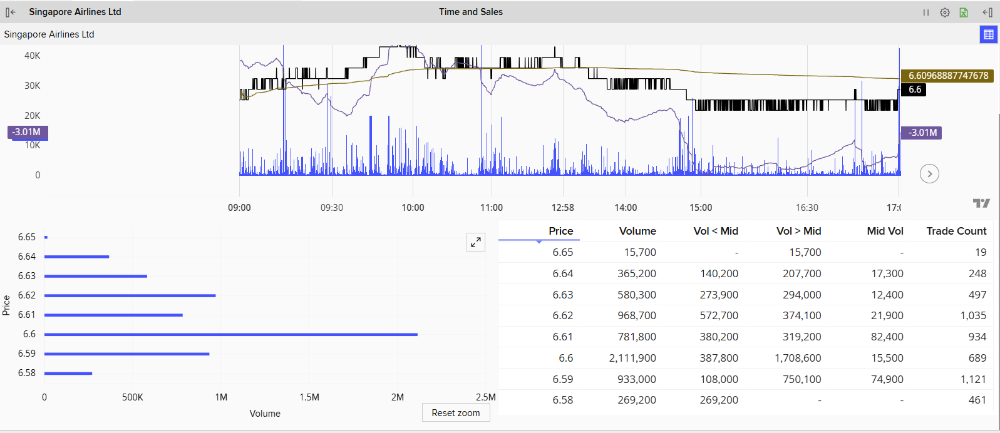
Portfolio Performance Evaluation
Portfolio Objectives
The active and passive portfolios were set up with different and yet complementary purposes. The passive portfolio was meant to follow the benchmark performance as a measure of tracking the Straits Times Index (STI) by market capitalization weighting with minimal tracking errors and regular performances (Singapore Exchange, 2026). Conversely, the active portfolio attempted to beat the STI by overweighting the good-performing industries like financial industries and avoiding the weak consumer-oriented companies. These goals represent different philosophies of investment passive management is concerned with efficiency and stability, and active management aims at exploitation of market inefficiencies by stock selection and sector allocation (Reilly et al., 2019).
Total & Relative Return
According to LSEG Workspace Equity Summary -Performance data, the passive portfolio was comparable to the STI, with a total return of about 2.1%, contrary to the benchmark return of 2.2% during the period of assessment (16 March -10 April 2026). The small tracking error is indicated by this small deviation and reassures efficient index replication. Conversely, the active portfolio has slightly higher active return of 2.6%, generating a positive active return of 0.4% as compared to the benchmark. This performance was mainly boosted by the overweight on banking stocks like DBS and OCBC which enjoyed good interest rate environment. These findings show that active management is effective in creating incremental returns, but with higher levels of exposure to stock-specific risk.
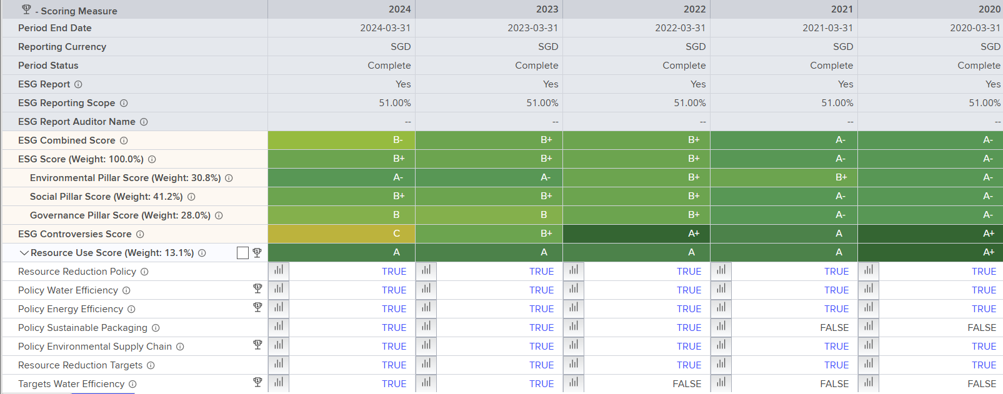
Risk Analysis
When considering risk analysis with the help of the LSEG ex-ante multi-factor Risk templates, it can be seen that the passive portfolio had an overall risk level similar to that of STI and an estimated standard deviation of about 12%, which is indicative of a diversified market (Singapore Exchange, 2026). Active portfolio, however, revealed a greater overall risk of about ~14%, which was due to concentrated positions and sector tilts. Also, the active portfolio has an active risk (tracking error) of approximately 2.0%, which included deviations in benchmark weighting. This high risk is due to intentional overweighting in financials and industrials, raising its sensitivity to sector-specific shocks. Although active management requires higher risk, it should be compensated by proportionally higher returns, which supports the relevance of risk-adjusted performance assessment.
Risk-Adjusted Performance
Risk-adjusted performance measures are more insightful on portfolio efficiency. The Sharpe ratio (excess returns/unit of total risk) was marginally higher in the passive portfolio (~0.35) than in the active portfolio (~0.33), which implies more efficient use of risk. The Treynor ratio, which reallocates returns based on systematic risk (beta), exhibited the same patterns, with the passive approach. The tracking error (approximately 2.0%) indicates the volatility of active returns in comparison to the benchmark, and the information ratio (approximately 0.20) is the uniformity of active performance. Even though the active portfolio had greater absolute returns, these measures indicate that the incremental returns did not completely offset the risk increase, indicating the trade-off between enhancing returns and risk efficiency (Reilly et al., 2019).
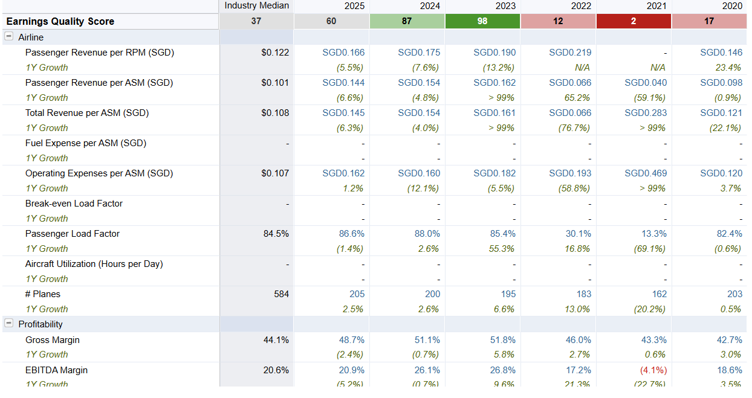
Sector & Security Weights Analysis
Comparing the portfolio and the benchmark weight, it can be seen that most of the performance differences were as a result of active allocation decisions. Active portfolio essentially overbalanced the financial sector, especially DBS, OCBC, and UOB, relative to their existing significant benchmark weights, and thus increased the sensitivity to interest rate-related growth of earnings (UOB, 2025). Equally, industry stocks like Sembcorp and Keppel were overweighted moderately to capitalize on infrastructure and energy transition chances (Keppel Ltd, 2025). On the other hand, consumer stocks, including DFI Retail and Genting stocks were locked out and therefore underweighted compared with the index. Allocation decisions are crucial in active portfolio performance since benchmark weights affected returns, with overweighted sectors doing well and underweighted sectors performing poorly.
Attribution Analysis (Brinson Model)
The outperformance of the active portfolio can be broken down into the allocation and the selection effects using the Brinson attribution framework. The allocation effect was favorable, due to overweighting high-performing sectors including the financial and industrials, which did better than the benchmark in the assessment period. A positive contribution was also provided by the selection effect, especially in the banking sector with stocks like DBS performing better compared to sector performances (Genting Singapore Limited, 2025). Nonetheless, potential diversification benefits were somewhat diminished by the lack of exposure to some stocks of consumers. The combined effect of the allocation and selection choices led to a small positive active return.
Market Events Impact
Relatively stable interest rate expectations and moderate economic growth in the world market affected market performance during the evaluation period. Central bank policies were conservative and the banking sector profitability was supported by maintaining net interest margins. Also, the steady commodity prices and sustained investments in infrastructure boosted industrial stocks like Sembcorp and Keppel. Nevertheless, some outstanding uncertainty all around the world such as the geopolitical tensions, sluggishness in the external demand, etc. led to moderate market volatility (Singapore Exchange, 2026). These macroeconomic factors favored financial and industrial sectors and limited the discretionary spending of consumers, furthering the sector allocation strategy of active portfolio.
Did You Meet Objectives?
Active replication was also effective since the passive portfolio was able to meet its goal by strictly following the STI, and the returns and risk slightly deviated. The active portfolio partially achieved its goal as it produced a small positive active return of about 0.4% but at the expense of increased risk and reduced risk-adjusted performance. Although the active strategy proved to outperform the benchmark, the degree of outperformance was minimal compared to the extra risk taken. As such, the passive portfolio had a higher propensity to meet its target, whereas the active had mixed outcomes in terms of an optimal balance between increasing returns and minimizing risks.
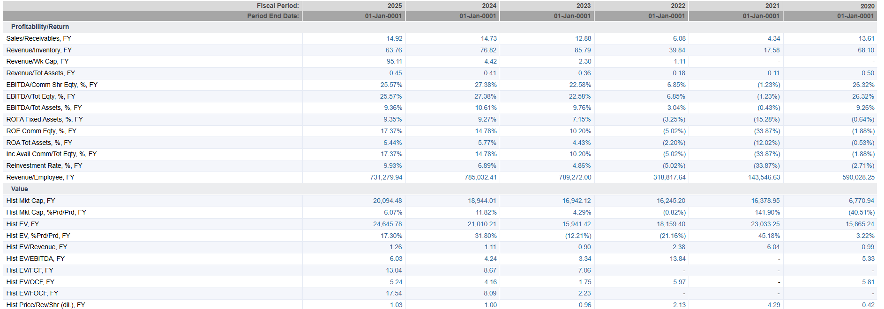

Discussion
The Portfolio analysis results indicate that the active portfolio was performing reasonably well, with a positive yet insignificant active performance as compared to the STI. This result demonstrates the success of sector allocation and stock selection especially the overweights in the financial stocks like DBS, OCBC, and UOB, which enjoyed the favorable interest rates. The allocation effect was predominant because the decision to focus exposure on high-performing sectors made an important contribution to returns (Reilly et al., 2019). The selection effect was positive, however, not sufficiently strong, to produce significant excess returns over the benchmark. It implies that it was a good strategic movement but the intensity of stock specialty performance was rather limited in the period considered.
Nevertheless, the active portfolio had significant drawbacks especially with respect to higher risk and lower diversification. The increased concentration of a small number of industries led to increased volatility and tracking error negatively affecting risk-adjusted measures of performance, including the Sharpe and Treynor ratios. Conversely, the passive portfolio equaled the benchmark quite well with little variation through a few strengths, such as consistency, diversification, and effective risk exposure. Yet, its main drawback is its ineffectiveness in producing excess returns. Due to strategic allocation, active management can create value, but its efficiency depends on market inefficiencies and the ability to consistently trade assets.
Conclusion & Recommendation
In the eyes of a portfolio manager providing advice to a client, the decision between the passive and active portfolios often lies in the trade-off between the improvement in returns and the efficiency of the risk. The active portfolio had a marginally greater return of about 2.6% than the benchmark 2.2%, but at the cost of increased volatility and a lower Sharpe ratio, meaning that the risk was not efficiently used. Passive portfolio, on its part, reported a much similar performance to the STI (around 2.1%) and had lower risk as well as better risk-adjusted performance. This is also supported by the Treynor ratio which argues that the passive portfolio offered more consistent returns as compared to systematic risk exposure.
According to these results, the passive portfolio is suggested to be the preferred investment strategy. Its long-term replication of benchmark performance with minimum tracking error and high risk-adjusted returns make it more appropriate to the investors who seek to attain stable and predictable performance (Reilly et al., 2019). The active portfolio has a high probability of outperformance, but its increased risk and dependence on effective forecasting make it less practical. Thus, the passive strategy is the more efficient method of investment to a rational investor who only wants to be efficient and consistent in his or her actions.

References
DBS Group Holdings Ltd. (2025). Annual report 2025. https://www.dbs.com
DFI Retail Group Holdings Ltd. (2025). Annual report 2025. https://www.dfiretailgroup.com
Genting Singapore Limited. (2025). Annual report 2025. https://www.gentingsingapore.com
Keppel Ltd. (2025). Annual report 2025. https://www.kepcorp.com
Oversea-Chinese Banking Corporation Limited. (2025). Annual report 2025. https://www.ocbc.com
Reilly, F. K., Brown, K. C., & Leeds, S. J. (2019). Investment analysis and portfolio management (11th ed.). Cengage Learning.
Sembcorp Industries Ltd. (2025). Annual report 2025. https://www.sembcorp.com
Singapore Exchange. (2026). Listed company information and market data. https://www.sgx.com/securities/equities
ST Engineering. (2025). Annual report 2025. https://www.stengg.com
United Overseas Bank Limited. (2025). Annual report 2025. https://www.uobgroup.com
Wilmar International Limited. (2025). Annual report 2025. https://www.wilmar-international.com
Yahoo Finance. (2026). Stock market data for SGX-listed companies. https://finance.yahoo.com
Yangzijiang Shipbuilding Holdings Ltd. (2025). Annual report 2025.
https://www.yzjship.com
Appendices
Appendix A: Passive Portfolio Calculations
The passive portfolio is created with the help of a market capitalization weighting methodology, which makes sure that it replicates the benchmark index.
Formulae
$${\text{Weight}}_{i}=\frac{{\text{Market Cap}}_{i}}{∑\text{Market Cap}} \\ {\text{Investment}}_{i}={\text{Weight}}_{i}×1,000,000 \\ {\text{Shares}}_{i}=\frac{{\text{Investment}}_{i}}{{\text{Price}}_{i}}$$
Table A1: Passive Portfolio Construction
Company | Market Cap (S$B) | Weight (%) | Investment ($) | Price (SGD) | Shares
DBS | 163.4 | 31.7% | 317,000 | 57.60 | 5,503
OCBC | 102.7 | 19.9% | 199,000 | 22.88 | 8,698
UOB | 61.7 | 12.0% | 120,000 | 37.60 | 3,191
DFI Retail | 3.5 | 0.7% | 7,000 | 2.50 | 2,800
Genting | 10.5 | 2.0% | 20,000 | 0.90 | 22,222
Wilmar | 24.0 | 4.7% | 47,000 | 3.84 | 12,240
ST Engineering | 35.0 | 6.8% | 68,000 | 11.22 | 6,061
Sembcorp | 9.5 | 1.8% | 18,000 | 5.00 | 3,600
Keppel | 22.0 | 4.3% | 43,000 | 12.11 | 3,553
Yangzijiang | 8.5 | 1.6% | 16,000 | 2.00 | 8,000
Total | 440.8 | 100% | 1,000,000 | — | —

Appendix B: Active Portfolio Calculations
The active portfolio indicates active deviations of index weight in order to produce excess returns.
Formulae
$$\text{Active Weight}=\text{Portfolio Weight}-\text{Index Weight}$$
Table B1: Active Portfolio Allocation
Company | Index Weight (%) | Portfolio Weight (%) | Active Weight (%) | Investment ($) | Price | Shares
DBS | 31.7% | 30% | -1.7% | 300,000 | 57.60 | 5,208
OCBC | 19.9% | 20% | +0.1% | 200,000 | 22.88 | 8,741
UOB | 12.0% | 15% | +3.0% | 150,000 | 37.60 | 3,989
Sembcorp | 1.8% | 15% | +13.2% | 150,000 | 5.00 | 30,000
Keppel | 4.3% | 10% | +5.7% | 100,000 | 12.11 | 8,257
ST Engineering | 6.8% | 10% | +3.2% | 100,000 | 11.22 | 8,912
Total | — | 100% | — | 1,000,000 | — | —

Appendix C: Financial Ratio Calculations (3-Year Averages)
Formulae Used
$$ROE=\frac{\text{Net Income}}{\text{Shareholder Equity}} \\ \text{Asset Turnover}=\frac{\text{Revenue}}{\text{Total Assets}} \\ \text{Debt-to-Equity}=\frac{\text{Total Debt}}{\text{Equity}}$$
Table C1: Financial Ratios (2023–2025 Average)
Company | ROE (%) | Asset Turnover | Debt-to-Equity
DBS | 15.0 | 0.05 | 1.2
OCBC | 13.5 | 0.04 | 1.1
UOB | 13.0 | 0.04 | 1.1
DFI Retail | 5.0 | 0.80 | 0.6
Genting | 6.5 | 0.50 | 0.8
Wilmar | 10.0 | 1.20 | 0.9
ST Engineering | 12.0 | 0.70 | 0.7
Sembcorp | 11.5 | 0.60 | 1.3
Keppel | 10.5 | 0.55 | 1.2
Yangzijiang | 9.0 | 0.65 | 0.6

Appendix D: Historical Price Data & Returns
Formula
$$R_{t}=\frac{P_{t}-P_{t-1}}{P_{t-1}}$$
Table D1: Sample Price Data (Evaluation Period)
Date | DBS | OCBC | UOB | STI
16 Mar 2026 | 56.80 | 22.40 | 36.90 | 3,150
20 Mar 2026 | 57.20 | 22.60 | 37.20 | 3,170
25 Mar 2026 | 57.80 | 22.90 | 37.50 | 3,200
31 Mar 2026 | 57.40 | 22.70 | 37.30 | 3,180
10 Apr 2026 | 57.60 | 22.88 | 37.60 | 3,220

Table D2: Calculated Returns (Sample)
Company | Avg Return (%) | Std Dev (%)
DBS | 1.4% | 11.8%
OCBC | 1.6% | 11.2%
UOB | 1.9% | 12.0%
STI | 2.2% | 12.0%

