TUGAS PRAKTIKUM ALGORITMA PEMROGRAMAN

“MEMBUAT FLOWCHART DAN PSEUDOCODE 4”



OLEH

Nia Ramadhani Tanjung

NIM 2311531006

MATA KULIAH : ALGORITMA PEMROGRAMAN

DOSEN PENGAMPU : Dr.WAHYUDI,S.T.M.T

FAKULTAS TEKNOLOGI INFORMASI

DEPARTEMEN INFORMATIKA

UNIVERSITAS ANDALAS

PADANG, 8 NOVEMBER 2023

**FLOWCHART**

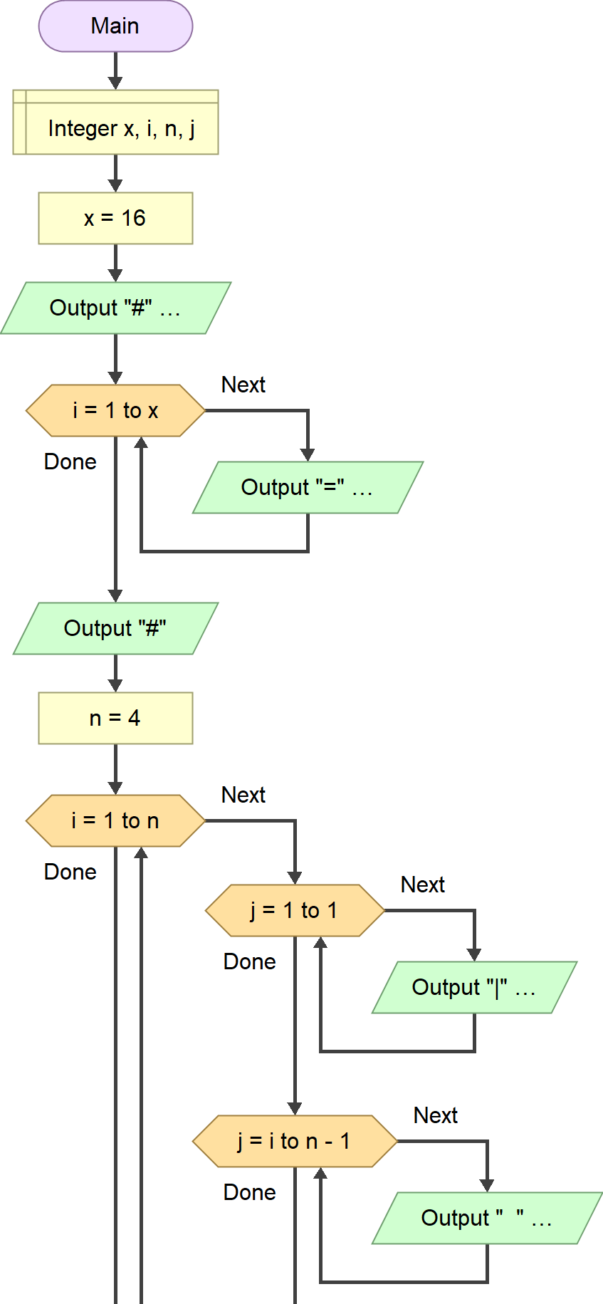

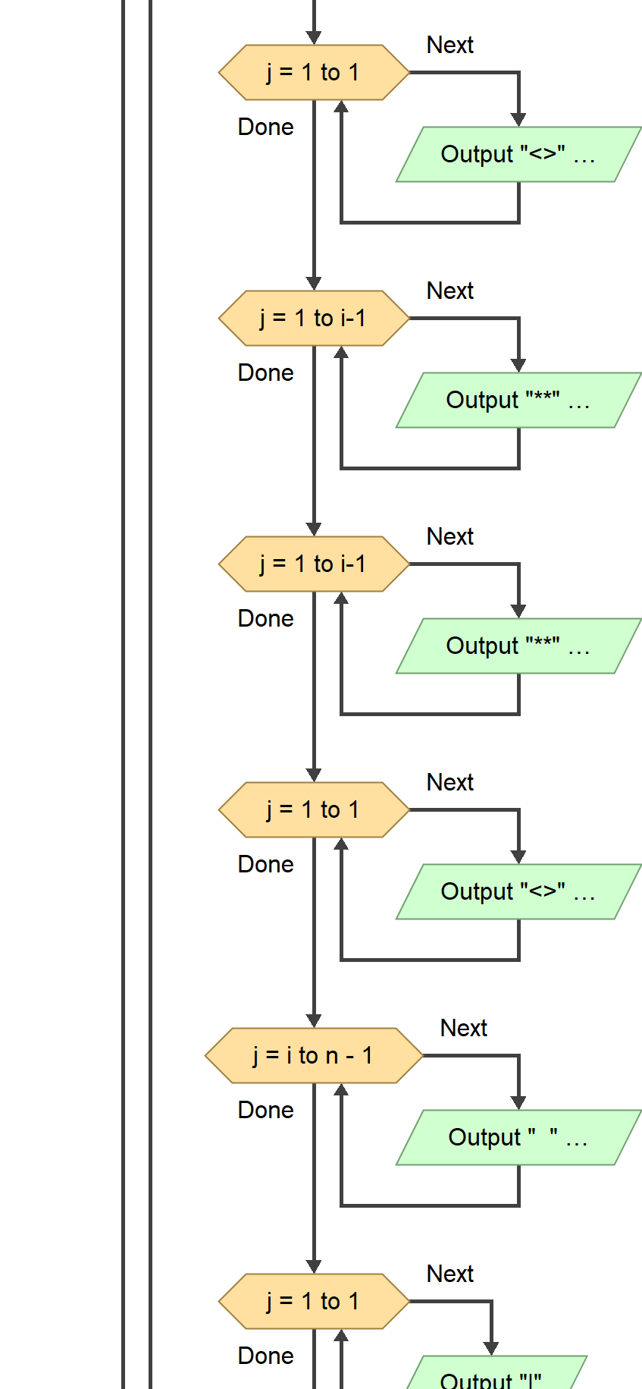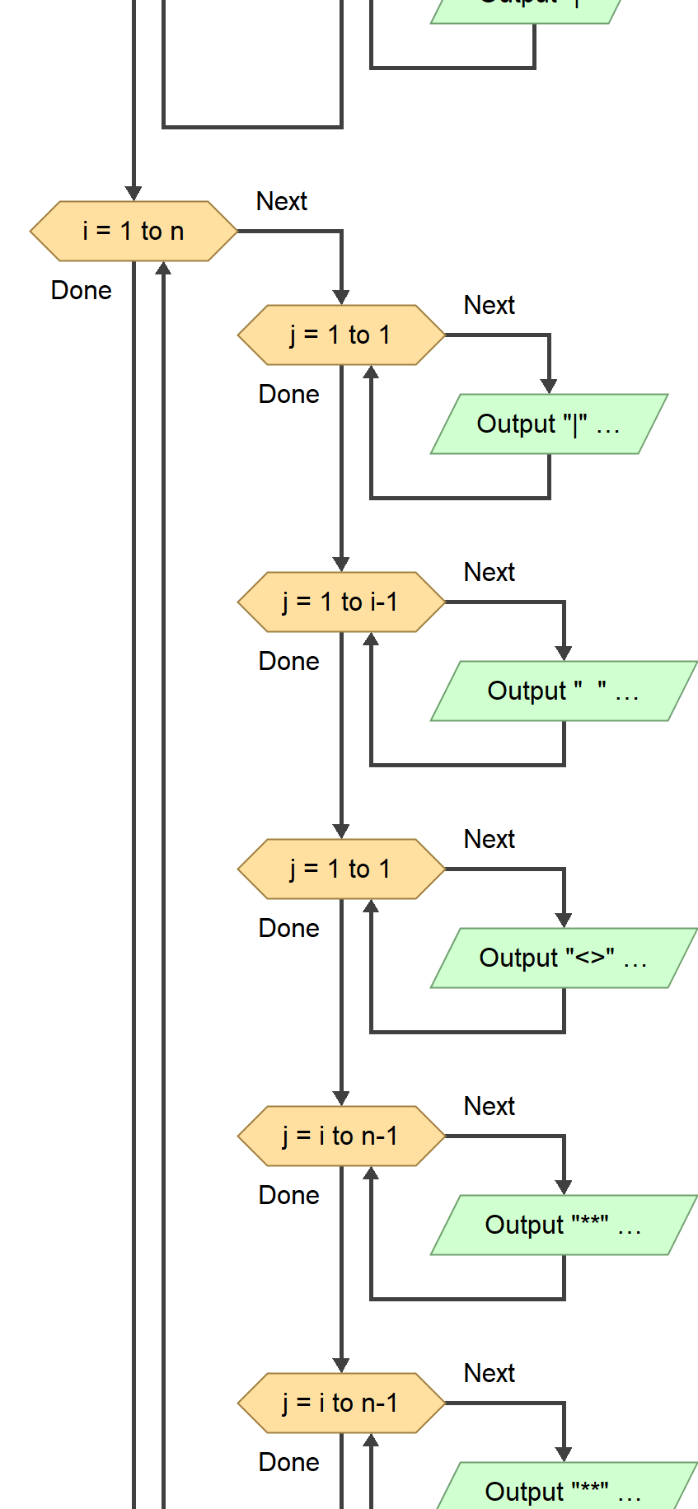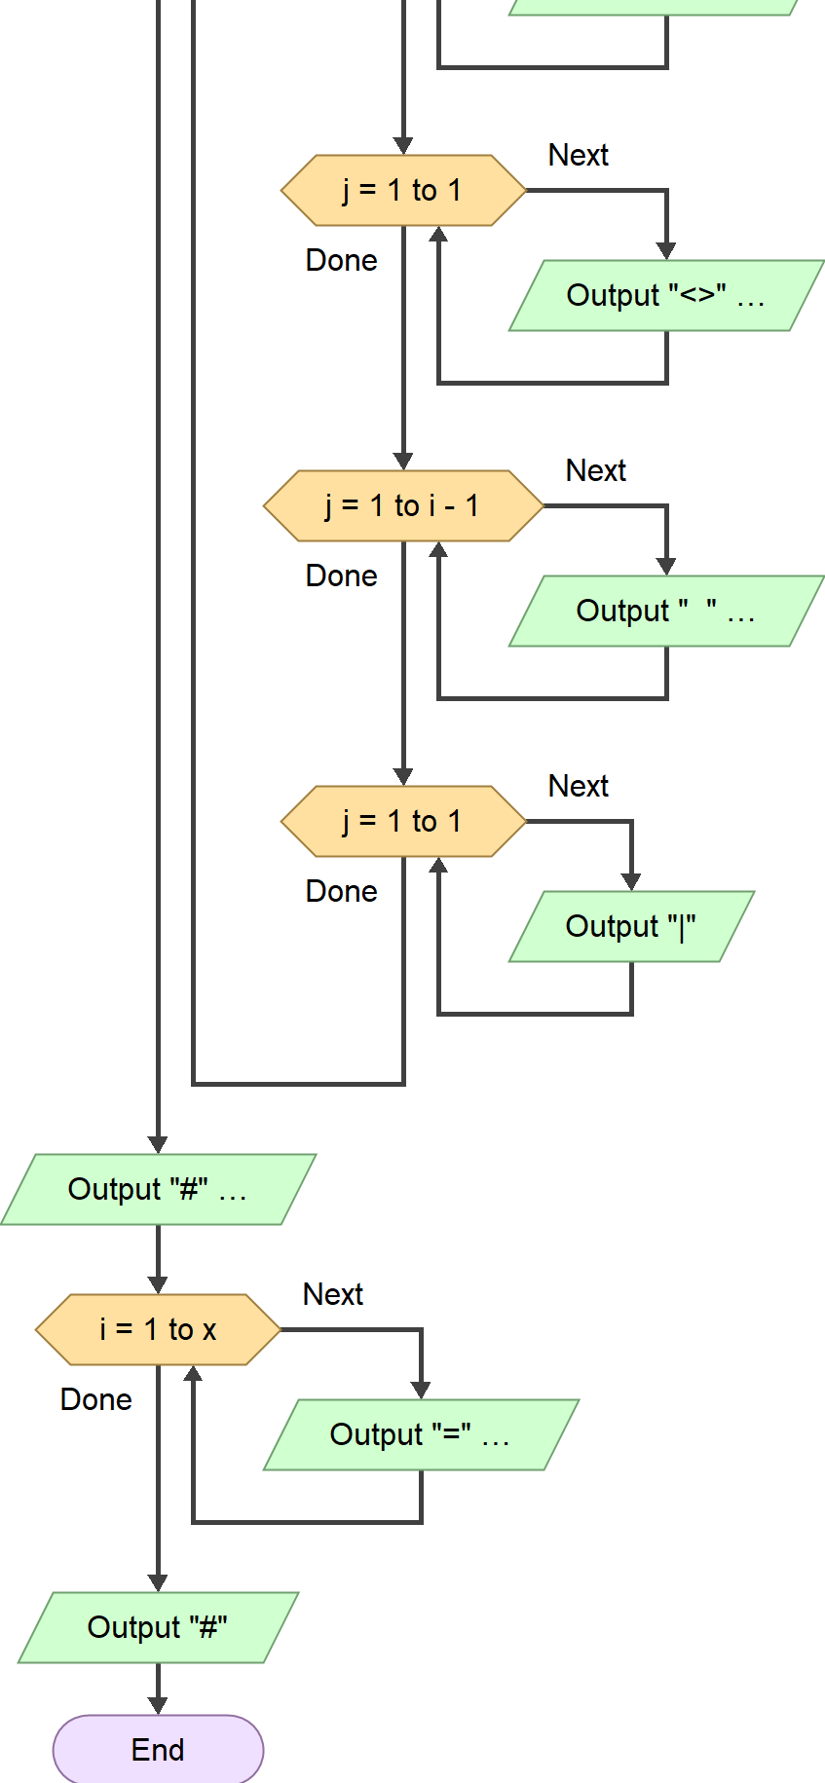

|  |
| --- |
| ProgramForLoop |
| Integer x, i; Integer n; Integer j |
| Input x = 16  Input n = 4  Output "#"  For i = 1; i <= x; i ++  Output "="  Output "#"  For i = 1; i <= n; i ++  For j =1; j <= 1; j++  Output "|"  For j = i; j < n; j ++  Output " "  For j =1; j <= 1; j++  Output "<>"  For j = 1; j < i; j ++  Output "**"  For j = 1; j < i; j ++  Output "**"  For j =1; j <= 1; j++  Output "<>"  For j = i; j < n; j ++  Output " "  For j = i; j <= i; j ++  Output "|"  For i = 1; i <= n; i ++  For j =1; j <= 1; j++  Output "|"  For j = 1; j < i; j ++  Output " "  For j =1; j <= 1; j++  Output "<>"  For j = i; j < n; j ++  Output "**"  For j = i; j < n; j ++  Output "**"  For j = 1; j <= 1; j++  Output "<>"  For j = 1; j < i; j ++  Output " "  For j =1; j <= 1; j++  Output "|"  Output "#"  For i = 1; i <= x; i ++  Output "="  Output "#"  End |