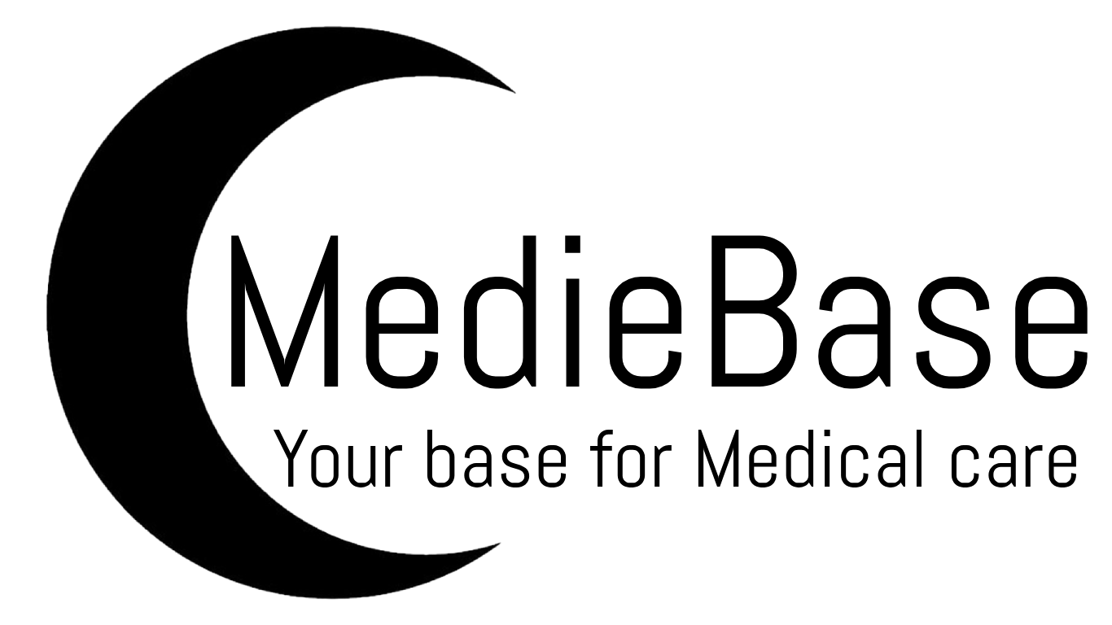
By Niall Corbishley + 3 team members (anonymised)
Introduction 2
Project 3
Intro to Project 3
Methodology 3
Requirements Engineering 4
Intro to Requirements Engineering 4
Importance of Requirements Engineering 4
Requirement Engineering in Requirement Document 5
The Projects Requirements 5
Modelling Diagrams 5
Intro to the modelling diagrams used 6
Flowchart 6
Justification 6
Model with Analysis 6
Data Flow Diagram 7
Justification 7
Model with Analysis 7
Entity relationship 8
Justification 8
Model with Analysis 8
Class Diagram (UML) 9
Justification 10
Model with Analysis 10
Prototype 10
User Acceptance Criteria 13
What are user acceptance criteria 13
Importance and use in practice 13
The model of Acceptance Criteria 13
Justification 14
Team Working Strategy 14
Method of team working strategy 14
Team working experience 14
Decisions about group presentation 15
Conclusion 15
Use of SDLC 15
Future testing 15
SWOT Analysis 15
Bibliography 15
References 15
Appendices 16

Introduction
The Software development life cycle is the process used for the development of Software as a way of connecting between the analysis and implementation. This helps in structuring code to be modular, readable and maintainable. The Software development Life cycle is split up into Requirement Gathering, Analysis and Design, implementation, Testing, Evolution. Requirement gathering is the process of obtaining the requirement from the user/users of the software to understand what the project needs to be able to do and needs to function. Then the collected requirement will be ordered and from most to least important, so the group end up with an order of what needs to be done and what needs to be prioritized for this project so the know what we can cut out if we need to simplify the requirement down. Analysis and Design is the process of reviewing the requirement and using them to design the systems that will be used and designing what the system will look like. Implementation is the process of the initial coding of the project and the creation of the system. This is usually work that is split up into individual sections of front end and back-end development. Each task is given to individual people. Testing is a phase in which the development team will run through the code and run it through scenarios and make sure that the code is working and functioning as expected this usually led to then a period of editing and correcting any issues within the code until it is fixed. Evolution is the process of improving the code and developing on the code to make it better and to add the additional functionality that might have been left out in the initial development.

Project

Intro to Project
The project is a medical database that is formed of patients and doctors. This database is to be used to by the doctors, patients and administration to access, alter and create new information for different users. It should for doctor allow them to access their own information, their patient's information as well as updating patient information and adding/removing patients from the database. The patient should be able to view their own information, report any symptoms and view their doctor information. The admin should be able to add/remove/update both patient and doctor information as well as assign patients to doctors.

Methodology
The group decided we would use a waterfall methodology, there were multiple discussions about which to use. The stages go in a linear fashion where you can't complete the next section before you finish the previous one, this suits the project as we can complete a section as we learn it. These are 5 stages in the waterfall cycle: Requirements, Design, Implementation, Verification, Maintenance. Requirement stage includes requirement gathering, requirement prioritization, acceptance requirements and a timeline. The design phase requires creating an overall design of the project including diagrams such as entity relationship diagrams and data flow diagrams, it also includes designing the front-end. The implementation stage includes actually coding the front and back end as well as any research needed to complete that. The verification stage involves testing the project to see if it is functional. Maintenance stage making sure the project stays functional including running servers and fixing bugs which appear.
(Layoan)
(Atlassian)

Requirements Engineering

Intro to Requirements Engineering
Requirement engineering entails gathering the requirements and prioritising requirements. There are different kinds of requirements which need to be gathered including user requirements, system requirements and business requirements. The acceptance criteria will be created, allowing clearer goals for the project, reducing the chance of errors. These are all put into a SRS (software requirement specification) document, this will be in the appendix. These requirements are going to be prioritised which indicates what aspects of program should be developed first. There are many methods to do this, however the group decided to use the moSCow method as it is simple and shows the importance of each requirement clearly. The moSCow method involves ranking the requirements into “must have”, “should have”, “could have” and “won’t have”.
(theknowledgeacademy.com)
(Bigelow)

Importance of Requirements Engineering
The importance of Requirement Engineering is that it will give the project focus and will give it direction. It will also help better meet the user's concept of what they want for this medical system and help better the companys reputation as a company by more closely satisfying the user needs in the project. This will also allow for the entire project team to get a much clear concept of what they are expected to create at the end of this project. With the prioritization of requirement allow for people to better direct themselves, the MoSCow method allow for easy prioritisation of methods and understanding what is important for the project.

Requirement Engineering in Requirement Document
There are many ways to create requirements however the one of the main ways is to interview stakeholders, due to the nature of this project that was difficult so the group decided we would create the requirements by looking at previous documents and the template for requirements document to make the most accurate requirements possible. We then presented the requirements to the stakeholder who confirmed they were good for the project. We also created a small survey we would send to staff and patients to help gather requirements; we kept it small in order to increase the likely hood of someone answering as less people would be willing to complete a larger survey.

The Projects Requirements
The group has split the requirements into functional and non-functional requirements, each requirement has an ID which allows the group to properly rank the requirements into the moSCow system. We split between functional and non-functional because they are focused on different things which makes it harder to compare them directly. We have ranked every requirement in the requirement documents (as seen in appendix). We have 10 functional requirements, and 7 non-functional requirements. There are three functional requirements which are assigned as “must have”. The first is having a database stores patient and staff information This is needed so staff can access the information to better treat patients, and so patients can be assigned to correct staff. The second is medical staff should be able to access the database, this is so that the staff can access the information as it is needed. The final is that patients can be added and removed, this is needed from when a patient arrives at a hospital and when they leave to not clog up the system. Each one has its own justification, but these were the most important ones. The non-functional weren’t ranked as they were all optional ways of implementing it and other ways were effective as well. One example is that access to the database should not take over 15 seconds at 1000 users, we picked this number because above 15 seconds is dangerous, and 1000 users is more than the system would typically use. Another non-functional requirement is users should be able to access different options through tabs at the top of the screen, this is an easy way to get to different options easily which will be intuitive for all users.

Modelling Diagrams

Intro to the modelling diagrams used
For the modelling diagram we have used a variety of diagrams to better make clear the function and abilities of both the program and the database. This should allow for the same idea to be communicated in a multitude of different ways to better convey that idea so it will be clear to people who need clarification.

Flowchart

Justification
Flowcharts are used to show the order of the program and what should happen. These are clear ways of showing what programs should do as they abstract out unnecessary details and allows both developers and stakeholders to easily understand the underlying logic of the program.

Model with Analysis
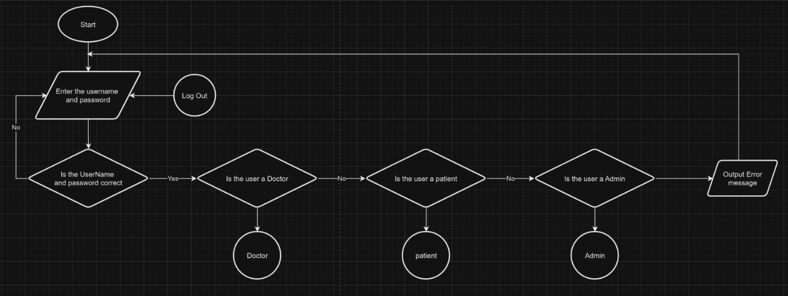
This is a flowchart showing the first menu a user would see. The user enters their details and gets redirected to the correct profile. If they give incorrect details, an error message is produced, and they are prompted to check their details and try again.
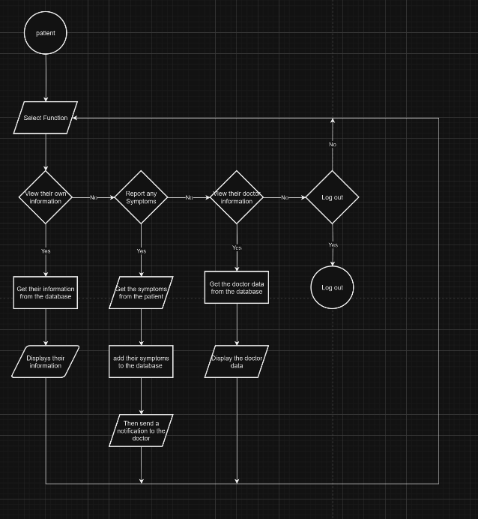
This flowchart illustrates what a doctor can do within the application. The flowcharts for users or administrators would look different to this due to varying ranges of permissions.

Data Flow Diagram

Justification
This project will have a large amount of information flowing throughout it, so it is important to be able to clearly visualise the locations where the information is stored in and how it is manipulated. A data flow diagram helps illustrate this by highlighting the different areas that information is sent to and what actions can be performed on it.

Model with Analysis
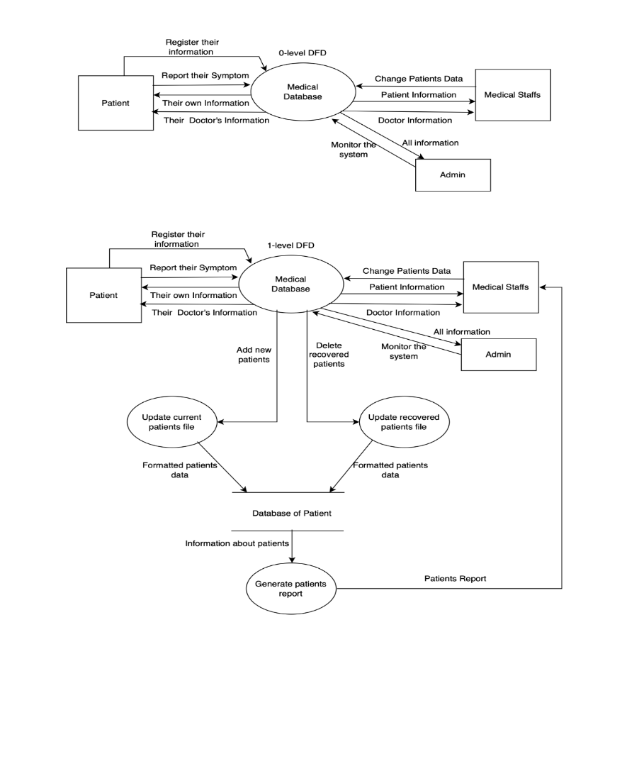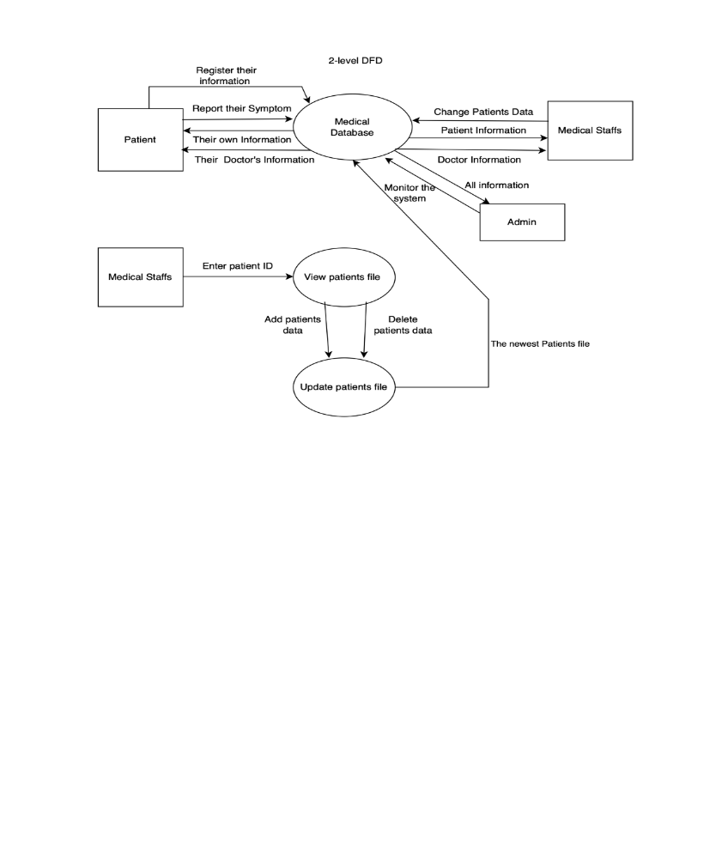
The above data flow diagrams for the database indicate the relationship between users and the medical database and what actions each type of user can take, as well as the impact their actions has on the rest of the database

Entity relationship

Justification
The purpose of using an entity relationship diagram in this database is to
highlight the connections between different groups in the database and
to define to some extent, what permissions an individual user would have

Model with Analysis
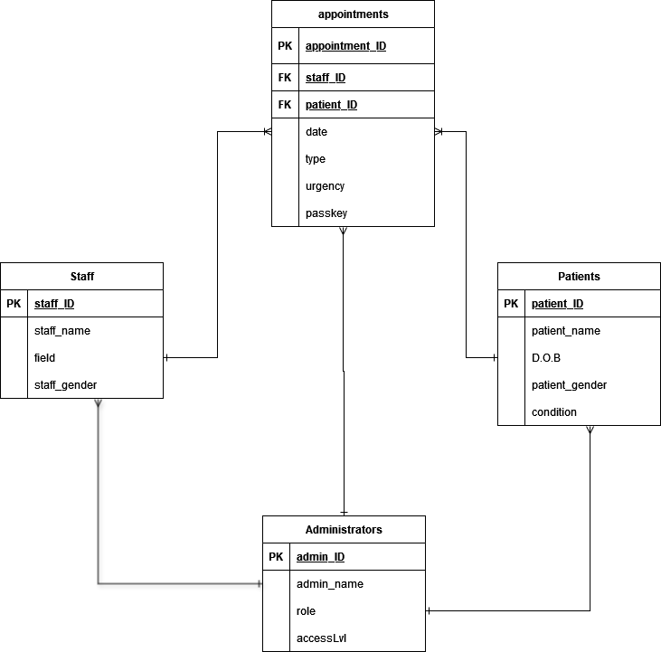The entity diagram above shows the relationships between the different tables in the database. Staff and patients only have access to a single table and only have access to their relevant information in the appointments table. The both have a one to one-or-many relationships with the appointments table as a single patient or doctor may have multiple appointments. Administrators have complete access to every table as long as they have the relevant access level.

Class Diagram (UML)

Justification
A UML class diagram was used to define the attributes and methods available to each class within the database. This is necessary for the implementation process, when the classes are created in code and ensuring that each class inherits the corrects attributes and methods

Model with Analysis
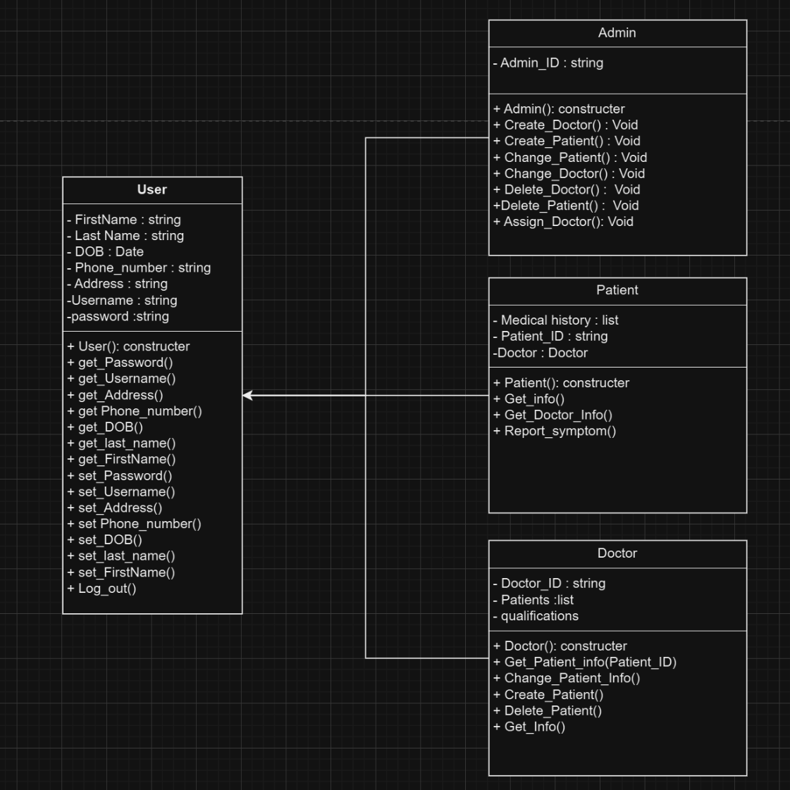
The above diagram illustrates the classes that would be present in the database. Every user belongs to a single class (Doctor, Patient, or Admin). These classes have their own set of attributes and methods, including a constructor method for creating new users. In addition to their own attributes and methods, each class also inherit some from the “User” superclass, which contains the majority of methods and attributes in the database. The inheritance is completed through polymorphism

Prototype
For prototype code, a way to sign in and the patient class as these 2 things show a lot of the programming techniques which would be used in the actual system.
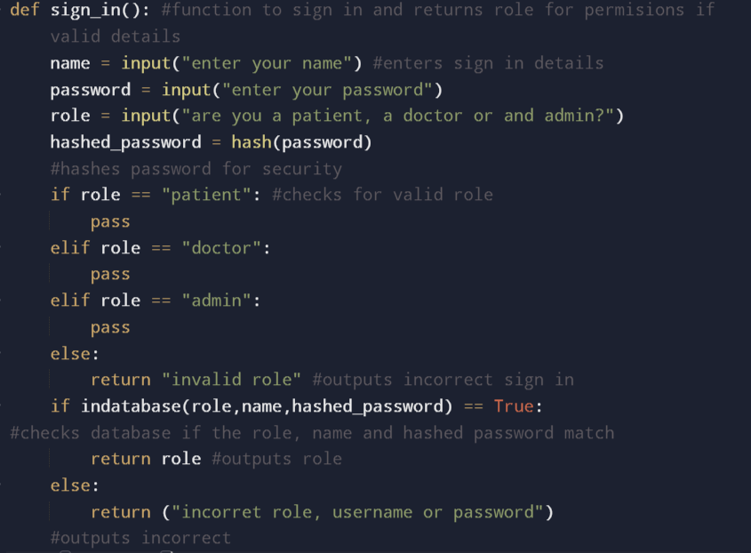
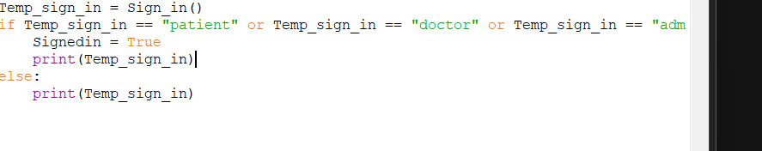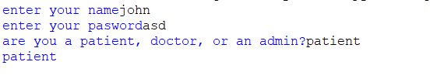
The role of the user is important as it shows what permissions are needed to be given to the user. If sign in is successful then the role is returned. if it fails, an error message is returned based on why it failed. The indatabase function returns True if the role name and hashed_password match the database.
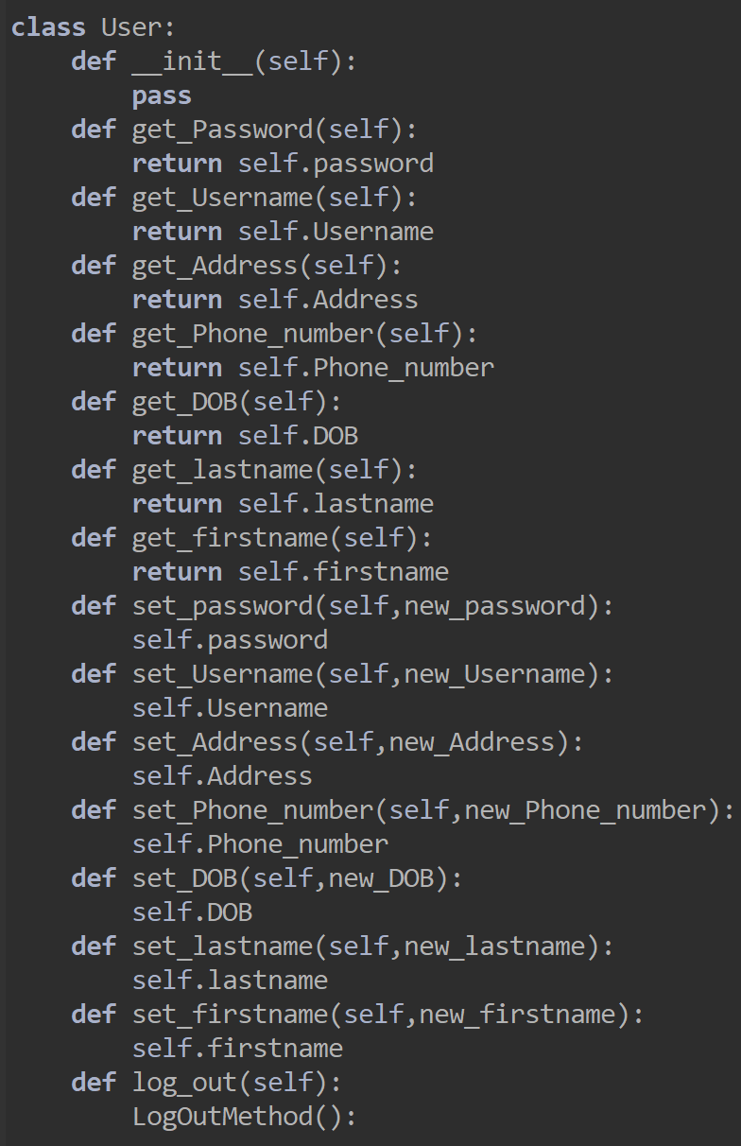
This is the main user class that has all the getters and setters for the class. This class has three sub classes since there is patient, doctor and an Admin which each has their own functionality and their own additional variables.
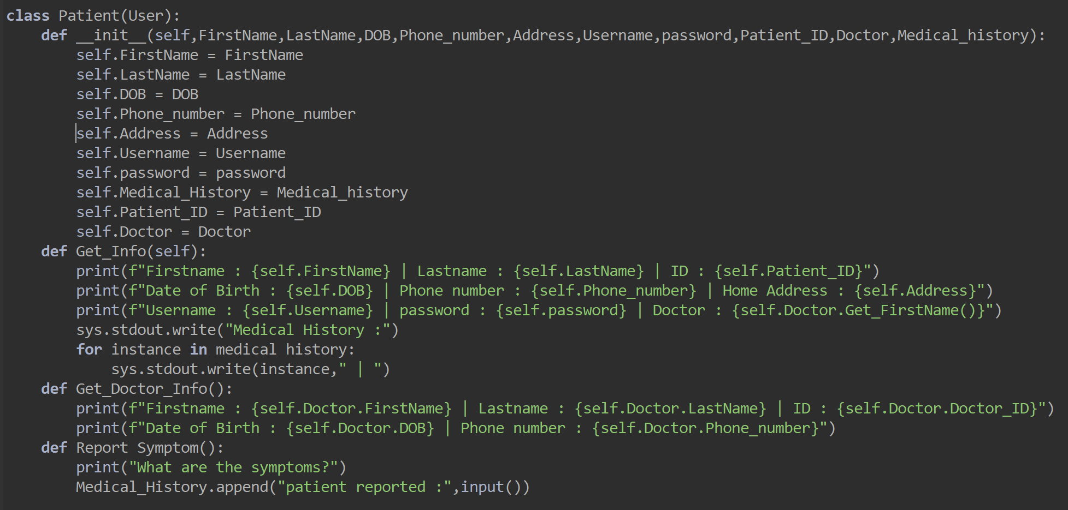
This is the Patient class which inherit from user class and additional funcianility like display the patient information getting the doctor information.

User Acceptance Criteria

What are user acceptance criteria
User acceptance criteria are a set of criteria which will satisfy the user, which includes what different users (patients, doctors and admins) need to do. A set of requirements is generated for each user which needs to be implemented. There are two main types of user acceptance criteria, scenario oriented and rule oriented.

Importance and use in practice
User acceptance criteria allow more specific plans to be formed for the project as they allow the team to have more goals to work towards. It also makes work more efficient as less time is wasted creating things which aren’t as important, which can lead to delays or important features being scraped.

The model of Acceptance Criteria
Through user stories, the group created scenario-oriented acceptance criteria, which are criteria which need to be met in the form of a scenario which each user wants the system to do. Each type of user generated a scenario for why and how they needed to use the system. These scenarios are broken down into smaller scenarios for more criteria. For example, “As a patient, I want to be able to access my information so that I can see my patient data which includes symptoms and who my doctor is” generated many scenarios like “Patient needs to access the database”.

Justification
17 user requirements were created, this allows the group to get a good level of depth as it covers every task that the users will do. Having more would lead to less quality as the task would need to be stretched over more points. It can also lead to more time being spent prioritising requirement. Having less would lead to certain feature being cut from requirements which would lead to the user being dissatisfied. The choices are also in line with the projects requirement document as we generated a similar amount of user requirements as functional and non-functional requirements. This is because we believe this to be the best number of requirements for a project this size.

Team Working Strategy

Method of team working strategy
The team working strategy was made to split up the work to be as balanced as possible so it plays to the individual strengths but will never overwhelm them with work. The bulk of the work is split up throughout the weeks as evenly as possible to keep each week with a consistent amount of work. Except for the last week of each section which is given to reviewing checking and polishing any remaining work this works well as the section the team is working on will always be completed as we are giving plenty of time to work on the project and plenty of time to finish any work that isn’t completed. Each individual section is always given to someone to complete, and the work is checked by another person afterwards to ensure consistency and quality.

Team working experience
The team working strategy worked well in part because the group each had their own task to do and could get on with the work independently of each other and would come back together to review. The team working strategy failed in parts because some people would go off independently and would create work that is inconsistent from the rest of the group concept of the project. Overall going forward in the future, the team would probably work more as a collective to stop confusion and would plan on working hours.

Decisions about group presentation
For the group presentation the team will split up the sections into different parts and will take turns for individual member to speak about sections. The individual slides will be mainly visual depictions with a little text but won’t be overdone with text and will be mainly to assist the talking point the individual would be talking about at the time. Also, the inclusion of diagrams and example code would be included to show the work that been done.

Conclusion

Use of SDLC
The waterfall method was used through the development of the project, the waterfall method has many stages which are completed in a linear structure. Requirement engineering is the first stage which was completed after the introduction. The group created functional and non-functional requirements. The next stage is design, the group created diagrams such as entity relationship diagrams. Implementation wasn’t part of this project, due to no code being required. However, some prototype code was created to show competence within this section. Future testing will be included after this and Maintenace can’t be done.

Future testing
Future testing needs to make sure the entire system is working. Some key things which need testing include: Account creation; Sign in; Edit details and many more. To test these the group would generate specific test cases for each thing. If the group were to test Sign in, the group would need to pass in correct data, incorrect data, invalid data and compare the results.

SWOT Analysis
A SWOT Analysis document was created which is seen in the appendix, which shows the strengths, weaknesses, opportunities and threats of the project.

Bibliography

References
Atlassian. (n.d.). Waterfall Methodology for Project Management.
Bigelow, S. J. (n.d.). What are the types of requirements in software engineering?
Layoan, S. (n.d.). Guide to Waterfall Methodology: Free Template & Examples.
theknowledgeacademy.com. (n.d.). Requirements Engineering: A Complete Guide for Software Projects .

Appendices

- Requirements Document Group 3
- Modelling Diagrams
- User Story and Acceptance Criteria
- Team Working Strategy
- SWOT analysis
- UI Design

