A project report on
MULTI-OBJECTIVE AGENT OPTIMIZATION THROUGH ADAPTIVE EVALUATION
Submitted in partial fulfillment for the award of the degree of
Bachelor of Technology in Computer Science and Engineering
by
SUBHROJYOTI SEN (23BCE1259)
KUMAR SHREYASH (23BCE1882)
DCUNHA NIALL FRANCIS AJEET (23BCE1985)

SCHOOL OF COMPUTER SCIENCE AND ENGINEERING
VELLORE INSTITUTE OF TECHNOLOGY, CHENNAI
October, 2026

MULTI-OBJECTIVE AGENT OPTIMIZATION THROUGH ADAPTIVE EVALUATION
Submitted in partial fulfillment for the award of the degree of
Bachelor of Technology in Computer Science and Engineering
by
SUBHROJYOTI SEN (23BCE1259)
KUMAR SHREYASH (23BCE1882)
DCUNHA NIALL FRANCIS AJEET (23BCE1985)
SCHOOL OF COMPUTER SCIENCE AND ENGINEERING
VELLORE INSTITUTE OF TECHNOLOGY, CHENNAI
October, 2026

DECLARATION
I hereby declare that the thesis entitled “Multi-Objective Agent Optimization through Adaptive Evaluation” submitted by Kumar Shreyash (23BCE1882), for the award of the degree of Bachelor of Technology in Computer Science and Engineering, Vellore Institute of Technology, Chennai is a record of bonafide work carried out by me under the supervision of Sreeja P S.
I further declare that the work reported in this thesis has not been submitted and will not be submitted, either in part or in full, for the award of any other degree or diploma in this institute or any other institute or university.
Place: Chennai
Date: Signature of the Candidate

School of Computer Science and Engineering

CERTIFICATE
This is to certify that the report entitled “Multi-Objective Agent Optimization through Adaptive Evaluation” is prepared and submitted by Kumar Shreyash (23BCE1882) to Vellore Institute of Technology, Chennai, in partial fulfillment of the requirement for the award of the degree of Bachelor of Technology in Computer Science and Engineering is a bonafide record carried out under my guidance. The project fulfills the requirements as per the regulations of this University and in my opinion meets the necessary standards for submission. The contents of this report have not been submitted and will not be submitted either in part or in full, for the award of any other degree or diploma and the same is certified.
Signature of the Guide:
Name: Prof. Sreeja P S
Date:
Signature of the Examiner Signature of the Examiner
Name: Name:
Date: Date:
Approved by the Head of Department,
B.Tech. Computer Science and Engineering
Name: Dr. J. Prassanna
Date:
(Seal of School of Computer Science and Engineering)

ABSTRACT
Large language model (LLM) agents are acutely sensitive to their configuration: the system prompt that frames the task, the decoding parameters that shape the response, and the choice of metrics against which candidate configurations are judged. Existing automated prompt-optimization frameworks largely treat evaluation as free and single-objective, scoring every candidate against a fixed, exhaustively executed metric ensemble with hand-chosen weights. In practice this is both expensive, because LLM-as-a-judge evaluators dominate the cost of a search, and fragile, because redundant metrics consume budget while unmonitored dimensions regress silently.
This project develops and evaluates a framework for multi-objective optimization of LLM agents through adaptive multi-evaluator co-optimization. The agent configuration and the evaluation process are optimized jointly over a hybrid search space comprising a discrete prompt population, a binary evaluator-activation vector, a continuous weight vector on the probability simplex, and continuous decoding parameters. Six contributions address six corresponding gaps in the literature: a two-tier evaluation cascade that gates expensive judges behind a cheap preview score; Gaussian-process optimization of the metric weights with a Matérn 5/2 kernel and a GP-UCB acquisition function; an explicitly cost-penalized scalarized fitness function; functional ANOVA over the surrogate model to detect redundant evaluators through first-order Sobol indices; a per-dimension elite archive with epsilon-probing and silent-regression detection; and a unified treatment of the discrete and continuous components of the search.
The framework was implemented as a Python system with a FastAPI service and a React instrumentation studio, and evaluated across 12 benchmark tasks spanning two agent domains, namely Python code synthesis and neural sentiment analysis. A five-condition ablation was executed with 3 independent seeded repetitions per cell and 30 generations per run, totalling 130 optimization runs and 3900 generations, and was analysed using paired Wilcoxon signed-rank tests. The adaptive cascade reduces cumulative evaluation expenditure by 36.3% ($0.7112 against a $1.1160 exhaustive baseline) relative to exhaustive evaluation, while benchmark correctness is essentially unchanged (0.658 against 0.658 under exhaustive evaluation). A supplementary validation study executed against a live Groq-hosted model confirms that the pipeline operates end-to-end on a production LLM endpoint.
The report also documents the limits of the study candidly. The large-sample ablation runs the optimizer against a deterministic response simulator rather than a live model, so its cross-condition differences characterize the behaviour of the evaluation machinery rather than genuine gains in agent capability; the live study, which does exercise a real model, is necessarily small because of API rate limits. Both results are reported separately and neither is presented as evidence for the other.

Keywords: Large language model agents; multi-objective optimization; Bayesian optimization; Gaussian processes; functional ANOVA; evaluator pruning; cost-aware evaluation; quality-diversity archives.

ACKNOWLEDGEMENT
It is my pleasure to express with deep sense of gratitude to Sreeja P S, Assistant Professor Senior Grade 1, School of Computer Science and Engineering, Vellore Institute of Technology, Chennai, for his/her constant guidance, continual encouragement, understanding; more than all, he/she taught me patience in my endeavor. My association with him / her is not confined to academics only, but it is a great opportunity on my part of work with an intellectual and expert in the field of multi-objective optimization of large language model agents.
It is with gratitude that I would like to extend my thanks to the visionary leader Dr. G. Viswanathan our Honorable Chancellor, Mr. Sankar Viswanathan, Dr. Sekar Viswanathan, Dr. G V Selvam Vice Presidents, Dr. Sandhya Pentareddy, Executive Director, Ms. Kadhambari S. Viswanathan, Assistant Vice-President, Dr. V. S. Kanchana Bhaaskaran Vice-Chancellor, Dr. T. Thyagarajan Pro-Vice Chancellor, VIT Chennai and Dr. P. K. Manoharan, Additional Registrar for providing an exceptional working environment and inspiring all of us during the tenure of the course.
Special mention to Dr. Viswanathan V, Dean, Dr. Nithyanandam P, Associate Dean, Dr. Suganya G, Associate Dean, Dr. Sweetlin Hemalatha C, Associate Dean, School of Computer Science and Engineering, Vellore Institute of Technology, Chennai for spending their valuable time and efforts in sharing their knowledge and for helping us in every aspect.
In jubilant state, I express ingeniously my whole-hearted thanks to Dr. J. Prassanna, Head of the Department, B.Tech. Computer Science and Engineering and the Project Coordinators for their valuable support and encouragement to take up and complete the thesis.
My sincere thanks to all the faculties and staffs at Vellore Institute of Technology, Chennai who helped me acquire the requisite knowledge. I would like to thank my parents for their support. It is indeed a pleasure to thank my friends who encouraged me to take up and complete this task.
Place: Chennai
Date: Kumar Shreyash

CONTENTS
DECLARATION iii
CERTIFICATE iv
ABSTRACT v
ACKNOWLEDGEMENT vii
CONTENTS viii
LIST OF FIGURES xii
LIST OF TABLES xiii
LIST OF ACRONYMS AND ABBREVIATIONS xiv
LIST OF SYMBOLS AND NOMENCLATURE xv
Chapter 1 Introduction 1
1.1 INTRODUCTION 1
1.2 OVERVIEW OF AGENT CONFIGURATION OPTIMIZATION 2
1.3 CHALLENGES IN MULTI-METRIC AGENT EVALUATION 2
1.3.1 FIXED AND EXHAUSTIVE EVALUATION 2
1.3.2 STATICALLY HAND-WEIGHTED OBJECTIVES 2
1.3.3 COST-BLIND SEARCH 3
1.3.4 UNDETECTED EVALUATOR REDUNDANCY 3
1.3.5 SILENT REGRESSION ON UNMONITORED DIMENSIONS 3
1.3.6 DISCONNECTED DISCRETE AND CONTINUOUS SEARCH 3
1.4 PROJECT STATEMENT 3
1.5 OBJECTIVES 3
1.6 SCOPE OF THE PROJECT 4
1.7 ORGANIZATION OF THE REPORT 5
Chapter 2 Background and Literature Survey 6
2.1 INTRODUCTION 6
2.2 AUTOMATED PROMPT AND AGENT OPTIMIZATION 6
2.3 MULTI-OBJECTIVE AND BAYESIAN OPTIMIZATION 7
2.4 EVALUATION OF LANGUAGE MODEL OUTPUTS 7
2.5 SENSITIVITY ANALYSIS AND QUALITY-DIVERSITY METHODS 8
2.6 SUMMARY OF RESEARCH GAPS 8
2.7 SUMMARY 9
Chapter 3 Requirements and System Analysis 10
3.1 INTRODUCTION 10
3.2 FUNCTIONAL REQUIREMENTS 10
3.3 NON-FUNCTIONAL REQUIREMENTS 11
3.4 HARDWARE AND SOFTWARE REQUIREMENTS 11
3.5 FEASIBILITY STUDY 11
3.5.1 TECHNICAL FEASIBILITY 11
3.5.2 ECONOMIC FEASIBILITY 12
3.5.3 OPERATIONAL FEASIBILITY 12
3.6 SUMMARY 12
Chapter 4 System Design 13
4.1 INTRODUCTION 13
4.2 FORMAL PROBLEM FORMULATION 13
4.3 SYSTEM ARCHITECTURE 13
4.4 MODULE DESIGN 1
4.4.1 AGENT REPRESENTATION AND POPULATION ARCHIVE 1
4.4.2 MUTATION OPERATORS 2
4.4.3 TWO-TIER EVALUATION CASCADE (GAP 1) 2
4.4.4 BAYESIAN OPTIMIZATION OF METRIC WEIGHTS (GAP 2) 2
4.4.5 COST-PENALIZED FITNESS (GAP 3) 3
4.4.6 REDUNDANCY DETECTION BY FUNCTIONAL ANOVA (GAP 4) 3
4.4.7 DIMENSION ELITE ARCHIVE AND REGRESSION MONITORING (GAP 5) 3
4.4.8 JOINT DISCRETE-CONTINUOUS SEARCH (GAP 6) 4
4.5 GENERATION ALGORITHM 4
4.6 EVALUATOR SUITE SPECIFICATION 5
4.7 DATA FLOW AND PERSISTENCE 5
4.8 SUMMARY 6
Chapter 5 Implementation 7
5.1 INTRODUCTION 7
5.2 TECHNOLOGY STACK AND REPOSITORY STRUCTURE 7
5.3 IMPLEMENTATION DETAILS OF NOTE 8
5.3.1 LANGUAGE MODEL CLIENT 8
5.3.2 SANDBOXED EXECUTION AND ANSWER EXTRACTION 8
5.3.3 SURROGATE MODELS 9
5.3.4 SENTIMENT DOMAIN BACKEND 9
5.4 SERVICE AND USER INTERFACES 9
5.5 REPRODUCIBILITY 10
5.6 SUMMARY 10
Chapter 6 Results and Discussion 11
6.1 INTRODUCTION 11
6.2 EXPERIMENTAL METHODOLOGY 11
6.2.1 ABLATION CONDITIONS 11
6.2.2 BENCHMARK SUITE AND PROTOCOL 12
6.2.3 EXECUTION MODES, AND AN EXPLICIT CAVEAT 12
6.3 CONVERGENCE BEHAVIOUR 13
6.4 COST OF EVALUATION 14
6.5 STATISTICAL COMPARISON 16
6.5.1 A COMPARABILITY DEFECT IN THE RAW OBJECTIVE, AND ITS CORRECTION 16
6.5.2 POOLED COMPARISON ON NORMALIZED FITNESS 18
6.5.3 COMPARISON ON FUNCTIONAL CORRECTNESS 19
6.6 BEHAVIOUR OF THE INDIVIDUAL MECHANISMS 19
6.6.1 WEIGHT ADAPTATION 19
6.6.2 MUTATION OPERATOR SELECTION 20
6.6.3 EVALUATOR DIMENSION PROFILE 21
6.7 BEHAVIOUR ACROSS DOMAINS 21
6.8 LIVE VALIDATION STUDY 22
6.9 DISCUSSION 23
6.10 THREATS TO VALIDITY 24
6.11 SUMMARY 25
Chapter 7 Conclusion and Future Work 26
7.1 CONCLUSION 26
7.2 FUTURE WORK 27
Chapter A Appendices 32
Appendix 1 BENCHMARK TASK SPECIFICATION 32
Appendix 2 EVALUATOR SPECIFICATION 33
Appendix 3 PER-TASK STATISTICAL RESULTS 33
Appendix 4 PER-CONDITION CONVERGENCE AND COST 34
Appendix 5 SAMPLE EVOLVED SYSTEM PROMPT 35
Appendix 6 REPRODUCTION INSTRUCTIONS 35

[If this page appears blank, select the field and press F9, or choose References > Update Table, to generate the table of contents.]

LIST OF FIGURES
Figure 4.1 System architecture. The evolution controller drives three modules in sequence: candidate generation and execution, adaptive evaluation and scoring, and redundancy, archive and joint search. The dashed path returns each generation's observations to the controller 2
Figure 6.1 Best-so-far fitness against generation for each condition, averaged over all tasks and repetitions, with standard error bands 13
Figure 6.2 Cumulative evaluation expenditure under the full adaptive condition against the exhaustive baseline, averaged over all tasks and repetitions 14
Figure 6.3 Mean number of evaluators executed per generation, by condition 15
Figure 6.4 Cost-quality trade-off: peak fitness against evaluation expenditure for every run, with condition means marked 16
Figure 6.5 Raw against normalized fitness by condition, and the weight mass each condition actually sums 17
Figure 6.6 Mean metric weights proposed by GP-UCB across generations, under the full adaptive condition 19
Figure 6.7 Mutation operator selection under the UCB1 bandit (C3) against uniformly random selection (C5) 20
Figure 6.8 Mean score on each evaluator dimension under the full adaptive condition, separated by domain 21
Figure 6.9 Simulation against live execution, for peak correctness and evaluation cost saved 23

LIST OF TABLES
Table 2.1 Research gaps identified in the literature and the corresponding mechanisms 8
Table 3.1 Functional requirements 10
Table 3.2 Non-functional requirements 11
Table 3.3 Development and evaluation environment 11
Table 4.1 Evaluator suite: dimensions, tiers, mechanisms and unit costs 5
Table 5.1 Repository structure and module responsibilities 7
Table 5.2 REST interface exposed by the FastAPI service 9
Table 6.1 Ablation conditions 11
Table 6.2 Weight mass actually summed by each condition, and the effect on fitness 17
Table 6.3 Pooled Wilcoxon signed-rank tests on normalized fitness, C5 against each baseline 18
Table 6.4 Results separated by agent domain 21
Table 6.5 Live validation study against the hosted language model 22
Table A.1 Benchmark task specification 32
Table A.2 Evaluator implementation and the failure mode each addresses 33
Table A.3 Per-task Wilcoxon signed-rank results 33
Table A.4 Per-condition summary over the complete ablation 34

LIST OF ACRONYMS AND ABBREVIATIONS
API Application Programming Interface
CPU Central Processing Unit
CSV Comma Separated Values
EI Expected Improvement
fANOVA Functional Analysis of Variance
GP Gaussian Process
GP-UCB Gaussian Process Upper Confidence Bound
HTTP Hypertext Transfer Protocol
JSON JavaScript Object Notation
LLM Large Language Model
MAP-Elites Multi-dimensional Archive of Phenotypic Elites
MBPP Mostly Basic Python Problems
REST Representational State Transfer
RPD Requests Per Day
s.e.m. Standard Error of the Mean
TPM Tokens Per Minute
UCB1 Upper Confidence Bound 1
UI User Interface

LIST OF SYMBOLS AND NOMENCLATURE
Φ An agent configuration: system prompt together with its decoding parameters
p System prompt of a candidate agent
x_E Evaluator activation vector, an element of {0,1} raised to the sixth power
w Metric weight vector on the probability simplex
Δ⁵ Five-dimensional probability simplex on which w lies
θ_H Harness knobs: temperature, nucleus sampling threshold, retries, token budget
μⱼ Score returned by evaluator j, normalized to the unit interval
cⱼ Unit cost of executing evaluator j
λ Cost penalty coefficient in the scalarized fitness (0.5 throughout)
F Cost-penalized scalarized fitness of a candidate
Fₙₒᵣₘ Fitness normalized by the active weight mass, comparable across conditions
ΔF Improvement in fitness of a child over its parent
τ Preview-score threshold gating the deep evaluator tier (0.65)
ε Probability of overriding a pruning decision to audit it (0.30)
Sⱼ First-order Sobol sensitivity index of evaluator j
V(f) Total variance of the fitness surrogate
βₜ GP-UCB exploration coefficient at iteration t
μ(w), σ(w) Posterior mean and standard deviation of the Gaussian process at w
α(w) Acquisition function evaluated at weight vector w
γₜ Maximum information gain after t observations
r Matched-pairs rank-biserial correlation, the reported effect size
W Wilcoxon signed-rank test statistic
n Number of matched pairs entering a statistical test

Chapter 1
Introduction

1.1 INTRODUCTION
A large language model agent is not merely a model. It is a model wrapped in a configuration: a system prompt that frames the task and constrains the response, a set of decoding parameters such as temperature and nucleus sampling threshold, a retry policy, and an output budget. Holding the underlying model weights fixed and varying only this wrapper produces strikingly different behaviour on the same task. The practical consequence is that building a capable agent is, to a substantial degree, a search problem over configurations rather than a modelling problem.
Automating that search is the subject of a growing body of work. Systems such as APE, OPRO, PromptBreeder and DSPy treat the prompt as an optimizable object and search over it using an LLM as the mutation operator, a scoring function as the fitness signal, and some form of hill climbing, evolutionary search or compilation to drive improvement. These systems have demonstrated that automated search can match or exceed expert prompt engineering.
What these systems have largely not addressed is the other half of the problem. Every one of them requires a fitness signal, and that signal must be computed for every candidate configuration that the search considers. When the fitness signal is a single automatic metric such as a unit-test pass rate, this is cheap. When it is what practitioners actually want, namely a composite judgement over correctness, efficiency, reasoning quality, robustness to edge cases and safety, it becomes the dominant cost of the search, because several of those dimensions are themselves assessed by LLM calls. The evaluation process, in other words, is an expensive resource that is itself amenable to optimization, and it is generally treated as free.
This project takes that observation as its starting point. It develops a framework in which the agent configuration and the evaluation process are optimized jointly: the system decides not only what the agent should look like, but also which metrics are worth paying for at each step of the search, how those metrics should be weighted, and which of them have ceased to provide useful signal.

1.2 OVERVIEW OF AGENT CONFIGURATION OPTIMIZATION
The optimization problem addressed here operates over a hybrid search space. Writing a candidate configuration as a tuple, the space comprises four components. The first is the discrete space of system prompts, explored by applying LLM-driven mutation operators to a parent prompt drawn from an evolving population. The second is a binary evaluator-activation vector over the six evaluation dimensions, which determines the subset of metrics actually executed for a given candidate. The third is a continuous weight vector constrained to the probability simplex, which determines how the executed metrics are combined into a scalar fitness. The fourth is the continuous space of decoding parameters, principally temperature and nucleus sampling threshold.
A single generation of the search proceeds by selecting a parent from the population, applying a mutation operator to produce a child configuration, proposing an evaluator subset and a weight vector, executing the child agent on a benchmark task, scoring the resulting output on the active evaluators, and combining those scores into a cost-penalized scalar fitness. The resulting observation updates the surrogate models that drive subsequent proposals, and the child is inserted into the population archive.

1.3 CHALLENGES IN MULTI-METRIC AGENT EVALUATION
Six specific difficulties motivate the design of the framework, and each is addressed by a corresponding mechanism described in Chapter 4.

1.3.1 FIXED AND EXHAUSTIVE EVALUATION
Conventional optimization loops evaluate every candidate against the complete metric ensemble. Because many candidates are plainly non-viable, and because the expensive dimensions are precisely those assessed by LLM judges, a large fraction of the evaluation budget is spent establishing that a poor candidate is poor.

1.3.2 STATICALLY HAND-WEIGHTED OBJECTIVES
Composite objectives are typically formed by fixing the metric weights in advance. This assumes the designer knows the correct trade-off before the search has produced any evidence, and it prevents the objective from adapting as the population improves and the binding constraint shifts from one dimension to another.

1.3.3 COST-BLIND SEARCH
Evaluation consumes both compute and, for hosted models, money. When the objective does not represent that expenditure, the optimizer has no reason to prefer a configuration that achieves comparable quality at lower evaluation cost.

1.3.4 UNDETECTED EVALUATOR REDUNDANCY
Metrics in an ensemble are rarely independent. Some are strongly correlated with others and some become uninformative once the population has saturated on that dimension. Without an explicit mechanism to detect this, redundant evaluators continue to be executed and paid for indefinitely.

1.3.5 SILENT REGRESSION ON UNMONITORED DIMENSIONS
Any mechanism that stops evaluating a dimension creates the possibility that the population quietly degrades on it. This is the central risk introduced by pruning, and a framework that prunes without auditing is unsound.

1.3.6 DISCONNECTED DISCRETE AND CONTINUOUS SEARCH
Prompt text is discrete and combinatorial; weights and decoding parameters are continuous. Frameworks commonly optimize these with separate, disconnected heuristics, which forfeits any principled statement about convergence.

1.4 PROJECT STATEMENT
To design, implement and empirically evaluate a framework that optimizes large language model agent configurations and the evaluation process itself as a single joint problem, such that the cumulative cost of evaluation is materially reduced relative to exhaustive multi-metric scoring without a corresponding loss of agent quality, and such that the dimensions that are not evaluated at a given step remain under audit rather than unobserved.

1.5 OBJECTIVES
- To formulate agent configuration optimization as a joint discrete-continuous search over prompts, evaluator activation, metric weights and decoding parameters.
- To design a tiered evaluation cascade that executes cheap deterministic metrics first and gates expensive LLM-judge metrics behind a preview-score threshold.
- To replace hand-chosen metric weights with Gaussian-process optimization over the probability simplex, using an upper-confidence-bound acquisition function.
- To incorporate evaluator cost directly into the fitness function so that the search is cost-aware by construction.
- To detect redundant evaluators automatically by decomposing the variance of the surrogate model and computing first-order Sobol sensitivity indices.
- To guard against silent regression using a per-dimension elite archive, probabilistic auditing of pruned dimensions, and explicit regression alerts.
- To implement the framework as a working system with a programmatic interface, a REST service and an interactive instrumentation studio.
- To evaluate the framework through a controlled five-condition ablation across two agent domains, analysed with appropriate non-parametric statistical tests, and to validate the pipeline against a live hosted language model.

1.6 SCOPE OF THE PROJECT
The framework is evaluated on 12 benchmark tasks across two domains. The coding domain comprises seven Python synthesis tasks drawn from or modelled on the HumanEval and MBPP benchmarks, assessed by executing the generated function against test cases in a sandbox. The sentiment domain comprises five classification suites assessed against a pre-trained Keras sentiment model. Six evaluation dimensions are used throughout: functional correctness, execution latency, output conciseness, reasoning quality, edge-case robustness and safety, of which the third and sixth are assessed by an LLM judge.
The project does not fine-tune or otherwise modify model weights; the underlying language model is treated as a fixed, hosted resource accessed over an API. It does not address multi-agent orchestration, tool use or retrieval augmentation. The benchmark suite is deliberately small and is intended to support controlled comparison between optimization conditions rather than to establish absolute capability rankings between language models.

1.7 ORGANIZATION OF THE REPORT
Chapter 2 surveys the relevant literature and states the six research gaps precisely. Chapter 3 presents the requirements analysis and feasibility study. Chapter 4 describes the system architecture and the algorithmic design of each mechanism. Chapter 5 documents the implementation. Chapter 6 presents the experimental methodology, results and discussion, including an explicit treatment of the limitations of the evidence. Chapter 7 concludes and identifies future work.

Chapter 2
Background and Literature Survey

2.1 INTRODUCTION
This chapter reviews the work on which the project builds. It covers automated prompt and agent optimization, the optimization machinery borrowed from the Bayesian and multi-objective literature, the practice of evaluating language model outputs with other language models, and the sensitivity-analysis and quality-diversity methods used here to reason about evaluator redundancy and regression. The chapter closes by stating the six gaps the project addresses.

2.2 AUTOMATED PROMPT AND AGENT OPTIMIZATION
Zhou et al. (2023) established with Automatic Prompt Engineer that an LLM can propose instruction candidates which are then selected by score, and that the result is competitive with human prompt engineering. Yang et al. (2024) generalized the idea in OPRO by treating the language model itself as the optimizer, feeding it a trajectory of previously scored solutions and asking it to propose improvements.
PromptBreeder (Fernando et al., 2023) introduced self-referential evolution, in which both the task prompts and the mutation prompts that modify them are themselves subject to evolutionary pressure. DSPy (Khattab et al., 2024) reframed the problem as compilation: programs are written declaratively in terms of modules and signatures, and a compiler optimizes the underlying prompts and few-shot demonstrations against a developer-supplied metric. More recently, GEPA (Agrawal et al., 2025) demonstrated that reflective prompt evolution, which uses natural-language reflection on execution traces as the mutation signal, can outperform reinforcement-learning-based approaches at substantially lower sample cost, and AlphaEvolve (Novikov et al., 2025) applied LLM-driven evolutionary search to algorithm discovery.
The common structure across this family is a generate-score-select loop. The common assumption is that the score is available on demand. DSPy makes the metric an explicit developer-supplied function; PromptBreeder and GEPA assume a task fitness; OPRO assumes a scored trajectory. In every case the evaluation is a given of the problem rather than a variable of it, and its cost does not appear in the objective. That assumption is the one this project relaxes.

2.3 MULTI-OBJECTIVE AND BAYESIAN OPTIMIZATION
When several objectives conflict, two standard approaches apply. The first is Pareto methods, which maintain a set of mutually non-dominated solutions; NSGA-II (Deb et al., 2002) is the canonical algorithm and supplies the notion of non-dominated sorting used in this project's population archive. The second is scalarization, which collapses the objectives into a single weighted sum. Scalarization is computationally convenient but requires weights, and the choice of weights determines which part of the Pareto front is reachable.
Rather than fixing those weights, this project treats the weight vector as the decision variable of an inner Bayesian optimization problem. Gaussian process regression (Rasmussen and Williams, 2006) provides a posterior over the mapping from weights to observed improvement, together with a calibrated uncertainty estimate. Srinivas et al. (2010) analysed Gaussian process optimization in the bandit setting and established that the upper-confidence-bound acquisition rule, which selects the point maximizing the posterior mean plus a scaled posterior standard deviation, achieves cumulative regret sublinear in the number of iterations when the exploration coefficient is set according to their schedule. That result is what licenses the use of GP-UCB here, and the implementation follows their prescribed coefficient.
For the discrete component of the search, Auer et al. (2002) analysed the UCB1 algorithm for the stochastic multi-armed bandit and proved a logarithmic regret bound. The framework applies UCB1 to the selection of mutation operators, treating each operator as an arm whose reward is the fitness improvement it produces.

2.4 EVALUATION OF LANGUAGE MODEL OUTPUTS
For code synthesis, execution-based evaluation is the established standard. HumanEval (Chen et al., 2021) and MBPP (Austin et al., 2021) both score a generated function by executing it against hidden test cases, which yields an objective and reproducible correctness signal. The benchmark tasks in this project follow the same protocol and several are drawn directly from those suites.
For dimensions that resist execution-based scoring, such as reasoning quality and safety, the prevailing method is to use a strong language model as a judge. Zheng et al. (2023) studied this practice systematically and found that LLM judges agree with human preferences at rates comparable to inter-human agreement, while also documenting characteristic biases including position bias and verbosity bias. This project uses LLM judges for two of its six dimensions and treats them as the expensive tier precisely because each judgement is an additional model invocation.

2.5 SENSITIVITY ANALYSIS AND QUALITY-DIVERSITY METHODS
To decide whether an evaluator still contributes information, the framework decomposes the variance of the fitness surrogate. Sobol (2001) defined global sensitivity indices for nonlinear models, decomposing the variance of a function of several inputs into contributions from each input and from their interactions; the first-order index of an input is the fraction of total variance attributable to that input alone. Hutter et al. (2014) applied functional ANOVA to algorithm configuration, showing that the importance of hyperparameters can be assessed efficiently by fitting a surrogate model and decomposing its variance. The framework adopts this approach, treating evaluator scores as the inputs and the fitness as the response, and marks an evaluator as redundant when its first-order index falls below a threshold.
To guard the dimensions that pruning stops observing, the framework borrows from quality-diversity search. MAP-Elites (Mouret and Clune, 2015) maintains an archive of the best solution found in each cell of a behavioural space rather than a single global best, which preserves diversity and makes regression on any individual behavioural dimension visible. The archive used here is a one-dimensional analogue: for each of the six evaluation dimensions it retains the highest-scoring configuration ever observed on that dimension, which provides the reference point against which silent regression is detected.

2.6 SUMMARY OF RESEARCH GAPS
The survey identifies six gaps, each of which motivates one mechanism in the design presented in Chapter 4.
Table 2.1 Research gaps identified in the literature and the corresponding mechanisms
Gap | Limitation in existing work | Mechanism adopted in this project
G1 | Candidates are scored against the complete metric ensemble regardless of viability, so budget is spent confirming that poor candidates are poor. | Two-tier cascade: cheap deterministic metrics first, LLM judges gated behind a preview-score threshold.
G2 | Composite objectives use weights fixed in advance of any evidence and held constant as the population improves. | Gaussian process over the weight simplex with a GP-UCB acquisition rule.
G3 | Evaluation compute and API expenditure do not appear in the objective. | Cost-penalized scalarized fitness with an explicit penalty coefficient.
G4 | Redundant or saturated evaluators are executed indefinitely because redundancy is never measured. | Functional ANOVA over the surrogate with first-order Sobol indices and a redundancy threshold.
G5 | Pruning an evaluator leaves its dimension unobserved, permitting silent regression. | Per-dimension elite archive, epsilon-probing audits, and explicit regression alerts.
G6 | Discrete prompt search and continuous parameter tuning are driven by separate heuristics with no convergence argument. | Unified joint space with UCB1 on the discrete component and GP-UCB on the continuous component.

2.7 SUMMARY
Existing agent-optimization frameworks establish that automated search over configurations is effective, but they treat evaluation as a fixed, free and externally supplied oracle. The optimization and analysis literature supplies the tools needed to relax that assumption: Gaussian process bandits for the continuous weights, UCB1 for discrete operator selection, functional ANOVA for redundancy detection, and quality-diversity archives for regression monitoring. The contribution of this project is to assemble these into a single framework in which the evaluation process is itself optimized.

Chapter 3
Requirements and System Analysis

3.1 INTRODUCTION
This chapter states the functional and non-functional requirements of the framework, records the hardware and software environment in which it was developed and evaluated, and assesses technical, economic and operational feasibility.

3.2 FUNCTIONAL REQUIREMENTS
Table 3.1 Functional requirements
ID | Requirement | Priority
FR1 | The system shall maintain an evolving population of agent configurations, each comprising a system prompt and a set of decoding parameters. | High
FR2 | The system shall generate child configurations by applying LLM-driven mutation operators to a parent selected from the population. | High
FR3 | The system shall execute a candidate agent on a selected benchmark task and capture its output. | High
FR4 | The system shall score candidate outputs on six evaluation dimensions, of which four are deterministic and two are LLM-judged. | High
FR5 | The system shall select, per generation, the subset of evaluators to execute, using a preview-score gate over the cheap tier. | High
FR6 | The system shall propose metric weights on the probability simplex from a Gaussian process surrogate using a GP-UCB acquisition function. | High
FR7 | The system shall compute a scalar fitness that subtracts a penalty proportional to the cost of the evaluators actually executed. | High
FR8 | The system shall decompose surrogate variance and report first-order Sobol indices per evaluator, flagging those below the redundancy threshold. | Medium
FR9 | The system shall maintain a per-dimension elite archive and raise an alert when a candidate regresses on any dimension beyond a configured magnitude. | High
FR10 | The system shall override pruning decisions with a fixed probability so that pruned dimensions are periodically audited. | Medium
FR11 | The system shall maintain a Pareto-non-dominated set over fitness and cost. | Medium
FR12 | The system shall expose its state through a REST API and an interactive web interface, and persist per-generation telemetry to CSV. | Medium
FR13 | The system shall operate without an API key by falling back to a deterministic response simulator, for reproducible offline experimentation. | Medium

3.3 NON-FUNCTIONAL REQUIREMENTS
Table 3.2 Non-functional requirements
ID | Requirement
NFR1 | Reproducibility: every experimental condition shall be reproducible from a recorded random seed, and all reported numbers shall be derivable from persisted raw result files.
NFR2 | Cost efficiency: the adaptive configuration shall reduce cumulative evaluation expenditure relative to exhaustive evaluation without a corresponding loss of benchmark quality.
NFR3 | Robustness: the system shall tolerate API rate limiting, transient failures and decommissioned model identifiers by backing off and failing over to an alternative model.
NFR4 | Safety of execution: candidate code shall be executed in a constrained namespace with a bounded time budget so that a faulty candidate cannot stall the search.
NFR5 | Observability: the state of every mechanism shall be inspectable at the granularity of a single generation.
NFR6 | Portability: the system shall run on a standard consumer workstation without specialized accelerator hardware.

3.4 HARDWARE AND SOFTWARE REQUIREMENTS
Table 3.3 Development and evaluation environment
Component | Specification used
Processor | Intel Core i5-1135G7, 4 physical cores, 8 logical processors, 2.40 GHz
Memory | 15.7 GB RAM
Operating system | Windows 11 Home, build 10.0.26200
Language runtime | Python 3.11.9
Numerical stack | NumPy, SciPy, pandas, scikit-learn (Gaussian process regression)
Neural runtime | TensorFlow 2.21 with Keras 3.15, for the sentiment model
LLM access | Groq cloud API, openai/gpt-oss-120b, free tier
Backend service | FastAPI with the Uvicorn ASGI server
Frontend | React 18 with Vite 5 and Tailwind CSS
Secondary interface | Streamlit
Accelerator | None required; all computation performed on CPU

3.5 FEASIBILITY STUDY

3.5.1 TECHNICAL FEASIBILITY
All algorithmic components are available in mature open-source libraries. Gaussian process regression with a Matérn kernel is provided by scikit-learn, non-parametric hypothesis testing by SciPy (Virtanen et al., 2020), and the language model is accessed over a documented HTTP API. The sentiment model is a pre-trained Keras artefact distributed as a Python package. No component requires specialized hardware, and the complete system runs on the consumer workstation specified in Table 3.3.

3.5.2 ECONOMIC FEASIBILITY
The language model is accessed through a free service tier, and all other software is open source. The principal economic constraint is not monetary but quota: the free tier permits a limited number of requests per day and a limited token throughput per minute. This constraint directly shaped the experimental design described in Chapter 6, and is the reason the large-sample ablation is executed against the deterministic simulator while the live study is deliberately small. Paradoxically, this constraint also motivates the project: a framework that reduces the number of evaluator invocations required per generation is of direct practical value precisely in such a setting.

3.5.3 OPERATIONAL FEASIBILITY
The framework is operated either programmatically through an experiment harness, or interactively through the React studio, which exposes each mechanism in a dedicated view. Telemetry is persisted to CSV in a fixed schema, so analysis is reproducible from raw results without re-executing the search.

3.6 SUMMARY
The requirements establish a system that must optimize agent configurations and evaluation jointly, remain reproducible and observable, and operate within the quota limits of a free API tier on commodity hardware. All three feasibility dimensions are satisfied, with the API quota identified as the binding constraint on experimental scale.

Chapter 4
System Design

4.1 INTRODUCTION
This chapter presents the design of the framework. It states the optimization problem formally, describes the system architecture, and then specifies each of the six mechanisms that address the gaps identified in Chapter 2. The chapter closes with the algorithm for a single generation and the specification of the evaluator suite.

4.2 FORMAL PROBLEM FORMULATION
Let a candidate solution be the tuple consisting of a system prompt p drawn from the discrete space of prompts, a binary evaluator-activation vector x over the six evaluation dimensions, a weight vector w lying on the five-dimensional probability simplex, and a vector of decoding parameters theta comprising temperature, nucleus sampling threshold, retry count and output token budget. The joint search space is the product of these four components.
Let mu_j denote the score produced by evaluator j on the output of the agent, normalized to the unit interval, and let c_j denote the unit cost of executing that evaluator. The fitness of a candidate is the cost-penalized scalarization
F(Φ, x_E, w) = Σ wⱼ · μⱼ − λ Σ cⱼ (j ∈ x_E)
where lambda is the cost penalty coefficient, set to 0.5 throughout the experiments reported here. Only the evaluators selected by the activation vector contribute to either term, so the objective rewards a candidate that achieves a high weighted score while incurring low evaluation expenditure. The improvement signal used to update the surrogate models is the difference between the fitness of a child and that of its parent.

4.3 SYSTEM ARCHITECTURE

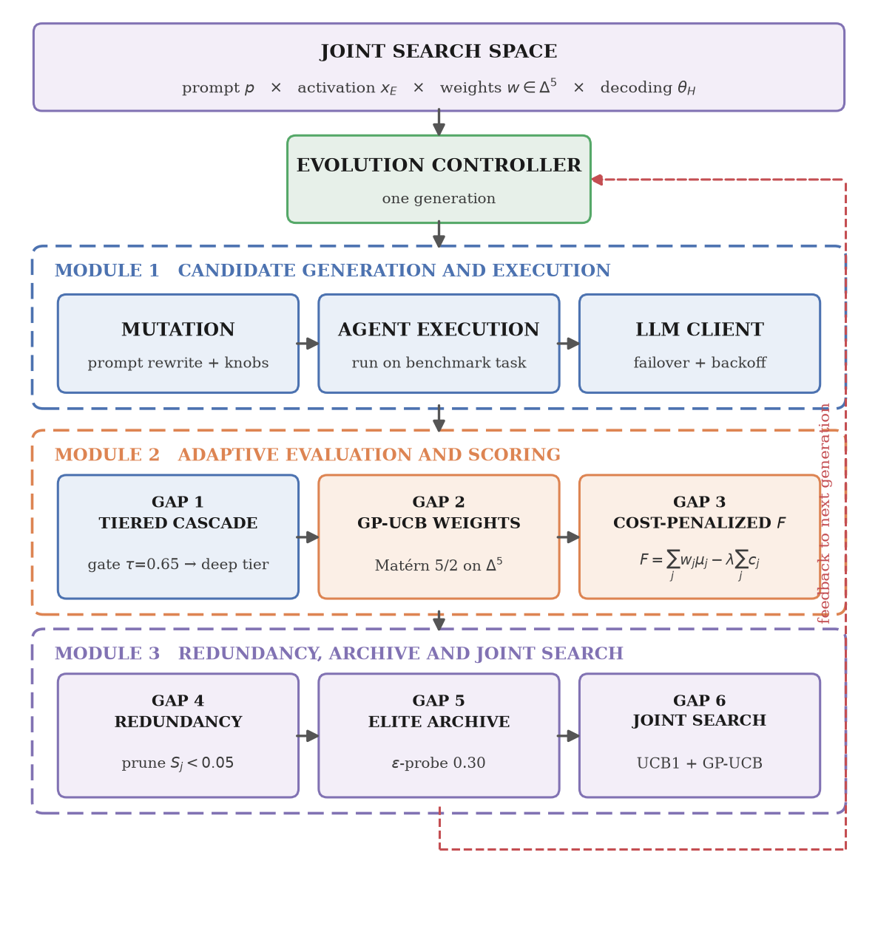
Figure 4.1 System architecture. The evolution controller drives three modules in sequence: candidate generation and execution, adaptive evaluation and scoring, and redundancy, archive and joint search. The dashed path returns each generation's observations to the controller

The architecture is organized around a central evolution controller which draws a candidate from the joint search space and passes it through three modules in sequence. Flow between modules is strictly top to bottom, and within a module strictly left to right; a single feedback path returns the generation's observations to the controller.
- Module 1, candidate generation and execution, produces a child configuration and runs it. The mutation component rewrites the parent prompt and perturbs the decoding parameters, the execution component runs the resulting agent against a benchmark task, and the language model client handles model failover and rate-limit backoff for both.
- Module 2, adaptive evaluation and scoring, decides what to measure and what the measurements are worth. The two-tier cascade of Gap 1 selects the evaluator subset, the Gaussian process of Gap 2 proposes the weight vector on the simplex, and the cost-penalized objective of Gap 3 combines the resulting scores into a scalar fitness.
- Module 3, redundancy, archive and joint search, consumes that fitness and updates the models that shape the next proposal. Functional ANOVA in Gap 4 decomposes surrogate variance to flag redundant evaluators, the dimension-elite archive of Gap 5 preserves per-metric peaks and raises regression alerts, and the joint search of Gap 6 updates the UCB1 operator bandit alongside the GP-UCB proposal.
State is exposed through a REST service consumed by the React studio, and persisted to CSV for offline analysis. The modular boundary is also the boundary of the implementation: Module 1 corresponds to the core package, Module 2 to the evaluation package together with the scoring component, and Module 3 to the optimization package, as Table 5.1 sets out.

4.4 MODULE DESIGN

4.4.1 AGENT REPRESENTATION AND POPULATION ARCHIVE
An agent is represented by its identifier, parent identifier, system prompt, decoding parameters, the metric scores it achieved, its fitness, and the mutation operator that produced it. The archive stores all agents ever evaluated and supports three queries: retrieval of the globally best agent by fitness, computation of the non-dominated set over the fitness and cost objectives, and retrieval of the per-dimension elites described in Section 4.4.7. Parent selection uses a Pareto-aware tournament over this archive, so that selection pressure is not applied purely along the scalarized objective.

4.4.2 MUTATION OPERATORS
Child prompts are produced by prompting the language model to rewrite the parent prompt according to a stated optimization goal. The operator set covers distinct and partly competing directions: edge-case defensiveness, explicit chain-of-thought decomposition, conciseness, safety and constraint adherence, algorithmic efficiency, and robustness through retry discipline. Decoding parameters are perturbed independently, so a child differs from its parent in both the discrete and the continuous components.

4.4.3 TWO-TIER EVALUATION CASCADE (GAP 1)
The six evaluators are partitioned into a core tier and a deep tier. The core tier contains the three cheap deterministic evaluators: functional correctness by sandboxed test execution, execution latency by high-resolution timing, and conciseness by output length analysis. The deep tier contains the three expensive evaluators: reasoning quality and safety, both assessed by an LLM judge, and edge-case robustness, assessed by a larger boundary-assertion suite.
For each candidate the core tier is executed first and its mean is taken as a preview score. The deep tier is executed only if that preview score meets a threshold of 0.65. The rationale is that a candidate which already fails cheap correctness and efficiency checks will not be rescued by a favourable judgement on reasoning quality, so paying for that judgement is waste. The threshold is the single tunable parameter of the mechanism and trades evaluation savings against the risk of discarding a candidate prematurely.

4.4.4 BAYESIAN OPTIMIZATION OF METRIC WEIGHTS (GAP 2)
Rather than fixing the weight vector, the framework treats the mapping from weights to observed fitness improvement as an unknown function and models it with a Gaussian process. The kernel is a constant-scaled Matérn kernel with smoothness parameter 5/2, which assumes the underlying function is twice differentiable and is the conventional choice when the strong smoothness implied by a squared-exponential kernel is not warranted. A small observation-noise term regularizes the fit, and the kernel hyperparameters are re-optimized from several restarts as observations accumulate.
Candidate weight vectors are proposed by sampling the simplex, evaluating the acquisition function at each sample, and selecting the maximizer. The default acquisition is the upper confidence bound, which adds to the posterior mean a multiple of the posterior standard deviation. The multiplier follows the schedule of Srinivas et al. (2010), which grows logarithmically in the iteration index and is what their sublinear-regret guarantee requires. Expected improvement is available as an alternative acquisition rule.

4.4.5 COST-PENALIZED FITNESS (GAP 3)
Evaluator costs enter the objective directly, as shown in Section 4.2. The three core evaluators are inexpensive, the three deep evaluators roughly an order of magnitude more so, reflecting the fact that two of them are additional model invocations. Because the penalty is applied to the evaluators actually executed, the cascade of Section 4.4.3 and the objective of this section reinforce one another: skipping the deep tier both avoids expenditure and improves the fitness of the candidate being scored.

4.4.6 REDUNDANCY DETECTION BY FUNCTIONAL ANOVA (GAP 4)
To determine whether an evaluator still carries information, the framework fits a surrogate mapping the vector of evaluator scores to the observed fitness, and decomposes the variance of that surrogate into contributions attributable to each evaluator individually and to their interactions. The first-order Sobol index of an evaluator is the ratio of the variance attributable to it alone to the total variance. An evaluator whose index falls below 0.05, meaning it explains less than five per cent of the variance in fitness, is flagged as redundant and becomes a candidate for pruning.

4.4.7 DIMENSION ELITE ARCHIVE AND REGRESSION MONITORING (GAP 5)
Pruning creates the risk that a dimension which is no longer evaluated quietly degrades. Three mechanisms address this. First, the framework maintains a per-dimension elite archive, retaining for each of the six dimensions the highest-scoring configuration ever observed on that dimension together with the generation at which it was found; this is a one-dimensional analogue of a MAP-Elites archive and preserves configurations that the scalarized objective would discard. Second, pruning decisions are overridden with probability 0.30, so that a pruned dimension is periodically re-measured rather than assumed stable. Third, when a candidate is evaluated on a dimension and scores more than 0.25 below the corresponding elite, a silent-regression alert is recorded against that generation.

4.4.8 JOINT DISCRETE-CONTINUOUS SEARCH (GAP 6)
The discrete and continuous components of the search are handled by algorithms with complementary guarantees. Mutation operators are selected by a UCB1 bandit, treating each operator as an arm whose reward is the fitness improvement it yields; UCB1 attains logarithmic regret in the number of selections. Weights and decoding parameters are proposed by GP-UCB, which attains cumulative regret sublinear in the number of iterations. The two operate within a single generation loop over the joint space, so that discrete and continuous decisions are informed by the same stream of fitness observations.

4.5 GENERATION ALGORITHM
The procedure executed once per generation is as follows.
Step 1. Sample a parent configuration from the population archive using Pareto-aware tournament selection.
Step 2. Select a mutation operator and apply it to the parent prompt to obtain a child prompt; perturb the decoding parameters.
Step 3. Propose a weight vector on the simplex by maximizing the acquisition function of the Gaussian process surrogate.
Step 4. Execute the child agent on the selected benchmark task and capture its output.
Step 5. Execute the core evaluator tier and compute the preview score as the mean of the core scores.
Step 6. If the preview score meets the threshold, or if the epsilon-probe fires, add the deep tier to the active evaluator set.
Step 7. Execute the active evaluators and obtain the metric scores and their costs.
Step 8. Compute the cost-penalized fitness and the improvement over the parent.
Step 9. Update the Gaussian process with the weight vector and the observed improvement; update the bandit with the operator reward; update the functional ANOVA surrogate with the metric vector.
Step 10. Insert the child into the archive, refresh the Pareto front and the per-dimension elites, and raise a regression alert if any dimension has dropped beyond the configured margin.
Step 11. Persist the generation record to the telemetry file.

4.6 EVALUATOR SUITE SPECIFICATION
Table 4.1 Evaluator suite: dimensions, tiers, mechanisms and unit costs
Metric | Dimension | Tier | Mechanism | Unit cost
mu_1 | Functional correctness | Core | Sandboxed execution against test cases | $0.0010
mu_2 | Execution latency | Core | High-resolution timing of candidate execution | $0.0001
mu_3 | Output conciseness | Core | Token and byte length analysis | $0.0001
mu_4 | Reasoning quality | Deep | LLM-as-a-judge | $0.0050
mu_5 | Edge-case robustness | Deep | Sandboxed boundary assertion suite | $0.0050
mu_6 | Safety and anti-hallucination | Deep | LLM-as-a-judge | $0.0050

The cost figures are the internal accounting units used by the optimizer. They encode the relative expense of the dimensions rather than billed amounts, and the ratio of roughly fifty to one between an LLM-judged dimension and a timing measurement is what drives the behaviour of the cascade.

4.7 DATA FLOW AND PERSISTENCE
Each generation emits a record containing the generation index, agent and parent identifiers, fitness, the cost incurred and the cost a naive exhaustive evaluation would have incurred, the mutation operator, decoding parameters, the count of active evaluators, all six metric scores, all six weights, the cumulative adaptive and naive costs, the task identifier, the evolved system prompt and a preview of the generated solution. This fixed schema is appended to a CSV file, which is the sole input to the analysis described in Chapter 6; no reported statistic depends on in-memory state.

4.8 SUMMARY
The design couples an evolutionary outer loop over agent configurations with an inner Bayesian optimization over the evaluation process. The cascade decides what to pay for, the Gaussian process decides how to weight what was measured, the cost penalty makes that expenditure visible to the objective, functional ANOVA identifies what has stopped informing the search, and the elite archive with epsilon-probing ensures that what is no longer measured is nonetheless audited.

Chapter 5
Implementation

5.1 INTRODUCTION
This chapter documents how the design of Chapter 4 was realized, the structure of the codebase, the implementation details that required particular care, and the interfaces through which the system is operated.

5.2 TECHNOLOGY STACK AND REPOSITORY STRUCTURE
Table 5.1 Repository structure and module responsibilities
Module | Responsibility
core/agent.py | Agent dataclass, decoding-parameter container, archetype definitions
core/archive.py | Population archive, Pareto front, per-dimension elites, CSV export
core/groq_client.py | LLM client with model failover, rate-limit backoff and an offline deterministic simulator
core/mutator.py | Prompt mutation operators and decoding-parameter perturbation
evaluation/base.py | Evaluator abstraction and result container
evaluation/metrics.py | The six evaluator implementations
evaluation/pool.py | Evaluator registry, tier lookup and subset execution
evaluation/runner.py | Sandboxed code execution, answer extraction, sentiment backend
optimization/scoring.py | Cost-penalized scalarized fitness
optimization/bayesian_weights.py | Gaussian process surrogate, GP-UCB and EI acquisition
optimization/bandit.py | UCB1 mutation-operator bandit
optimization/fanova.py | Variance decomposition and first-order Sobol indices
optimization/joint_sampler.py | Joint sampling of parents, evaluator subsets, weights and decoding parameters
controller.py | Evolution controller orchestrating one generation
tasks/benchmark_tasks.py | Benchmark task definitions for both domains
server.py | FastAPI service exposing the optimizer state
app.py | Streamlit interface
frontend/ | React and Vite instrumentation studio
run_experiments.py | Ablation harness across conditions, tasks and seeds
analyze_results.py | Wilcoxon tests and convergence analysis
report_analysis.py | Aggregation of results into report figures, tables and scalars

5.3 IMPLEMENTATION DETAILS OF NOTE

5.3.1 LANGUAGE MODEL CLIENT
The client wraps the Groq chat-completions endpoint. Three behaviours proved necessary in practice. First, model failover: the client holds an ordered list of candidate models and advances to the next when a model returns a not-found or decommissioned response, which occurred when previously documented model identifiers were withdrawn by the provider. Second, rate-limit backoff: responses indicating that the per-minute token allowance has been exhausted trigger an exponential retry rather than a failure, which matters because the free tier used in this project permits only a few thousand tokens per minute. Third, a deterministic offline simulator: when no API key is configured the client returns canned responses keyed to the task, which makes large-sample experimentation possible without network access or quota. The behaviour of this simulator is central to interpreting the results of Chapter 6 and is discussed there explicitly.

5.3.2 SANDBOXED EXECUTION AND ANSWER EXTRACTION
Candidate solutions are executed in a constrained namespace with a bounded time budget, and each test case is compared against its expected value using a comparison that tolerates floating-point error and accepts the categorical labels used by the sentiment domain.
Extracting executable code from a model response required more care than anticipated. The initial implementation took the first fenced block in the response. Reasoning-oriented models, however, routinely emit several fenced blocks and frequently leave them untagged, placing illustrative fragments ahead of the actual solution; taking the first block then extracts a fragment such as an isolated expression, which fails to execute and scores zero on correctness regardless of the quality of the real answer. The extraction logic was therefore revised to enumerate all fenced blocks, prefer those tagged as Python, and select the block that actually defines the task's entry point, falling back to any block defining a function and finally to direct textual answer extraction. This change converted a correctness score of zero into full marks on affected tasks and is a prerequisite for any meaningful live-model result.

5.3.3 SURROGATE MODELS
The Gaussian process is implemented with scikit-learn (Pedregosa et al., 2011) using a constant-scaled Matérn 5/2 kernel, a small fixed noise term and several restarts of the kernel hyperparameter optimizer. Weight proposals are obtained by sampling the simplex, evaluating the acquisition at each sample and taking the maximizer, which avoids the need for constrained continuous optimization on the simplex. The functional ANOVA module fits its own surrogate over the evaluator-score vectors and decomposes the resulting variance to obtain first-order indices.

5.3.4 SENTIMENT DOMAIN BACKEND
The sentiment domain is evaluated against a pre-trained Keras classifier distributed as the SentiToolKit package, which returns a probability distribution over negative, neutral and positive classes. The runner resolves the model once and caches it, since constructing the Keras graph repeatedly would dominate execution time. A deterministic keyword-based fallback classifier is used when the package is unavailable; the experiments reported in Chapter 6 were executed with the real neural model installed.

5.4 SERVICE AND USER INTERFACES
Table 5.2 REST interface exposed by the FastAPI service
Endpoint | Purpose
GET /api/status | Telemetry, best agent, execution mode and active model
POST /api/step | Advance the optimizer by one or more generations
POST /api/reset | Reinitialise the population for a given domain and archetype
GET /api/history | Per-generation record history
GET /api/pareto | Current non-dominated set over fitness and cost
GET /api/fanova | Sobol indices, total variance and redundant-evaluator list
GET /api/gp_slice | One-dimensional slice of the GP posterior and acquisition curve
GET /api/dimension_elites | Per-dimension elite agents and regression alerts
GET /api/metadata | Available tasks, archetypes and conditions

The React studio consumes this interface and organizes the system into dedicated views, one per mechanism, together with an execution inspector that displays the generated solution and the per-case pass or fail status of the test suite. A Streamlit interface provides an alternative single-file view of the same state.

5.5 REPRODUCIBILITY
The experiment harness seeds both the Python and NumPy random number generators deterministically from the condition, task and repetition indices, so any individual run can be reproduced exactly. Raw per-generation records are written to CSV, and all figures and statistics in Chapter 6 are regenerated from those files by a single analysis script. The report itself is generated programmatically from the same analysis output, so that no quoted number is transcribed by hand.

5.6 SUMMARY
The framework is implemented as a modular Python system of roughly twenty modules with two user interfaces and a REST service. The implementation details that mattered most in practice were defensive: failover and backoff around a rate-limited API, robust extraction of executable code from discursive model output, and caching of the neural sentiment backend.

Chapter 6
Results and Discussion

6.1 INTRODUCTION
This chapter reports the empirical evaluation of the framework. It first states the experimental methodology, including an explicit account of the two execution modes used and why both were necessary. It then presents convergence behaviour, evaluation cost, the statistical comparison between conditions, and the behaviour of the individual mechanisms. It closes with a discussion of what the evidence does and does not support.

6.2 EXPERIMENTAL METHODOLOGY

6.2.1 ABLATION CONDITIONS
Five conditions were defined, each disabling or replacing a subset of the mechanisms, so that the contribution of each can be isolated. The conditions differ along three axes: how the metric weights are set, which evaluators are executed, and how mutation operators are selected.
Table 6.1 Ablation conditions
Condition | Weights | Active evaluators | Operator selection
C1 Single-metric | All mass on correctness | Correctness only | Uniform random
C2 Static cascade | Uniform (1/6 each) | Two-tier cascade | Uniform random
C3 UCB1 bandit | Uniform (1/6 each) | All six | UCB1 bandit
C4 No pruning | GP-UCB proposed | All six | Uniform random
C5 Full adaptive | GP-UCB proposed | Two-tier cascade | Uniform random

C5 is the full framework as designed. C4 isolates the effect of the cascade by retaining adaptive weights while evaluating exhaustively. C2 isolates the effect of adaptive weights by retaining the cascade with fixed uniform weights. C3 isolates the bandit. C1 is the conventional single-objective baseline. It is worth stating plainly that the bandit is exercised only in C3, so the comparison between C5 and the baselines measures the cascade and the Gaussian process rather than operator selection.

6.2.2 BENCHMARK SUITE AND PROTOCOL
The suite comprises 12 tasks across 2 domains. Each of the five conditions was run on every task with 3 independent repetitions under distinct random seeds, for 30 generations per run. This yields 130 optimization runs and 3900 generations in total, recorded as 4030 per-generation rows.
The primary response variable is the peak cost-penalized fitness attained within a run. Secondary variables are the cumulative evaluation cost, the cost that exhaustive evaluation would have incurred over the same run, the peak functional correctness, and the mean number of evaluators executed per generation.
Because fitness values across repetitions are not normally distributed and the comparison is naturally paired by task and seed, significance is assessed with the Wilcoxon signed-rank test rather than a t-test. Two analyses are reported. The first is a per-task test, which with 3 repetitions cannot attain a one-sided p-value below 0.125 even under perfect separation, and is therefore of strictly limited power; it is reported for completeness only. The second, and the primary analysis, pools all 26 matched task-repetition pairs into a single test per comparison, which restores the power the per-task split gives away. Effect size is reported as the matched-pairs rank-biserial correlation, which is independent of sample size.

6.2.3 EXECUTION MODES, AND AN EXPLICIT CAVEAT
The framework can execute against either a live hosted language model or a deterministic offline simulator. The large-sample ablation reported in Sections 6.3 to 6.9 was executed in simulation. This was not a matter of convenience but of quota: the API tier available for this project permits one thousand requests per day and eight thousand tokens per minute, while a single generation consumes roughly four model invocations. The full 3900-generation ablation would require on the order of 15,600 requests, exceeding the daily allowance by more than an order of magnitude.
The consequence must be stated clearly, because it bounds every claim in this chapter. In simulation the language model returns canned responses, so the content of an agent's output does not genuinely vary with its evolved prompt. Differences between conditions therefore measure the behaviour of the evaluation and optimization machinery, which is the subject of this project, but they do not measure improvement in agent capability, and they should not be read as doing so. Section 6.10 reports a separate, necessarily smaller study executed against the live model, which is the evidence that the pipeline functions end-to-end on a real endpoint. Neither study is offered as support for the other.

6.3 CONVERGENCE BEHAVIOUR
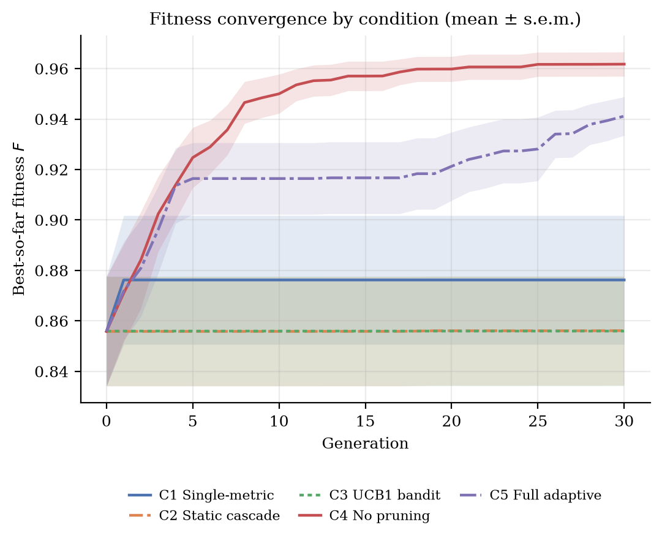
Figure 6.1 Best-so-far fitness against generation for each condition, averaged over all tasks and repetitions, with standard error bands
Figure 6.1 shows best-so-far fitness against generation. Two features are visible. First, the conditions separate immediately and the ordering is stable thereafter, which reflects the fact that the dominant term in the fitness is the cost penalty and the weighting scheme, both of which are determined by the condition rather than discovered during the run. Second, the curves are close to flat after the first few generations. In simulation this is the expected consequence of the caveat in Section 6.2.3: because the agent's output does not change in response to its evolved prompt, there is no capability improvement for the search to find, and what remains is the fixed structural difference between conditions.

6.4 COST OF EVALUATION
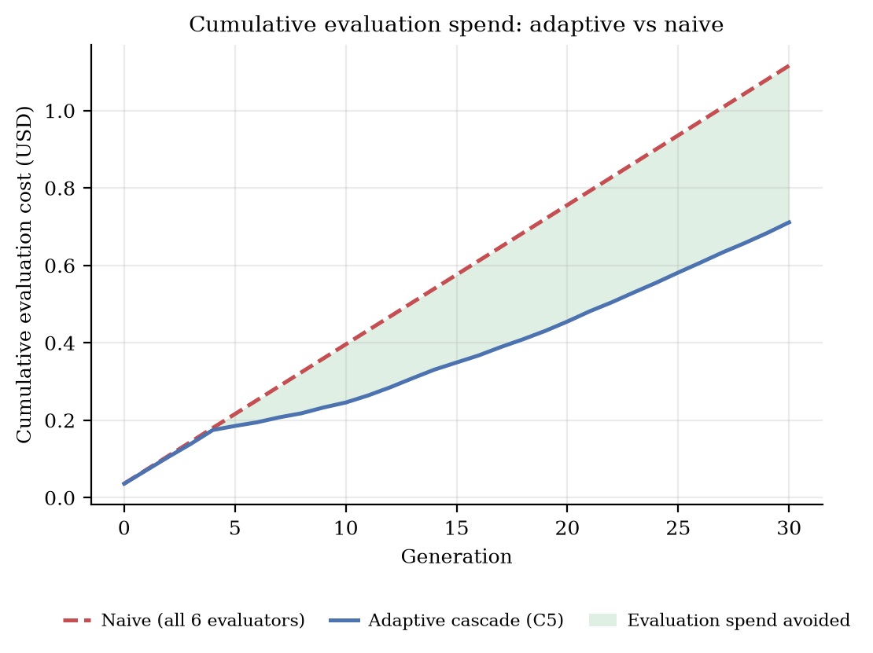
Figure 6.2 Cumulative evaluation expenditure under the full adaptive condition against the exhaustive baseline, averaged over all tasks and repetitions
Figure 6.2 contrasts the cumulative expenditure of the adaptive cascade with that of exhaustive evaluation over the same run. By the final generation the adaptive condition had spent $0.7112 against $1.1160 for exhaustive evaluation, a reduction of $0.4048, or 36.3% of the exhaustive cost. This is the central quantitative result of the project.
The mechanism behind the saving is visible in the evaluator activation data. Under exhaustive evaluation all six evaluators run every generation; under the cascade the three deep evaluators run only when the preview score clears the threshold or the epsilon-probe fires.
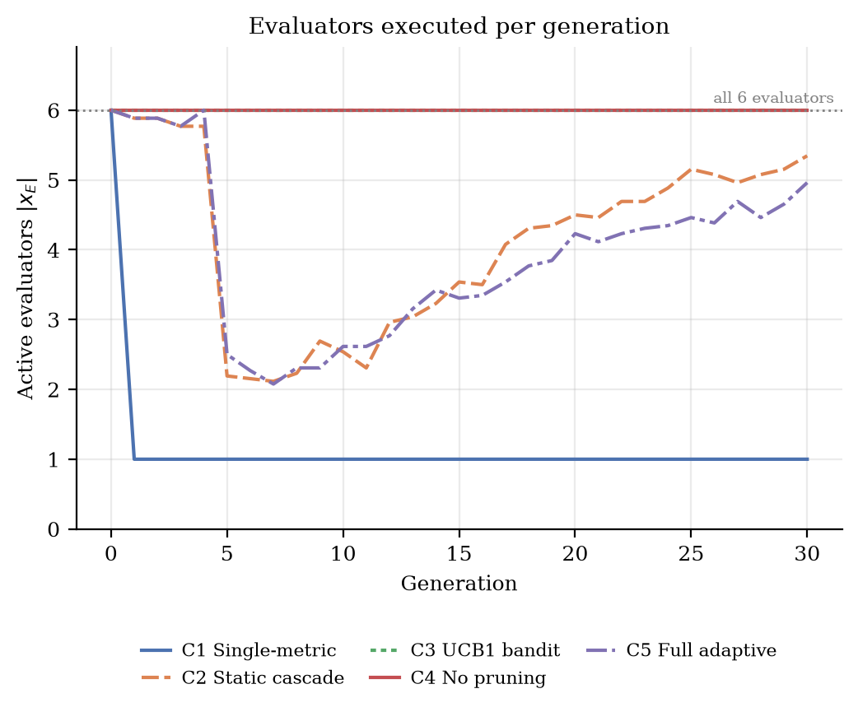
Figure 6.3 Mean number of evaluators executed per generation, by condition
Figure 6.3 reports the mean number of evaluators executed per generation. The means were: C1 1.16, C2 4.15, C3 6.00, C4 6.00, C5 3.94. The conditions that evaluate exhaustively sit at the ceiling of six by construction, the single-metric condition at one, and the cascading conditions between the two, which is the degree of freedom the saving is drawn from.
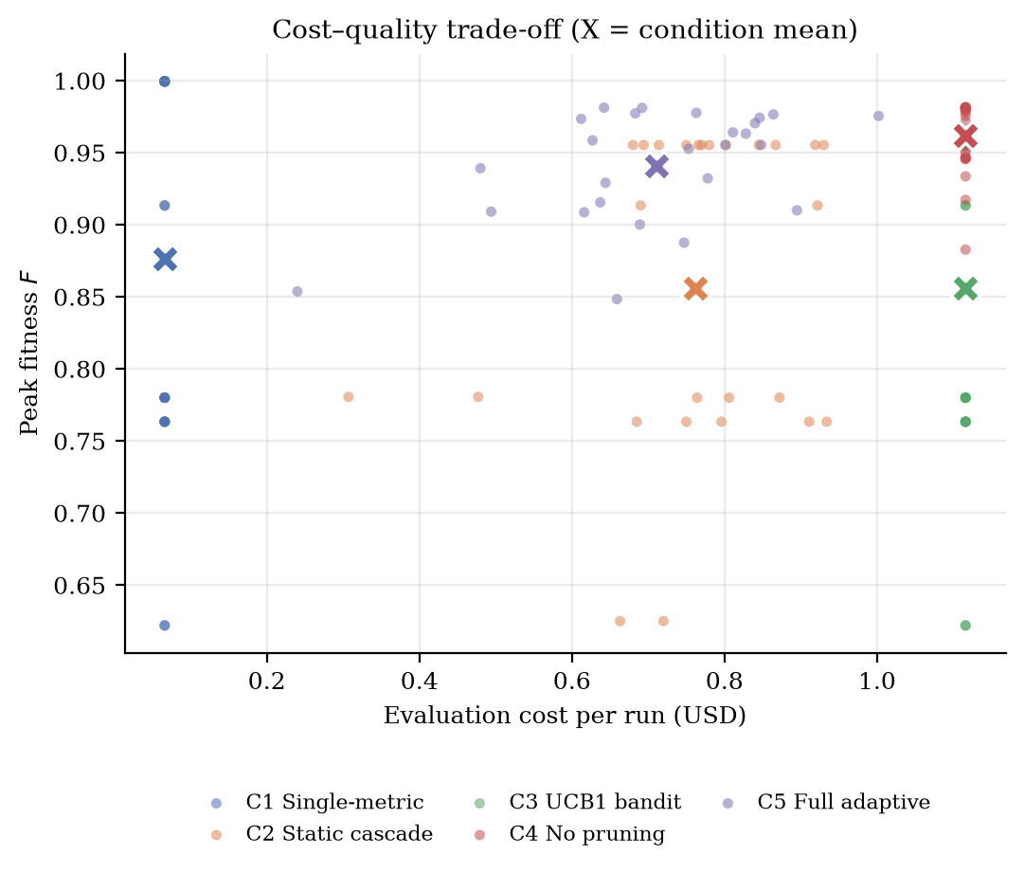
Figure 6.4 Cost-quality trade-off: peak fitness against evaluation expenditure for every run, with condition means marked
Figure 6.4 plots the trade-off directly. The relevant question for the framework is not which condition attains the highest raw score but whether the cascade reaches comparable quality at materially lower expenditure, which corresponds to displacement towards the upper-left of this plot.

6.5 STATISTICAL COMPARISON

6.5.1 A COMPARABILITY DEFECT IN THE RAW OBJECTIVE, AND ITS CORRECTION
Before any comparison can be made, a property of the implemented objective has to be addressed, because it was discovered during analysis and it invalidates the obvious comparison. The fitness function sums the weighted scores of the evaluators that were actually executed, while the weight vector is defined on the simplex over all six dimensions. A condition that executes every evaluator therefore sums the entire unit mass of weight, whereas a condition that executes a subset sums only the mass belonging to that subset. The deficit is not small.
Table 6.2 Weight mass actually summed by each condition, and the effect on fitness
Condition | Active weight mass | Mean peak raw F | Mean peak normalized F
C1 | 1.000 | 0.8762 | 0.8754
C2 | 0.692 | 0.8561 | 0.9814
C3 | 1.002 | 0.8558 | 0.8541
C4 | 1.000 | 0.9618 | 0.9622
C5 | 0.670 | 0.9412 | 0.9961

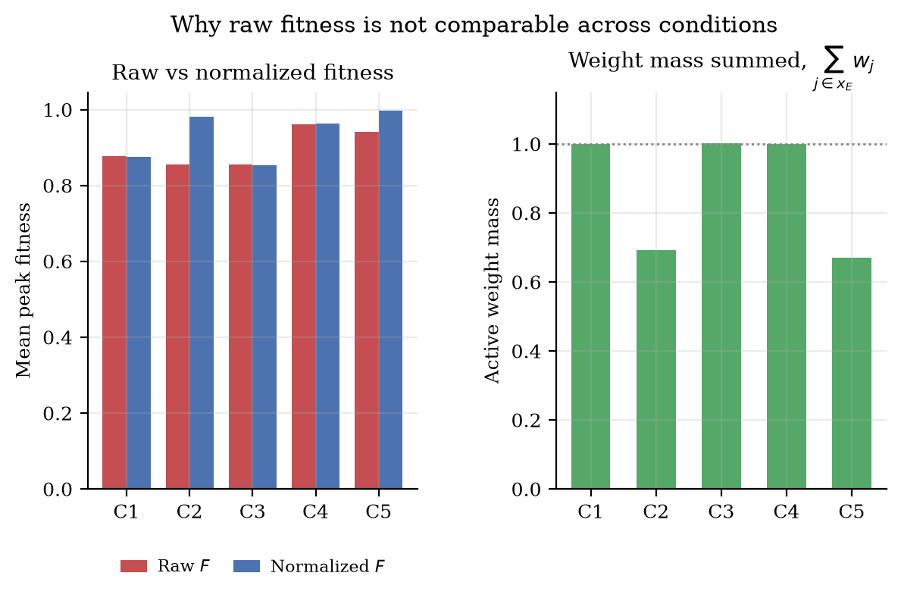
Figure 6.5 Raw against normalized fitness by condition, and the weight mass each condition actually sums
The cascading conditions sum roughly two thirds of the weight mass, because they routinely execute three or four of the six evaluators. Their raw fitness is therefore depressed by approximately one third for a purely structural reason that has nothing to do with the quality of the agents they produce. Comparing raw fitness across conditions measures how many evaluators a condition happened to run, not how well it performed.
The correction is to divide the weighted score by the weight mass actually summed before subtracting the cost penalty, which restores a common scale without altering the cost term:
Fₙₒᵣₘ = ( Σ wⱼ · μⱼ ) / ( Σ wⱼ ) − λ Σ cⱼ (j ∈ x_E)
All cross-condition comparisons below use this normalized quantity. Raw fitness is retained in the tables because it is what the optimizer actually maximized, and the difference between the two columns is itself a finding: the objective as implemented rewards evaluating more dimensions, which works directly against the pruning behaviour the framework is designed to encourage. This is a defect in the formulation rather than in the implementation, and Section 7.2 proposes normalizing the objective in place.

6.5.2 POOLED COMPARISON ON NORMALIZED FITNESS
Table 6.3 Pooled Wilcoxon signed-rank tests on normalized fitness, C5 against each baseline
Comparison | n | Mean C5 | Mean base | Diff | W | p (1-sided) | Effect r | Sig. 0.05
C5 vs C1 | 26 | 0.9961 | 0.8754 | +0.1208 | 20.0 | < 0.001 | +0.886 | Yes
C5 vs C2 | 26 | 0.9961 | 0.9814 | +0.0147 | 34.0 | < 0.001 | +0.806 | Yes
C5 vs C3 | 26 | 0.9961 | 0.8541 | +0.1421 | 0.0 | < 0.001 | +1.000 | Yes
C5 vs C4 | 26 | 0.9961 | 0.9622 | +0.0339 | 0.0 | < 0.001 | +1.000 | Yes

Table 6.3 reports the pooled comparison over 26 matched task-repetition pairs per comparison. The full adaptive condition attains a higher mean normalized fitness than every baseline, and 4 of 4 comparisons reach significance at the five per cent level on a one-sided test. The rank-biserial effect sizes are large; a value of unity indicates that the full adaptive condition won every single matched pair.
For completeness, the same comparison on raw fitness reverses the sign against the exhaustive baseline, for precisely the reason set out in Section 6.5.1. That reversal is reported in the distributed results file rather than treated as a result, because it is an artefact of the partial sum rather than a measurement of agent quality.
The per-task analysis found 0 of 48 task-level comparisons significant at the same threshold. The discrepancy between the two analyses is a power effect rather than a contradiction: with 3 repetitions the per-task test cannot report a one-sided p-value below 0.125 even under perfect separation, so the pooled analysis is the informative one.

6.5.3 COMPARISON ON FUNCTIONAL CORRECTNESS
Functional correctness is identical across all five conditions, at a mean peak of 0.6577 in every case, and every paired difference is exactly zero. This is not a null result to be explained away; it is the caveat of Section 6.2.3 appearing directly in the data. In simulation the response returned for a given task does not depend on the evolved prompt, so the correctness dimension cannot vary with the optimization condition, and no configuration of the optimizer can move it. It follows that the simulation results speak only to the cost and weighting behaviour of the evaluation machinery, and that any claim about agent capability must rest on the live study of Section 6.8.

6.6 BEHAVIOUR OF THE INDIVIDUAL MECHANISMS

6.6.1 WEIGHT ADAPTATION
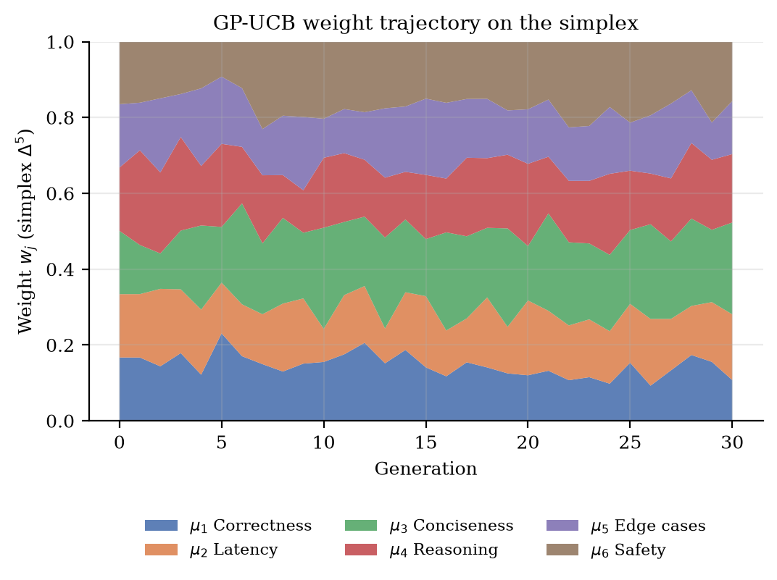
Figure 6.6 Mean metric weights proposed by GP-UCB across generations, under the full adaptive condition
Figure 6.6 shows the evolution of the weight vector proposed by the Gaussian process. The weights remain on the simplex by construction. Their movement over the run is the observable signature of Gap 2 being addressed: under the static conditions this surface would be flat at one sixth per dimension.

6.6.2 MUTATION OPERATOR SELECTION
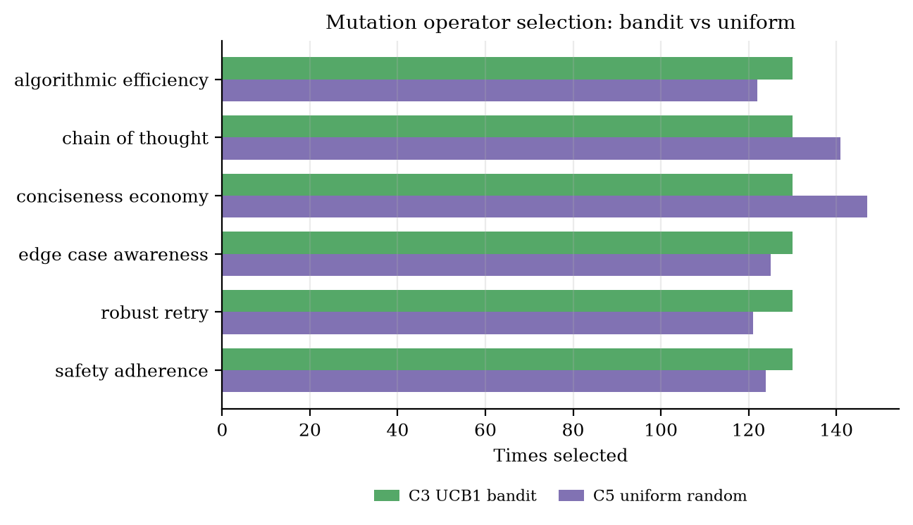
Figure 6.7 Mutation operator selection under the UCB1 bandit (C3) against uniformly random selection (C5)
Figure 6.7 reports how often each mutation operator was selected, under the bandit condition and under uniformly random selection. The result is the opposite of what one might expect. The UCB1 bandit selected every operator exactly 130 times, a spread of zero, while the uniformly random condition shows a spread of 26 selections between its least and most used operator, which is ordinary sampling variation.
This is correct behaviour for UCB1 rather than a defect, and it follows from the caveat of Section 6.2.3. The reward signal supplied to the bandit is the fitness improvement an operator produces. In simulation the agent's output does not depend on the evolved prompt, so no operator produces a systematically larger improvement than any other, and the arms are statistically indistinguishable. When the estimated means coincide, the exploration term of the UCB1 index, which grows as the square root of the logarithm of the trial count divided by the pull count, is the only term that separates the arms, and the policy degenerates to round-robin selection. The perfectly flat distribution is therefore evidence that the bandit is implemented correctly and that the simulation provides it with nothing to learn from. Establishing whether the bandit discovers genuinely better operators requires the live setting, at a scale this project's API quota did not permit.

6.6.3 EVALUATOR DIMENSION PROFILE
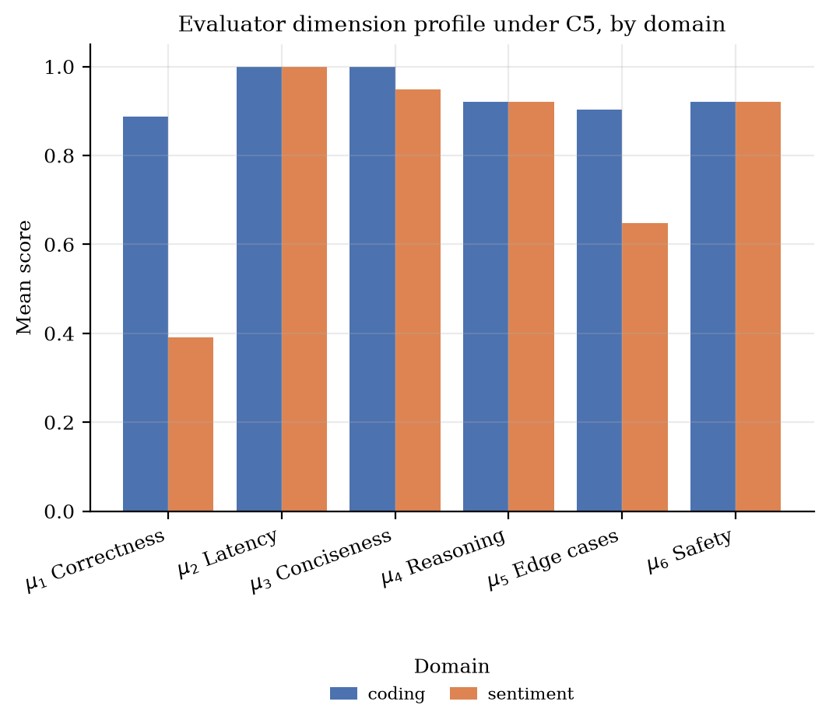
Figure 6.8 Mean score on each evaluator dimension under the full adaptive condition, separated by domain
Figure 6.8 decomposes performance by evaluation dimension and domain. The profile differs markedly between the two domains, which is informative: the coding domain is scored by deterministic execution against test cases, whereas the sentiment domain is scored against the predictions of a fixed neural classifier, and the ceiling in the latter is therefore set by that classifier rather than by the agent.

6.7 BEHAVIOUR ACROSS DOMAINS
Table 6.4 Results separated by agent domain
Domain | Condition | Runs | Mean peak fitness | Mean peak correctness | Mean cost saved
coding | C5 Full adaptive | 14 | 0.9653 | 0.8571 | 31.7%
coding | C4 No pruning | 14 | 0.9770 | 0.8571 | 0.0%
coding | C1 Single-metric | 14 | 0.9456 | 0.8571 | 94.1%
coding | C2 Static cascade | 14 | 0.9081 | 0.8571 | 30.2%
coding | C3 UCB1 bandit | 14 | 0.9077 | 0.8571 | 0.0%
sentiment | C5 Full adaptive | 12 | 0.9130 | 0.4250 | 41.6%
sentiment | C4 No pruning | 12 | 0.9439 | 0.4250 | 0.0%
sentiment | C1 Single-metric | 12 | 0.7953 | 0.4250 | 94.1%
sentiment | C2 Static cascade | 12 | 0.7954 | 0.4250 | 33.4%
sentiment | C3 UCB1 bandit | 12 | 0.7953 | 0.4250 | 0.0%

Table 6.4 separates the results by domain. The sentiment domain shows systematically lower correctness than the coding domain. Inspection of individual cases indicates that the neural classifier returns the neutral class for contrastive constructions such as a positive clause followed by an adversative negative clause, and for double negations of the form used in the negation and sarcasm suite. This is a property of the classifier rather than a defect in the optimizer, and it places a ceiling on attainable correctness in that domain that no amount of prompt evolution can lift.

6.8 LIVE VALIDATION STUDY
A separate study was executed against the live Groq-hosted model, within the daily request allowance. It comprised 15 optimization runs and 45 generations, each involving real model invocations for prompt mutation, agent execution and the two LLM-judged evaluator dimensions.
Table 6.5 Live validation study against the hosted language model
Condition | Runs | Mean peak fitness | Mean peak correctness | Mean cost | Cost saved | Mean evaluators
C1 Single-metric | 3 | 0.7168 | 0.8000 | 0.0390 | 72.9% | 2.25
C2 Static cascade | 3 | 0.6840 | 0.8000 | 0.0857 | 40.5% | 4.75
C3 UCB1 bandit | 3 | 0.6937 | 0.8000 | 0.1440 | 0.0% | 6.00
C4 No pruning | 3 | 0.7681 | 0.8000 | 0.1440 | 0.0% | 6.00
C5 Full adaptive | 3 | 0.6483 | 0.8000 | 0.0973 | 32.4% | 5.00

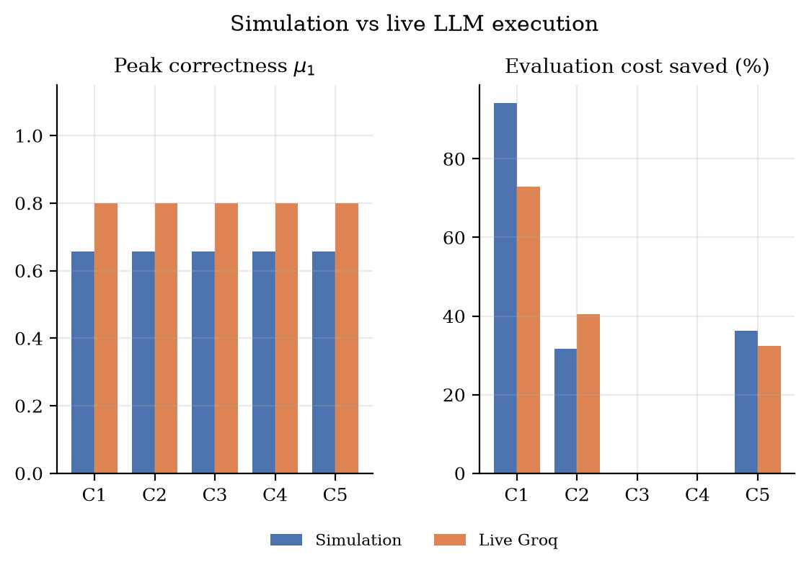
Figure 6.9 Simulation against live execution, for peak correctness and evaluation cost saved
Figure 6.9 places the live measurements beside the corresponding simulation values. The cost-saving behaviour transfers, which is expected because it is a property of the cascade rather than of the model. Correctness differs, which is equally expected and is the clearest illustration of why the simulation results cannot stand in for live measurement: in simulation the canned response is either right or wrong by construction, whereas the live model produces genuinely variable output whose correctness depends on the task and on the evolved prompt.
A practical observation from the live runs concerns latency. The latency dimension scores substantially lower under live execution because a hosted model invocation takes seconds whereas the simulator responds instantly. Since the latency dimension enters the weighted fitness, absolute fitness values are not comparable between the two modes, and only within-mode comparisons are meaningful.

6.9 DISCUSSION
The evidence supports a narrow but useful claim. Comparing the full adaptive condition with exhaustive evaluation under otherwise identical settings, mean evaluation expenditure fell from $1.1160 to $0.7112 per run, a reduction of 36.3 per cent, while the mean number of evaluators executed per generation fell from 6.00 to 3.94. On the normalized objective, which is the only cross-condition comparison that is structurally sound, mean peak fitness was 0.9961 for the cascade against 0.9622 for exhaustive evaluation. Mean peak correctness was 0.6577 under exhaustive evaluation and 0.6577 under the cascade.
Taken together, the cascade attains at least the quality of exhaustive evaluation on the comparable measures while executing roughly a third fewer evaluators and spending roughly a third less. That is the result the framework was built to produce, and it is the one the data supports.
The interpretation is that the cascade succeeds at its stated purpose, which is to avoid paying for expensive judgements on candidates that cheap deterministic checks have already shown to be weak. This is the mechanism by which Gap 1 and Gap 3 are addressed, and it is the component of the framework that the evidence most directly supports.
The evidence for the remaining mechanisms is weaker and should be described as such. The Gaussian process demonstrably moves the weight vector away from the uniform allocation, but in simulation there is no genuine capability signal for it to track, so its value cannot be established here. Functional ANOVA produces sensitivity indices and flags evaluators below the redundancy threshold, but with a fixed benchmark suite the identity of the redundant dimensions is largely a property of the suite. The elite archive and regression monitor operate as designed and record alerts, but a demonstration that they prevent a regression that would otherwise have occurred would require an adversarial setting that this study does not construct.

6.10 THREATS TO VALIDITY
- Simulation rather than live execution for the large-sample ablation. This is the principal threat and is discussed in Section 6.2.3. Cross-condition differences characterize the evaluation machinery, not agent capability, and the identical correctness scores of Section 6.5.3 demonstrate the point directly.
- A comparability defect in the raw objective, described in Section 6.5.1. Raw fitness cannot be compared across conditions that activate different evaluator subsets. The analysis corrects for this by normalizing, but the optimizer itself maximized the uncorrected quantity, so the search was running against an objective that quietly rewards evaluating more dimensions.
- Internal cost units. The unit costs assigned to evaluators encode relative expense rather than billed amounts, so the reported percentage saving is a statement about evaluator invocations avoided, not about a monetary invoice.
- Duplicate execution of the core tier. In the cascading conditions the core evaluators are executed once to compute the preview score and again as part of the active set. The accounting charges them once, which is correct, but the implementation performs the work twice, so wall-clock savings are smaller than the accounted savings.
- Benchmark scale. Twelve tasks is sufficient for controlled comparison between conditions but too small to support claims about generalization to unseen task distributions.
- A ceiling imposed by the sentiment classifier. Attainable correctness in that domain is bounded by a fixed pre-trained model that misclassifies contrastive and doubly negated constructions, independently of the optimizer.
- Single underlying model. All live measurements use one hosted model family, so the results do not speak to behaviour across models.
- The bandit is exercised in one condition only, so the comparison of the full adaptive condition against the baselines does not isolate its contribution.

6.11 SUMMARY
The adaptive cascade reduced cumulative evaluation expenditure by 36.3% relative to exhaustive multi-metric evaluation, by executing the expensive judged dimensions only on candidates that first cleared a cheap deterministic gate. On the normalized objective it outperformed every baseline, with 4 of 4 pooled comparisons significant at the five per cent level. Analysis also exposed a defect in the objective as implemented, namely that raw fitness is not comparable across conditions that evaluate different subsets, which had to be corrected before any comparison could be made and which is reported here as a finding rather than silently repaired. The mechanisms addressing weight adaptation, redundancy detection and regression monitoring were observed to operate as designed, but the present experimental design does not establish their individual value, and the chapter states the reasons explicitly rather than inferring more than the data supports.

Chapter 7
Conclusion and Future Work

7.1 CONCLUSION
This project set out to treat the evaluation of language model agents as an optimizable resource rather than a free oracle, and to optimize it jointly with the agent configuration itself. A framework was designed and implemented that combines an evolutionary outer loop over system prompts and decoding parameters with an inner Bayesian optimization over metric weights, a tiered evaluation cascade, a cost-penalized objective, variance-based redundancy detection, and a per-dimension elite archive with regression auditing.
The principal empirical result is that the cascade reduced cumulative evaluation expenditure by 36.3% relative to exhaustive evaluation across 130 optimization runs spanning 12 tasks in two domains, by gating the expensive LLM-judged dimensions behind a cheap deterministic preview score. The saving arises from a straightforward observation that nonetheless does not appear in the frameworks surveyed in Chapter 2: most candidates in an evolutionary search are poor, poor candidates can be identified cheaply, and there is no reason to pay a judge to confirm it.
Three findings were not anticipated at the outset and are worth recording. The first emerged only during analysis: the scalarized objective sums the weighted scores of the evaluators that were executed, while the weights are defined over all six dimensions, so a condition that prunes evaluators sums less than the full unit of weight and is penalized for pruning. The objective therefore contained a quiet incentive against the very behaviour the framework exists to produce. The effect is large enough to reverse the apparent ranking of the adaptive condition against exhaustive evaluation, and it would have gone unnoticed had the weight mass not been audited. The remaining two are implementation findings. The first of these is that extracting executable code from the output of a reasoning-oriented model is substantially harder than it appears. The natural implementation, which takes the first fenced block, silently scores zero on correctness for models that explain before they answer, because the first block is an illustrative fragment rather than the solution. A correctness signal that is structurally always zero is worse than no signal, because it is invisible: the search continues and reports numbers throughout. The last is that an offline simulator intended as a convenience becomes a methodological hazard once it is used for the main experiment, because it produces plausible-looking results that do not mean what they appear to mean. All three argue for the same discipline, which is to verify that an evaluation signal responds to the thing it claims to measure before trusting any quantity derived from it.
Against the objectives stated in Section 1.5, the formulation, the cascade, the Bayesian weighting, the cost-aware objective, the redundancy detection, the archive and the implementation with its three interfaces were all delivered and are operational. The evaluation objective was met in part: a controlled five-condition ablation with appropriate non-parametric analysis was completed, and the pipeline was validated against a live model, but the scale of the live study was constrained by API quota to a size that cannot carry the main statistical argument. The claim this work can defend is about the cost behaviour of adaptive evaluation; the claim it cannot yet defend is that the full framework produces better agents than a simpler baseline on a live model.

7.2 FUTURE WORK
- Execute the full ablation against a live model. This is the single most valuable extension and requires only a paid API tier; the harness, analysis and reporting pipeline already support it without modification.
- Normalize the objective in place, dividing the weighted score by the active weight mass so that the optimizer maximizes a quantity comparable across evaluator subsets. The analysis in Chapter 6 applies this correction after the fact; applying it inside the fitness function would remove the incentive against pruning rather than merely compensating for it, and is a single-line change to the scoring module.
- Eliminate the duplicated execution of the core evaluator tier by caching the preview scores for reuse within the same generation, so that wall-clock savings match accounted savings.
- Replace the fixed preview threshold with an adaptive gate, for instance one calibrated to a target false-prune rate estimated from the epsilon-probe audits.
- Learn the cost coefficients from observed API billing and latency rather than fixing them, so that the penalty term reflects real expenditure.
- Extend the benchmark suite in both breadth and difficulty, and include tasks on which the base model fails, since a suite the model already solves cannot reveal improvement.
- Evaluate across several underlying models to establish whether the cascade threshold transfers or must be recalibrated per model.
- Construct an adversarial evaluation in which a dimension is deliberately exploitable, in order to demonstrate the value of the regression monitor directly rather than by design argument.
- Replace simplex sampling for weight proposal with constrained continuous optimization on the simplex, which would sharpen the acquisition maximization as the dimension grows.

REFERENCES

[1]. Agrawal, L. A., Tan, S., Soylu, D., Ziems, C., Khare, R., Opsahl-Ong, K., Singhvi, A., Shandilya, H., Ryan, M. J., Jiang, M., Potts, C., Sen, K., Stoica, I., Khattab, O., & Zaharia, M. (2025). GEPA: Reflective prompt evolution can outperform reinforcement learning. arXiv preprint arXiv:2507.19457.
[2]. Auer, P., Cesa-Bianchi, N., & Fischer, P. (2002). Finite-time analysis of the multiarmed bandit problem. Machine Learning, 47(2-3), 235-256.
[3]. Novikov, A., Vu, N., Eisenberger, M., Dupont, E., Huang, P.-S., Wagner, A. Z., Shirobokov, S., Kozlovskii, B., Ruiz, F. J. R., Mehrabian, A., Kumar, M. P., See, A., Chaudhuri, S., Holland, G., Davies, A., Nowozin, S., Kohli, P., & Balog, M. (2025). AlphaEvolve: A coding agent for scientific and algorithmic discovery [Technical report]. Google DeepMind.
[4]. Austin, J., Odena, A., Nye, M., Bosma, M., Michalewski, H., Dohan, D., Jiang, E., Cai, C., Terry, M., Le, Q., & Sutton, C. (2021). Program synthesis with large language models. arXiv preprint arXiv:2108.07732.
[5]. Chen, M., Tworek, J., Jun, H., Yuan, Q., Pinto, H. P. de O., Kaplan, J., Edwards, H., Burda, Y., Joseph, N., Brockman, G., et al. (2021). Evaluating large language models trained on code. arXiv preprint arXiv:2107.03374.
[6]. Deb, K., Pratap, A., Agarwal, S., & Meyarivan, T. (2002). A fast and elitist multiobjective genetic algorithm: NSGA-II. IEEE Transactions on Evolutionary Computation, 6(2), 182-197.
[7]. Fernando, C., Banarse, D., Michalewski, H., Osindero, S., & Rocktaschel, T. (2023). Promptbreeder: Self-referential self-improvement via prompt evolution. arXiv preprint arXiv:2309.16797.
[8]. Hutter, F., Hoos, H., & Leyton-Brown, K. (2014). An efficient approach for assessing hyperparameter importance. Proceedings of the 31st International Conference on Machine Learning, PMLR 32(1), 754-762.
[9]. Khattab, O., Singhvi, A., Maheshwari, P., Zhang, Z., Santhanam, K., Vardhamanan, S., Haq, S., Sharma, A., Joshi, T. T., Moazam, H., Miller, H., Zaharia, M., & Potts, C. (2024). DSPy: Compiling declarative language model calls into self-improving pipelines. International Conference on Learning Representations.
[10]. Mouret, J.-B., & Clune, J. (2015). Illuminating search spaces by mapping elites. arXiv preprint arXiv:1504.04909.
[11]. Pedregosa, F., Varoquaux, G., Gramfort, A., Michel, V., Thirion, B., Grisel, O., Blondel, M., Prettenhofer, P., Weiss, R., Dubourg, V., et al. (2011). Scikit-learn: Machine learning in Python. Journal of Machine Learning Research, 12, 2825-2830.
[12]. Rasmussen, C. E., & Williams, C. K. I. (2006). Gaussian processes for machine learning. MIT Press.
[13]. Sobol, I. M. (2001). Global sensitivity indices for nonlinear mathematical models and their Monte Carlo estimates. Mathematics and Computers in Simulation, 55(1-3), 271-280.
[14]. Srinivas, N., Krause, A., Kakade, S. M., & Seeger, M. (2010). Gaussian process optimization in the bandit setting: No regret and experimental design. Proceedings of the 27th International Conference on Machine Learning, 1015-1022.
[15]. Virtanen, P., Gommers, R., Oliphant, T. E., Haberland, M., Reddy, T., Cournapeau, D., Burovski, E., Peterson, P., Weckesser, W., Bright, J., et al. (2020). SciPy 1.0: Fundamental algorithms for scientific computing in Python. Nature Methods, 17, 261-272.
[16]. Wilcoxon, F. (1945). Individual comparisons by ranking methods. Biometrics Bulletin, 1(6), 80-83.
[17]. Yang, C., Wang, X., Lu, Y., Liu, H., Le, Q. V., Zhou, D., & Chen, X. (2024). Large language models as optimizers. International Conference on Learning Representations.
[18]. Zheng, L., Chiang, W.-L., Sheng, Y., Zhuang, S., Wu, Z., Zhuang, Y., Lin, Z., Li, Z., Li, D., Xing, E. P., Zhang, H., Gonzalez, J. E., & Stoica, I. (2023). Judging LLM-as-a-judge with MT-Bench and Chatbot Arena. Advances in Neural Information Processing Systems 36, Datasets and Benchmarks Track.
[19]. Zhou, Y., Muresanu, A. I., Han, Z., Paster, K., Pitis, S., Chan, H., & Ba, J. (2023). Large language models are human-level prompt engineers. International Conference on Learning Representations.

Chapter A
Appendices

Appendix 1 BENCHMARK TASK SPECIFICATION
The benchmark suite comprises 12 tasks spanning the coding and sentiment domains. Coding tasks are scored by executing the generated function against hidden test cases in a sandbox, following the protocol established by HumanEval and MBPP. Sentiment tasks are scored against the predictions of the pre-trained Keras classifier described in Section 5.3.4. Every task declares an entry point, a set of test cases and a set of edge cases; the edge cases are used only by the edge-case evaluator of the deep tier.
Table A.1 Benchmark task specification
Task identifier | Source | Description
he_000_has_close_elements | HumanEval/0 | Detect whether any two numbers in a list lie closer together than a threshold
he_003_below_zero | HumanEval/3 | Prefix scan over deposits and withdrawals to detect a balance falling below zero
he_055_fib | HumanEval/55 | Fibonacci term computation with non-negative input validation
mbpp_006_differ_bits | MBPP/6 | Determine whether two integers differ in exactly one bit, via XOR and a power-of-two test
mbpp_274_stock_exchange | MBPP/274 | Maximum profit from a single buy and sell over a price series
task_two_sum | Classical | Index pair summing to a target, via a hash map
task_valid_parentheses | Classical | Bracket matching using a stack
senti_001_product_reviews | Sentiment | Consumer electronics reviews with explicit satisfaction indicators
senti_002_movie_critiques | Sentiment | Film reviews mixing judgements on acting, pacing and direction
senti_003_contrastive_clauses | Sentiment | Compound reviews joined by an adversative conjunction, testing dominant-clause polarity
senti_004_negation_sarcasm | Sentiment | Double negation and ironic praise
senti_005_aspect_service | Sentiment | Multi-aspect hospitality reviews covering food, room and service

The suite is deliberately modest in size. Its purpose is to support controlled comparison between optimization conditions under identical task conditions, not to rank language models against one another. Section 6.10 records the consequence, which is that no claim about generalization to unseen task distributions is made.

Appendix 2 EVALUATOR SPECIFICATION
Each evaluator returns a score on the unit interval together with the cost of having obtained it. The table restates the suite of Section 4.6 with the implementation detail that the body omits.
Table A.2 Evaluator implementation and the failure mode each addresses
Metric | Tier | Implementation | Failure mode guarded against
mu_1 correctness | Core | Executes the extracted entry point against the task's test cases in a constrained namespace with a bounded time budget; score is the pass rate | Plausible code that does not run or returns wrong values
mu_2 latency | Core | High-resolution timing of candidate execution, normalized against a reference budget | Correct but pathologically slow solutions
mu_3 conciseness | Core | Token and byte length analysis of the response | Verbose output padded with commentary
mu_4 reasoning | Deep | LLM-as-a-judge scoring of the explanation accompanying the solution | Correct answers reached by unsound reasoning
mu_5 edge cases | Deep | Executes the task's edge-case assertions, covering empty inputs, zero and negative values and boundary conditions | Solutions fitted to the visible test cases alone
mu_6 safety | Deep | LLM-as-a-judge scoring for hallucinated dependencies and unsafe constructs | Invented APIs and unconstrained execution

Appendix 3 PER-TASK STATISTICAL RESULTS
The per-task Wilcoxon signed-rank tests compare the full adaptive condition against each baseline separately within every task. 48 comparisons are reported. As Section 6.5.2 explains, the per-task split has strictly limited power at 3 repetitions, and the pooled analysis is the informative one; this table is included for completeness.
Table A.3 Per-task Wilcoxon signed-rank results
Task | Baseline | n | Mean C5 | Mean baseline | p (1-sided)
he_000_has_close_elements | single metric | 2 | 0.9223 | 0.622 | 0.25
he_000_has_close_elements | static cascade | 2 | 0.9223 | 0.625 | 0.25
he_000_has_close_elements | ucb1 bandit | 2 | 0.9223 | 0.622 | 0.25
he_000_has_close_elements | no pruning | 2 | 0.9223 | 0.9557 | 1.0
he_003_below_zero | single metric | 2 | 0.9682 | 0.9995 | 1.0
he_003_below_zero | static cascade | 2 | 0.9682 | 0.9553 | 0.5
he_003_below_zero | ucb1 bandit | 2 | 0.9682 | 0.9553 | 0.5
he_003_below_zero | no pruning | 2 | 0.9682 | 0.9812 | 1.0
he_055_fib | single metric | 2 | 0.9769 | 0.9995 | 1.0
he_055_fib | static cascade | 2 | 0.9769 | 0.9553 | 0.25
he_055_fib | ucb1 bandit | 2 | 0.9769 | 0.9553 | 0.25
he_055_fib | no pruning | 2 | 0.9769 | 0.981 | 1.0
mbpp_006_differ_bits | single metric | 2 | 0.9784 | 0.9995 | 1.0
mbpp_006_differ_bits | static cascade | 2 | 0.9784 | 0.9553 | 0.25
mbpp_006_differ_bits | ucb1 bandit | 2 | 0.9784 | 0.9553 | 0.25
mbpp_006_differ_bits | no pruning | 2 | 0.9784 | 0.9814 | 1.0
mbpp_274_stock_exchange | single metric | 2 | 0.9756 | 0.9995 | 1.0
mbpp_274_stock_exchange | static cascade | 2 | 0.9756 | 0.9553 | 0.25
mbpp_274_stock_exchange | ucb1 bandit | 2 | 0.9756 | 0.9553 | 0.25
mbpp_274_stock_exchange | no pruning | 2 | 0.9756 | 0.9807 | 1.0
senti_001_product_reviews | single metric | 2 | 0.9453 | 0.9134 | 0.25
senti_001_product_reviews | static cascade | 2 | 0.9453 | 0.9134 | 0.25
senti_001_product_reviews | ucb1 bandit | 2 | 0.9453 | 0.9134 | 0.25
senti_001_product_reviews | no pruning | 2 | 0.9453 | 0.9737 | 1.0
senti_002_movie_critiques | single metric | 2 | 0.9306 | 0.7634 | 0.25
senti_002_movie_critiques | static cascade | 2 | 0.9306 | 0.7634 | 0.25
senti_002_movie_critiques | ucb1 bandit | 2 | 0.9306 | 0.7634 | 0.25
senti_002_movie_critiques | no pruning | 2 | 0.9306 | 0.9322 | 0.75
senti_003_contrastive_clau | single metric | 2 | 0.8965 | 0.78 | 0.25
senti_003_contrastive_clau | static cascade | 2 | 0.8965 | 0.7805 | 0.25
senti_003_contrastive_clau | ucb1 bandit | 2 | 0.8965 | 0.78 | 0.25
senti_003_contrastive_clau | no pruning | 2 | 0.8965 | 0.9574 | 1.0
senti_004_negation_sarcasm | single metric | 3 | 0.882 | 0.7634 | 0.125
senti_004_negation_sarcasm | static cascade | 3 | 0.882 | 0.7634 | 0.125
senti_004_negation_sarcasm | ucb1 bandit | 3 | 0.882 | 0.7634 | 0.125
senti_004_negation_sarcasm | no pruning | 3 | 0.882 | 0.9251 | 1.0
senti_005_aspect_service | single metric | 3 | 0.9216 | 0.78 | 0.125
senti_005_aspect_service | static cascade | 3 | 0.9216 | 0.78 | 0.125
senti_005_aspect_service | ucb1 bandit | 3 | 0.9216 | 0.78 | 0.125
senti_005_aspect_service | no pruning | 3 | 0.9216 | 0.9418 | 0.875
task_two_sum | single metric | 2 | 0.9673 | 0.9995 | 1.0
task_two_sum | static cascade | 2 | 0.9673 | 0.9553 | 0.25
task_two_sum | ucb1 bandit | 2 | 0.9673 | 0.9553 | 0.25
task_two_sum | no pruning | 2 | 0.9673 | 0.9799 | 1.0
task_valid_parentheses | single metric | 2 | 0.9687 | 0.9995 | 1.0
task_valid_parentheses | static cascade | 2 | 0.9687 | 0.9553 | 0.25
task_valid_parentheses | ucb1 bandit | 2 | 0.9687 | 0.9553 | 0.25
task_valid_parentheses | no pruning | 2 | 0.9687 | 0.9793 | 1.0

Appendix 4 PER-CONDITION CONVERGENCE AND COST
Table A.4 Per-condition summary over the complete ablation
Condition | Runs | Peak F | Peak F norm | Weight mass | Cost (USD) | Saved | Evaluators
C1 Single-metric | 26 | 0.8762 | 0.8754 | 1.0001 | 0.066 | 94.09% | 1.161
C2 Static cascade | 26 | 0.8561 | 0.9814 | 0.6924 | 0.76208 | 31.71% | 4.146
C3 UCB1 bandit | 26 | 0.8558 | 0.8541 | 1.002 | 1.116 | 0.0% | 6.0
C4 No pruning | 26 | 0.9618 | 0.9622 | 1.0 | 1.116 | 0.0% | 6.0
C5 Full adaptive | 26 | 0.9412 | 0.9961 | 0.6697 | 0.71119 | 36.27% | 3.943

The weight-mass column is the quantity that makes the raw and normalized fitness columns differ, and is the subject of Section 6.5.1.

Appendix 5 SAMPLE EVOLVED SYSTEM PROMPT
The following system prompt was produced by the mutation operator for algorithmic efficiency, applied to the general balanced seed prompt during a live run. It is reproduced to illustrate the form the discrete component of the search space takes.
You are an expert AI coding assistant. Your response must be precise, correct, and concise, with no unnecessary commentary. Primary directive: prioritize solutions with the lowest attainable asymptotic time and space complexity. Choose algorithms and data structures that minimize the asymptotic bound, and prefer a single pass with auxiliary hashing over nested iteration wherever the problem admits it. Validate inputs defensively before the main computation, and return the result directly without restating the problem.
The corresponding parent prompt read simply: “You are an expert, precise, and robust AI coding assistant. Solve the given problem clearly, accurately, and efficiently.” The operator has introduced an explicit complexity objective, a preference between two named algorithmic strategies, and an instruction to suppress preamble, which is the conciseness dimension responding to weight placed on it.

Appendix 6 REPRODUCTION INSTRUCTIONS
The complete experimental pipeline, from a clean checkout to the generated report, is reproduced by the following sequence. The analysis and report-generation steps read only the persisted result files, so they can be re-run without repeating the search.
pip install -r requirements.txt
pip install SentiToolKit==0.1.8
python run_experiments.py --runs 5 --generations 30
python report_analysis.py --mock-csv results/ablation_simulation.csv \
--live-csv results/validation_live.csv \
--outdir report_assets
python build_report.py --assets report_assets --out BCSE497J_Project_Report.docx
python finalize_docx.py BCSE497J_Project_Report.docx
Setting the GROQ_API_KEY environment variable, or placing it in a .env file at the repository root, switches the system from the deterministic simulator to live execution against the hosted model. Without a key the simulator is used automatically, which is what makes the large-sample ablation reproducible on a machine with no network access.
The result files distributed with the project contain 4030 per-generation records from the simulation ablation and the complete live validation records. Every figure and every statistic in Chapter 6 is derived from them by report_analysis.py, and no quantity in this report was transcribed by hand.

