UA92-131/B3/24-25
FRONT-END DEVELOPMENT
Niall Corbishley
L39596869

Contents
Introduction 1
Survey and Requirements Gathering 2
Reasoning Behind Survey Questions 3
Key Takeaways from Requirements Gathering 4
Website Functionality 4
Homepage (index.html) 4
Article Page (AI.html, smartphone.html, cybersecurity.html) 5
Account Page (account.html) 6
Technical Features 7
Bootstrap v5.3.3: 7
JavaScript: 8
HTML: 8
User Input Handling and Validation 8
Navigation and Interaction 9
Additional Design Considerations for Each Page 9
Homepage (index.html): 9
Article Page (AI.html, smartphone.html, cybersecurity.html) 10
Account Page (account.html): 10
Accessibility Evaluation 11
Conclusion 14

GitHub Repository:
https://github.com/NiallCorbishley/PhoenixTech
Deployed Site:
https://niallcorbishley.github.io/PhoenixTech/

Introduction
Phoenix Tech is an online technology news platform that provides up-to-date reports on the latest developments in hardware, software, artificial intelligence, smartphones, and cybersecurity. The website is designed to be user-friendly, incorporating a clean layout with a navigation bar, featured articles, and an account registration system.

Survey and Requirements Gathering
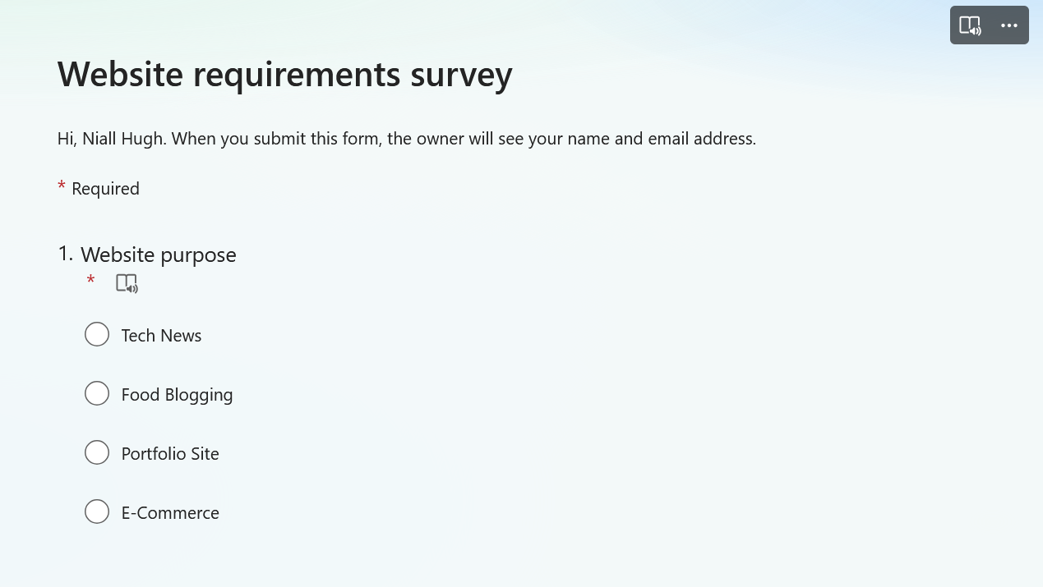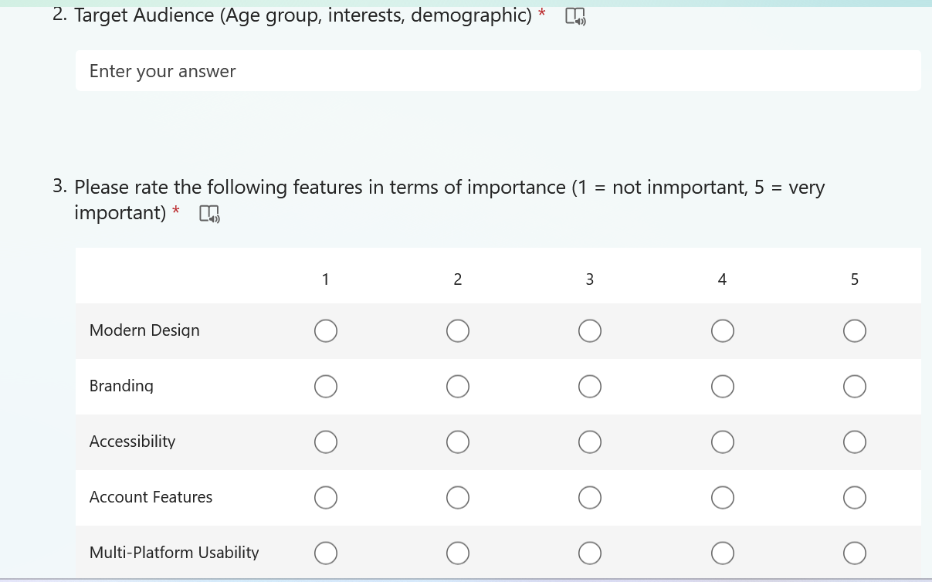

Reasoning Behind Survey Questions
The survey method employed in gathering user requirements plays a crucial role in shaping both the functional and non-functional aspects of the website. Each question is designed with a specific purpose in mind:

Website Purpose (Q1):
This question establishes the primary function of the website by asking users what they believe the site should offer. The reasoning here is to set a clear direction for the overall design and content strategy. By understanding the intended purpose, designers can ensure that every element—from layout to content—is aligned with the core mission of delivering timely technology news.

Demographic and Target Audience Identification (Q2):
By collecting demographic information, the survey aims to define the user base more accurately. The responses help tailor the website’s design and functionality to meet the needs of various segments of the audience (e.g., age groups, professional backgrounds, tech-savviness). This information is critical for creating user personas and ensuring that the content and features resonate with the intended users.

Feature Prioritization (Q3)
Utilizing a Likert scale, this question allows respondents to rate the importance of various features. The quantitative data gathered through this method helps in identifying which functionalities are considered essential by the users and which are secondary. This prioritization guides resource allocation during development, ensuring that critical features receive the focus they deserve.

User Suggestions for Features (Q4)
An open-ended question invites respondents to offer any additional features they believe would enhance the website. This qualitative input is invaluable as it captures ideas that structured questions might overlook. It also provides insights into user expectations and innovative suggestions that can drive future improvements and iterations of the platform.

Key Takeaways from Requirements Gathering
Once the requirements had been gathered, it was then necessary to combine the data from users with knowledge of web design. The following checklist was created:
- The site must have a modern, but simple design – no overwhelming colours or popups
- The homepage should feature recent/key articles for easy access by users
- Users should be able to navigate anywhere from each page on the website
- Users should be able to create an account through a form that is validated
- Data collected from users through the account creation process must be handled in accordance with Global Data Protection Regulations (GDPR)

Website Functionality

Homepage (index.html)
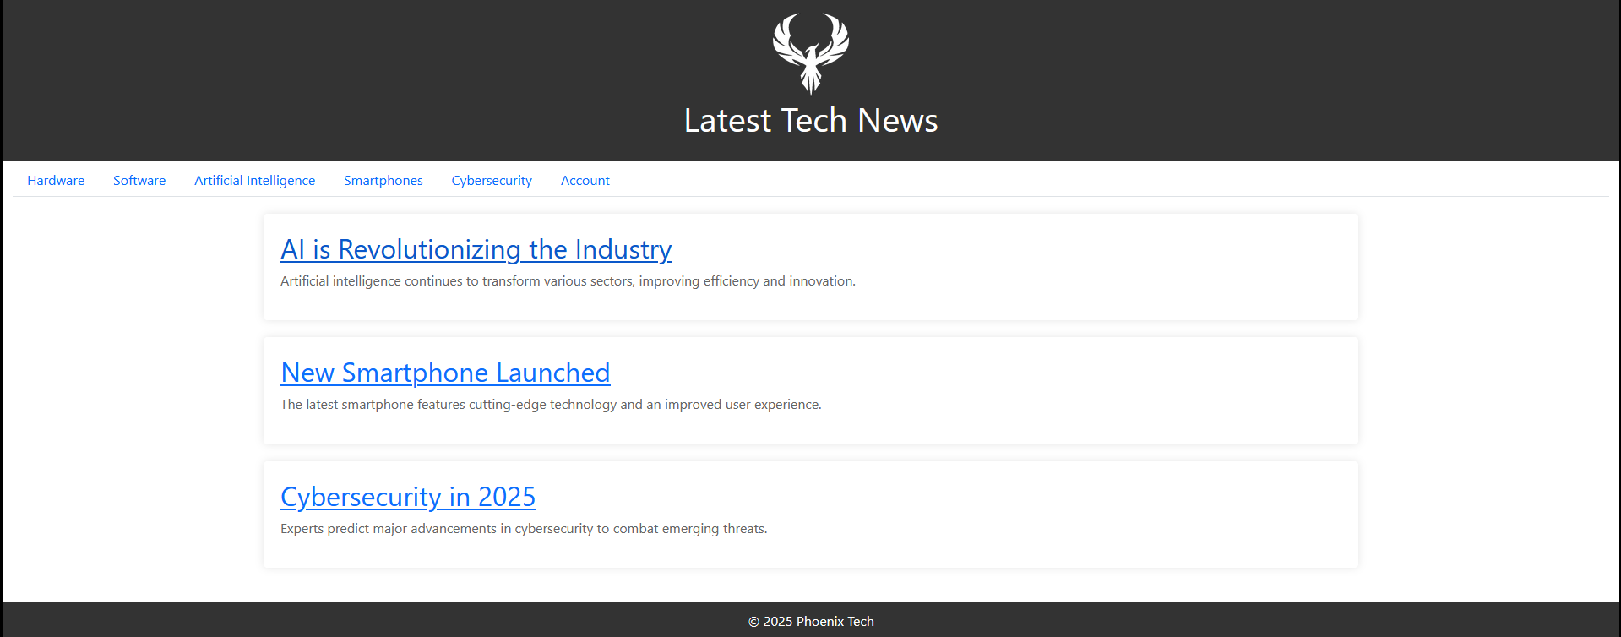
The homepage serves as the main entry point for users and is designed to engage and direct them seamlessly. Key design elements include:
- Header and Branding:
A prominently placed logo and title set the tone for the site. The header establishes brand identity and serves as a consistent navigational element throughout the website.

- Navigation Bar:
The navigation bar provides clear access to different categories such as Hardware, Software, AI, Smartphones, and Cybersecurity. The design ensures that users can intuitively move between sections.

- Featured Articles:
A dynamically arranged list of featured articles is presented in a card or grid format. Visual hierarchy is emphasized through larger images and bold titles, which invite users to explore the content.
- Footer:
The footer includes copyright information
- Interactive Elements:
The homepage incorporates responsive design principles using frameworks like Bootstrap, ensuring that the layout adjusts seamlessly across devices. Additionally, the user can click on the logo in the header, which is present throughout the site, to return to this homepage at any point

Article Page (AI.html, smartphone.html, cybersecurity.html)
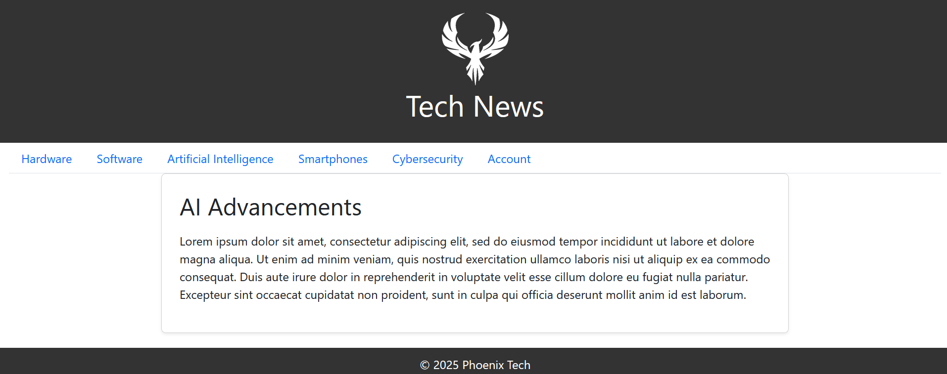
Each article page is carefully designed to maximize readability and engagement:

- Structured Layout:
Leveraging Bootstrap’s grid system, the content is divided into clearly defined sections that support both text and multimedia. This helps maintain an uncluttered look.
- Typography and Readability:
The design emphasizes clear typography with a focus on legibility, using appropriate font sizes and line spacing. This is essential for lengthy technical articles.
- Consistent Navigation:
The header, footer, and navigation bar are retained from the homepage, ensuring a consistent user experience.

Account Page (account.html)
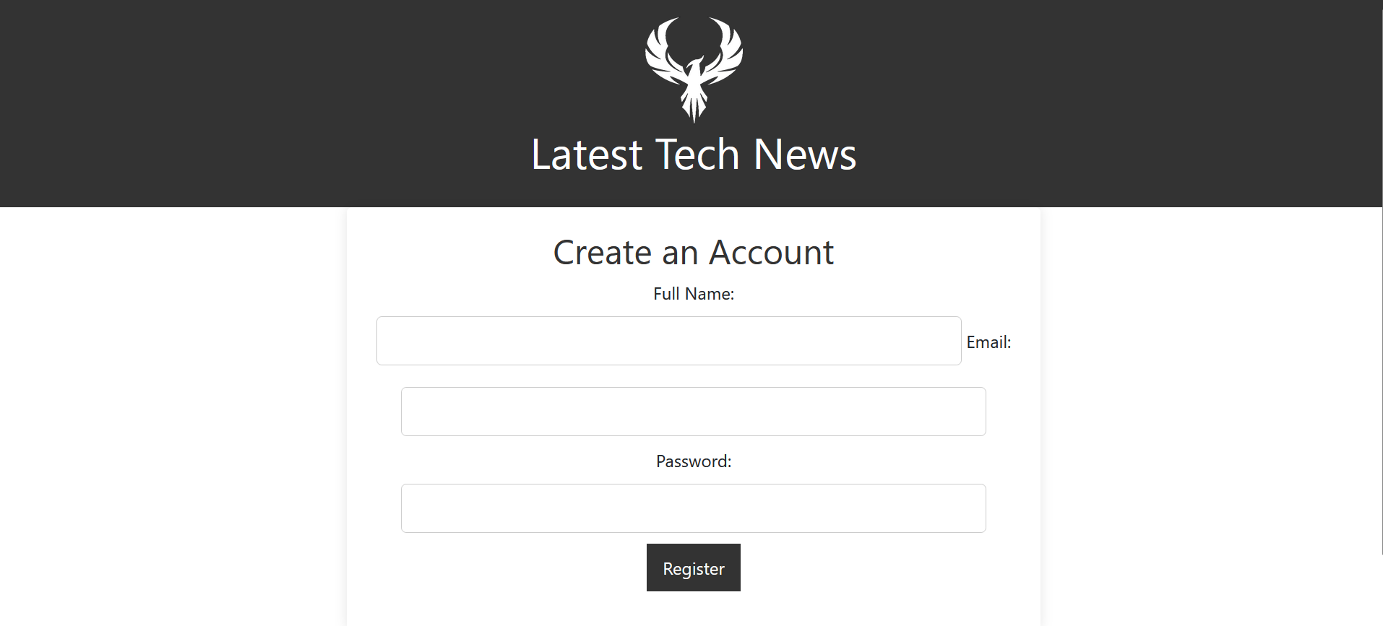
The account page is tailored for user registration and login with an emphasis on ease-of-use and security:
- User Registration Form:
The page contains an intuitive form with fields for Full Name, Email, and Password. Each input field is clearly labeled to minimize errors.

- Visual Feedback and Validation:
Basic validation is implemented to ensure all required fields are completed, and the password field enforces a minimum length which is communicated by a small popup that appears when a user hovers their mouse over the password box.
The submit button is clearly distinguished and uses JavaScript functions to handle the validation and processing of user input.
- Overall Layout:
Like the other pages, the account page retains the header, navigation bar, and footer for consistency and easy navigation.

Technical Features

Bootstrap v5.3.3:
Utilized for its responsive grid system and pre-built components, Bootstrap significantly enhances the aesthetic and functionality of navigation elements and article layouts. It also creates a consistent look throughout the website.
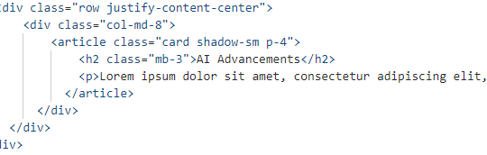

JavaScript:
Handles dynamic interactions, form validation, and navigation redirections in addition to testing features with the console.log function
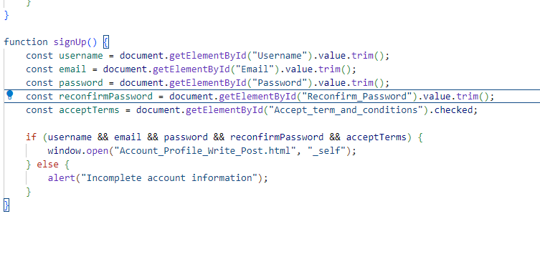

HTML:
Forms the backbone of the website, providing structure and some navigation features. Meta tags are also used to define information about the website for search engine optimisation and allowing the website to access necessary libraries for content display
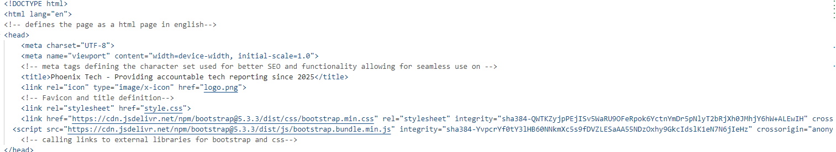

User Input Handling and Validation
- Form Validation:
The account registration form uses JavaScript to enforce field requirements, ensuring that the username, email, and password (with a minimum length) are correctly entered before submission.
- Interactive Feedback:
The `signUp` function confirms that all necessary fields are completed, providing immediate feedback to the user for a seamless experience

Navigation and Interaction
- Hyperlinks and Redirections:
The website employs hyperlinks within the navigation bar and clickable article titles to allow users to easily move between different sections
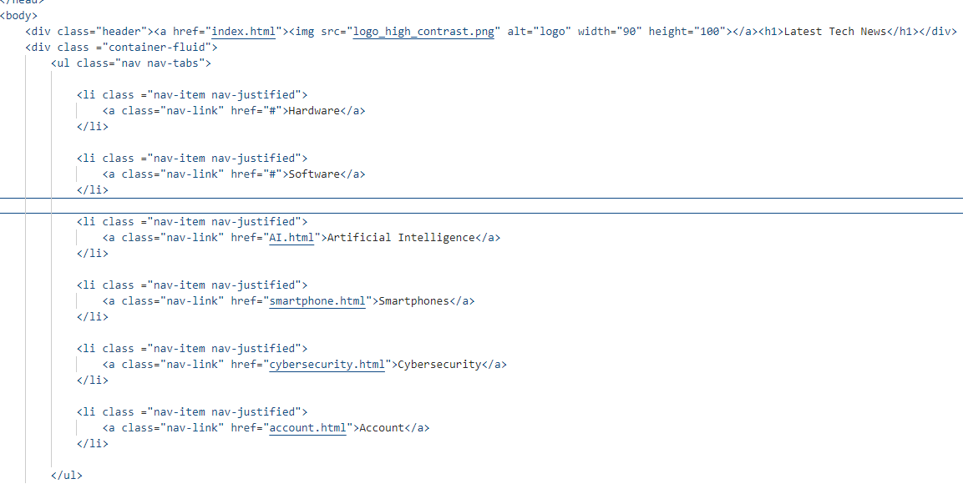

Additional Design Considerations for Each Page

Homepage (index.html):
- User Journey Focus:
The homepage is designed as a gateway to the entire website. It incorporates clear calls to action and intuitive navigation, guiding users directly to featured articles and categories that match their interests.
- Visual Hierarchy:
Elements such as the header, navigation bar, and featured articles are arranged in a way that prioritizes content clarity. The use of larger images and bold typography draws attention to the most important sections.
- Responsive Design:
Utilizing Bootstrap’s responsive grid system, the homepage layout adapts seamlessly across different devices and screen sizes, ensuring that both desktop and mobile users have an optimal viewing experience.

Article Page (AI.html, smartphone.html, cybersecurity.html)
- Content-Driven Layout:
The article page emphasizes readability through a clean, uncluttered layout. Adequate white space, clear headings, and a logical content flow make the page inviting for in-depth reading.
- Multimedia Integration:
The design supports the inclusion of images, videos, and interactive media that complement the text, enhancing the storytelling aspect of each article.
- Social and Interactive Features:
Social media sharing buttons and comment sections are integrated into the page design to encourage reader interaction and community building. These elements are strategically placed to be noticeable yet unobtrusive.
- Accessibility Considerations:
The article page design takes into account accessibility standards, ensuring that content is readable for users with disabilities through proper contrast ratios, scalable fonts, and keyboard navigation.

Account Page (account.html):
- Simplicity and Clarity:
The account page is intentionally designed to be straightforward. The registration form is organized in a step-by-step manner, reducing the cognitive load on users and streamlining the sign-up process.
- Visual Cues for Validation:
Real-time validation feedback, such as color changes or icons next to form fields, helps users quickly identify and correct errors. This enhances usability and reduces form abandonment rates.
- Security and Trust Elements:
Design elements such as security icons, clear privacy statements, and concise instructions build user confidence in the account creation process.
- Consistent Styling:
The page maintains the overall website’s visual language by using the same header, navigation bar, and footer. This consistency reinforces brand identity and ensures cohesive user experience.

Accessibility Evaluation
In order to ensure that Phoenix Tech meets high accessibility standards a comprehensive accessibility review was conducted using an established checklist based on WCAG 2.1 guidelines and employed recognized evaluation tools. The following details our process, the issues identified, and the solutions implemented.
Accessibility Checklist Overview
An accessibility checklist from the A11Y Project was used, covering key areas such as:
- Perceivable:
  - All non-text content has text alternatives (e.g., alt attributes for images).
  - Captions or transcripts are provided for multimedia elements.
- Operable:
  - The website is fully navigable via keyboard.
  - Focus indicators are clear and prominent.
  - Users are given sufficient time to read and interact with content.
- Understandable:
  - Content is written in clear, simple language.
  - Navigation and interactions are consistent across the website.
  - Form fields are properly labeled and include error suggestions.
- Robust:
  - Code adheres to web standards ensuring compatibility with various browsers and assistive technologies.
Identified Issues and Solutions
- Missing Alt Text on Images
  - Issue: Images lacked descriptive alt text, impacting screen reader accessibility.
  - Solution: Added meaningful alt attributes to all image elements.
  - Action Taken: Reviewed the HTML markup and updated image tags to include descriptive alt text.
- Insufficient Color Contrast
  - Issue: Some text/background combinations fell below WCAG-recommended contrast ratios.
  - Solution: Adjusted color palettes to ensure a minimum contrast ratio of 4.5:1 (or 3:1 for larger text).
  - Action Taken: Modified the CSS file to update color values, improving readability for users with visual impairments.
- Missing ARIA Landmarks
  - Issue: Navigation and key content regions lacked defined ARIA roles.
  - Solution: Implemented ARIA landmarks (e.g., role="navigation", role="main") to aid assistive technology users.
  - Action Taken: Updated the HTML structure to include appropriate ARIA attributes in the header, nav, and main content sections.
- Form Label Associations
  - Issue: Form inputs were not consistently associated with their corresponding <label> tags.
  - Solution: Ensured each form element has a clearly defined <label> with a matching for attribute.
  - Action Taken: Revised the account registration form markup to properly link labels with inputs, enhancing accessibility and usability.
- Keyboard Navigation Issues
  - Issue: Some interactive elements were not fully accessible via keyboard.
  - Solution: Enhanced focus indicators and ensured that interactive elements are reachable and operable using keyboard navigation.
  - Action Taken: Implemented and verified tabindex properties and focus styles to maintain a logical navigation order across all pages.
HTML and CSS Validation
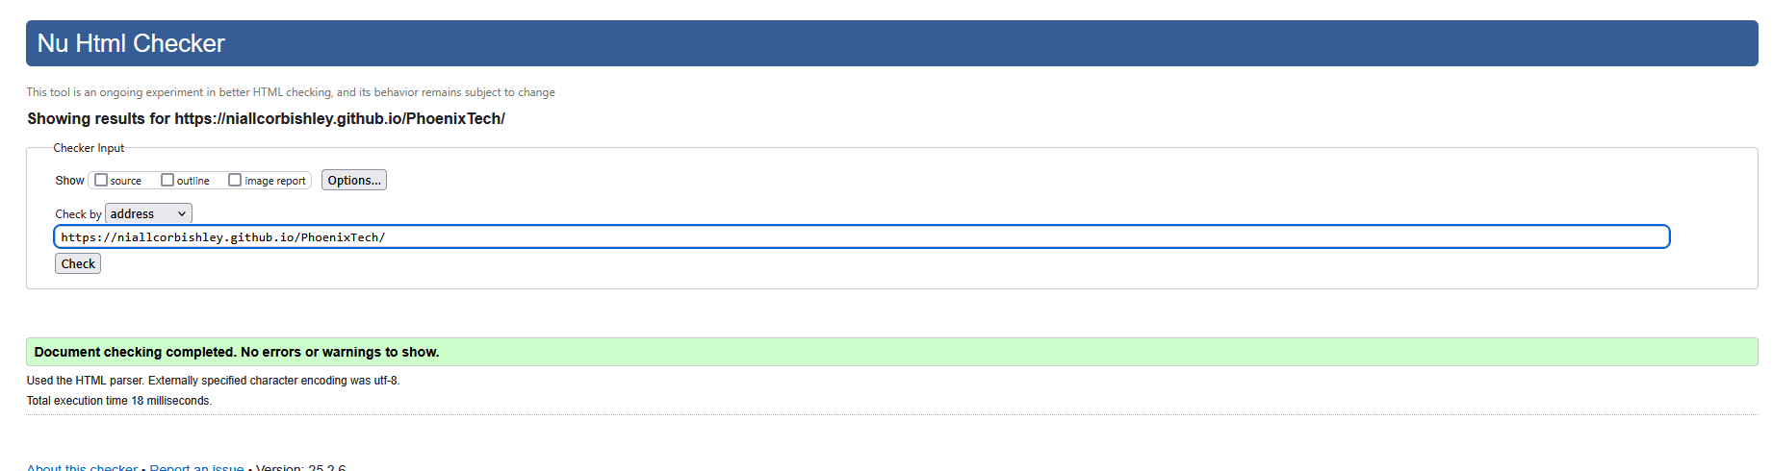
- W3C Markup Validation:
The HTML code was checked using the W3C Markup Validation Service, ensuring it complies with modern HTML standards.
- W3C CSS Validation:
The CSS code was validated using the W3C CSS Validation Service, confirming adherence to current CSS standards.
- Outcome:
Both HTML and CSS passed the validation tests with no critical errors detected, which confirms that the website’s underlying code is clean, standard-compliant, and maintainable.
By rigorously applying these accessibility checks and addressing the identified issues, Phoenix Tech now offers an enhanced, inclusive experience for all users. The improvements not only meet recognized standards but also contribute to a more user-friendly interface that supports a diverse audience.

Conclusion
The Phoenix Tech website exemplifies a comprehensive front-end development project that successfully integrates modern design principles, user-centered methodologies, and robust technical features. Through a detailed requirements analysis that combined survey insights and stakeholder feedback, the project has clearly defined both functional and non-functional requirements that ensure the platform meets the evolving needs of its diverse user base.
Each webpage—from the engaging, responsive homepage to the content-rich article pages and the intuitive account registration page—has been meticulously designed to balance aesthetics, usability, and performance. The integration of frameworks like Bootstrap, along with well-structured HTML, CSS, and JavaScript, has resulted in a seamless and consistent user experience across devices.
A significant focus was also placed on accessibility. By employing established checklists and evaluation tools, key accessibility issues were identified and addressed, ensuring that the website not only meets WCAG 2.1 guidelines but also provides an inclusive experience for all users. Additionally, both the HTML and CSS code have been validated using the W3C validators, confirming the site's adherence to modern web standards.
Overall, Phoenix Tech stands as a robust, user-friendly, and accessible platform for technology news, reflecting thoughtful planning, rigorous testing, and a commitment to continuous improvement in line with industry best practices.
Logo Credit: https://www.pngwing.com/en/free-png-zppnh

