# The six archetypal narratives of system dynamics (SD)

## ***Growth:*** How systems become active

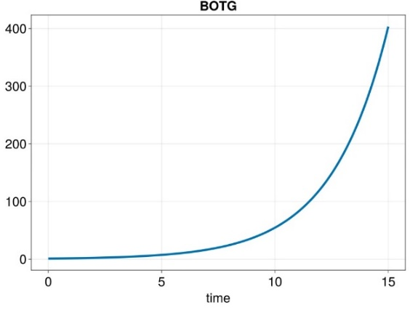

$$activation$$

$$P$$

$$\left(+\right)$$

$$+$$

$$+$$

***SPD***

***CLD***

$$P$$

$$activation=μP$$

$$μ$$

The ***Growth*** archetype describes a quantity or population that ***reinforces $\left(+\right)$*** its own growth – perhaps by replicating in proportion to its own size. This leads to the explosive dynamic shown in the above BOT graph. In our example, $P$ is the cellular concentration of a transcription protein that upregulates its own expression by docking to its own promoter. The DE for this system is:

$$\dot{P}=μP$$

Notice that we can use a causal-loop diagram (***CLD***) to sketch the causal structure of the SPD.

## ***Decay:*** How systems relax

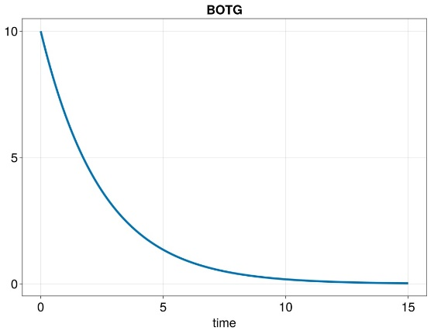

$$u$$

$$decay$$

$$\left(-\right)$$

$$+$$

$$-$$

***SPD***

***CLD***

$$P$$

$$breakdown=αP$$

$$α$$

The ***Decay*** archetype replaces the reinforcing feedback loop of the Growth archetype by a ***balancing $\left(-\right)$*** feedback loop in which greater values of $P$ decrease more rapidly than smaller values. Balancing loops act to stabilise systems that would otherwise be unstable. One example is the breakdown of a protein $P$ in a cell, since when more protein molecules are present, more are available to be broken down by cellular enzymes. We call $α$ the ***breakdown constant***. The DE looks like this:

$$\dot{P}=-αP$$

## ***Goal-seeking:*** How systems converge toward a stable fixed point

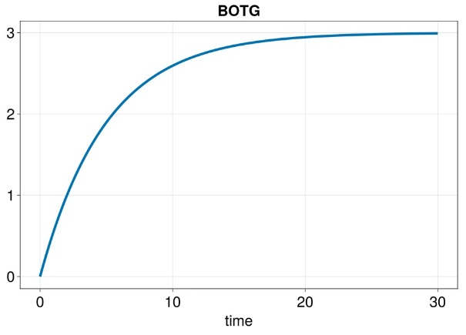

***SPD***

$$u$$

$$breakdown$$

$$\left(-\right)$$

$$-$$

***CLD***

$$+$$

$$+$$

$$expression$$

$$P$$

$$β$$

$$αP$$

$$β$$

$$α$$

***Goal-seeking*** behaviour is common in biological systems, which are able to maintain constant values of temperature, pH or population size. The way to achieve this always involves allowing two competing influences to interact. For example, in a logistic population the birth rate competes with the availability of a resource capacity $K$:

$$\dot{P}=rP\left(1-P/K\right)=rP-\left(\frac{r}{K}\right)P^{2}$$

Our example of a goal-seeking system is the so-called ***leaky rain-barrel***, into which water ($P$) rains down at a constant rate $β$, while at the same time water leaks out of the bottom of the barrel at a rate $αP$ that increases with the height of water in the barrel. Many cells use this idea to maintain a constant concentration of some protein $P$: they express $P$ at the constant rate $β$, while simultaneously using enzymes to break down $P$ at the rate $αP$. This leads to the following DE, and the behaviour shown in the BOTG above:

$$\dot{P}=β-αP$$

## ***Overshoot:*** How systems undermine their own growth

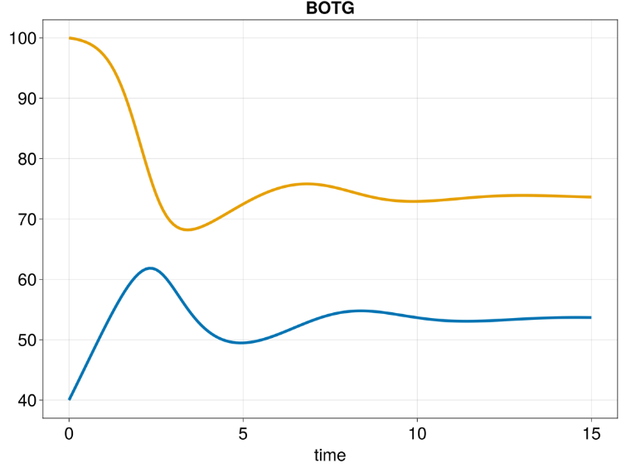

$$A$$

$$D$$

$$+$$

$$-$$

$$-$$

*dugongs dying*

*grazing*

*algae regrowth*

*algae*

*dugongs*

$$+$$

$$+$$

$$-$$

$$-$$

$$-$$

$$-$$

$$+$$

$$\left(-\right)$$

$$\left(-!\right)$$

$$\left(+\right)$$

*dugong birth*

$$+$$

$$+$$

The ***Overshoot*** archetype always involves at least two stocks and four causal loops. Even without knowing the details of the DEs, we can see from the SPD and the CLD above that some interesting influences are occurring in this system. First, there are two *reinforcing* loops by which the algae (A) and dugongs (D) grow; and the *balancing* loop in which grazing on algae reduces the death-rate of the dugongs (D), but also limits the numbers of algae. If these were the only loops, we would have a logistic system in which dugongs and algae limit each other’s growth. But there is another loop!

The final balancing loop links dugongs to algae’s regrowth. If the dugongs not only eat mature algae, but also dig out their roots, this degrades the algae’s ability to regrow, and leads to the collapse of the algae as a feeding resource. This archetype is also called ***Overshoot and Collapse***; it underlies the famous ***Tragedy of the Commons***, in which one or two stakeholders in some common resource take just a little more than their share, leading to the resource’s collapse. Here are the DEs:

$$\left\{\begin{matrix}\dot{D}=rD\left(1-D/A\right)-g D \\ \dot{A}=h rA\left(1-A/{\left(h K\right)}\right) \\ \begin{matrix}g=\frac{K_{A}}{K_{A}+A} ; & h=\frac{K_{D}}{K_{D}+D}\end{matrix}\end{matrix}\right.$$

In this archetype, the two inhibition functions $g$ and $h$ are important – we will learn more about such functions later in this course.

*Please notice the relevance of this archetype to our planet’s current* ***Global Climate and Diversity Crisis****: once the narrative reaches a certain* ***tipping point****, the system necessarily collapses!*

## ***Oscillation:*** How delay maintains systems in periodic motion

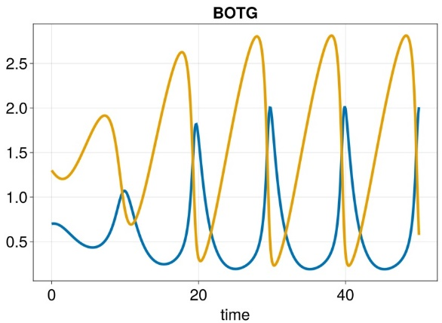

$$F6P$$

$$p\left[1\right]$$

$$ADP$$

$$p\left[2\right]$$

supply

dissociation

catalysis

breakdown

The ***Oscillation*** archetype always involves two stocks interacting via both immediate and delayed processes – the process shown here in grey is a ***delayed***, or ***lagged***, process. Our example is Sel’kov’s abbreviated model of glycolysis oscillations in yeast. Here, fructose-6-phosphate (F6P; F) is supplied to the system at a moderate rate $p_{2}$, and then breaks down into ADP (A) at the very slow rate $p_{1}$. These two processes cause the concentration of F6P (yellow curve) within the system to accumulate sharply, while the ADP concentration builds very slowly. Eventually, these two increasing concentrations reach a ***tipping point*** where the lagged, but fast, catalytic reaction $F6P\underset{→}{2 ADP}ADP$ sweeps all the F6P into ADP. When this catalysed reaction has too little F6P to continue, it switches off and the cycle repeats itself. We call such a system a ***relaxation oscillator***: in each cycle, a slow accumulation leads to torrential relaxation of the system. Relaxation also underlies the pulsing motion of landslides. The DEs for Sel’kov’s glycolysis oscillator are:

$$\left\{\begin{matrix}\dot{A}=-A+p_{1}F+A^{2}F \\ \dot{F}= p_{2}-p_{1}F-A^{2}F\end{matrix}\right.$$

## ***Switching:*** How systems decide

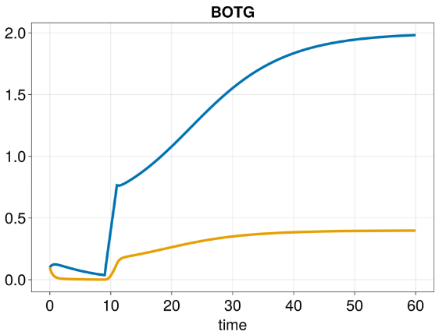

$$RNA$$

$$p\left[1\right]$$

$$P$$

$$p\left[2\right]$$

***Switching*** is a decision between two or more alternatives; switching again relies on delayed feedback. In our example, the protein concentration $P$ rises through leaky-barrel expression of RNA ($R$) together with breakdown $p_{1}P$. Similarly, $R$ rises through promoter activation by $P$; however, this activation is delayed, so that the entire $\left(P,R\right)$ system can only maintain non-zero concentration levels if either $P$ or $R$ rises high enough to overcome this delay. Once the switch achieves this condition, both $P$ and $R$ amplify each other to maintain the high concentration values of 2.0 and 0.4. The DEs of this switch are:

$$\left\{\begin{matrix}\dot{P}=R-p_{1}P \\ \dot{R}=\frac{P^{2}}{1+P^{2}}-p_{2}R\end{matrix}\right.$$