Skill DS6: How to drive a pendulum crazy

What new skills will I possess after completing this unit?
- Interpreting phase diagrams physically
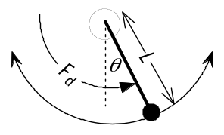
- Understanding chaos in continuous systems
- Familiarity with the idea of a Poincaré map

Step 1: What are the new skills?
Chaos in continuous systems cannot occur in less than three dimensions, nor in linear systems, so we now look for chaos in a damped, driven pendulum.
- The above diagram shows a particle of mass m on a rigid rod of negligible mass and length L moving on a vertical circle of radius L. Derive the equation of motion 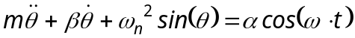 of the particle, where 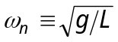 is the natural frequency of the pendulum, θ is the anticlockwise angle measured from the vertical downward position, β is the damping coefficient, and ω is the angular frequency of a force F_{d} driving the pendulum.
- Set 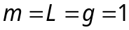 and build a flow model of the resulting simpler equation:
- 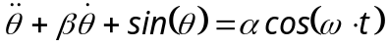
- Set 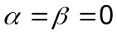 to obtain the undamped pendulum equation 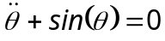. Use initial conditions 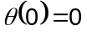 and 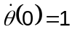 to generate a phase-plot of against over 10 seconds. Describe in words the behaviour of your pendulum over time.
- Raise the 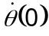 to just under 2 and redo exercise (iii). What is happening?
- Set 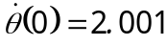 and redo exercise (iv) over 50 seconds. Explain your results.
- Explain the critical value of by considering the total energy of the system (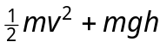) at the top and bottom of the swing. To cope with this critical behaviour, change the Model Settings to the ode113 solver with MaxStep 0.1.
- The damped pendulum equation is 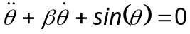. Set damping 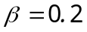, run your model with , for 20s, and interpret your phase-plot.

Step 2: How do these skills work?
OK, we know how to interpret the motion of the pendulum, so now let's drive it.
- Equation (1) is the full equation for the damped driven pendulum. Solve (1) numerically over 500 seconds with , 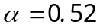, 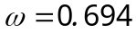 and initial conditions 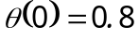, 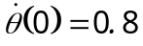, then display and interpret a phase-plot.
- The pendulum's orientation lies in the range 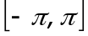. Use the accompanying function orient() in a SimBiology rule to convert the rotation angle θ to a new parameter orientation. Display a phase-plot of against orientation.
- This plot exhibits a period-3 limit cycle. What exactly does this phrase mean?
- Poincaré sections help us to visualise periodic motion by depicting just one data point in each driving period 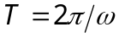. What is the value of T?
- The accompanying function Poincare() generates the Poincaré plot on the right. Use this code to create a plot type Poincare, set sample time T to your answer from exercise (xi), and plot against orientation. Discard the first 100s of data to allow the pendulum to relax into the period-3 limit cycle shown in the figure.
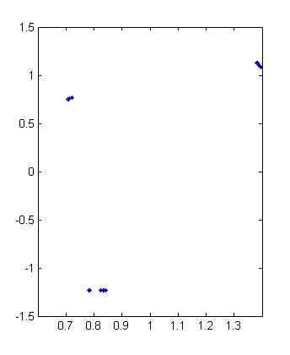
- The three groups of dots in your map represent an attractor: the pendulum is pulled to visit each group repeatedly. Why are the dots in a group spread out?

Step 3: How can I apply these skills?
Now we will drive our pendulum into chaos using the full dynamical equation (1).
- Use your model to generate a phase plot of against with 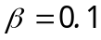, 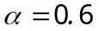, , 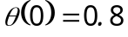 and for 500s. What is the main difference between this plot and that of exercise (viii)?
- The pendulum's motion is no longer periodic, but wanders unpredictably round the phase plane. Explain why we cannot call this motion random.
The specific parameter choices of exercise (xiv) produce a wild and unpredictable form of motion in the pendulum which is in fact chaotic. To prove this we need to demonstrate both sensitivity to initial conditions and strange attractors.
- Using the parameter settings from exercise (xiv), create a phase plot of the driven pendulum for the following three initial values of θ: 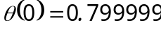, and 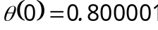. What can you deduce from these three plots?
Once again we see here the sensitivity to initial conditions of chaotic systems:
- A trajectory 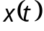 of a system is chaotic if changes in depend exponentially upon changes in the initial condition 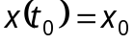 in the following sense: a change 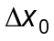 in 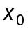 leads to a change 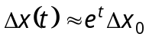 at later times t.
Sensitivity to initial conditions is extremely important in evolution, since it enables developmental processes to react rapidly to changes in genes or environment.
Recall that chaos is periodic motion with infinite period. To demonstrate that the pendulum's motion is bound to a strange attractor, we therefore need a Poincaré map which gives us a picture of the periodic components of the motion.
- Create a Poincaré section of the chaotic pendulum over 400 seconds.
The points in your Poincaré section show no obvious order, but in exercise (xviii) below you will prove that they in fact form a fractal shape in phase space.

Congratulations!
You have modelled a simple physical system and observed both limit cycles and chaos in it, using the important tool of Poincaré maps.

How can I deepen my new understanding?
- Make a cup of tea while you generate a Poincaré section of the chaotic pendulum over 15000 seconds. Now you can definitely see the deep structure of the phase points! In Matlab, use box-counting to prove this is a fractal.

