Skill DS7: Enzymes: Transistors of the chemical world

What new skills will I possess after completing this unit?
- Building ODEs as balance equations for chemical reactions
- Familiarity with Michaelis-Menten kinetics and the Monod factors
- Ability to model a general chemical switch

Step 1: What are the new skills?
We will now apply our new skills to biology and biochemistry. One important family of non-elementary chemical reactions is the enzymatic conversion of a substrate S to a product P by binding to an enzyme X to form the intermediate complex XS:
- 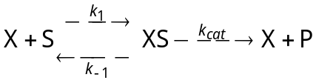 .
- Build a mass action model of reaction (1) for the case of the enzyme galactosidase, which catalyses the breakdown of lactose into glucose and galactose. Use the rate values 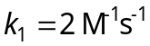, 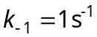 and 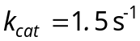, with initial concentrations 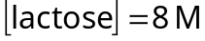 and 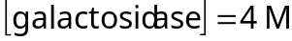. Prettify the layout by selecting all components and pressing Ctrl-L, then adjusting the position of the species labels. Generate a BOTG of the model over 5 seconds.
The dynamics you observed in exercise (i) occur frequently in biochemistry. We can model them more efficiently by making the approximation that reaction (1) has settled into a steady state in which the rate of change of the bound enzyme-substrate complex XS is zero. The balance equation (inputs–outputs) for XS is then:
- 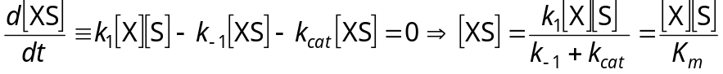,
where 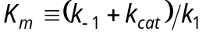 is the Michaelis constant. But the total enzyme concentration (bound plus unbound) is a constant 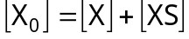, in which case
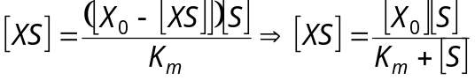,
so that the rate of the enzymatic reaction is given approximately by
- 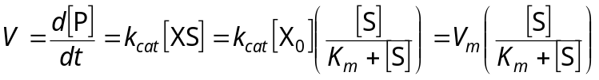,
where 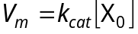 is the maximum reaction rate. Equation (3) is the Michaelis-Menten equation for reaction (1).

Step 2: How do these skills work?
- Create a new model of the galactosidase reaction using Michaelis-Menten kinetics. The model is now somewhat simpler: , but you need to tell SimBiology that galactosidase is both reactant and product in the reaction, and calculate the Michaelis constant 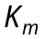 and the maximum rate 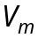. Discuss carefully the differences in behaviour between the new model and the model from exercise (i).
- Create in Matlab an inline function 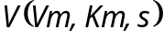 which models equation (3), and use plots of V against 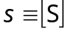 to make sense of the following three statements: (a) V is a saturating function of s; (b) is the least upper bound of V; (c) is the half-response value of s in the function V.

Step 3: How can I apply these skills?
There is another way of viewing the Michaelis-Menten equation (3). Imagine that X is some biochemically important protein which is switched from an inactive state X₀ into the active state X₁ by binding to a small inducer molecule S to form the active complex XS. We say then that S activates X. Using an argument identical to that above, we can show that if 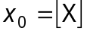, 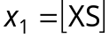, and 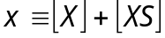, then
- 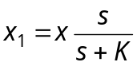, where 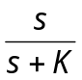 is the Monod activation factor.
Similarly, if S represses X (i.e. S makes X inactive), then:
- 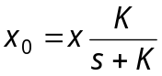, where 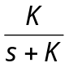 is the Monod repression factor.
The Monod factors give us a mathematical way of describing the activation and repression of biochemical factors. They make use of the saturating properties which you investigated in exercise (iii).
- Create a Matlab m-file monod(s,K) which implements the Monod factors. A positive value of half-response value K indicates activation; a negative value gives repression. Test your function by plotting graphs.

Congratulations!
You understand how chemical reactions are switched on and off by enzymes and inducers, and you know how to model this switching behaviour using the Michaelis-Menten equation and the Monod activation and repression factors. These switches are the basic information processing steps inside the cell.

How can I deepen my new understanding?
- A gene-product X is transcribed at rate 1mM/s only when a transcription factor S is present in concentrations of around 3mM. Simultaneously, X is degraded by other intracellular proteins with a half-life of 2 seconds. In a particular experiment, the concentration of S in a particular cell is gradually raised from zero at a constant rate of 1mM/s. Sketch a graph of how you expect the concentration of X to develop over the course of the experiment.
- Use the Monod factors to build a model of the situation described in exercise (v), and so verify your sketched BOTG. In order to be able to use your monod() function from exercise (iv) in SimBiology, you must ensure that it is on the current path, and also that it uses the element-wise Matlab operations.

