Skill DS8: Building a brainy bacterium

What new skills will I possess after completing this unit?
- Understanding the functioning of transcription networks
- Familiarity with Hill functions
- Understanding the basic rules of cellular concentrations

Step 1: What are the new skills?
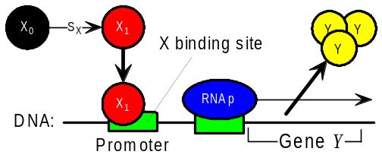
Any cell, whether pro- or eukaryote, is confronted with the need to solve problems posed by its environment. So what does the 'brain' of a cell look like?
An E. coli bacterium is basically a 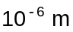 long bag of around 4000 different proteins of about 1000 molecules each. It senses its environment via signalling proteins which enter the cell, and responds by producing proteins which either act on the environment or change the cell's internal state. These proteins are called transcription factors, or regulators: they change the cell's internal state by binding to the promoter of a target gene Y to regulate the rate at which Y is transcribed into RNA (see diagram above). The internal state of an E. coli cell consists in the instantaneous concentrations of about 300 different transcription factors which regulate the rates of expression of the 4000 proteins.
So the 'brain' of a cell consists of a transcription network which works just like other cognitive processing systems such as neural or immune networks. It contains thousands of chemical species which interact with each other via reactions. Suppose X is a transcription factor which regulates production of a protein Y, then the rate of production of Y is a function 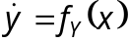 of the concentration of X in its active form. 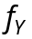 is the input function of the gene Y which codes for the protein Y.
We already know how to use Monod factors to describe the activation and repression of chemicals by a single inducer molecule. In general, however, several (n) regulator molecules may be required to regulate a target gene, and we describe this more general situation using the following Hill functions:
- 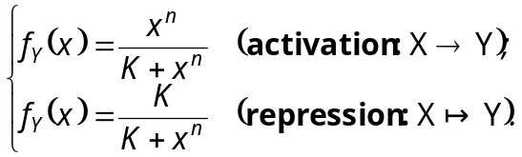
- In Matlab, verify the following statements concerning the accompanying input function 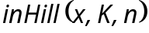: (a) 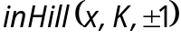 implements the familiar Monod expressions; (b) K is the half-response level of X; (c) n (the cooperativity) determines the abruptness of the Hill function's step-like shape.
Evolution can tune all these parameters via mutations of the DNA sequence of the binding sites for X. Note that many genes have a nonzero minimal transcription level (basal expression level β₀) which is modelled by adding a term β₀ to 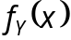.

Step 2: How do these skills work?
The concentration of all gene products is reduced over time by dilution and degradation; let’s see the result of combining transcription with degradation.
- Let β₁ be the (constant) expression rate of gene product C, and α be the degradation rate. Derive the ODE 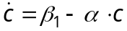 for the concentration of C, and show that as 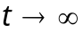, c approaches the stable equilibrium value 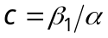.
Exercise (ii) illustrates the importance of degradation for cellular information processing: the combination of constant expression with exponential degradation always leads to a constant concentration 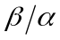 for gene products. This value can then function as a stored value in the 'brain' of the cell.
Suppose now that the expression rate of exercise (ii) is suddenly changed from 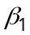 to the new constant value 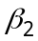. In this case c will start to exponentially approach the new equilibrium value 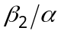 according to the equation
- .
- Derive the half-response time 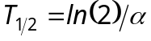 taken for c to change halfway from one equilibrium value to the next in equation (2).
- Build a model to test each of the above three predictions. This is sometimes called the Leaky Rain-barrel Model – why?
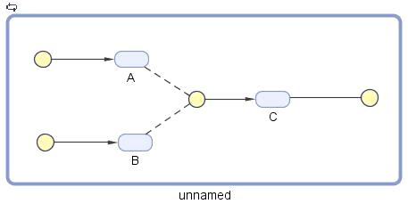

Step 3: How can I apply these skills?
- Create and test a model in which both the transcription factors A and B are required to activate transcription of gene C, and multiple copies of A are required with cooperativity 1.5. The product C then degrades with half-life 0.3466s.
The reaction is 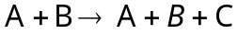. We will allow A and B to rise linearly, and use the accompanying input function inAnd() to combine them:
- Create the three species A, B and C, and link them with four reactions as shown in the model above right.
- Set the expression rates of A and B to 2 and 1 respectively; set the degradation of C to the mass action rule 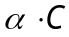. We can calculate the value of α from the given half-life: 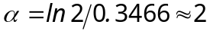. Choose Unknown as the kinetic law in the expression of C, then enter the kinetic equation , where 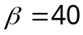, 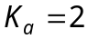, 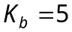. □
- Comment on the maximum and half-response values of [C] in this model.

Congratulations!
You now understand the basic functioning of transcription networks.

How can I deepen my new understanding?
- Derive equation (2) by using new initial conditions for the ODE of exercise (ii).
- Three regulators were inserted into the DNA of E. coli, and connected as a repression cycle: . C was also a positive regulator for the Green Fluorescent Protein gene GFP. In an experiment, protein A is initially present in the cell, while the concentrations of B and C are zero. A, B and C all have identical values for degradation/dilution rate α, maximum expression rate β, half-response constant K and cooperativity n. Play with these parameter values to discover what behaviour was observed.

