Skill DS9: Hey! Switch my brain back on!

What new skills will I possess after completing this unit?
- Familiarity with the Griffith model of genetic switching
- Understanding how bifurcations arise as nullcline intersections

Step 1: What are the new skills?
Sensitivity to initial conditions is characteristic of chaotic systems, but it is also related to multistability: the ability of a system to switch between different stable states. Multistability is important for eukaryotic cells: although all cells in your body have the same DNA, they can 'decide' whether to become a cone cell in the eye or a B-cell in the immune system, and store this state over your lifetime.
In 1971 Griffith proposed the model shown below of how a genetic switch in the cell nucleus might work. Griffith considers a protein, P, which is translated from a messenger RNA, R, and assumes that P positively regulates transcription of its own RNA (R). He assumes that this regulation is a cooperative phenomenon involving two molecules of P, and so is described by Hill kinetics together with degradation/dilution:
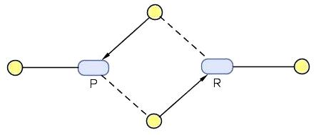
- 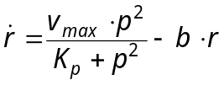.
In addition, R is translated into P at a constant rate. By the mathematical technique of non-dimensionalisation we can study the full behaviour of Griffith's equations while setting this transcription rate to 1, together with 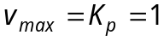. In this case the equations of Griffith’s genetic switch become:
- 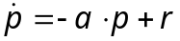 ; 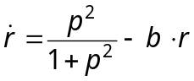 .
- Build the Griffith model using the Hill kinetics provided in SimBiology, and set 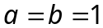, 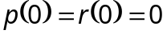. Check that your model runs as you expect.
- Now we will probe the Griffith model by injecting a single dose of 1 unit of P into the system: Click on Events in Project Explorer, then add an event with Trigger "time>=5" and Event Function "P=1". If you run the model now over 50 seconds, you should see both P and R rise at 5s and then fall back to zero.
- The degradation rate a of P is a critical parameter of the model: set 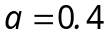, then re-run the model. At 5s the system gets switched on by a single event!
- Below the critical value 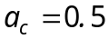, the Griffith system bifurcates into a switch: for 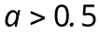 the system has just one attractor 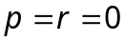, but at 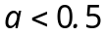 there are at least two attractors: 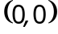 and 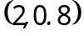. Check the existence of the attractor attractor at the origin by halving the dose of the P injection at 5s.

Step 2: How do these skills work?
- Show that Griffith’s system has three fixed points when 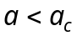, where 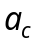 is a critical value to be determined. What happens when 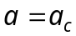?
The nullclines of (2) are the straight line 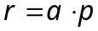 and the sigmoidal curve 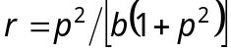 (see diagram below), and the critical points of the system lie at their intersection. Suppose we vary a while holding b constant: this is easy to visualise, since a is the slope of the line. We see from the diagram that for large values of a there is only one intersection at , but as a gets smaller, the line becomes tangent to the curve and then two more intersections pop into existence. A bifurcation is any case where critical points appear or disappear, and the bifurcation parameter a determines when they appear. Our bifurcation here is called a blue-sky bifurcation, proving that mathematicians are human after all!
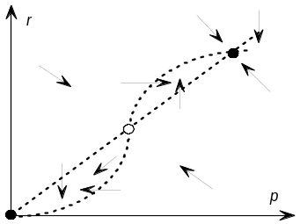
- To find , we compute the critical points, then see where they merge. The nullclines intersect when 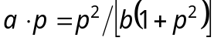, which has a trivial solution at 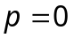 (and so also 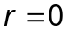). Show that the other intersections satisfy the quadratic equation 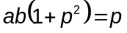. Solve this equation and show that the solutions merge when 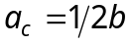 (where 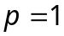).
The nullclines in the diagram tell us a lot about the phase portrait for . The vector field is vertical on the line 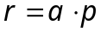 and horizontal on the sigmoidal curve. We can sketch other arrows by noting the signs of and from equations (2). It seems that the middle fixed point is a saddle and the other two are attractors.
This phase portrait is shown in the diagram below. Its biological interpretation is that Griffith's model can act like a genetic switch, provided P decays slowly enough. In this case there are two stable steady states: one at the origin, meaning that the gene is silent and there is no protein around to turn it on; and one where p and r are large, meaning that the gene is active and sustained by the high level of P.
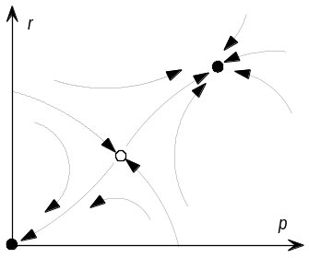

Step 3: How can I apply these skills?
- The Jacobian of Griffith's model at the point 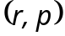 is 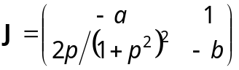. Use the eigenvalues of J to confirm that the critical points of our model are indeed two stable nodes (attractors) and one saddle.
- Now use a phase plot of your Griffith model to explore these critical points.

Congratulations!
You know what a bifurcation is, and how it can implement a biological switch.

How can I deepen my new understanding?
- The spruce budworm destroys Canadian forest by eating leaves of the balsam fir tree. Budworm outbreaks obey the ODE 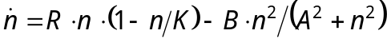, where the first term is a logistic model for budworm density n with carrying capacity K. The second term represents predation: B is the predation rate, and A is the threshold density above which budworms become visible to birds. 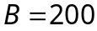 and 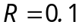 are constants, but 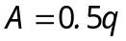 and 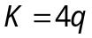 depend on the forest quality q, which obeys the ODE 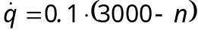 as budworms eat its foliage. Investigate the budworm behaviour using 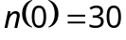 and 

