Skill DS11: Dear Dr. Sommer, how can I capsize a boat?

What new skills will I possess after completing this unit?
- Ability to plot and interpret bifurcation diagrams
- Understanding the influence of critical parameters on phase portraits
- Predicting physical behaviour from bifurcation diagrams

Step 1: What are the new skills?
The word bifurcation has cropped up several times, but what exactly is it? In discrete populations it meant the period-doubling of a limit cycle; in the Holling-Tanner model it was an abrupt change from point attractor to cycles; in the Griffith switch it was the appearance of two critical points as a particular parameter – the degradation rate of a protein – was reduced.
- A bifurcation is any value μ₀ of some system parameter μ at which the system behaviour becomes unstable, i.e.: the system has a different kind or number of critical points for different values of μ in the range 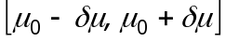.
- How does the behaviour of the system 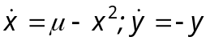 depend on μ?
We find the critical points by solving the equations 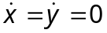, and the number of these solutions depends on the value of μ: If 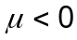 there are no critical points; if 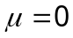 there is one saddle; and if 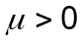 there are two nodes.
- Run the accompanying function demoSaddleNode() to see how this bifurcation develops as μ changes from negative to positive values.
- Now suppose that μ is some physical property of the system's environment which drifts slowly over time from 1 down to -1. Build the model of Example 1, together with a third species μ which drifts in this way; then look at a BOTG of x. Note: if your model works, you will get a SimBiology runtime error – try reducing the duration of the run until you see what is happening.
Have you ever stood up in a boat? If you lean out just a little, all is OK, but if you lean just a bit too far, you get another name for a bifurcation: a catastrophe!
- A blue-sky, or saddle-node, bifurcation has the canonical form 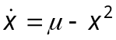. As μ changes from negative values, a neutral point appears at 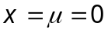, then as we find a stable node at 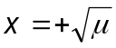 and an unstable node at 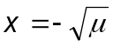.
- If you do not yet see the danger of bifurcations, please talk to your teacher!

Step 2: How do these skills work?
There are many other kinds of bifurcation than the saddle-node. We will now explore a number of varieties which are important in the world of biology.
- The transcritical bifurcation has canonical form 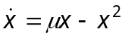. When 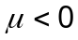 there are two critical points: an unstable node at 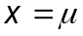 and a stable node at 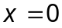; when there is one neutral point at ; when there are two critical points: an unstable node at and a stable node at .
- Run the accompanying function demoTranscritical() to see how a transcritical bifurcation develops as μ changes from negative to positive values.
- The pitchfork bifurcation has canonical form 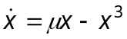. When there is a stable node at ; when there is one neutral point at ; when there are three critical points: an unstable node at and stable nodes at 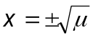.
- Run the accompanying function demoPitchfork() to see how a pitchfork bifurcation develops as μ changes from negative to positive values.
- The Hopf bifurcation has canonical form 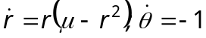. When 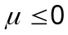 the origin is a stable focus with a clockwise flow around it; when there is an unstable focus at the origin and a stable limit cycle at 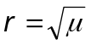.
- There are two forms of Hopf bifurcation: supercritical and subcritical. The above definition is the supercritical, or soft, Hopf bifurcation. Run the accompanying function demoHopfSuperSoft() to see how a supercritical Hopf bifurcation develops as μ changes from negative to positive values.
- The subcritical, or hard, Hopf bifurcation has opposite sign: 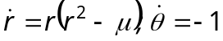; run the function demoHopfSubHard() to see how this develops as μ changes from positive to negative values. As you watch, trace the trajectory of a phase point inside the unstable limit cycle as μ falls below zero. Why is this also called a dangerous Hopf bifurcation in engineering applications such as aeroplane wing vibrations?

Step 3: How can I apply these skills?
Our examples so far have been codimension-1 bifurcations: they involved only one bifurcation parameter. The Griffith switch 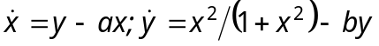 has a codimension-2 bifurcation, since both a and b are bifurcation parameters.
- The accompanying function demoGriffith() demonstrates bifurcation in the Griffith model when 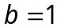 and a falls from 0.6 to 0.3. Study this bifurcation diagram, then answer the following question. Imagine the protein concentration attains a steady value when 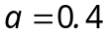; at a later time the cell briefly raises the value of a to 0.6, and then lowers it back to the original value of 0.4. What do you think will happen? Test your hypothesis by adapting your Griffith model to simulate this experiment.

Congratulations!
You understand the importance, uses and dangers of bifurcation, and you can plot a bifurcation diagram.

How can I deepen my new understanding?
- Tuna are fished in the north Atlantic Ocean at a rate h, and this leads to the following differential model for the population 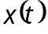 in 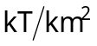:
- 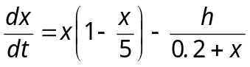.
Determine and classify the critical points and plot a bifurcation diagram. Interpret this model and your findings in physical terms and build a SimBiology model to verify your interpretation.

