Skill DS12: Welcome to the 3-dimensional world of chaos!

What new skills will I possess after completing this unit?
- Understanding the way in which real systems enter chaos
- Ability to analyse real physical systems from a dynamical perspective

Step 1: What are the new skills?
In 1976 Otto Rössler was given the task of designing a chaotic chemical reaction (i.e., proceeds unpredictably). He did not succeed, but during his attempt he developed the following set of equations:
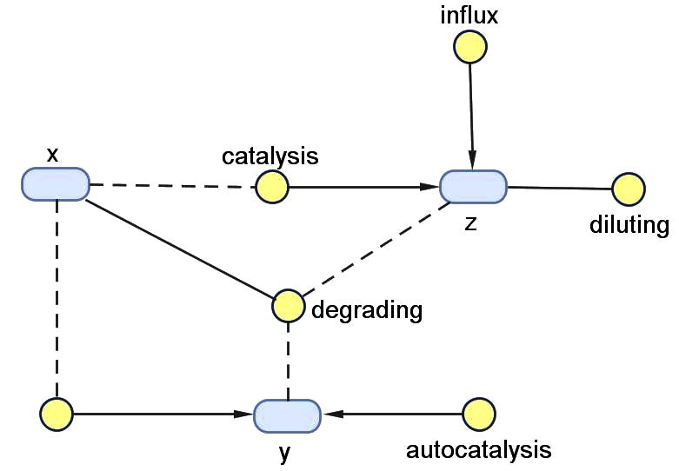
- 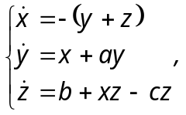
where a, b and c are all constants.
- Notice that this system is only marginally capable of chaos: it is a third-order system, but linearity is violated only in one place – where?
- Run the Rössler model shown above over 200 seconds with 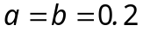, 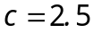 and 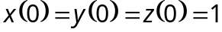. What behaviour do you observe in a BOTG?
- Now set 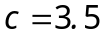 and then 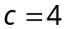. Do you recognise what is happening here?
- Let's check this out. First, are we sure period-doubling is occurring? Check this by observing the stable behaviour in XY phase-plots of the above experiments.
- These results are difficult to interpret due to the initial transient behaviour. Use the accompanying plot type PTPhasePlot() to discard the first 100 seconds of a 300s trace, and obtain unambiguous results for 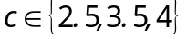.

Step 2: How do these skills work?
We have established period-doubling – this information is already enough to indicate that Rössler had found something interesting. But we have a problem:
- Trajectories cannot cross themselves! So when , how does the phase-point at the crossover know which direction to go along the trajectory?
- Use the accompanying plot type PTPhasePlot3() to view the behaviour of x, y and z for 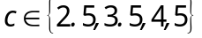. Again discard the first 100s of a 300s trace.
- So: why do you think we need three dimensions in order for chaos to occur?
- Now let's explore. Try out: 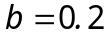, 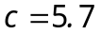, .
- Now try: 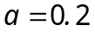, , .

Step 3: How can I apply these skills?
- A complex system is a system which exhibits complex behaviour. Complex behaviour is behaviour which is globally stable, but which arises from components which could equally well generate chaotic behaviour. Complex behaviour arises through self-organisation: system-level influence adjusts the critical parameters to regions of relative stability.
Self-organisation is a fundamental property of living systems. A living system must respond flexibly to its environment (think of a hare weaving to escape a lynx), and chaotic attractors provide this flexibility to react spontaneously. Yet living systems must also respond robustly to situations with predictable outcomes (think of the lynx weaving to catch the hare), and simple attractors provide this. What links the two is learning, which enables the organism to distinguish when each is needed.
We do not cover learning in this course – that will wait until our next course on intelligent systems. However you have seen in exercise (x) just how unpredictable the jump between order and chaos can be. In the remainder of this unit I give you a variety of techniques you could use for mapping out the Rössler system to investigate how its chaotic behaviour might be controlled in a learning system.
- Estimation: Look at your answer to exercise (x), and sketch by hand a map of where you think the stable and chaotic regions of the parameter b are.
- Fractals: Is the Rössler attractor really chaotic? Try box-counting it.
- Poincaré section: This tool is particularly useful for systems with many dimensions: the idea is that we reduce a higher-order system to an easily visualisable 2-dimensional plot by plotting only points where the trajectory crosses some appropriate phase-plane in a particular direction. Use the accompanying plot-type PTPoincare() to analyse exercise (x) by plotting the xy-coordinates of points crossing the plane 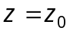 for appropriate z₀. Use box-counting on this section of the chaotic attractor.
- Attractors: Remember that a system will spend most of its time around an attractor. The trajectories generated by SimBiology are interesting, but they are important for the clues they give us to the location and type of attractors. Always think: What deeper truth is this trajectory telling me?
- Automation: It is a lot of work setting up many trajectory experiments in SimBiology; however it is possible to load and run a SimBiology model automatically from within an m-file. Find out from Help how to do this, then create a function RoesslerBifurc() which generates a Poincaré section of the Rössler model for each of the values of b used in exercises (x) and (xiii).
- Bifurcation diagram: The Feigenbaum diagram which we used to analyse the discrete logistic map is simply a map of 1-D Poincaré sections associated with each value of some critical parameter. Extend your function RoesslerBifurc() from exercise (xv) to generate a Feigenbaum diagram. Is it helpful to create a 3-D bifurcation diagram of 2-D Poincaré sections against b?

Congratulations!
You are now familiar with many powerful tools for analysing dynamical systems, and you know how to combine them to analyse real-world systems.

How can I deepen my new understanding?
- I cannot emphasis sufficiently how important it is to interpret your findings carefully. Nobody will be interested in your analysis unless you can interpret it for them, but your interpretation must also be accurate, or you lead your reader astray. I have tried above (not altogether successfully) to interpret the Rössler model as a chemical system – practise your interpretation skills now by finding an interpretation of the Rössler system as a mechanical oscillator.

