|  |  |
| --- | --- |
| PART 1 of 2 | |
| 1. Modify Game.h   Download  [StarterKit](https://bitbucket.org/MuddyGames/gameplay-programming-i-lab-06) | /// <summary>  /// Change 1 Add GL.H and Glu.h  /// This hooks up OpenGL with our Game  /// </summary>  #include <gl/GL.h>  #include <gl/GLU.h>  using namespace std; |
| 1. Modify the file Game.cpp file to Draw a Triangle Shape using OpenGL   SFMLOpenGL | Add the following methods to Game.cpp initialize() method  glClearColor(0.0f, 0.0f, 0.0f, 0.0f);  glMatrixMode(GL_PROJECTION);  glLoadIdentity();  gluPerspective(45.0, window.getSize().x / window.getSize().y, 1.0, 500.0);  glMatrixMode(GL_MODELVIEW); |
| 1. Modify Game.cpp draw() method as follows | void Game::draw()  {  cout << "Draw up" << endl;  glClear(GL_COLOR_BUFFER_BIT | GL_DEPTH_BUFFER_BIT);  glBegin(GL_TRIANGLES);{  glVertex3f(0.0, 2.0, -5.0);  glVertex3f(-2.0, -2.0, -5.0);  glVertex3f(2.0, -2.0, -5.0);  }  glEnd();  window.display();  } |
| 1. Finally modify your code to include drawing of the Primitives | GL_POINTS  GL_LINES  GL_LINE_STRIP  GL_LINE_LOOP  GL_TRIANGLES  GL_TRIANGLE_STRIP  GL_TRIANGLE_FAN  GL_QUADS  GL_QUAD_STRIP  GL_POLYGON |

NOTES: Updating SFML OpenGL Project

Windows SDK includes Opengl32.lib and glu32.lib. These files can be found in the following directories.

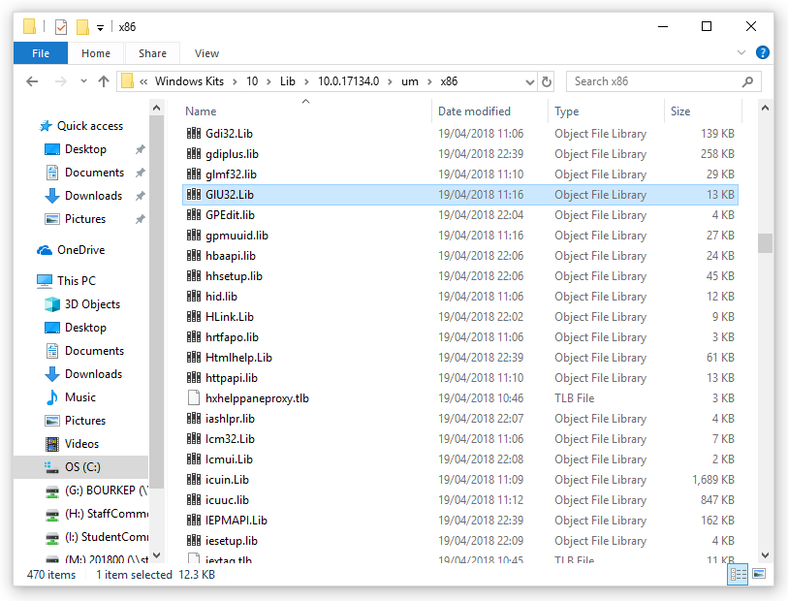

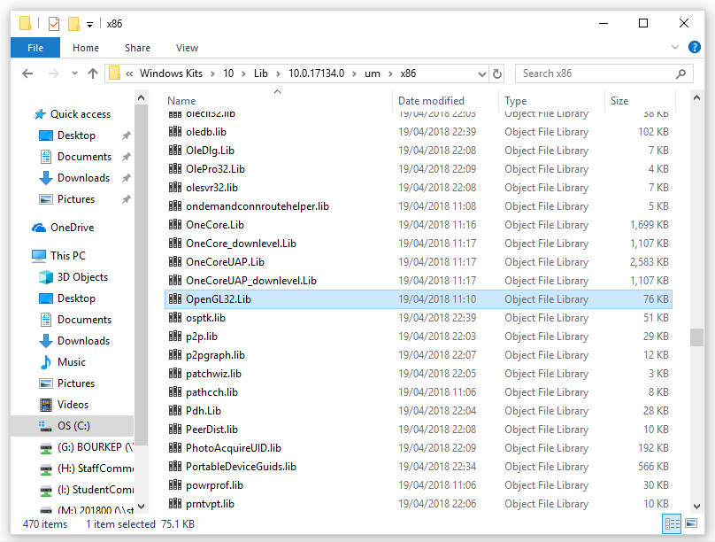

**Locate Open GL Libraries (This maybe different on your machine)**

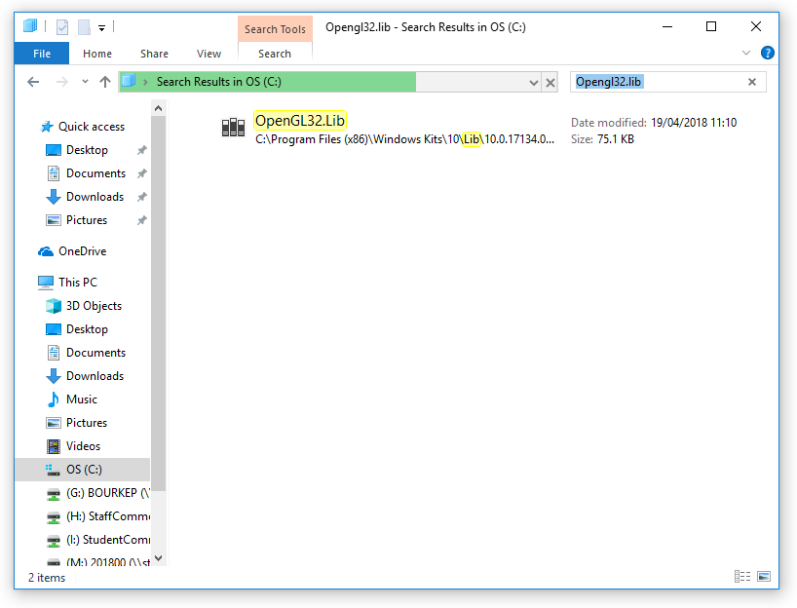

**Setup Environment Variable**

Set an environment variable as follows

C:\Users\#####>set OPENGL_SDK=C:\Program Files (x86)\Windows Kits\10\Lib\10.0.17134.0\um\x86

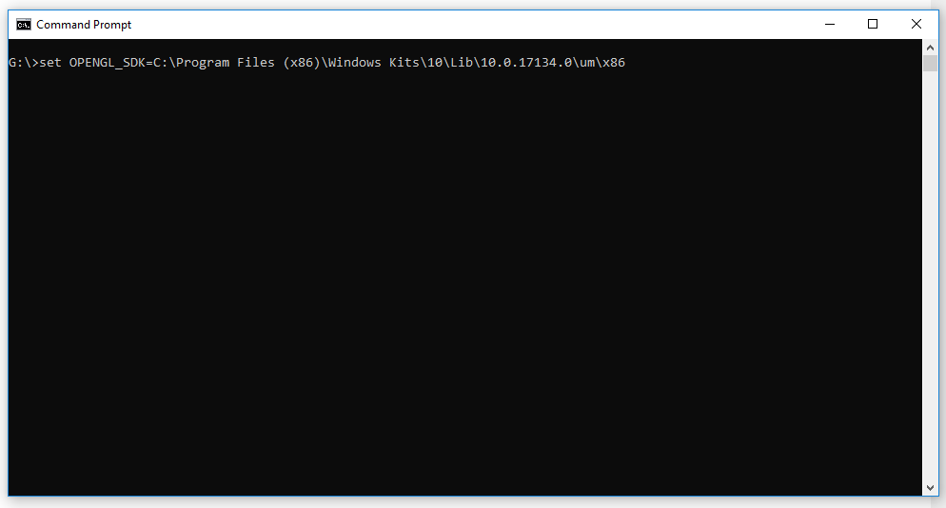

Check that environment variable had been set correctly

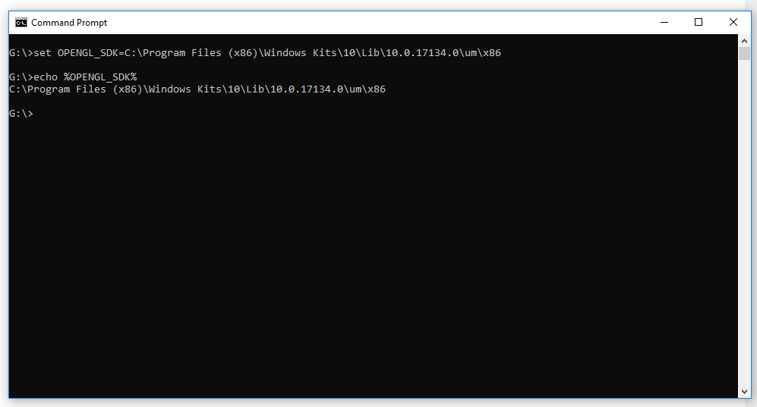

**Include Settings**

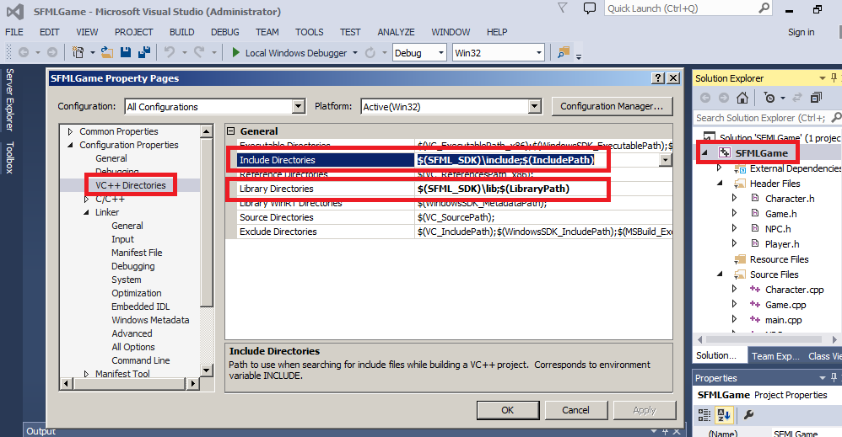

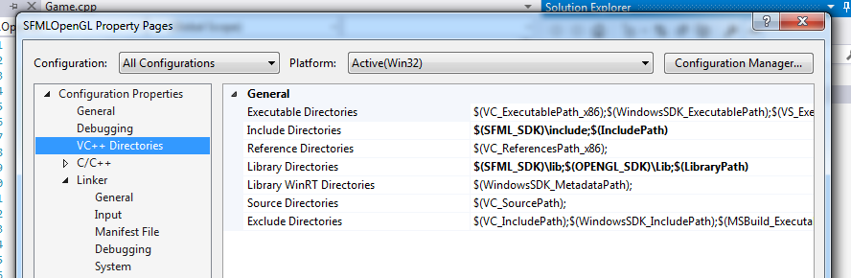

Library Dependencies

sfml-main-d.lib  
sfml-graphics-d.lib  
sfml-system-d.lib  
sfml-window-d.lib  
OpenGL32.lib  
GlU32.lib

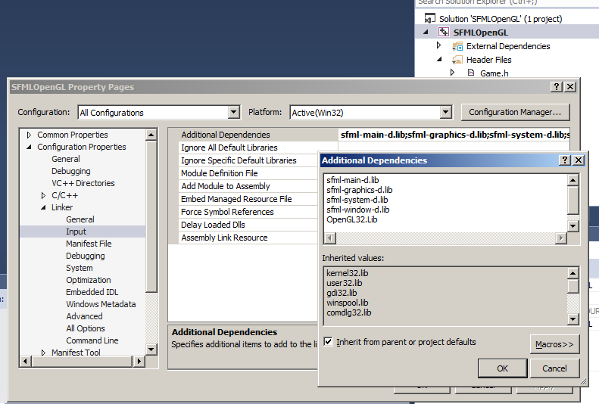

|  |  |
| --- | --- |
| PART 2 of 2 | |
| 1. Modify the file Game.cpp and for “all primitives” | Investigate the use of  glLoadIdentity(); |
| 1. Modify Game.cpp | Investigate the use of  glRotatef(rotationAngle, 0.0f, 0.0f, 1.0f); |
| 1. Modify Game.cpp | Investigate the use of  glTranslatef(1.0f, 0.0f, 0.0f); |
| 1. Modify Game.cpp | Investigate the use of  glScalef(1.0f, 1.0f, 1.0f); |

**Demonstrate completed SFML OpenGL files at the end of the LAB and ensure program been checked**

|  |  |  |  |
| --- | --- | --- | --- |
| **Student Name** |  | **Student Number** |  |
| **Date** |  | **Checked** |  |
| **Group** | **A / B** |  |  |