CS 150 Topics List

Chapter 17

1. Text vs. Binary I/O (17.2, 17.3)
   1. Stream objects.
   2. Binary I/O is more efficent
2. Binary I/O Classes (17.4)
   1. 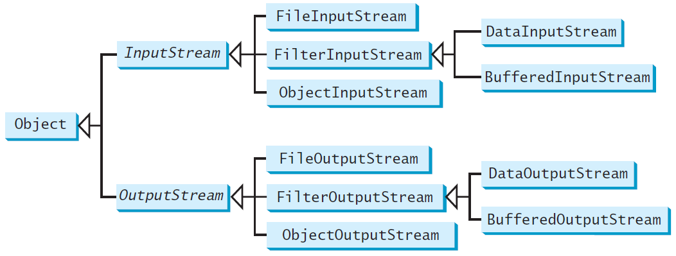
   2. Use *finally* to close streams.
   3. UTF-8 text encoding.
   4. Detecting end of file with EOFException (DetectEndOfFile.java on p. 687)
3. Object I/O (17.6)
   1. Serializable interface
   2. Transient keyword.
4. Random-Access Files (17.7)
   1. File pointer can be moved.
   2. Know modes r and rw (read-only and read-write)