Nanocms
Source Code on GitHub: https://github.com/kalyan02/NanoCMS
Extract to the www directory of phpstudy
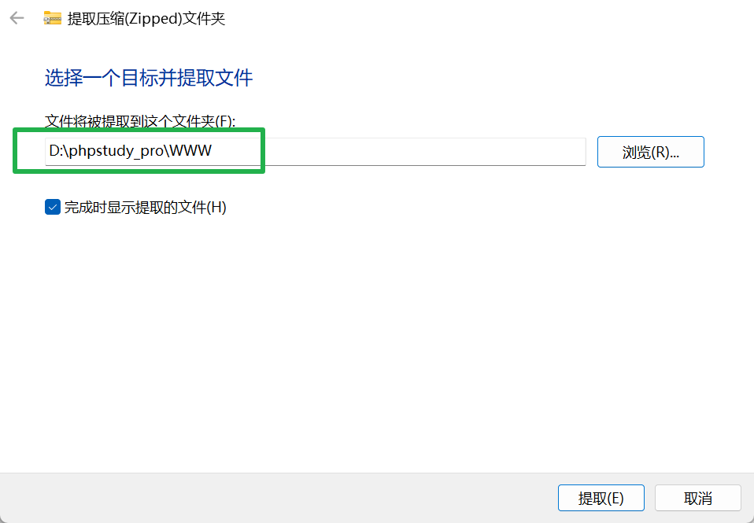
Rename the extracted folder to "nano"
Open your browser and visit: http://localhost/nano/index.php
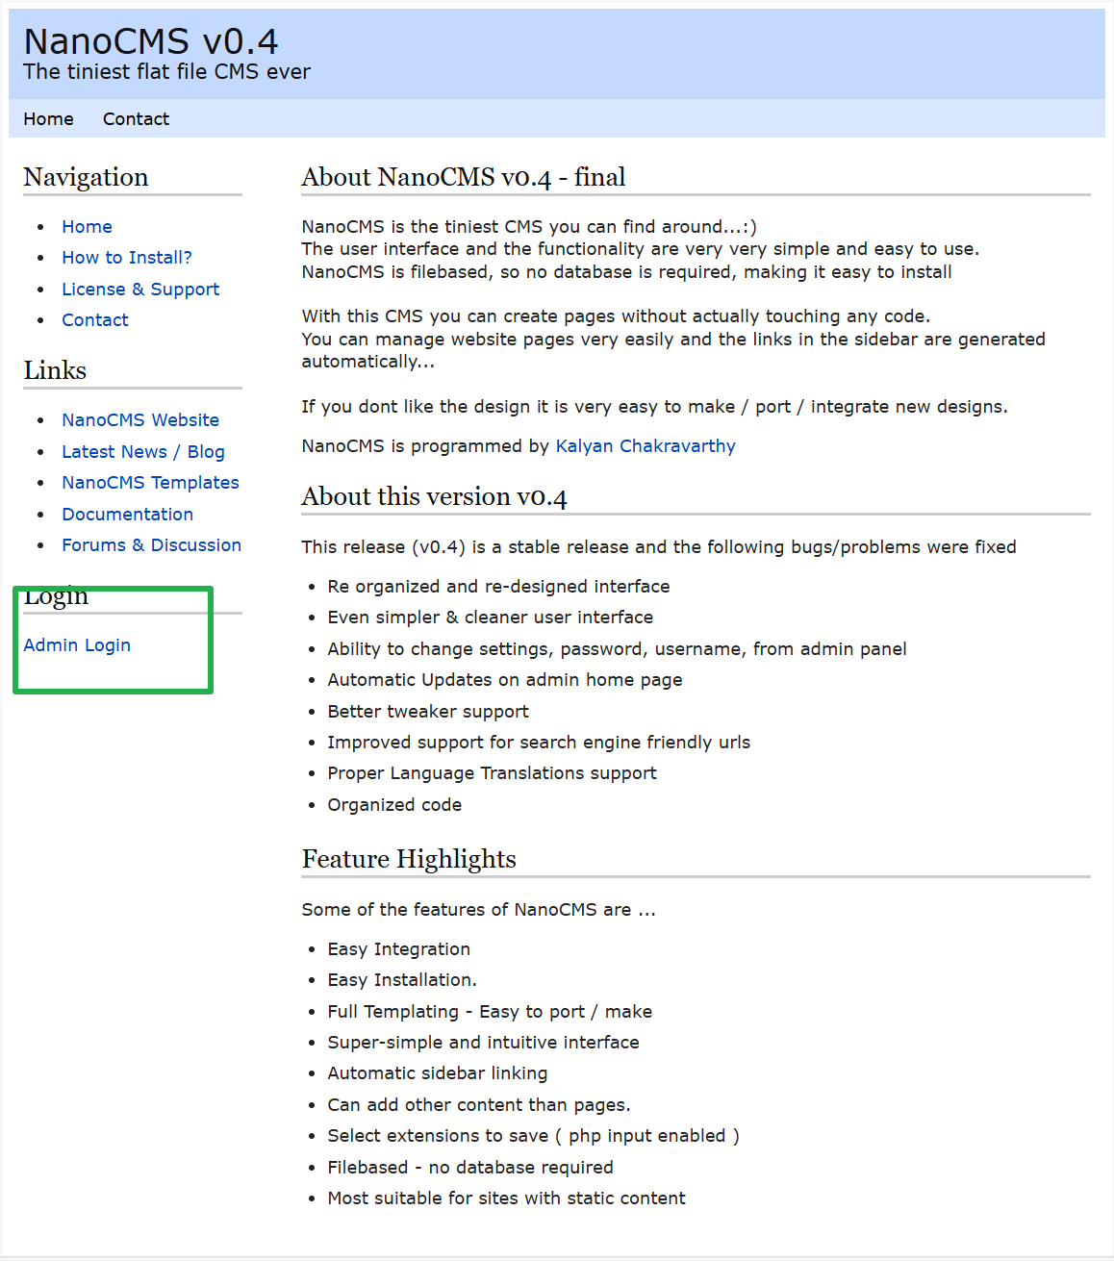
Select "admin login"
Username and password: admin/demo
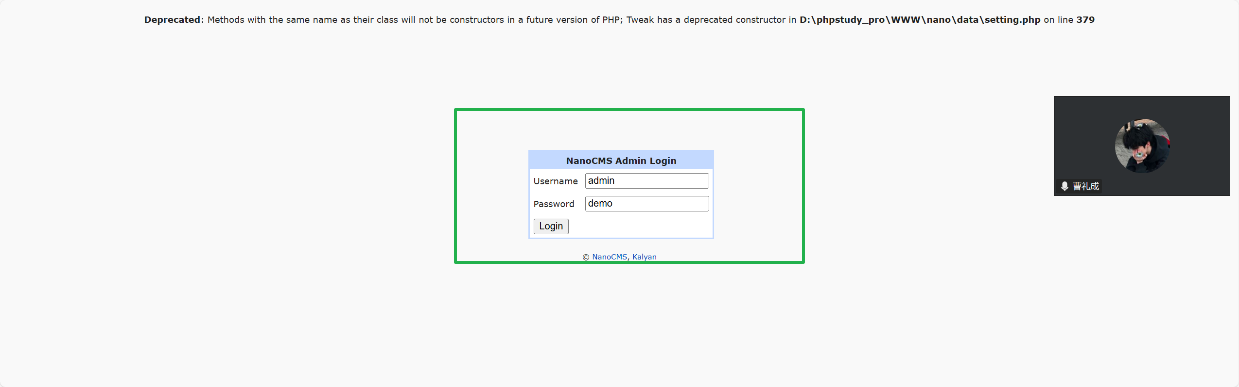
Log in directly to access the admin page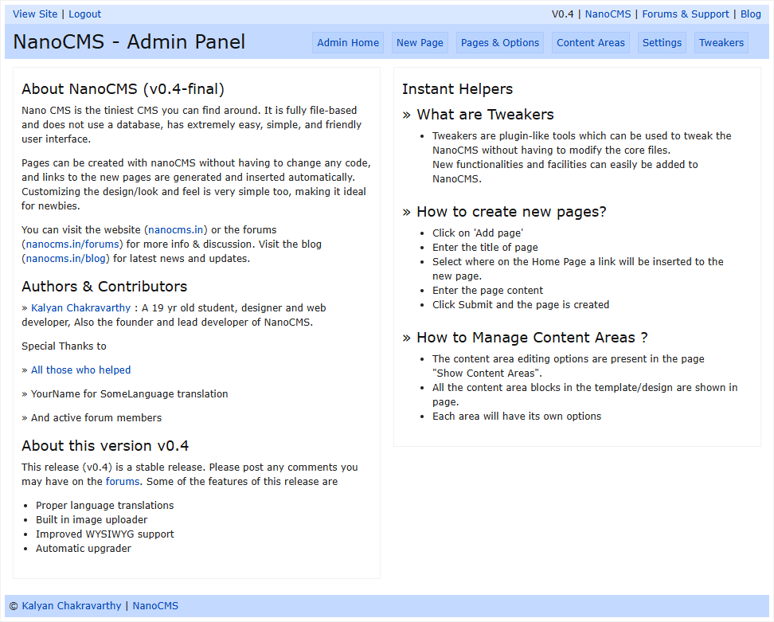
Stored XSS (Two Vulnerabilities)
There is a "new page" function for adding pages. Test for XSS.
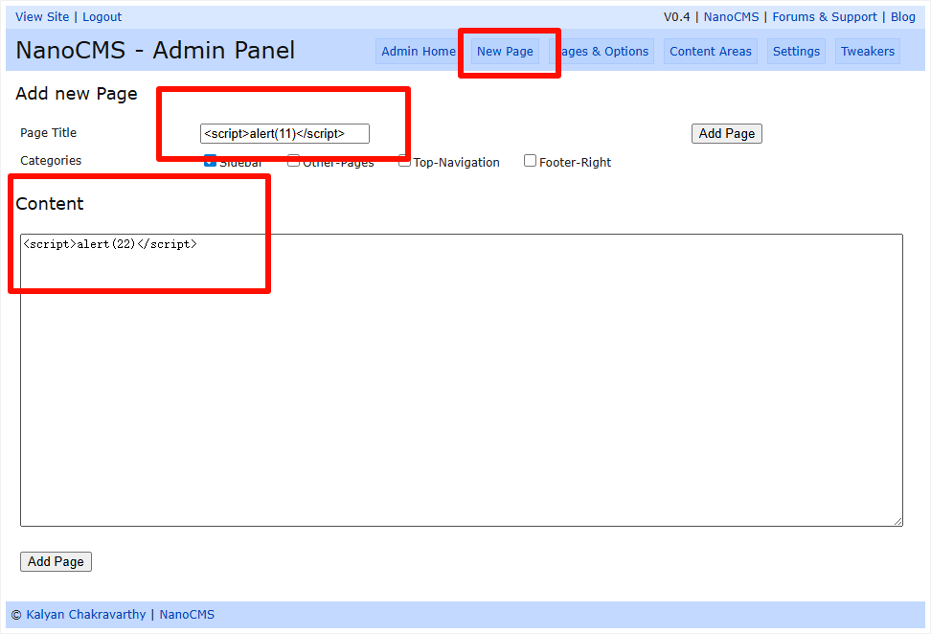
Then click on "Pages & Options" to view the page we added. The title XSS is triggered.
Clicking into the page can also trigger a content XSS. Both are stored XSS.
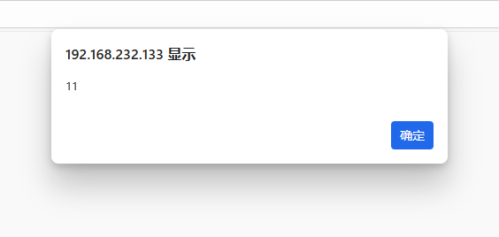 | 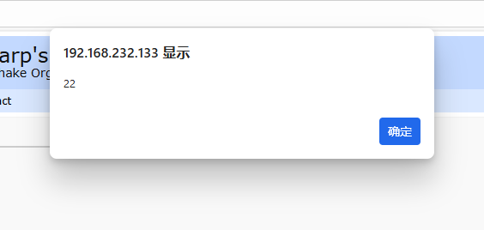
Four Reflected XSS Vulnerabilities
Content Areas page

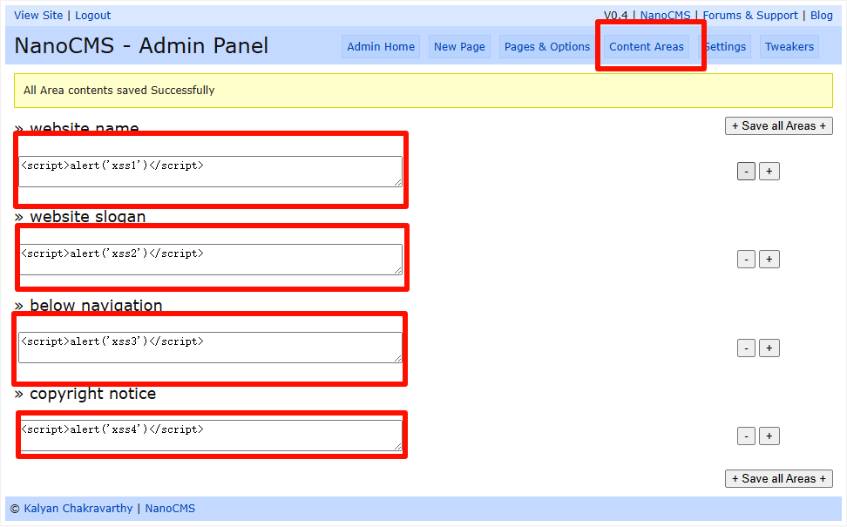
再点view site回到首页 发现已经全部改了 并弹出4个xss
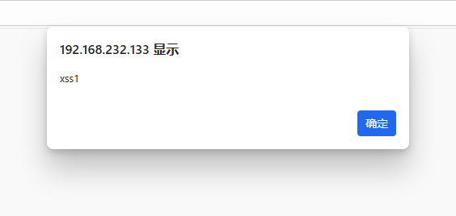 | 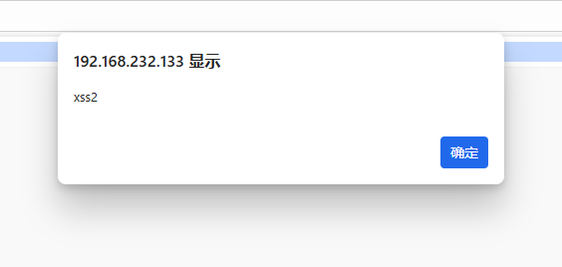

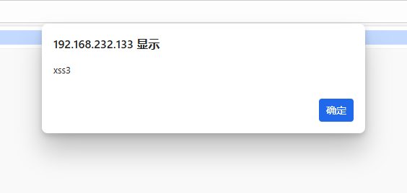 | 