AWS WordPress Project:

-Creating a highly available WordPress website on AWS.

# Problem Statement:

- A customer needs a blog website that she can use to post content, so users can see her work. The customer has some type of technical skills but would love to automate some of the technical tasks. The customer wants a service that can automate all the database tasks, but still want to have some type of control of the computing processes that run her site. More importantly, the customer wants the website to be inside a virtual private network for security reasons.

# Solution Statement:

- I advise the customer to go with Amazon AWS for hosting her website because AWS has a centralized system in terms of managing resources and services. She can benefit from it and AWS can also make her website highly available so users can access her website.

# AWS Services for the website:

- AWS Cloud platform: to host and manage the website.

- WordPress: to build the blog website.

- VPC: for the networking setting.

- RDS: to automate the database tasks.

- EC2: for the computing processes of the website and still give her the option to change it later on.

-MySQL: to store the website information.

-Security Group: to secure her AWS resources.

-Keypairs: to access the EC2 through an ssh command line.

-Let's login into our AWS account. I am going to use my IAM user to access my AWS account because it's best practice to use an IAM user who has administration privilege to access the account instead the root user.

-Let's create a highly available WordPress website:

I am creating the project in the N. Virginia (us-east-1) region because that is where the customer wanted the site to be hosted it. The goal is to create all the resources outside of global resources in this region because it's easy for the customer to manage all her resources.

### VPC Network Design:

-VPC IP Range: 172.20.0.0/16

4 subnets: 2 public subnets, 2 private subnets

2 zones: us-east-1a and us-east-1b

172.20.1.0/24 public-sub 1:us-east-1a

172.20.2.0/24 public-sub 2:us-east-1b

172.20.3.0/24 private-sub 1:us-east-1a

172.20.4.0/24 private-sub 2:us-east-1b

# Creating a VPC for the website

# creating a DB subnet for the database

# Creating RDS service with mySQL database for information storage:

# Launching an EC2 for the website

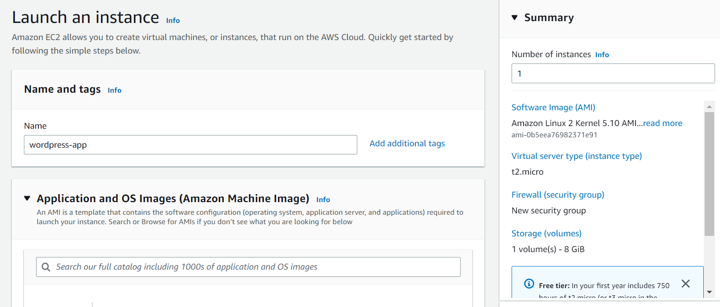

# Connecting into the EC2 instance

# Making sure that the httpd webserver is running on the instance

# Checking the EC2 instance for the public IP to access the wordpress website

# Accessing the Wordpress login page

# Accessing a page from the blog

# After creating the website domain name with Godaddy, I used Route 53 to manage the DNS records and to check the health of the website.