College of Computing and Informatics

Computer Science Department
University of Sharjah
Fall 2025/2026

Nexly: An Agentic AI-Powered Chatbot for student Advising

A project submitted
in partial fulfillment of the requirements for the degree of Bachelor of Science in Computer Science

by
Zyead Alwsh – U22106802
Theyab Mohammed - U21100918
Niaz Mahmud - U21102204
Abdullah Almazzmi - U21102590

Supervised by
Dr. Bouziane Brik

Nov 2025
ACKNOWLEDGEMENT

We would like to express our heartfelt gratitude to our supervisor, Dr. Bouziane Brik, whose guidance, patience, and expertise have been instrumental throughout this project. We also extend our sincere thanks to our families and friends for their unwavering support, encouragement, and understanding during this journey. Their belief in us provided the foundation for our commitment to excellence. This project reflects their collective contributions and faith in our potential.
UNDERTAKING

This is to declare that the project entitled “Nexly: An Agentic AI-Powered Chatbot for student Advising” is an original work done by undersigned, in partial fulfillment of the requirements for the degree “Bachelor of Science in Computer Science” at the Computer Science Department, College of Computing and Informatics, University of Sharjah, UAE.

All the analysis, design and system development have been accomplished by the undersigned. Moreover, this project has not been submitted to any other college or university.

Zyead Alwsh

Theyab Mohammed

Niaz Mahmud

Abdullah Almazzmi
ABSTRACT

Nexly is an intelligent academic advising chatbot designed to enhance student support at the University of Sharjah. This report summarizes the first phase of the senior project, building on the junior project groundwork. The motivation stems from challenges in traditional advising long wait times, inconsistent information, and accessibility barriers, which demand scalable, real-time solutions. Nexly addresses this by leveraging a Large Language Model (LLM) with a Retrieval-Augmented Generation (RAG) approach to provide accurate,

context-aware guidance. Key developments in this phase include migrating the prototype from a mobile application to a responsive Next.js web app, integrating a Supabase backend (PostgreSQL database and authentication service), and deploying initial academic data schemas (courses, study plans) for testing. We fine-tuned a 4-billion-parameter LLM (Qwen-4B) on domain-specific data using Kaggle’s GPU resources to tailor the model to university-specific queries. The system’s architecture has been redesigned to incorporate an agentic AI model capable of using external tools and data, while fully deprecating earlier mobile components. We outline the current implementation status, planned experiments for evaluating answer quality, and a project timeline with identified risks. The results so far indicate a viable path toward a robust, multi-lingual academic advisor chatbot that can provide instant, reliable support to students.
Table of Contents
LIST OF TABLES 6
LIST OF FIGURES 7
CHAPTER 1: Introduction 10
1.1 Overview 11
1.2 Project Motivation 11
1.3 Problem Statement 11
1.4 Project Aim and Objectives 12
1.5 Project Scope 13
1.6 Project Software and Hardware Requirements 13
1.7 Project Limitations 15
1.8 Project Expected Output 16
7.1 Project Schedule 17
CHAPTER 2: Related Existing System 17
2.1 Introduction 18
2.2 Existing Systems 18
2.3 Overall Problems of Existing Systems 19
2.4 Overall Solution Approach 20
CHAPTER 3: Methodology and Requirements 20
3.1 Stakeholders 21
3.2 Functional Requirements 21
3.3 Non-functional requirements 22
3.4 Data and Model Requirements (for AI/Data Science projects) 22
3.5 Interaction Flow/Use Case Diagrams 23
3.6 Constraints and Assumptions 23
CHAPTER 4: Architecture and System Design 23
4.1 Overview 24
4.2 Software architecture 24
4.3 Algorithms / Model Architecture (for AI/Machine Learning/Data Science) 25
4.4 User Interface and Interaction Design 26
CHAPTER 5: Implementation Plan 29
5.1 Description of Implementation 30
5.2 Technology Stack and Tools 30
5.3 Special Considerations for Implementation 31
5.4 Key Implementation Phases or Milestones 31
CHAPTER 6: Conclusion and Results 37
References 37

CHAPTER 1: Introduction

Overview
Academic advising is a vital part of college life, guiding students through courses, study habits, and graduation procedures. Traditional advising is often plagued with endemic issues such as long wait times, inaccurate information, and limited access. These issues highlight the need for scalable, intelligent systems to provide timely, targeted advice. Nexly addresses this issue with an AI-powered academic advising chatbot, designed for the University of Sharjah based on an Agentic AI model that can smartly interact with external tools and data sources. The system employs Large Language Models (LLMs), which are fine-tuned with domain-specific university data, to deliver precise, contextual, and reliable responses to students.

During this project phase, Nexly evolved from a mobile prototype to a Next.js web application with an overhauled user interface prioritizing accessibility, responsiveness, and a unified experience across devices. The obsolescence of the mobile app was implemented to bring uniformity and focus development on the web-based system in a way that it would be used seamlessly on desktop and mobile browsers alike. The fresh UI is complemented by a Supabase backend, which manages authentication, course data, and study plans to facilitate real-time academic inquiries.

Lastly, Nexly is a modern approach to academic advising that combines modified LLM expertise, Agentic AI capabilities, and a clean web UI in order to deliver accurate, in-the-moment academic guidance. Through transforming the way that students can tap into university information and advice, Nexly aims to enhance advising efficiency, promote well-informed decision-making, and set the foundation for AI-facilitated education services within the University of Sharjah.

Project Motivation
With the new high-speed academic environment, students are often in need of help with course prerequisites, deadline enrollments, and college regulations. Traditional advising methods are beset with inefficiencies such as advisors' short time, extensive waiting lines, and inconsistent advice. This disarray leads to misinformation and bad choices, which account for student failure. Intelligent academic support technologies that can provide timely and personalized advice to a growing student population are sorely needed. Large Language Models (LLMs) recently revolutionized conversational AI by enabling the potential for contextual understanding and response generation that's human-like. This project aims to apply these developments to the academic advising at our university.

Problem Statement
The project is an answer to the challenge of supplying on-demand and precise academic counsel through an AI chatbot. Good information about course selection, degree rules, and university regulation is largely unavailable to most students due to limited direct access. The problem is further compounded by the static nature of FAQs and the limited scope of the existing systems. Nexly will address this gap by providing an academic virtual advisor in the form of a natural language one that can interact with students naturally, answer queries related to academics and guide them through university protocols. The principal concern is to ensure that the chatbot provides the right, relevant, and context-sensitive responses while maintaining the trust and attention of student users.

Project Aim and Objectives
Provide Context-Aware Advice: Provide individualized academic advice by referencing context from conversation and the student's academic history (when available), making sure answers are contextualized to the user's context and purpose of question.
Real-Time Information Access: Link with university information (courses, programs, deadlines) so the chatbot can provide real-time responses regarding course availability, registration dates, advisor hours, etc. (subject to data availability and permissions).
Platform Accessibility: Ensure the solution is available on all devices. This is achieved initially through a responsive Next.js web application that functions well on both desktop and mobile browsers, providing on-the-go assistance without the need for a specific mobile app.
Scalability and Security: Design the system to scale with more users and queries while ensuring security of student data. This means taking advantage of cloud-ready infrastructure and robust authentication/authorization. For example, Supabase's managed PostgreSQL ensures that data is stored securely, and user authentication tokens encrypt dialogues and any user-specific data.
Increased Student Engagement: Enhance the advising process through functionalities like personalized recommendations and possibly community-oriented Q&A. The chatbot may also be able to offer peer-to-peer assistance or steer students to relevant forums/resources, thereby increasing overall student engagement in academic planning.
Accuracy and Reliability: Minimize misinformation through the use of a RAG approach – retrieving answers from verified university sources and using an LLM to generate answers based on those sources. There should be a built-in confidence-checking feature so that when the chatbot is low-confidence with an answer, it should not respond or request clarification from the user. This objective is crucial to building credibility in Nexly's answers.
By achieving these objectives, Nexly plans to transform the college advising process. Students will be given real-time, accurate counsel, reducing dependency on harried academic staff and enabling better-informed decisions regarding their own education. The first phase of the senior project is focused on laying the foundation for these purposes, as described in the sections below.

Project Scope
The scope of Nexly is focused on academic advising for University of Sharjah students. It covers topics such as course information, study plans, academic policies, important dates, and common administrative procedures. Nexly is designed as a web-based application accessible via browsers on desktops and mobile devices (responsive design), which replaces the earlier plan for separate native mobile apps. By narrowing the scope to the university’s academic domain, we can fine-tune the system to provide in-depth support (e.g. course prerequisites, degree audit guidance) rather than broad open-domain chatting. Integration with live university systems (like student information systems) is limited in this phase; Nexly will primarily rely on a curated knowledge base of university information and publicly available data. Future phases may extend scope to deeper integrations (e.g. pulling a student’s personal schedule or records) pending necessary approvals.

Project Software and Hardware Requirements
Software Requirements:
- Frontend Framework: Next.js (React-based web framework)
- Styling Framework: Tailwind CSS for responsive and consistent UI design
- Backend Platform: Supabase (PostgreSQL database, authentication, and API services)
- Programming Languages:
  - TypeScript / JavaScript (for web application)
  - Python (for AI and fine-tuning scripts)
- AI & Machine Learning Libraries:
  - Transformers (for model loading and fine-tuning)
  - PyTorch (deep learning framework)
  - Sentence-Transformers (for embedding generation)
- API & Server Frameworks:
  - Flask (Python-based API for model inference)
  - Node.js API routes (for communication between frontend and backend)
- Development Tools:
  - Visual Studio Code (IDE)
  - GitHub (version control and repository hosting)
  - Kaggle and Google Colab (GPU resources for model fine-tuning)
- Deployment & Hosting:
  - Vercel (for hosting the Next.js application)
  - Supabase Cloud (for database and authentication services)
Hardware Requirements:
- For Development:
  - Processor: Intel Core i7 / AMD Ryzen 7 (or equivalent)
  - Memory (RAM): Minimum 16 GB
  - Storage: Minimum 50 GB free space
  - GPU: Optional (for local AI testing, e.g., NVIDIA GTX 1660 or higher)
  - Operating System: Windows 10 / 11, macOS, or Linux
- For AI Model Fine-Tuning:
  - GPU: NVIDIA Tesla T4 / V100 / A100 or equivalent
  - VRAM: Minimum 16 GB
  - Cloud Platform: Kaggle, Google Colab, or equivalent GPU-enabled environment
- For Deployment (Server Requirements):
  - CPU: 8-core or higher
  - RAM: Minimum 16 GB
  - Storage: Minimum 100 GB SSD
  - Internet Connectivity: Stable broadband connection for real-time responses
  - Hosting Environment: Cloud server (e.g., AWS, Azure, or Supabase infrastructure)

Project Limitations
- Data Scope Limitations: Nexly's database is restricted to public university data such as course descriptions, study plans, academic policies, and advising procedures. The system will not handle or process confidential student information such as grades, transcripts, or academic records. Integration with the University's internal Student Information System (SIS) or other secured databases is not within this phase due to the privacy and accessibility limitations of the data.
- Functional Limitations: The current version of Nexly includes text-based counseling and does not support sophisticated features such as voice recognition, speech output, or live human advisor chat. Additionally, while the system is built on Retrieval-Augmented Generation (RAG) to provide accuracy, it may also encounter occasional rare inaccuracies or unavailable responses if the information is incorrect, does not exist, or is outdated in the knowledge base.
- Platform and Deployment Limitations: Nexly has been fully transitioned to a web application on Next.js, and the mobile app version has been retired. Native Android or iOS apps are not a part of the current implementation to maintain consistency and avoid duplicated development. The web app is made mobile-friendly and accessible via browsers on any device, however.
- Model and AI Constraints: The AI model used, Qwen-4B, is domain-tuned on data but still operates within the boundaries of a small-to-medium-sized LLM. The model is reliant on external GPU for tuning and may be restricted in scalability or real-time inference if put on low-performance devices. Also, the chatbot is currently English-only support with Arabic support to be deployed in future.
- Integration and Agentic AI Scope Although Nexly's architecture has been structured to support Agentic AI capabilities (e.g., use of external APIs or third-party tools), all these abilities are partially implemented in this phase. The chatbot has not yet conducted live operations such as scheduling appointments, pulling current university data, or conducting administrative transactions. These are planned for future development pending institutional clearances and availability of APIs.
- Constraints of Evaluation and Testing The testing of Nexly is qualitative and functional, conducted by project members and a small group of student volunteers. Large-scale user testing and formal deployment across the university fall outside the scope of this phase. Model performance will also vary depending on the complexity of query, network state, and server load.

Project Expected Output
- Functional Academic Advising Chatbot: The primary goal is to create a working chatbot that will be able to understand student questions about courses, study plans, academic policies, and registration procedures. The chatbot should respond with clear, factual, and contextually relevant answers based on verified university information using the Retrieval-Augmented Generation (RAG) technique.
- Integration of Fine-Tuned LLM: One of the primary desired results is the successful fine-tuning of the Qwen-4B Large Language Model on domain-specific datasets extrapolated from the academic content of the University of Sharjah. This ensures that the model generates correct, institution-specific responses and demonstrates measurable improvement in performance compared to a general-purpose LLM.
- Integration of Agentic AI Capabilities: Nexly will demonstrate the foundation of an Agentic AI system—one that can potentially utilize external tools and perform some actions, such as retrieving course data or consulting university documents dynamically. Though primitive at this phase, successful delivery of basic agentic behavior will validate Nexly's extensibility and readiness for more advanced capability in subsequent phases.
- Responsive Web-Based Platform: The project seeks to deliver a full Next.js web application that replaces the aging mobile application. The target is a new, responsive, and mobile-friendly interface with the same user experience on any device. Secure authentication, structured data storage, and easy interaction with the AI components are ensured by using Supabase as backend.
- Accuracy, Reliability, and User Satisfaction: One of the most important measures of success is how reliable and accurate Nexly's responses are. The system should correctly extract correct information from the knowledge base and minimize hallucinations or off-topic responses. Secondly, the chatbot should receive positive feedback from student testers regarding usability, clarity, and utility, demonstrating that it is a viable academic advising tool.
- Scalable and Secure Architecture: The anticipated outcome includes the development of a secure, scalable system architecture that can support increased user demand and data growth. The user data must be protected by security mechanisms like authentication, authorization, and encrypted communication, thus maintaining trust in the system's reliability and adherence to privacy.
- Basis for Future Development: Finally, the project aims to pave the way for future innovations such as multilingual functionality (Arabic integration), more comprehensive system integrations with university databases, and other advanced agentic features. Having an effective and stable prototype at this phase ensures that Nexly can evolve into a full-fledged academic advising assistant in later phases.

Project Schedule
https://uoshj-my.sharepoint.com/:x:/g/personal/u21100918_sharjah_ac_ae/EWh-S-W6LxtLvz1lS5Pj-1cBJoXvJBXFjdn9TMGoJ0o1fQ?e=NfBPq0

CHAPTER 2: Related Existing System

Introduction
This chapter explores existing research, tools, and systems related to academic advising chatbots and AI-driven student support solutions. It reviews prior work in the field, identifies their limitations, and outlines how Nexly builds upon and improves existing methodologies. The analysis focuses on university-based chatbots, AI-powered assistants, and retrieval-based systems that have been deployed in educational settings, highlighting the advancements and shortcomings that shaped Nexly’s design approach.

Existing Systems

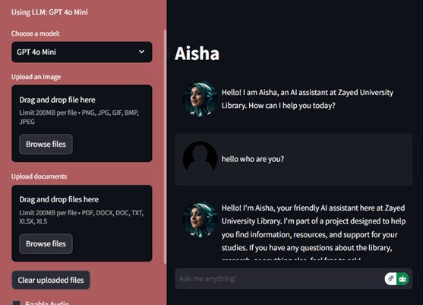

AISHA – Artificially Intelligent Super Helpful Assistant (Zayed University):
AISHA is a library assistant chatbot that uses OpenAI’s GPT-based models integrated through the LangChain framework. It employs Retrieval-Augmented Generation (RAG) to retrieve data from library sources and generate accurate responses. AISHA’s design includes multiple integrations, such as catalog searches, voice interaction, and transparency features that show users how the AI arrived at its response. However, its scope is limited to library and reference services rather than comprehensive academic advising.

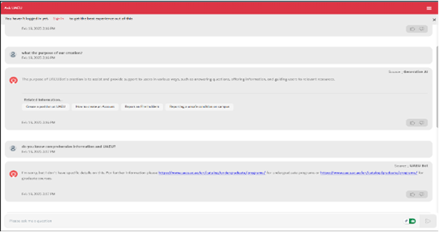

UAEU Bot – United Arab Emirates University:
The UAEU Bot is a text and voice-based chatbot that helps students access university services such as class schedules, admissions information, and contact directories. It is connected to internal databases, allowing it to retrieve personalized data such as GPA or course schedules. Despite its functionality, the UAEU Bot primarily follows predefined conversational flows and lacks the flexibility of advanced LLMs. Its responses are often structured and static, limiting adaptability to open-ended or contextual student queries.
Globally, various universities have experimented with AI chatbots for advising and student support using rule-based or retrieval-based systems. However, these often lack deep contextual understanding, natural language fluency, and adaptability to specific institutional policies.

Overall Problems of Existing Systems
- Limited Contextual Understanding: Most systems rely on static FAQ databases or pre-scripted dialogues, which fail to handle follow-up questions or complex academic scenarios.
- Restricted Scope: Many chatbots are focused on narrow domains (e.g., library support or admissions) and cannot offer holistic academic advising across courses, degree requirements, and policies.
- Lack of Real-Time Adaptation: Current systems do not dynamically adapt to updated academic information, leading to outdated or incomplete responses.
- Absence of Agentic Intelligence: Existing chatbots lack the ability to perform autonomous actions, such as retrieving external data or performing system-level tasks on behalf of users.
- Fragmented Platforms: Some institutions deploy separate mobile and web applications, resulting in inconsistent user experiences and higher maintenance costs.

Overall Solution Approach
Nexly builds upon the foundations of systems like AISHA and UAEU Bot by adopting proven techniques such as Retrieval-Augmented Generation (RAG) for accurate information retrieval and vector-based knowledge storage for semantic search. The project integrates these existing methodologies within a modern, scalable web application architecture powered by Next.js and Supabase, ensuring reliable data management and authentication. By combining structured database lookups with LLM-generated responses, Nexly merges the strengths of retrieval-based systems with the conversational fluidity of generative AI.
Nexly introduces several novel contributions beyond existing solutions:
- Agentic AI Framework: Incorporates an agentic model capable of reasoning and performing limited tool-based actions, paving the way for future integration with university systems (e.g., GPA lookups, schedule planning).
- Fine-Tuned LLM: Utilizes a fine-tuned Qwen-4B language model trained specifically on University of Sharjah data to deliver accurate, context-aware, and domain-specific responses.
- Unified Web Platform: Replaces the earlier mobile application with a responsive, mobile-friendly Next.js web interface, ensuring consistent performance and accessibility across devices.
- Confidence and Accuracy Mechanism: Implements a confidence-scoring system to minimize misinformation, allowing the chatbot to prompt for clarification when uncertain.
- Multilingual Readiness: Designed with future support for English and Arabic, enhancing accessibility for the diverse student community at the University of Sharjah.
By integrating established AI techniques with these innovative approaches, Nexly aims to set a new standard for academic advising automation—providing students with a trustworthy, efficient, and intelligent academic assistant that overcomes the limitations of existing systems.

CHAPTER 3: Methodology and Requirements

Stakeholders
Stakeholder | Description | Type
University Students | Primary users who interact with Nexly for academic guidance and course-related information. | Primary Stakeholder
Academic Advisors and Faculty Members | Use Nexly as a support tool to streamline advising processes and reduce workload. | Primary Stakeholder
Project Development Team | Responsible for designing, developing, fine-tuning, and deploying the Nexly system. | Primary Stakeholder
University of Sharjah IT Department | Provides infrastructure support, ensures compliance with university data and network security policies. | Secondary Stakeholder
University Administration and Management | Oversees system adoption, policy alignment, and long-term institutional integration. | Secondary Stakeholder
Future Students and Prospective Users | Potential users who may benefit from Nexly’s advising features in later phases. | Tertiary Stakeholder
Supervising Instructors and Evaluators | Evaluate the technical and academic quality of the Nexly project. | Secondary Stakeholder

Functional Requirements
Requirement | Description
User Authentication | The system must allow users to register, log in, and securely access their accounts using Supabase authentication.
Conversational Interface | Users must be able to input academic queries and receive AI-generated, context-aware responses.
Retrieval-Augmented Generation (RAG) | The system must retrieve relevant university data (courses, study plans, policies) and use it to generate grounded responses.
Knowledge Base Management | The chatbot must access and maintain a structured database containing course information, prerequisites, and academic regulations.
Language Understanding | The chatbot should understand natural language queries in English and respond accurately. Arabic support will be added in later phases.
Agentic AI Capability | The system must be capable of identifying when to perform specific external actions, such as retrieving additional information or suggesting resources.
Context Retention | The chatbot must maintain short-term conversational context to handle follow-up questions effectively.
Response Accuracy Validation | The system must verify generated responses through a confidence-scoring mechanism to ensure reliability.
Administrative Access | Administrators should be able to update the knowledge base and manage system configurations through secure backend tools.

Non-functional requirements
- Execution qualities:
Requirement | Description
Usability | The user interface must be intuitive, responsive, and accessible on both desktop and mobile devices.
Security | All user data and communications must be encrypted (via HTTPS) and protected through Supabase authentication.
Performance | The system must respond to user queries within 5 seconds on average.
Reliability | The system must maintain stable operation with minimal downtime during normal use.
Privacy | The system must not access or store personal student data unless authorized, ensuring compliance with university data protection standards.

- Evolution qualities:
Requirement | Description
Maintainability | The system codebase should be modular and well-documented to allow future updates and debugging.
Scalability | The architecture must support expansion in both user base and data volume without performance degradation.
Extensibility | The system should support future integration with university APIs (e.g., SIS or GPA lookup).
Testability | Unit and integration testing must be implemented to ensure system reliability after updates.
Portability | The system should be deployable on cloud platforms like Vercel or local university servers with minimal reconfiguration.

Data and Model Requirements (for AI/Data Science projects)
Requirement | Description
Data Sources | Publicly available University of Sharjah data such as course catalogs, study plans, academic calendars, and policy documents.
Preprocessing | Data must be cleaned, tokenized, and split into manageable chunks (~250 words) for embedding and retrieval.
Embedding Model | The system uses the Sentence-Transformer model (multi-qa-mpnet-base-dot-v1) for generating embeddings.
LLM Base Model | Qwen-4B model fine-tuned on university-specific text data for domain adaptation.
Fine-Tuning Requirements | Training performed using Kaggle GPU environments; datasets must include diverse academic queries for improved generalization.
Accuracy Target | The fine-tuned model should achieve at least 85% correctness on test questions derived from official academic sources.
Evaluation Metrics | Semantic similarity (cosine similarity), manual correctness evaluation, and response latency.

Interaction Flow/Use Case Diagrams

Constraints and Assumptions
Constraints:
- Resource limitation: GPU access is limited to free-tier resources (Kaggle and Colab), constraining fine-tuning scale.
- Data Access Restrictions: Only publicly available academic information can be used
- Deployment Constraints: The application must be deployable on low-cost or free hosting services such as Vercel and Supabase.
- Model size: The LLM must be lightweight enough (Qwen-4B) to operate efficiently on a single GPU or CPU environment.

Assumptions:
- Internet Connectivity: Users are assumed to have stable internet access when using the web application.
- User Device Compatibility: Users will access Nexly via modern browsers supporting JavaScript and WebSocket technologies.
- Data Validity: University data retrieved from public sources (e.g., websites, catalogs) is assumed to be accurate and up to date.
- Model Generalization: The fine-tuned model will generalize effectively across a variety of academic queries.
- Institutional Support: It is assumed that the university IT department will provide future support for integration and deployment.

CHAPTER 4: Architecture and System Design

Overview
Nexly is a modular, web-based architecture with an integrated frontend, backend, and AI capacity to offer students of the University of Sharjah with smart academic guidance. The architecture is client-server based to allow user interaction, data collection, and AI-powered responses to be managed in a secure and efficient way.
At a high-level perspective, Nexly consists of four basic layers:
Frontend Interface (Client-Side) – Provides an accessible and responsive user interface for students to interact with the chatbot.
Backend API Layer (Server-Side) – Handles communication among the frontend, database, and AI engine.
Database and Knowledge Base Layer – stores structured academic data such as course details, study plans, and advising information.
AI and Model Layer – Processes queries, retrieves information based on embeddings, and produces text utilizing a fine-tuned Qwen-4B language model.
Information flows from the user interface to the backend, where the system retrieves contextually relevant information via a Retrieval-Augmented Generation (RAG) pipeline. The information is then passed through the AI model, which generates a natural-sounding answer that is displayed back to the user. The modular design maintains scalability, maintainability, and rapid performance.

Software architecture
The Nexly software architecture is based on a three-tier client-server model, consisting of the Presentation Layer, Application Layer, and Data Layer.
1. Presentation Layer (Frontend)
- Developed using Next.js, a React-based web framework that provides server-side rendering and optimized performance.
- Tailwind CSS is used for responsive and consistent UI design, ensuring accessibility across all devices.
- The frontend is responsible for:
  - Rendering the chat interface.
  - Handling user input and authentication.
  - Displaying AI-generated responses.
- It communicates with the backend through secure RESTful APIs.
2. Application Layer (Backend)
- The backend serves as the intermediary between the user interface, database, and AI model.
- Built using Node.js for API management and Flask (Python) for handling AI inference requests.
- Core functions include:
  - Managing requests and responses.
  - Handling user authentication via Supabase APIs.
  - Processing user queries through the RAG pipeline.
  - Communicating with the AI model to generate responses.
- Implements security measures such as HTTPS encryption and token-based authentication for safe data exchange.
3. Data Layer (Database and Knowledge Base)
- Managed through Supabase (PostgreSQL), which stores:
  - Course information.
  - Study plan data.
  - University policies.
  - User login credentials.
- Uses pgvector extension to store and retrieve semantic embeddings for efficient vector-based searches.
- Supports structured data retrieval for AI grounding and verification.
4. AI and Model Layer
- The AI module integrates a fine-tuned Qwen-4B LLM (Large Language Model) trained on University of Sharjah–specific data.
- Incorporates the RAG (Retrieval-Augmented Generation) approach:
  - User query is embedded using Sentence-Transformer embeddings.
  - Relevant academic documents are retrieved from the vector database.
  - The query and retrieved content are combined into a prompt.
  - The fine-tuned model generates a grounded, factual response.
- This approach ensures responses are both accurate and contextually aligned with university information.

Algorithms / Model Architecture (for AI/Machine Learning/Data Science)
1. Retrieval-Augmented Generation (RAG) Algorithm
The RAG pipeline combines information retrieval with text generation. Its algorithmic flow is as follows:
- Input Processing:
  - User query is tokenized and embedded into a high-dimensional vector using a Sentence-Transformer model.
- Document Retrieval:
  - The vector representation of the query is compared to stored document embeddings in pgvector, and the top-k most relevant entries are selected.
- Context Construction:
  - Retrieved documents are concatenated to form a context block, which provides grounding information for the AI model.
- Response Generation:
  - The context and user query are combined into a structured prompt and sent to the fine-tuned Qwen-4B model, which generates a natural-language response.
- Post-Processing:
  - The response is filtered for accuracy, formatted, and returned to the frontend.
This hybrid approach allows Nexly to avoid hallucinations and ensures the chatbot provides verified academic information.
2. Fine-Tuned Qwen-4B Model Architecture
The Qwen-4B model is a transformer-based LLM optimized for language understanding and response generation.
- Base Model: Qwen-4B (4 billion parameters).
- Fine-Tuning Objective: Domain adaptation for University of Sharjah content (study plans, course guides, policies).
- Training Environment: Google Colab and Kaggle GPUs (Tesla T4).
- Optimization Techniques:
  - Low-Rank Adaptation (LoRA) for efficient fine-tuning.
  - Learning rate scheduling and batch normalization to prevent overfitting.
  - Evaluation based on semantic similarity and factual accuracy.
By fine-tuning the model, Nexly achieves institution-specific contextual understanding while maintaining general language fluency.

User Interface and Interaction Design

The whole Nexly User Interface (UI) has been redesigned to present a smooth and uniform experience across all devices — from tablets and mobile phones to personal computers. The redesigned interface is easier to access, responds faster, and is less complicated in design to enable easy use of Nexly by students and academic advisors from anywhere.

Developed using Next.js and Tailwind CSS, the UI adapts dynamically to differences in screen sizes and input devices with an uncluttered intuitive presentation and unobstructed visual structure. Key design elements such as larger touch-friendly buttons, collapsible menus, and adaptive text all work towards maximum usability on small screens without loss of features on desktops.

This new interface aligns with Nexly's vision of a single, user-centric web experience. Deprecating the standalone mobile app and integrating all functionality into a single responsive web site enforces consistency, reduces maintenance, and makes the most accessibility available to all. The result is a clean, optimized, and visually elegant interface that makes the most of Nexly's ability to provide smart, real-time academic guidance in the most accessible way possible.

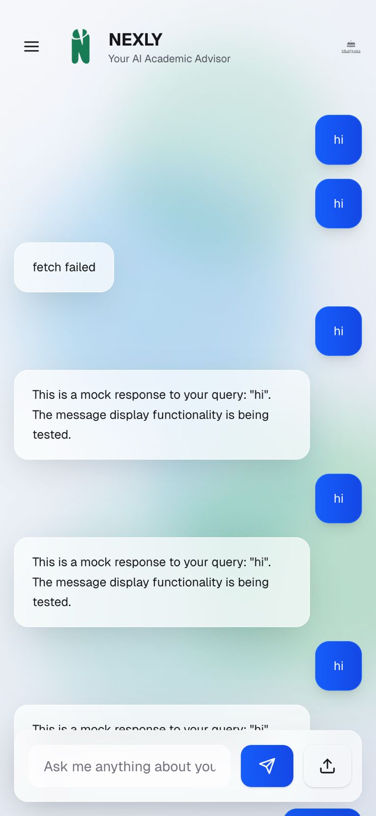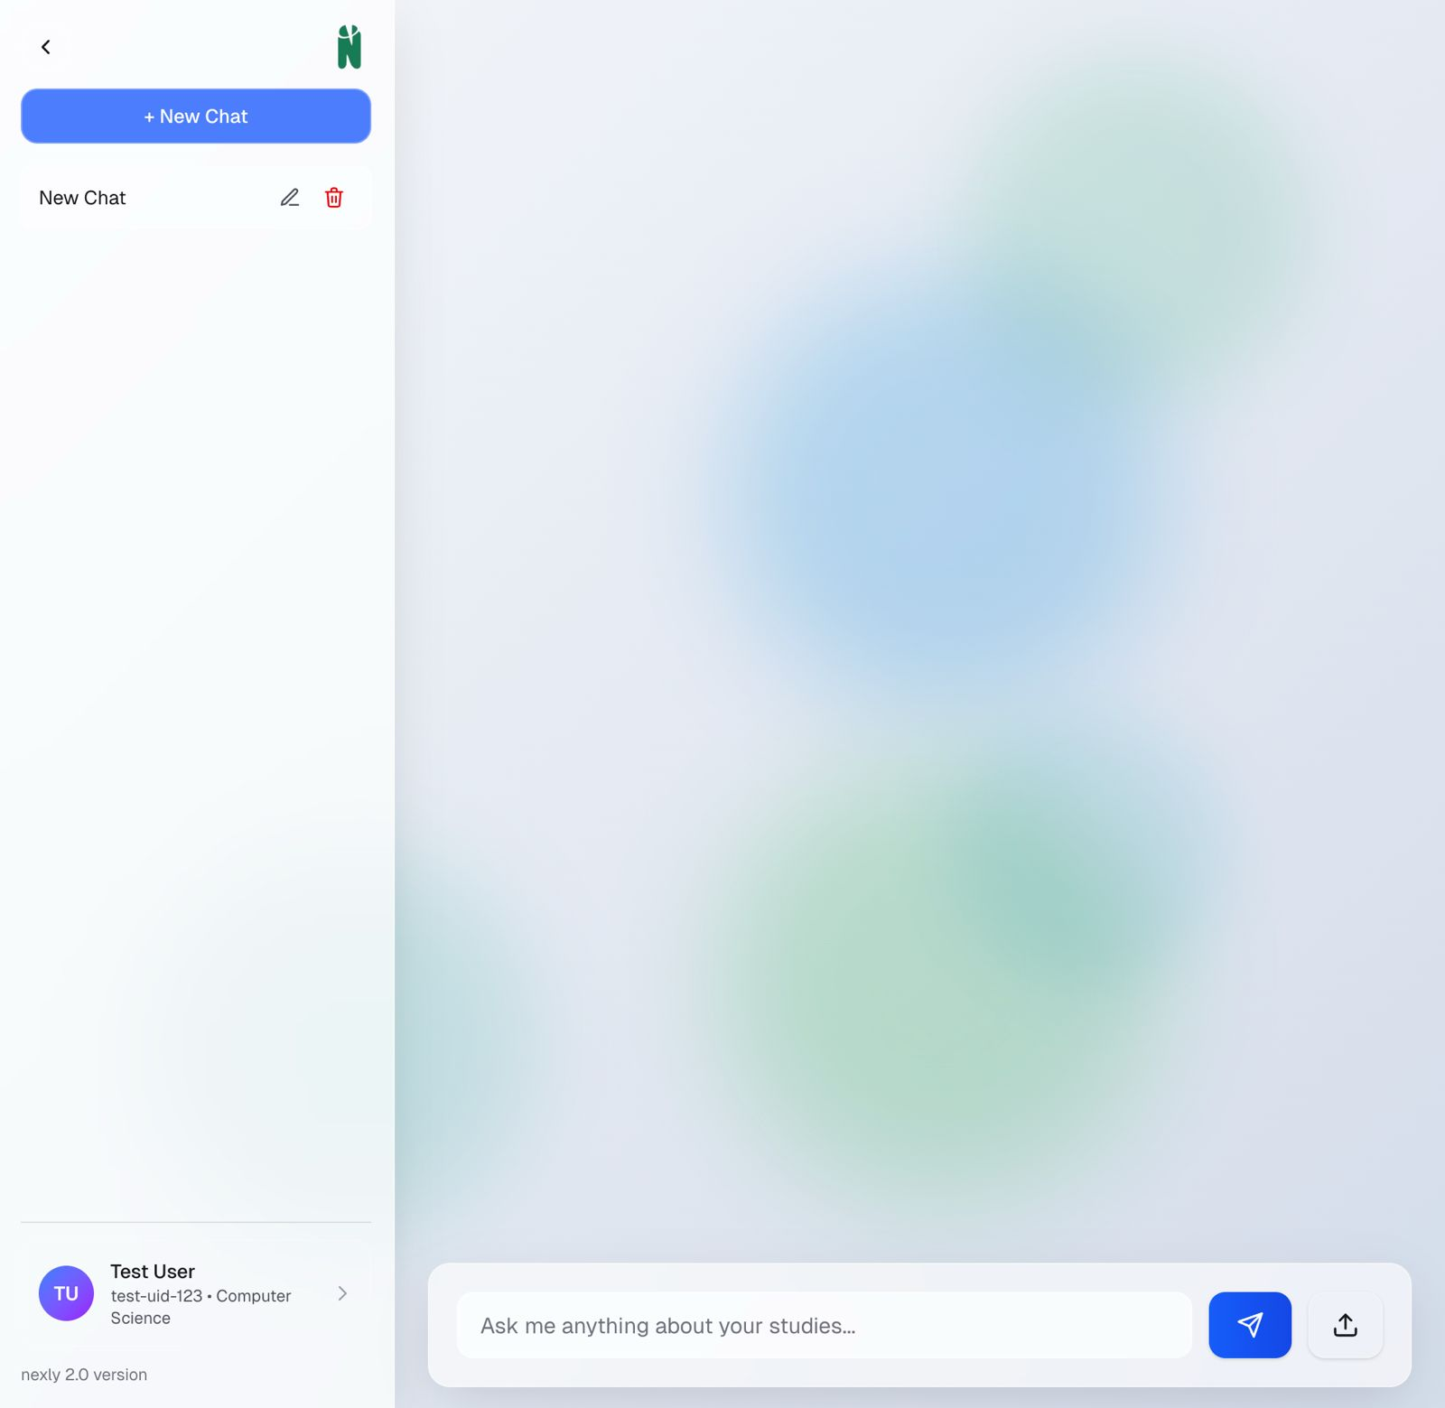

The screenshot above showcases the brand new and modernized user interface of the Nexly web application. The new interface is a complete redesign of the previous design with an emphasis on accessibility, responsiveness, and consistency. The UI is fully dynamic, meaning it resizes automatically for any device one uses to access the website — be it a desktop computer, tablet, or mobile phone. This gives every user the same responsive navigation, clutter-free design, and streamlined performance, regardless of screen size or platform.

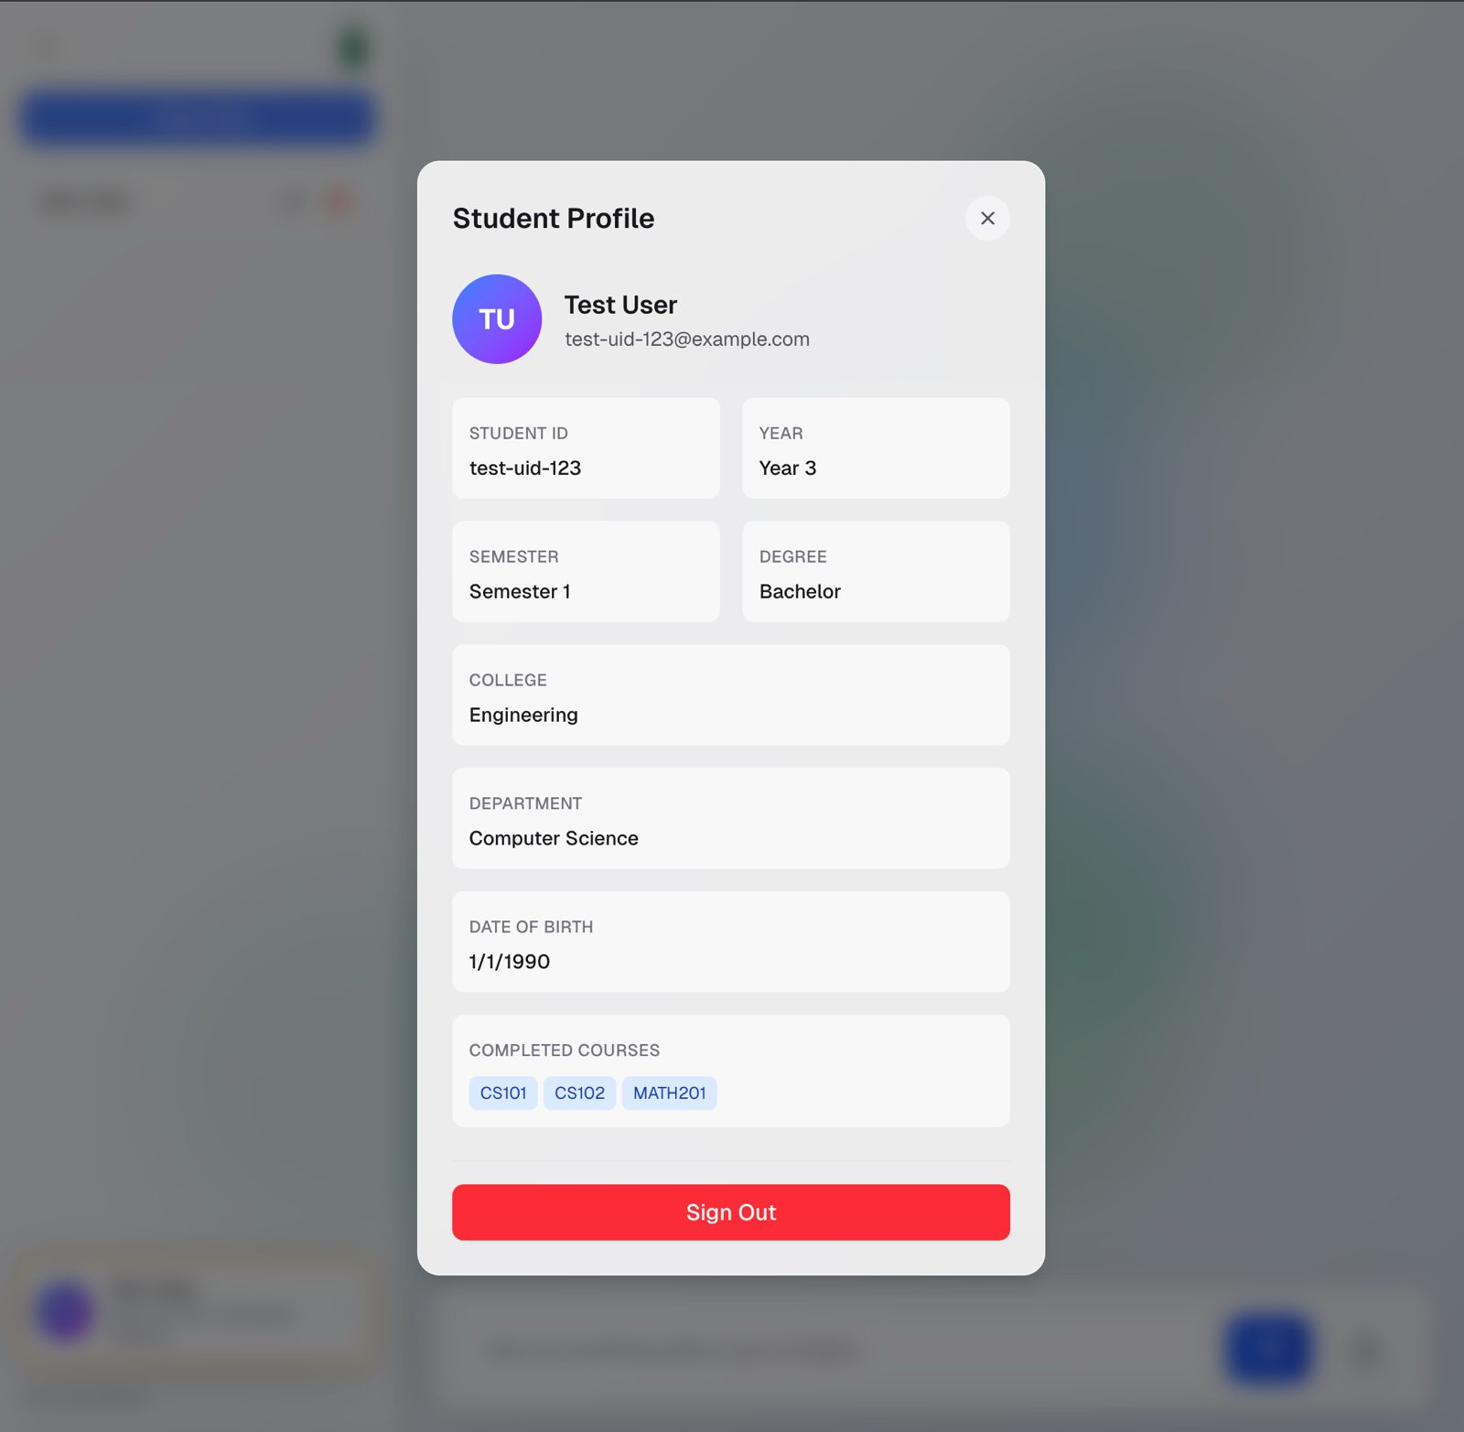
The following image presents the information pertaining to every user account, a very important input in making Nexly more personalized and accurate in its output. The points of data are stored securely and used to help the Large Language Model (LLM) to provide more context-specific and personalized scholarly advising outputs

CHAPTER 5: Implementation Plan

Description of Implementation
This chapter outlines the Nexly implementation plan, from development, deployment, and system conversion into an active academic advising platform. It outlines the key stages of implementation from frontend and backend development, through AI model integration, and deploying to the cloud. The chapter also identifies the technologies, tools, and resources utilized in supporting the implementation process. By defining the step-by-step approach, this section ensures that Nexly's development occurs in a systematic and efficient manner towards a solid, scalable, and user-friendly solution for the University of Sharjah.

Technology Stack and Tools
Component | Technology / Tool | Description / Purpose | Type
Frontend Framework | Next.js (React) | Builds the user interface and handles client-side rendering. | Open-source
Styling Framework | Tailwind CSS | Ensures consistent and responsive design across devices. | Open-source
Backend Platform | Node.js & Flask | Node.js handles API routing; Flask manages AI inference requests. | Open-source
Database & Authentication | Supabase (PostgreSQL) | Stores structured data (courses, study plans, users) and manages authentication. | Cloud service
Vector Database | pgvector | Stores and retrieves semantic embeddings for RAG retrieval. | Open-source
AI Model | Qwen-4B | Fine-tuned LLM for academic advising responses. | Open-source
Embedding Model | Sentence-Transformers | Generates embeddings for semantic document retrieval. | Open-source
Development Environment | Visual Studio Code | Primary IDE for coding and debugging. | Commercial (Free license)
Collaboration Tools | GitHub | Version control and code repository management. | Open-source
Cloud Hosting | Vercel & Supabase Cloud | Hosts the web application and backend. | Cloud-based
Training Platform | Kaggle / Google Colab | Provides GPU access for fine-tuning and model evaluation. | Cloud-based

Special Considerations for Implementation
- Cloud Deployment:
The system is fully cloud-hosted using Vercel (for the Next.js frontend) and Supabase Cloud (for database and authentication). This ensures 24/7 uptime, easy updates, and minimal maintenance.
- Real-Time AI Inference:
Since Nexly provides real-time responses to user queries, it was essential to optimize model inference time. The use of a fine-tuned Qwen-4B model with LoRA optimization significantly reduced latency while maintaining accuracy.
- Data Privacy and Security:
All user sessions are authenticated through Supabase Auth, and communication occurs over secure HTTPS channels. No personal academic data (like GPA or transcripts) is stored or processed to comply with privacy regulations.
- Scalability:
The architecture supports future scaling to accommodate more users and data. Cloud-based services such as Supabase and Vercel automatically manage load balancing and resource allocation.

Key Implementation Phases or Milestones
In the first phase of this senior project, our implementation efforts have focused on transitioning from concept and prototype (established during the junior project) to a functional system foundation. Below we detail the implementation progress so far and outline the plan moving forward into the next phase.
Current Repository and Development Status: As of this report, the Nexly codebase (in the GitHub repository) reflects the following major implemented components:
- Next.js Web Application: We bootstrapped a Next.js project (using TypeScript for type safety) to serve as Nexly’s front-end. The repository contains pages for authentication (signup/login) and the main chat interface. We utilized a UI library (e.g., Tailwind CSS or Material UI) to speed up development of a clean interface. The chat page is functional – a user can input a query and receive a displayed answer. Right now, for testing, the answers are fetched from the integrated back-end pipeline described earlier. We have also included placeholders for multi-turn conversation display (showing past questions and answers in a scrollable view). State management on the front-end is kept simple (using React hooks and context) since most heavy logic is server-side. The responsiveness of the UI has been verified on different screen sizes to ensure mobile browser compatibility.

- Supabase Integration: The repository includes configuration for connecting to our Supabase instance (using the Supabase client library). API keys and database URL are stored securely (not committed to the repo, but configured via environment variables). The user authentication flow is working: new users can register with email (with email verification enabled), and returning users can log in. Upon login, the Next.js app obtains a JWT from Supabase which is stored (in memory or local storage) and used to authenticate API calls. We created database schemas in Supabase for courses and study plans and inserted sample data. For example, a sample “Computer Science BSc” study plan is stored, listing required courses by semester. We also added a small set of course entries (with attributes like code, name, credit hours, prerequisite codes, etc.). These serve both as a test data set and as a seed for building the Q&A knowledge base. The repository’s back-end code can query this database – for instance, we have an API route that can retrieve course info by code. This is currently used in the pipeline such that if the AI needs details on a course, it can get them from the DB (via an internal call). Supabase also provides real-time capabilities and fine-grained access control, which we plan to leverage later (e.g., to restrict certain data to admin or to allow live updates of content that the front-end can subscribe to).

- LLM and RAG Pipeline Implementation: A significant portion of the implementation effort has gone into setting up the RAG pipeline and integrating the LLM:
  - We have written scripts (in Python, maintained separately from the Next.js app but documented in the repo) to scrape and preprocess university content. Using Python’s Selenium and BeautifulSoup libraries, we crawled the public sections of the University of Sharjah website and extracted text from relevant pages (such as the academic catalog, advising office pages, FAQs, and some PDF documents like academic calendar or guidelines). The raw text from these sources has been cleaned and split into manageable chunks (~250 words each), which are then passed through a sentence-transformer model to generate embeddings We utilized the open-source model multi-qa-mpnet-base-dot-v1 for embedding generation, which produces a 768-dimensional vector for each text chunk. These embedding vectors, along with metadata (like which document and section they came from), are stored – currently in memory or a local file for development, but we are transitioning to storing them in the Postgres (using pgvector) as mentioned.

  - On the Next.js backend side, when a user query arrives, our implementation calls out to a Python microservice (or uses a Node.js binding) to perform the similarity search on those embeddings. For now, this means the Next.js API route sends the query text to a Python script which returns the top relevant text chunks (this is a temporary setup; in the next phase we plan to have this fully integrated either via a Node library for embeddings or by querying the Postgres if we load the vectors there). With the retrieved context, the Next.js API assembles the prompt for the LLM.

- LLM Fine-Tuning: We selected Qwen-4B (specifically Qwen-4B-Chat, an open LLM provided by Alibaba) as our base model. To customize it for Nexly, we performed a fine-tuning process. We compiled a domain-specific dataset comprising synthetic QA pairs and text from UoS sources. For example, we generated question-answer pairs from the university handbook (questions like “What are the graduation requirements for the College of Engineering?” with answers taken from the handbook text). We also included real FAQs from advising offices if available. Because Qwen-4B is relatively lightweight (4B parameters), we were able to fine-tune it using Kaggle’s free GPU notebooks (which offer Tesla T4 GPUs) over several sessions. The fine-tuning was done with low precision (mixed-INT8) to fit memory, and we trained for a few epochs on our dataset. The result is a model that is more familiar with UoS terminology and can produce succinct, factual answers instead of generic ones. For instance, pre-fine-tuning, the model might waffle or hallucinate an answer about “credit requirements”, but post-tuning it more reliably says something like “You need at least 123 credit hours including 12 credits of electives, as per the 2023 study plan.” Fine-tuning improved the model’s ability to use the context we give it and to refrain from making up information outside that context.

- Inference Setup: Post fine-tuning, the model weights are saved and loaded for inference. During development, we load the fine-tuned model on a local machine with GPU for testing queries. The Next.js backend currently sends the prompt to this model and receives the generated answer. This is implemented via an API call to a local Flask server running the model (a setup chosen to decouple the Node environment from the Python ML stack). While a bit hacky for now, it works for prototype purposes: when a user asks a question on the deployed app (if we host the Next.js), that request can hit our ML server (which we run on a cloud VM) to get the answer. In Phase 2, we will containerize this or use a more scalable approach, but this approach allowed us to integrate the AI quickly for demonstration.

- Agent Placeholder: We have stubbed out the structure for agent actions. For example, our code recognizes certain keywords like “search” or “calculate” in the LLM’s output (if it were to request a tool). While we haven’t fully implemented the agent logic, the idea is to catch these requests and fulfill them. One simple implementation we’ve done is a “web search” tool stub: if a query seems out of scope of our internal data, the system can (with a special prompt) fetch results from an internet search API (we tested with a Bing search API key) and then feed those results back to the model. This is not active for end users now, but the backend code is structured to allow this kind of loop. We consider this preparation for building a more robust agent that could perhaps query a live UoS website for very new information that isn’t yet in our database (for example, a new announcement).
Planned Development Steps (Phase 2): With the foundation in place, the next phase of implementation will focus on expanding features, robustness, and evaluation:
- Expand Knowledge Base: We will complete the data ingestion of all relevant UoS materials. This includes fully scraping the undergraduate catalog, key policy documents, and populating the database with all course descriptions and study plans for each college. We are waiting for official data from the university (if provided) to ensure accuracy. If not provided, we will rely on our web-scraped data but double-check for accuracy. We will also incorporate an updated academic calendar and common procedures (like registration steps, financial aid info) into the knowledge base. More content will improve the answer coverage of Nexly.

- Integrate Vector Database: As mentioned, we plan to move the embedding store into the Postgres DB via pgvector, or alternatively stand up a dedicated vector store (Chroma) if performance is an issue. This will simplify retrieval calls and improve query speed. We will need to write scripts to batch insert the embeddings and then test similarity queries. Supabase’s documentation and community examples will guide our integration here. By the end of this step, our retrieval component will be a simple SQL query (ORDER BY cosine_similarity(embedding, query_vector)) rather than the current external Python service.

- Refine LLM and Model Serving: We are considering additional fine-tuning or model improvements. If the Qwen-4B performance is not satisfactory on certain question types, we might experiment with a larger model (like Qwen-7B or Llama-2-7B) or use techniques like LoRA (Low-Rank Adaptation) to fine-tune more efficiently. However, larger models will be harder to serve; thus, we may also look at quantization to 4-bit or using a model like Mistral-7B which has strong performance. We will make a decision based on tests – if Qwen-4B answers well for most questions, we stick with it. Otherwise, part of Phase 2 will be upgrading the model. On the serving side, we plan to deploy the model behind a REST API. This could be done on a cloud provider with GPU instances (for example, an AWS EC2 with a GPU running our Flask server). We will containerize this deployment for reliability. The Next.js backend will then simply call this API. By doing this, we isolate the AI service which could then also be scaled or replaced without affecting the front-end.

- Implement Advanced Agent Actions: With a robust QA pipeline established, we will work on adding at least one agentic feature. A likely candidate is live query of the student information system (SIS) for certain questions, if we can get a testing API or sample data. Alternatively, we might implement a schedule planning helper: for example, if a student says “Plan my courses for next semester,” the agent could compile a list based on their program requirements (pulling from the study plan and courses offered). Another useful tool is a FAQ mining agent: if the chatbot is asked something that our system cannot answer yet, it could automatically search the university’s site in real-time for an answer. This would replicate some of the functionality we initially had with Exa (the external search) but in a controlled manner. Technically, implementing these will involve writing specific handlers and possibly fine-tuning the prompt to invoke them (using a format like function calling). For example, using the concept of OpenAI’s function calling, we can prompt the model in a way that if it determines it needs external info, it returns a JSON with an action request. Our system then executes that and returns the info to the model to finalize the answer. This is an ambitious part of the implementation, but even a basic version will greatly enhance Nexly’s capability and showcase the agent concept.

- User Interface Enhancements: We will improve the front-end based on initial user feedback. Planned enhancements include: showing source citations in the answers (so the user can click a link to, say, the Academic Handbook if the answer was drawn from there), allowing users to rate responses or mark if the answer was helpful (for evaluation purposes), and possibly a way to choose the query language (English/Arabic) or switch the interface language. For multilingual support, we’ll integrate an Arabic translation of the interface and ensure our model can handle Arabic questions (this might involve incorporating Arabic text in our fine-tuning or using an Arabic-capable embedding model). We’ll also add a simple history or ability to start a new conversation (managing multiple threads).

- Testing and Evaluation Implementation: We are going to build an evaluation pipeline (discussed more in the next section). Implementation-wise, this includes creating a set of test queries and expected answers, and a script to automatically run our model against them. We might integrate this as a command-line tool in the repo. Additionally, any feedback or ratings from users will be logged (with consent) to a file or database table for analysis. This data will help direct our refinements.

- Documentation and Deployment Scripts: We will finalize documentation in the repository (README and possibly a wiki) so that the project can be easily set up or deployed by someone else. Dockerfiles may be written for the components (Next.js app and the AI service) to containerize the whole application. This ensures that in the final handover, running Nexly on a server or lab machine is straightforward.

CHAPTER 6: Conclusion and Results
The development of Nexly, the smart academic advising chatbot of the University of Sharjah, was driven by the need to shatter the limitations of traditional advising systems—Such as waiting in queues, getting fragmented information, and the limited availability of advisors. In this project, an AI-powered and scalable solution was envisioned and developed to provide students with real-time, accurate, and personalized academic advising.

In short, the Nexly project not only addresses the inefficiencies of traditional advising but also represents a giant step toward digital transformation in higher education. Institutions of higher learning that adopt this solution can enhance student satisfaction, reduce advisor workload, and offer uniform, data-driven advising to all students. It is recommended that the project be ongoing to add Arabic language support, include agentic capability for real-time action, and integrate with institutional systems for personalized advising. These advancements will position Nexly as a premier model for intelligent academic support in institutions of learning.

References

- Abdul-Rahman, A., & Abu-Naser, S. (2023). AI-supported academic advising: Exploring ChatGPT’s current capabilities and limitations. Education Sciences, 13(9), 885. https://doi.org/10.3390/educsci13090885
- Al-Khateeb, H., & Al-Tahat, M. (2023). Robo academic advisor: Can chatbots and artificial intelligence revolutionize auto-advising? Contemporary Educational Technology, 15(2). https://doi.org/10.30935/cedtech/13948
- Chukwuere, J. E. (2024). Developing generative AI chatbots: A conceptual framework for higher education. https://arxiv.org/pdf/2403.19303
- Exa AI. (2025). Web Search API documentation. Retrieved from https://exa.ai
- Google Developers. (2025, February 21). Gemini 2.0 Flash—release notes. Retrieved from https://developers.google.com
- Johnson, J., Douze, M., & Jégou, H. (2017). FAISS: A library for efficient similarity search and clustering of dense vectors [Software]. GitHub. https://github.com/facebookresearch/faiss
- Lewis, P., Perez, E., Piktus, A., Karpukhin, V., Goyal, N., … & Riedel, S. (2020). Retrieval-Augmented Generation for knowledge-intensive NLP tasks. Advances in Neural Information Processing Systems, 33 from https://arxiv.org/pdf/2005.11401
- LlamaIndex Team. (2024). Building RAG from scratch (open-source only!). LlamaIndex Docs. Retrieved from https://docs.llamaindex.ai/en/stable/
- Reimers, N., & Gurevych, I. (2021). multi-qa-mpnet-base-dot-v1 [Model card]. Hugging Face. https://huggingface.co/sentence-transformers
- Richardson, L. (2023). Beautiful Soup 4 documentation (Version 4.13). https://www.crummy.com/software/BeautifulSoup
- Selenium Project. (2024). WebDriver documentation from https://www.selenium.dev/documentation/
- Soliman, N., & Bakhit, Y. (2023). Role of AI chatbots in education: A systematic literature review. International Journal of Educational Technology in Higher Education, 20(15). https://doi.org/10.1186/s41239-023-00426-1
- Yan, S.-Q., Gu, J.-C., Zhu, Y., & Ling, Z.-H. (2024). Corrective Retrieval-Augmented Generation. https://arxiv.org/pdf/2401.15884

