6 ECTS Extension - Get a Real Quote
E-Mail send to Scoro & Monday
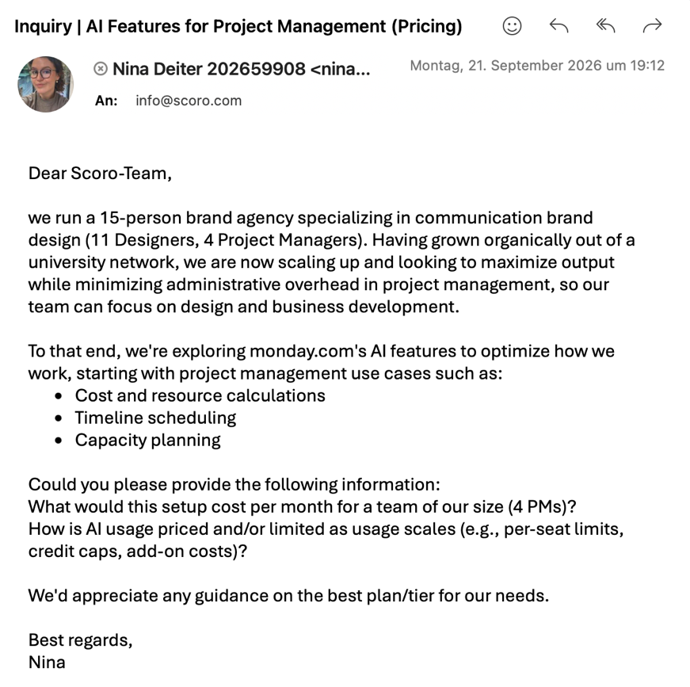
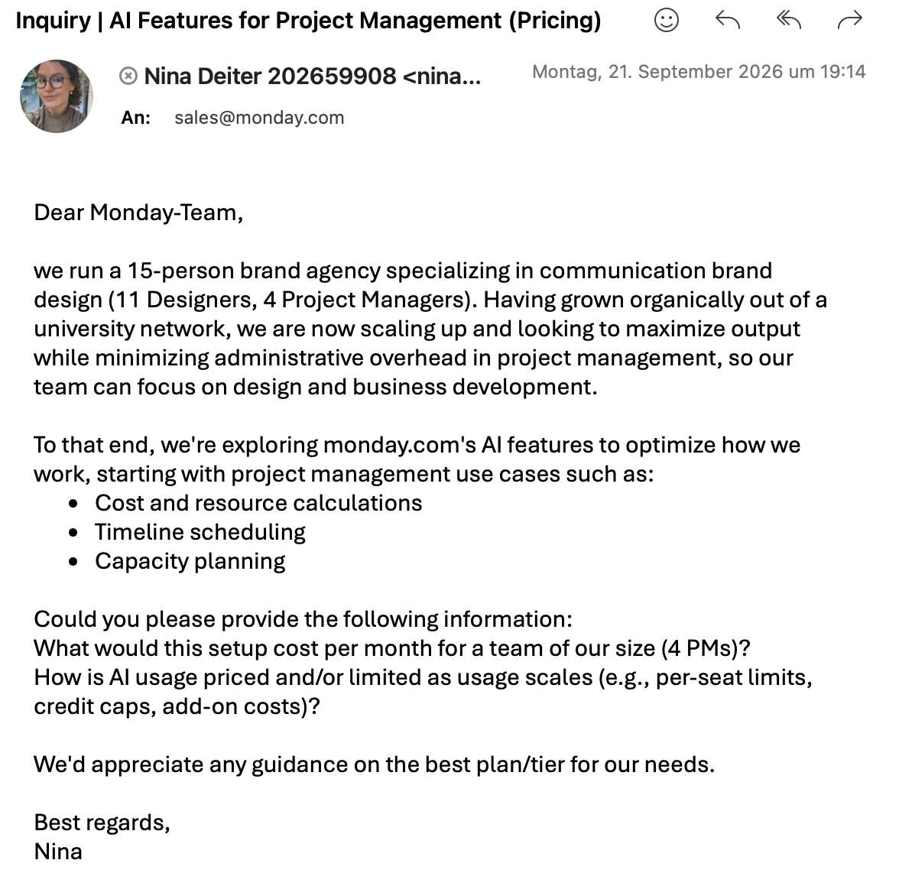
Reply from the Monday
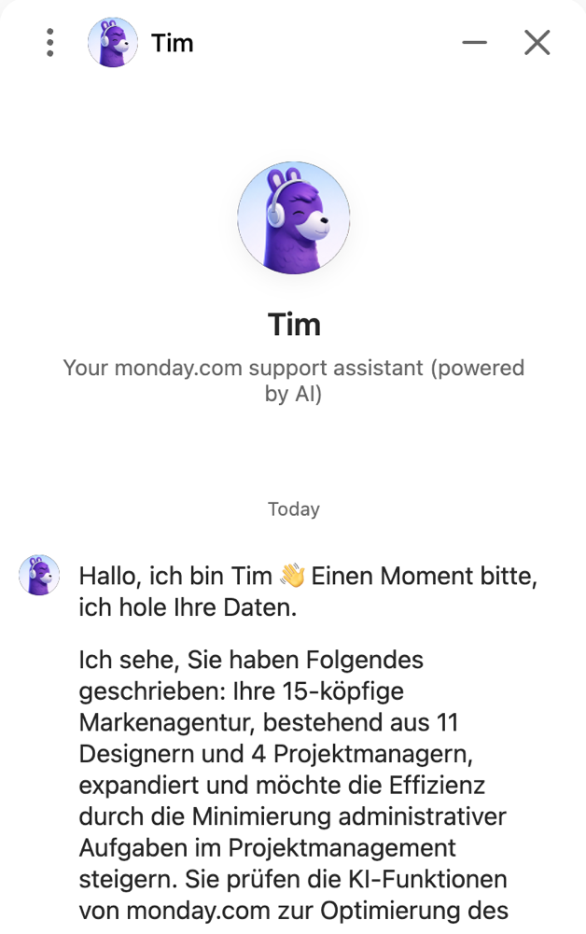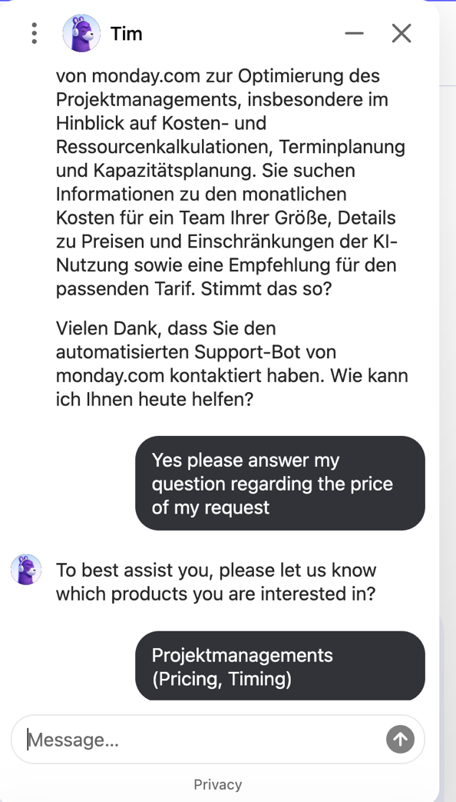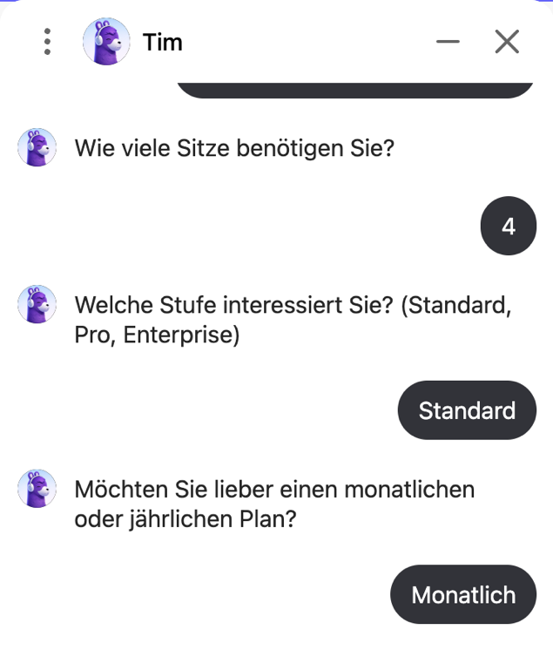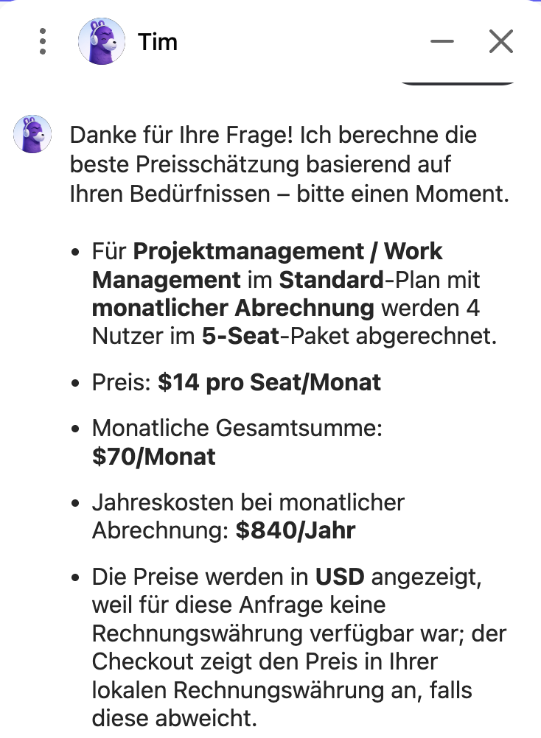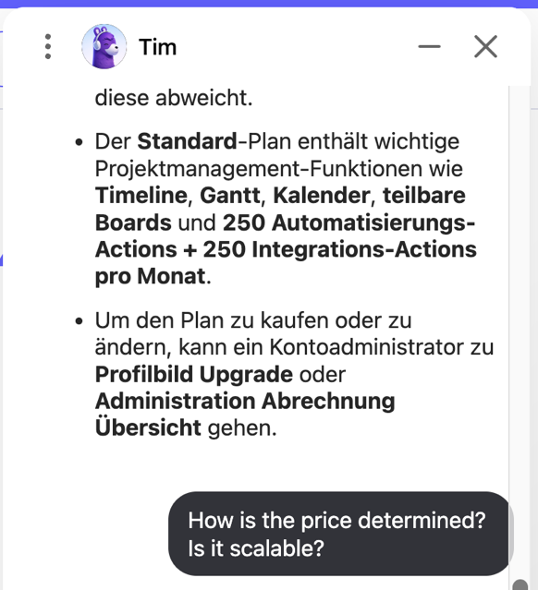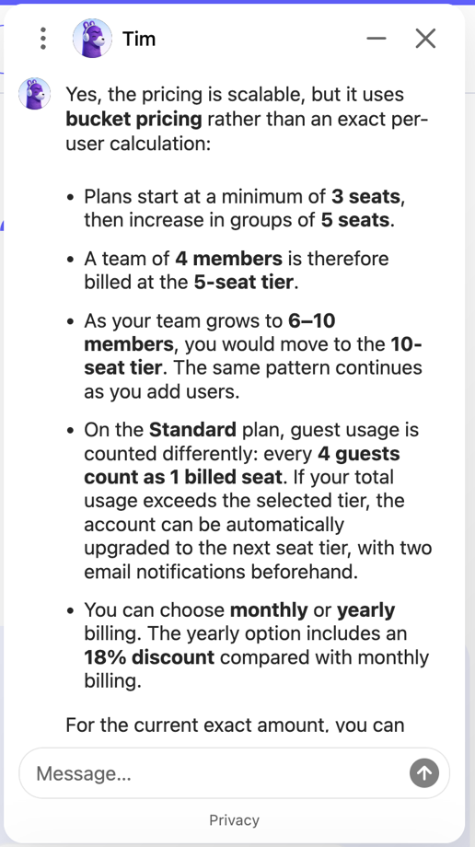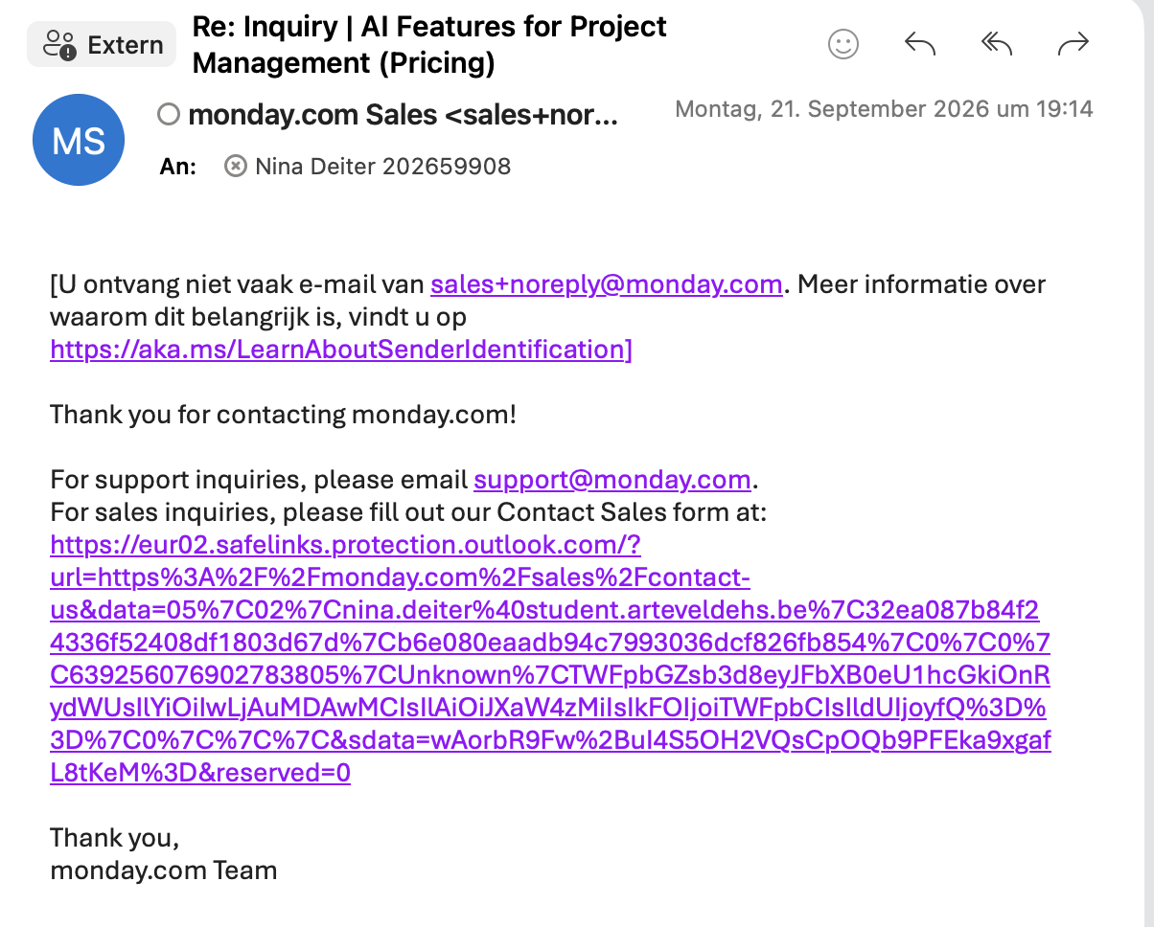

No reply from Scoro
What this tells you about how AI is actually priced above the self-serve tier
This tells me that AI pricing isn’t always very transparent. Here, it’s laborious to get an actual cost estimate. Also, the chatbot from Monday doesn’t give me a specific cost estimate. But, for example, when I wrote the Signal post, I looked up Langdock’s token prices, and they were really transparent. So I think it depends on the vendor.

