

Replace scene strings with proper references!
Keeps reference to a scene asset and tracks it's path in the editor, so it can be used in the game at runtime.
GitHub | Asset Store | OpenUPM

Why
It's a well known fact that scenes can't be referenced like prefabs, textures etc. The Unity SceneManager API works with relative scene paths or names.
Use this class to avoid manually typing and updating scene path strings - it will try to do it for you as best as it can, including when building the player.

Features
- The SceneReference class works on lists, scriptable objects, game objects, multiple-select.
- Small button on the right to add or remove from the build settings. The +/- sign and color indicate what the operation would be.
- Paths are updated during build (guaranteed by the ISerializationCallbackReceiver).
Here is how it looks like:
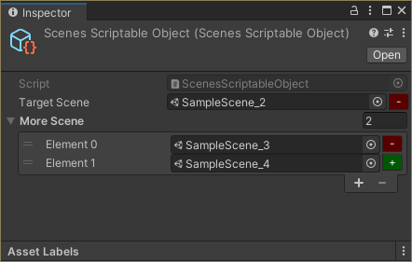
Here is how it looks in debug mode (what data is stored):
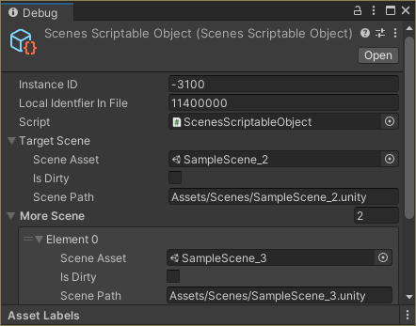
Here is how it looks in the code:
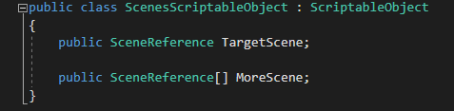

Icon made by Magnific and Atif Arshad from www.flaticon.com

