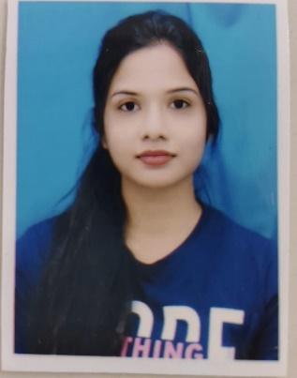RESUME

NIBEDITA PATRA

**Mobile-+91-7735281391**

**Email**- [patranibedita17@gmail.com](mailto:patranibedita17@gmail.com)

**LinkedIn-** [**https://www.linkedin.com/in/nibedita-patra-145339293/**](https://www.linkedin.com/in/nibedita-patra-145339293/)

**Current Address- Bhubaneswar,Odisha**

________________________________________________________________________________________ **Summary:-**

* Enthusiastic and detail-oriented MCA graduate with a strong foundation in computer science and programming. Adept at developing and implementing software solutions, with a focus on problem-solving and efficiency.
* Possesses hands-on experience in various programming languages, including PYTHON with framework DJANGO MYSQL AND JAVASCRIPT.
* Proven ability to work collaboratively in team environments, coupled with excellent Communication Skill. Eager to apply academic knowledge and practical skills to contribute effectively to innovative SOFTWARE DEVELOPMENT PROJECTS.
* A quick learner with a passion for staying updated on emerging technologies. Ready to leverage a solid academic background and passion for coding in an entry-level software development role.

**Educations:-**

* [Gandhi Engineering College, Bhubaneswar, Odisha]2022-2024

Master of Computer Applications form Gandhi Engineering College, Bhubaneswar, Odisha.

* [SriRam Chandra Bhanj Deo University, Baripada,Odisha]2019-2022

Bachelor of Science from Sriram Chandra bhanj college,Baripada,Odisha,757001.

**Project Profile:-**

**PROJECT:** For my MCA Major Project Submission, I have design a “EMPLOYEE REIMBURSEMENT SYSTEM” Project by Using .NET.

**Project Description**:

Employees Reimbursement System is a web application useful for an organization where in the employees will add the bills need to be reimburse by the organization .That means when an employee of an organization submits the bill, this bill need to be approved by the higher officials of the organization than only the money will be reimbursed.

**Personal skills:-**

* Expert in implementation of each step of project.
* Excitement to learn new technologies and methodologies.
* Always eager to learn new things that can enhance existing technology.

**Technical skills:-**

* Programming Languages : PYTHON, JAVASCRIPT, HTML, CSS
* Database : MYSQL
* Developer Tools : VS Code, ANDROID STUDIO, SUBLIME
* Framework/Libraries : DJANGO, AJAX, REACT, JQUERY
* Additional Skills : OOPS, C, GIT And DBMS

**Internship/Training:-**

* Taken training from Chetu Pvt Ltd as Developer Trainee Noida in Python , Django, MySQL and Javascript.
* Empowering Rural Futures With Azure AI skills.

# Personal Attributes:-

* Problem Solving
* Adaptability
* Creativity
* Leadership
* Responsibility
* Honesty

# Personal Information:-

* Father’s Name : Harish Chandra Patra
* DOB : 21/02/2002
* Gender : Female
* Nationality : Indian
* Religion : Hindu
* Marital Status : Unmarried
* Permanent : At /Po-: Baripada, PS - Baripada, District- Mayurbhanj, Odisha

**Languages:-**

|  |  |  |  |
| --- | --- | --- | --- |
| **Language** | **Read** | **Write** | **Speak** |
| **English** | ü | ü | ü |
| **Hindi** | ü | ü | ü |
| **Odia** | ü | ü | ü |

**Hobbies:-**

* Dancing.
* Traveling.
* Cooking.

# Declaration:-

* HEARBY DECLARE THAT THE DETAILS AND INFORMATION GIVEN ABOVE ARE COMPLETE AND TRUE TO THE BEST OF MY KNOWLEDGE.

**NIBEDITA PATRA**