🧠 1. SIMPLE EXPLANATION (Beginner Friendly)
👉 What is Software Testing?
Software testing means:
👉 Checking whether a software works correctly or not.
- You give input
- You check the output
- If output ≠ expected → ❌ defect (bug)
💡 Example:
- You enter password → app should login
- If it crashes → bug → testing failed

📌 2. KEY CONCEPTS (Structured)
🔹 1. Purpose of Testing
- Find bugs
- Ensure quality
- Improve user satisfaction
- Reduce cost (early bug detection)
👉 Why important?
👉 Fixing bugs later = expensive (company loss)

🔹 2. Manual Testing
✔ Definition:
Testing done by humans without automation tools
✔ Key Points:
- Human executes test cases
- Flexible
- Good for UI & usability
- Slow + error-prone
💡 Real-Life Example:
Imagine checking a website manually:
- Click buttons
- Fill forms
- Check UI → all done by human
👉 Why important?
👉 Only humans can judge user experience

🔹 3. Automation Testing
✔ Definition:
Testing done using tools/scripts
✔ Key Points:
- Fast execution
- Reusable scripts
- High accuracy
- Requires setup & tools
💡 Real-Life Example:
- Script automatically logs in 1000 times
- Checks response in seconds
👉 Why important?
👉 Saves time in large projects

🔹 4. Manual vs Automation (Core Difference)
Feature | Manual | Automation
Speed | Slow | Fast
Accuracy | Low (human errors) | High
Cost | Low initially | High initially
Best for | Small / exploratory | Large / regression
👉 Why important?
👉 Interviewers LOVE this comparison question

🔹 5. When to Use What?
✔ Use Manual Testing:
- Small projects
- UI/UX testing
- Exploratory testing
✔ Use Automation Testing:
- Regression testing
- Performance testing
- Large projects

🔹 6. Testing Tools (VERY IMPORTANT)
- Selenium → Web automation
- JUnit → Unit testing
- TestNG → Advanced testing
- JMeter → Load testing
- Appium → Mobile apps
👉 Why important?
👉 Tools = practical knowledge → interview bonus

🎯 3. IMPORTANT DEFINITIONS (MEMORIZE)
🔥 Software Testing:
“Process of evaluating a system to find differences between expected and actual results.”
🔥 Manual Testing:
“Testing performed by humans without automation tools.”
🔥 Automation Testing:
“Testing performed using scripts and tools to execute test cases.”
🔥 Defect/Bug:
“A mismatch between expected and actual result.”

🎤 4. VIVA QUESTIONS (WITH ANSWERS)
🟢 Basic Level
Q1: What is software testing?
👉 Checking whether software works correctly and meets requirements.

Q2: Why is testing important?
👉 To find bugs, improve quality, and reduce cost.

Q3: What is a bug?
👉 A defect where actual output ≠ expected output.

🟡 Intermediate Level
Q4: Difference between manual and automation testing?
👉 Manual = human, slow, flexible
👉 Automation = tool-based, fast, reusable

Q5: When should we use automation testing?
👉 Regression, performance, large-scale projects

Q6: Give examples of testing tools.
👉 Selenium, JUnit, TestNG, JMeter, Appium

🔴 Advanced Level
Q7: Why not automate everything?
👉
- High cost
- Not good for UI/UX
- Requires maintenance

Q8: Can manual and automation testing be used together?
👉 YES ✅
👉 Best approach = hybrid testing

😈 5. TRICKY QUESTIONS (EXAMINER STYLE)
❓ If automation is better, why do we still need manual testing?
👉 Because:
- Humans understand UX better
- Exploratory testing needs thinking
- Automation cannot detect visual issues easily

❓ Which testing is cheaper?
👉
- Short-term → Manual
- Long-term → Automation

❓ Is automation always faster?
👉 Setup time is high → not always faster initially

⚡ 6. QUICK REVISION (LAST MINUTE)
- Testing = finding bugs
- Manual = human, flexible, slow
- Automation = tools, fast, reusable
- Use manual → small/UI
- Use automation → regression/large projects
- Best approach → BOTH

🧠 7. HOW TO ANSWER IN INTERVIEW (TIPS)
✅ Always follow structure:
- Definition
- Key points
- Example
👉 Example:
“Manual testing is testing done by humans without tools. It is flexible and useful for usability testing. For example, checking UI manually.”

✅ Speak confidently:
- Don’t rush
- Use simple English
- Give examples → interviewer impressed instantly

🧠 1. SIMPLE EXPLANATION (Beginner Friendly)
👉 What is STLC?
👉 STLC = Step-by-step process followed in testing
It tells:
👉 “What to do before testing, during testing, and after testing”
💡 Simple understanding:
Like cooking 🍳
- First → read recipe
- Then → plan
- Then → prepare ingredients
- Then → cook
- Then → taste & fix
- Finally → serve
👉 Same way, testing follows steps → called STLC

📊 2. STLC PHASES (FLOW)
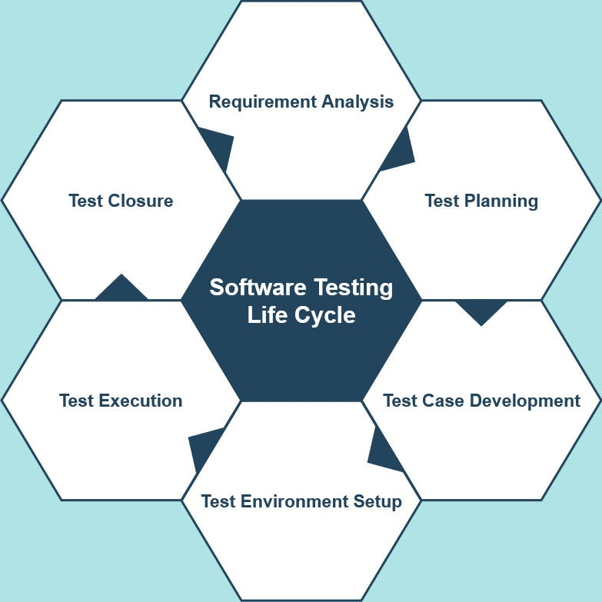
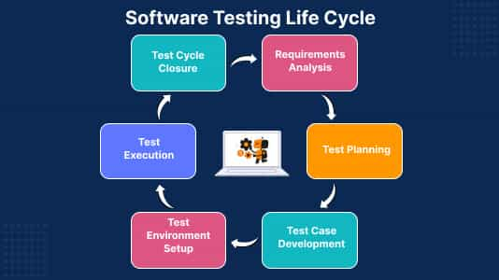
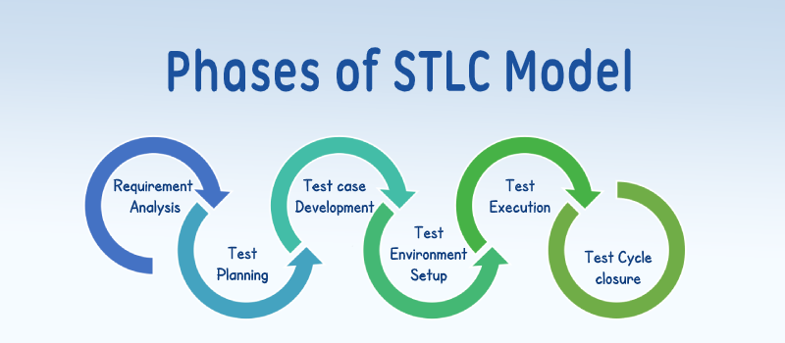
4
📌 7 Phases:
- Requirement Analysis
- Test Planning
- Test Case Design
- Test Environment Setup
- Test Execution
- Defect Reporting & Tracking
- Test Closure

🔍 3. EACH PHASE EXPLAINED (WITH EXAMPLES + IMPORTANCE)

🔹 1. Requirement Analysis
✔ Simple:
Understand what needs to be tested
💡 Example:
Client says:
👉 “Login system should work with email + password”
Tester:
👉 Understands all scenarios (valid/invalid login)
🎯 Why important?
👉 If you misunderstand requirements → testing becomes useless ❌

🔹 2. Test Planning
✔ Simple:
Plan how testing will be done
💡 Example:
- How many testers?
- Which tools? (manual/automation)
- Timeline?
🎯 Why important?
👉 Without planning = chaos 😵
👉 Ensures smooth process

🔹 3. Test Case Design
✔ Simple:
Write step-by-step test cases
💡 Example:
Test Case:
- Enter valid email
- Enter password
- Click login
- Expected → login success
🎯 Why important?
👉 Clear test cases = better coverage + fewer mistakes

🔹 4. Test Environment Setup
✔ Simple:
Prepare system where testing happens
💡 Example:
- Setup server
- Install app
- Configure database
🎯 Why important?
👉 Wrong environment = wrong results ❌

🔹 5. Test Execution
✔ Simple:
Run test cases and check results
💡 Example:
- Execute login test
- Compare expected vs actual
🎯 Why important?
👉 This is where bugs are found 🔍

🔹 6. Defect Reporting & Tracking
✔ Simple:
Report bugs and track until fixed
💡 Example:
Bug:
👉 Login fails for valid user
Tester:
👉 Logs bug → developer fixes → tester retests
🎯 Why important?
👉 Without tracking → bugs get lost ❌

🔹 7. Test Closure
✔ Simple:
Finish testing and prepare report
💡 Example:
- Total test cases = 100
- Passed = 95
- Failed = 5
🎯 Why important?
👉 Helps improve future projects

🧾 4. IMPORTANT DEFINITIONS (MEMORIZE)
🔥 STLC:
“Sequence of activities performed during testing to ensure software quality.”
🔥 Test Case:
“A set of conditions used to verify functionality.”
🔥 Test Environment:
“Setup where testing is executed (hardware + software).”
🔥 Defect:
“A mismatch between expected and actual result.”

🎤 5. VIVA QUESTIONS (WITH ANSWERS)
🟢 Basic
Q1: What is STLC?
👉 It is a process defining all steps involved in software testing.

Q2: How many phases are in STLC?
👉 7 phases

Q3: What is test case?
👉 Step-by-step instructions to test functionality

🟡 Intermediate
Q4: What happens in requirement analysis?
👉 Identify testable requirements and understand system

Q5: What is entry and exit criteria?
👉
- Entry → condition to start phase
- Exit → condition to finish phase

Q6: What is defect tracking?
👉 Monitoring bugs until they are fixed

🔴 Advanced
Q7: Why is STLC important?
👉
- Ensures structured testing
- Improves quality
- Reduces risk

Q8: What happens if environment is wrong?
👉 Testing results become invalid

😈 6. TRICKY QUESTIONS
❓ Is STLC same as SDLC?
👉 ❌ No
- SDLC → Development process
- STLC → Testing process

❓ Can testing start without requirements?
👉 ❌ No (very risky)

❓ Is test execution the most important phase?
👉 Not alone
👉 All phases are equally important

⚡ 7. QUICK REVISION (LAST MINUTE)
👉 STLC = 7 phases
👉 Requirement → Plan → Design → Setup → Execute → Report → Close
👉 Entry = start condition
👉 Exit = end condition
👉 Defect tracking = bug lifecycle

🎯 8. HOW TO ANSWER IN INTERVIEW
👉 Use this format:
Definition → Phases → Example
Example:
“STLC is a process that defines steps involved in testing. It includes phases like requirement analysis, test planning, test design, execution, defect tracking, and closure. For example, before testing a login feature, we first understand requirements, create test cases, execute them, and report bugs.”

🧠 1. SIMPLE EXPLANATION (Super Easy)
👉 STLC (Software Testing Life Cycle) =
A step-by-step process testers follow to test software properly
💡 Simple line to remember:
👉 “First understand → then plan → then write → then test → then report → then finish”

📊 2. COMPLETE FLOW (Big Picture)
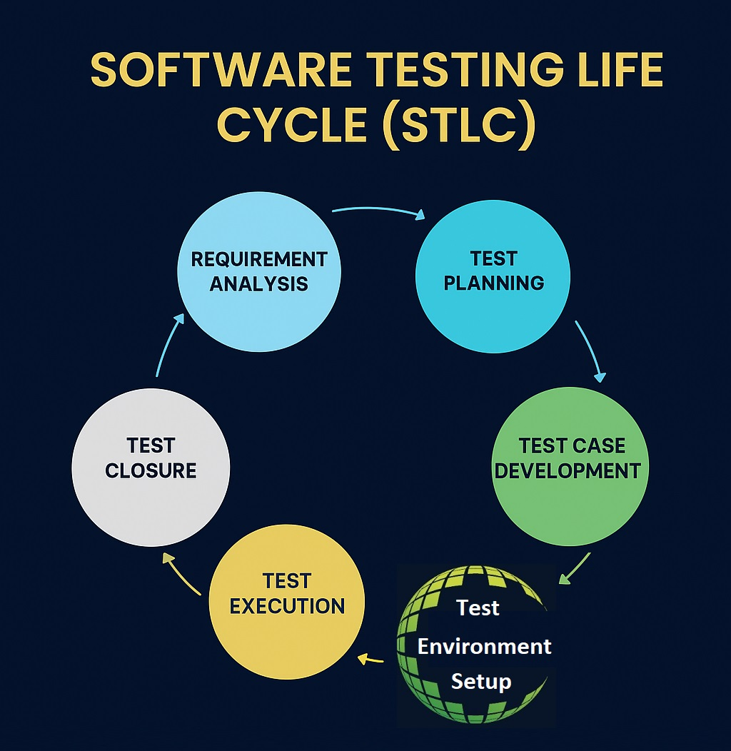


👉 Flow:
Requirement → Planning → Design → Setup → Execution → Defects → Closure

🔍 3. EACH PHASE (DEEP UNDERSTANDING + EXAMPLES + WHY IMPORTANT)

🔹 Phase 1: Requirement Analysis
✔ Simple:
Understand what needs to be tested
💡 Real Example:
E-commerce app:
- Product search
- Cart
- Payment
Healthcare:
- Patient registration
- Appointment booking
📦 Deliverables:
- RTM (Requirement Traceability Matrix)
🎯 Why important?
👉 If requirement is wrong → everything fails ❌

🔹 Phase 2: Test Planning
✔ Simple:
Decide how testing will be done
💡 Example:
- Tools? (manual/automation)
- Team size?
- Timeline?
📦 Deliverables:
- Test Plan
- Schedule
- Resource plan
🎯 Why important?
👉 Without planning → delays + confusion

🔹 Phase 3: Test Case Development
✔ Simple:
Write step-by-step test cases
💡 Example:
E-commerce:
- Add item → checkout → payment → success
Healthcare:
- Book appointment → confirm slot
📦 Deliverables:
- Test cases
- Test data
- Automation scripts (if any)
🎯 Why important?
👉 Ensures full coverage

🔹 Phase 4: Test Environment Setup
✔ Simple:
Prepare system for testing
💡 Example:
- Setup server
- Dummy payment API
- Test database
📦 Deliverables:
- Environment setup doc
- Credentials
🎯 Why important?
👉 Wrong environment = false bugs ❌

🔹 Phase 5: Test Execution
✔ Simple:
Run test cases
💡 Example:
- Execute checkout
- Check confirmation email
📦 Deliverables:
- Test logs
- Defect reports
🎯 Why important?
👉 This is where actual bugs are found

🔹 Phase 6: Defect Reporting & Tracking
✔ Simple:
Report bugs and track them
💡 Example:
- Coupon not applied → bug logged
- Dev fixes → tester verifies
📦 Deliverables:
- Defect log
- Metrics report
🎯 Why important?
👉 Ensures bugs are fixed properly

🔹 Phase 7: Test Closure
✔ Simple:
Finish testing and summarize
💡 Example:
- 100 test cases → 95 passed
- Lessons learned
📦 Deliverables:
- Test Summary Report
- Sign-off
🎯 Why important?
👉 Helps improve future testing

🧾 4. IMPORTANT DEFINITIONS (MEMORIZE 🔥)
👉 STLC:
“Sequence of activities performed during testing to ensure software quality.”
👉 RTM (Requirement Traceability Matrix):
“Document that maps requirements with test cases.”
👉 Test Plan:
“Document describing testing strategy, scope, and resources.”
👉 Test Case:
“Step-by-step instructions to verify functionality.”
👉 Defect:
“Difference between expected and actual result.”

🎤 5. VIVA QUESTIONS (WITH ANSWERS)

🟢 Basic
Q1: What is STLC?
👉 Process of performing testing in phases.

Q2: Name all STLC phases
👉 Requirement → Planning → Design → Setup → Execution → Defect → Closure

🟡 Intermediate
Q3: What is RTM?
👉 Document linking requirements to test cases

Q4: What is test plan?
👉 Document defining testing strategy and scope

Q5: What happens in test execution?
👉 Run test cases and compare actual vs expected

🔴 Advanced
Q6: What are deliverables in STLC?
👉 Outputs of each phase (RTM, Test Plan, Reports)

Q7: What is entry and exit criteria?
👉
- Entry → condition to start phase
- Exit → condition to complete phase

😈 6. TRICKY QUESTIONS

❓ Can testing start without test cases?
👉 Yes (exploratory testing) but not recommended

❓ What if defect is found in requirement phase?
👉 It’s cheapest to fix → best case scenario ✅

❓ Which phase is most important?
👉 All are important (trick question)

❓ What is difference between RTM and Test Case?
👉
- RTM → mapping document
- Test Case → execution steps

⚡ 7. QUICK REVISION (LAST MINUTE)
👉 7 phases of STLC
👉 Each phase has:
- Objective
- Activities
- Deliverables
- Entry/Exit
👉 RTM = requirement mapping
👉 Test Plan = strategy
👉 Execution = finding bugs
👉 Closure = final report

🧠 8. HOW TO ANSWER IN INTERVIEW (PRO TIP)
👉 Always follow:
Definition → Phases → Example → Importance
💡 Example answer:
“STLC is a process that defines different phases of testing such as requirement analysis, test planning, test case design, execution, defect tracking, and closure. For example, in an e-commerce app, we first analyze features like cart and payment, then create test cases, execute them, and report bugs. This ensures software quality.”

