System Capacity & Care Load Analytics for Unaccompanied Children
Research paper: EDA, capacity metrics, insights, and recommendations
Dataset coverage: 2023-01-12 to 2025-12-21 | Reported rows: 720 | Complete calendar days after indexing: 1,075

1. Abstract
This project develops a centralized healthcare-system analytics framework for monitoring unaccompanied children across CBP custody and HHS care. The analysis converts daily operational counts into interpretable capacity metrics: total system load, net intake pressure, backlog accumulation, rolling stress windows, volatility, and discharge offset ratios. The framework supports proactive staffing, shelter planning, and policy-level situational awareness.

2. Data and Methodology
The dataset was ingested as a daily time series, dates were converted to datetime format, rows were chronologically ordered, and a complete daily index was created. Missing non-reporting dates were flagged; active load values were interpolated for continuous trend visualization, while event flows on non-reporting days were treated as zero for dashboard continuity. Original reported rows remain identifiable through an is_reported flag.
Validation checks were applied to flag duplicated dates, missing dates, and logical anomalies such as transfers exceeding same-day CBP custody or discharges exceeding same-day HHS care. These checks are transparency indicators rather than automatic exclusions because government operational reporting may include timing lags.

3. Key Performance Indicators
KPI | Value | Interpretation
Total children under care | 2,502 | Most recent system-wide care responsibility
Peak system load | 11,762 on 2023-12-20 | Highest observed capacity load
Average system load | 6,232 | Mean daily combined CBP + HHS care load
Net intake pressure | -32,212 | Cumulative transfers into HHS minus discharges
Discharge offset ratio | 2.01 | Average discharges per transfer into HHS
Care load volatility index | 2,911.6 | Standard deviation of total system load
Stress threshold | 9,952 | 90th percentile total load threshold

4. Exploratory Data Analysis
Across the study period, the system recorded 67,337 apprehensions placed into CBP custody, 92,641 transfers out of CBP custody, and 124,853 discharges from HHS care. The latest reported load was 2,502 children, consisting of 18 in CBP custody and 2,484 in HHS care. HHS care accounted for the dominant share of system load, making HHS shelter and case-management capacity the main driver of total capacity pressure.
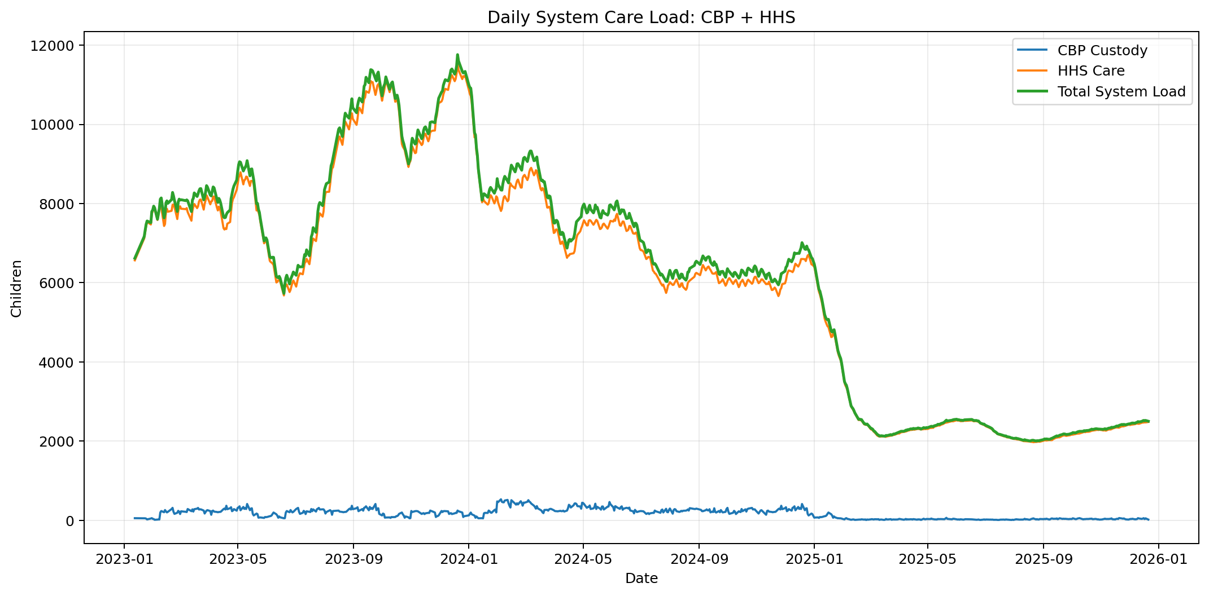
Figure 1. Daily system load shows combined CBP and HHS responsibility.
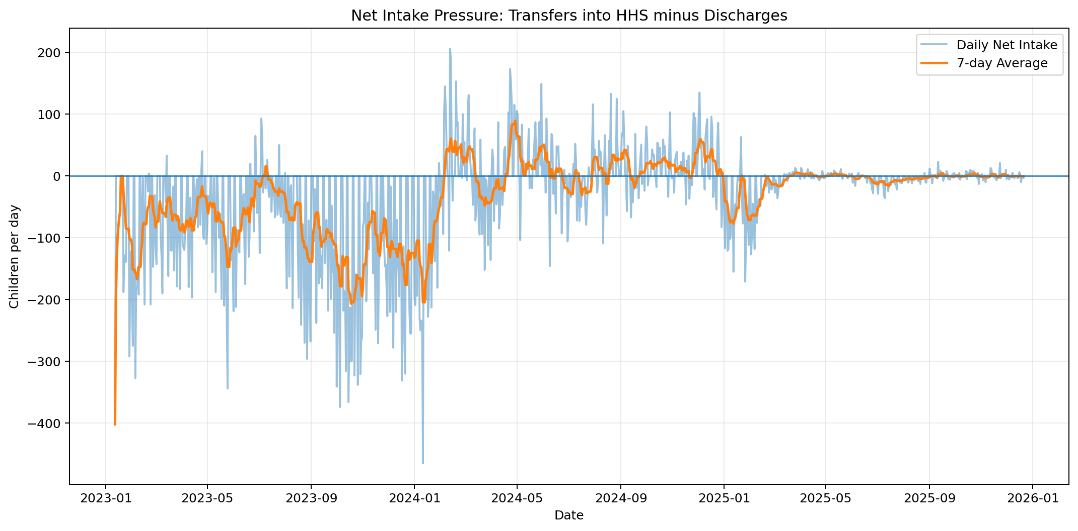
Figure 2. Net intake pressure tracks whether transfers into HHS exceed discharges.
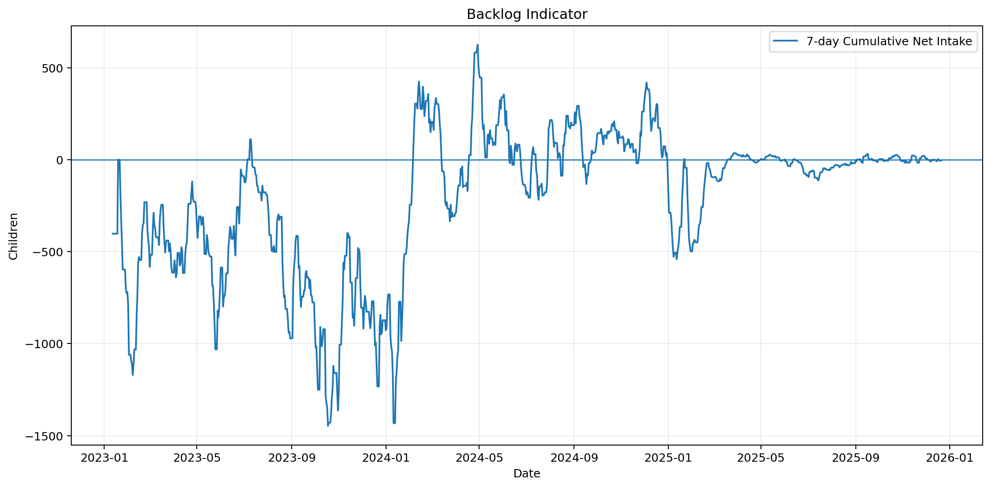
Figure 3. The 7-day backlog indicator highlights sustained inflow-outflow imbalance.
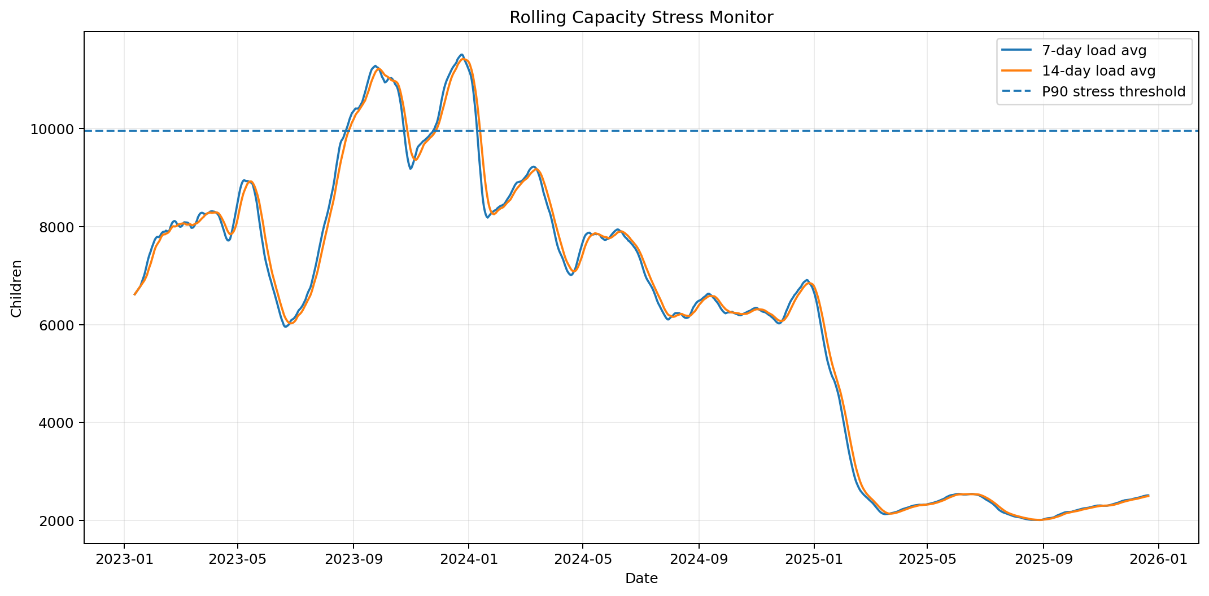
Figure 4. Rolling averages and P90 threshold identify capacity stress periods.
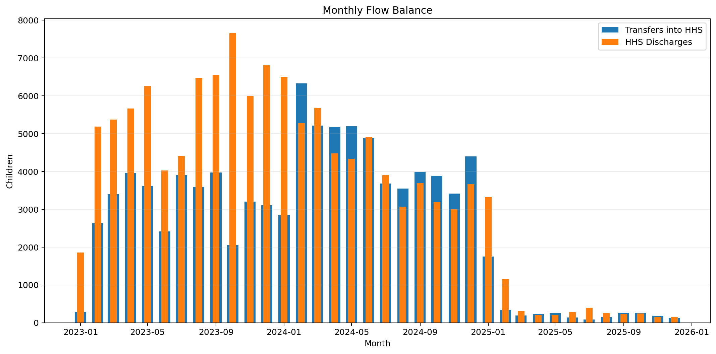
Figure 5. Monthly flow balance compares transfers into HHS with discharges.
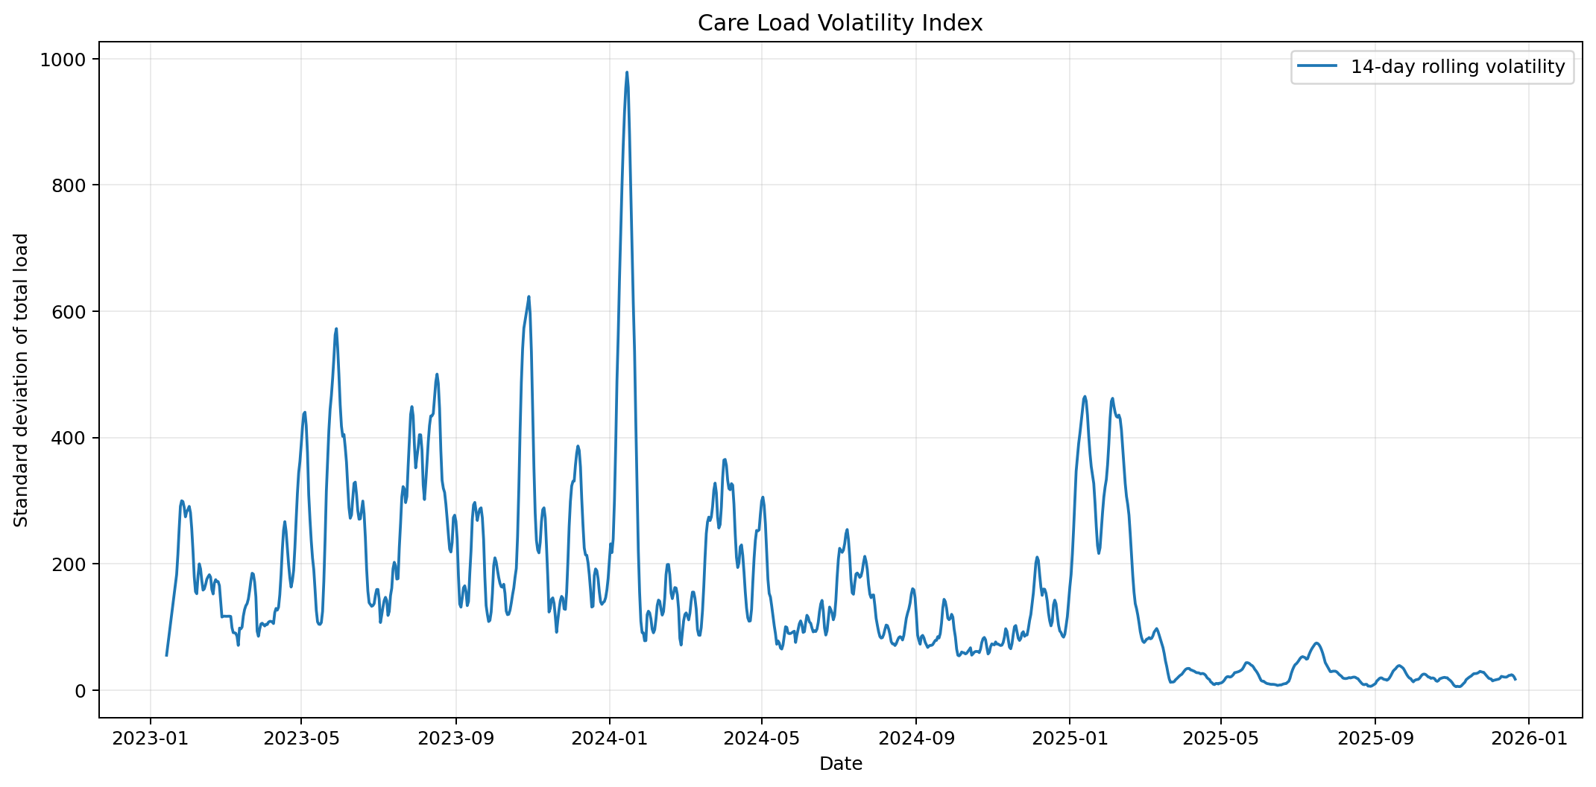
Figure 6. Volatility index captures system stability and planning uncertainty.

5. Stress, Relief, and Backlog Findings
Sustained high-load stress windows were identified by days at or above the 90th percentile load threshold of 9,952 children. Detected stress windows: 2023-08-22 to 2023-10-21 (61 days); 2023-11-21 to 2024-01-06 (47 days)
Backlog windows were identified where 7-day cumulative net intake remained positive. Detected backlog windows: 2024-02-06 to 2024-03-13 (37 days); 2024-04-18 to 2024-06-08 (52 days); 2024-06-16 to 2024-06-23 (8 days); 2024-07-29 to 2024-08-14 (17 days); 2024-08-18 to 2024-09-12 (26 days)
Relief windows were identified where the 7-day average net intake was negative, indicating discharges were exceeding transfers. Detected relief windows: 2023-01-12 to 2023-01-18 (7 days); 2023-01-22 to 2023-07-05 (165 days); 2023-07-12 to 2024-02-05 (209 days); 2024-03-14 to 2024-04-17 (35 days); 2024-06-24 to 2024-07-08 (15 days)

6. Recommendations
- Adopt the total system load and P90 stress threshold as a daily capacity-risk signal for leadership review.
- Use the net intake and backlog indicator as early-warning metrics to trigger temporary staffing, bed-capacity, and transportation planning.
- Separate operational decisions for CBP short-stay load and HHS longer-duration care load because HHS dominates total capacity exposure.
- Monitor discharge offset ratio weekly; sustained values below 1.0 indicate inflow is exceeding system relief capacity.
- Maintain anomaly flags in dashboards rather than deleting records so analysts can distinguish true pressure from reporting-timing effects.

7. Conclusion
The project provides a policy-aligned capacity analytics framework that transforms raw counts into actionable indicators of care load, system pressure, backlog risk, and operational relief. The Streamlit dashboard operationalizes these metrics for continuous monitoring and decision support.

