Analysis of three observable trends based on the data.

1. The male demographic dominates this game in player percentage:

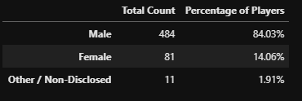

1. The target age demographic is between 20-24 years old. Not only in player count but also in purchase count:

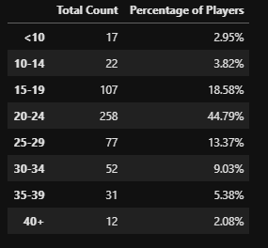

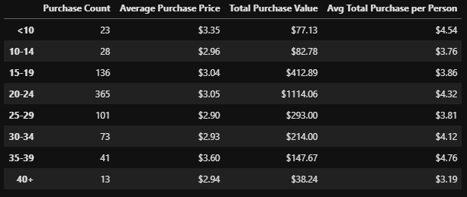

1. The most popular and profitable item is the Final Critic:

