# Intro

This document is TEAM 3’s object behaviour model for MelodyMaker

# Interface layout

This diagram depicts options our text interface provides.

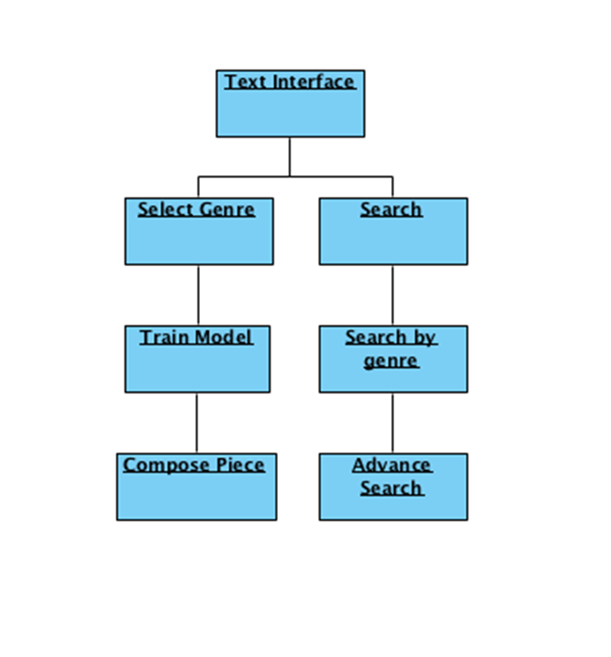

# Decision Tree:



# Sequence diagram

# 

# State diagram

# 