MultiFX

Image52.png

Codesign Methods and Tools - Nese10

Boccardi Pierfrancesco Antonio 288917 Domini Nicola 279592 Sellini Andrea 283422

Table of Contents

Actors_multifx

Class_multifx

Components_multiFx

PowerWindow_CloseRightWindow

TuneVolumeUp

TuneVolumeDown

TuneParameterFxUp

TuneParameterFxDown

NextEffect

BackFx

Bypass

Switch_ON

Switch_OFF

Table of Figures

Actors_multifx

Class_multifx

Components_multiFx

PowerWindow_CloseRightWindow

TuneVolumeUp

TuneVolumeDown

TuneParameterFxUp

TuneParameterFxDown

NextEffect

BackFx

Bypass

Switch_ON

Switch_OFF

Use Case Diagram

# Actors_multifx

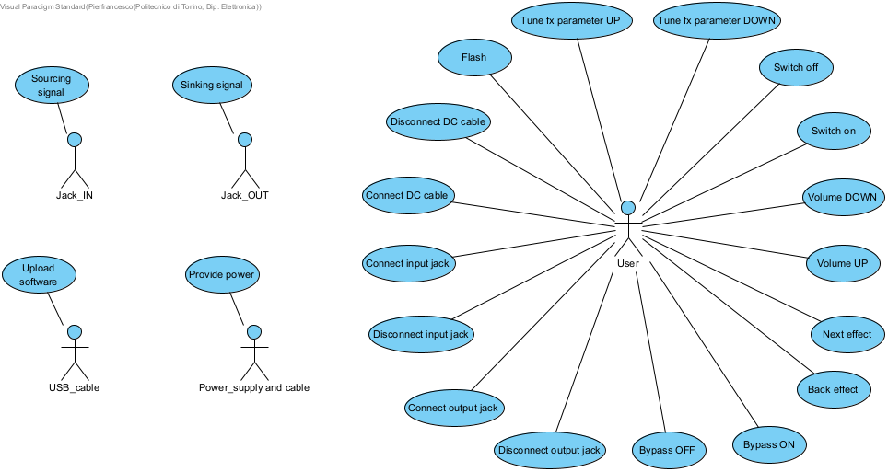

## Image1.png USB_cable

Name: USB_cable

A USB cable having a micro USB 2.0 male connector.

## Image1.png User

Name: User

Human being with full control of at least one hand.

Minimum age: 3 years old.

Language: basic English.

Non blind.

## Image1.png Power_supply and cable

Name: Power_supply and cable

Connector:

-male DC connector;

-internal diameter: 2.1 mm;

-external diameter: 5.5 mm;

-external pin length: 9.5 mm;

-central pin positive;

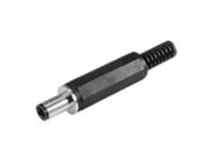

Power:

-DC;

-Voltage range: +4V to 17V ;

-max current at least 500 mA;

## Image1.png Jack_OUT

Name: Jack_OUT

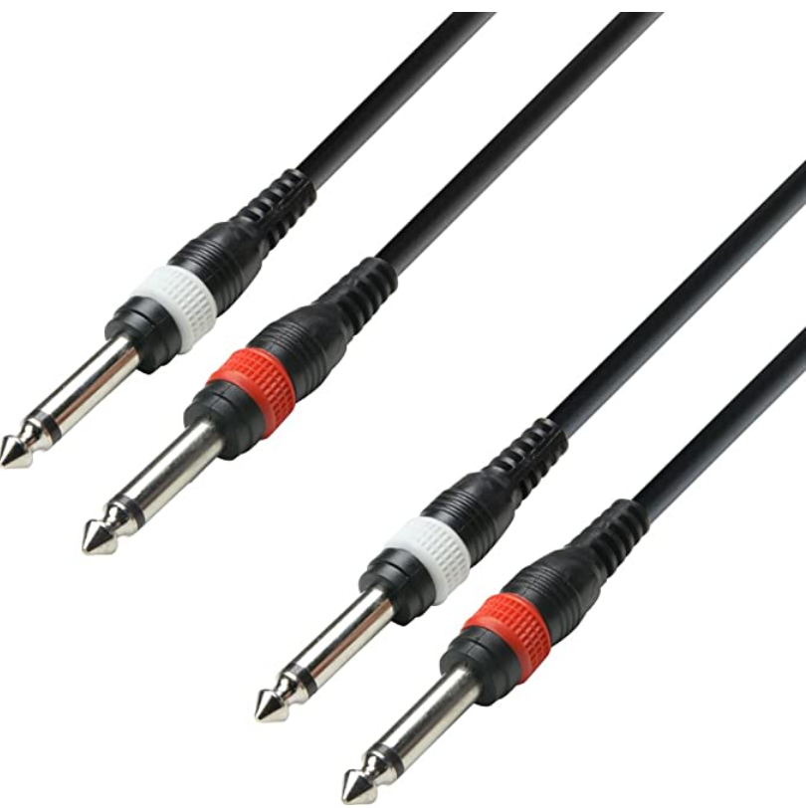

Standard mono TRS jack cable 6.35mm.

Max output level: Line +5dBm (with output load 10 kΩ or more).

Max length 6.0 m.

## Image1.png Jack_IN

Name: Jack_IN



Standard mono TRS jack cable 6.35mm.

Nominal input level: −20dBm.

Max length: 6.0 m.

## Image5.png Disconnect DC cable

Name: Disconnect DC cable

The User can remove the Power_supply and cable from the CONN1: 5mm7_2mm_DC_THT. In this way, the MultiFX_nese10_2122 can not work, even if it is switched ON, because there is no voltage supply.

## Image5.png Connect DC cable

Name: Connect DC cable

The User can insert (insertMaleConn()) the Power_supply and cable inside the CONN1: 5mm7_2mm_DC_THT in order to supply the MultiFX_nese10_2122. However, before the system is turned on (switchOn()) the supply voltage will not reach the internal circuit.

## Image5.png Disconnect output jack

Name: Disconnect output jack

The User can remove the Jack_OUT from the CONN3: 6mm35_JACK_Female_THT. However, in this way he/she can not be able to get the processed audio signal anymore.

## Image5.png Disconnect input jack

Name: Disconnect input jack

The User can remove the Jack_IN from the CONN2: 6mm35_JACK_Female_THT. However, in this way he/she can not be able to provide any audio signal anymore.

## Image5.png Connect output jack

Name: Connect output jack

The User can insert (insertMaleJack()) the Jack_OUT inside the CONN3: 6mm35_JACK_Female_THT in order to acquire the audio signal processed by MultiFX_nese10_2122.

It can be inserted before or after the system is turned on, but until that moment there is no way to use the processed audio signal.

## Image5.png Connect input jack

Name: Connect input jack

The User can insert (insertMaleJack()) the Jack_IN inside the CONN2: 6mm35_JACK_Female_THT in order to provide the audio signal to process to MultiFX_nese10_2122.

It can be inserted before or after the system is turned on, but until that moment there is no way to process the audio signal.

## Image5.png Flash

Name: Flash

The User in order to upload correctly the software must perform the following operations in the given order:

1. pressBoot()
2. pressReset()
3. releaseReset()
4. releaseBoot()

## Image5.png Upload software

Name: Upload software

Using the USB_cable it is possible to update software.

## Image5.png Tune fx parameter DOWN

Name: Tune fx parameter DOWN

User rotates POT2: 10K_t20%_LOG_POT_H20mm_THT counterclockwise (FxDown()). Parameter value of the selected effect is decreased until User stops the rotation and is sent to the processing unit in order to obtain the desired signal processing:

- in case of delay() time delay is increased

- in case of tremolo() modulation frequency is increased

- in case of phaser() modulation frequency is increased

The new decreased value is updated on the OLED: OLED_Display (updateDisplay()).

## Image5.png Volume DOWN

Name: Volume DOWN

The User rotates POT1: 10K_t20%_LOG_POT_H20mm_THT counterclockwise (volumeDown()). Volume value is sent to the processing unit so that amplitude of output signal decreases until User stops the rotation. The new decreased value of volume is updated (updateDisplay()) on the OLED_Display.

## Image5.png Sourcing signal

Name: Sourcing signal

Jack_IN provides an electric signal coming from a musical instrument with nominal input level -20dBm.

This signal is being processed by the system.

## Image5.png Sinking signal

Name: Sinking signal

Jack_OUT receives an electric signal processed by the system with the following characteristics: Line +5dBm (with output load 10 kΩ or more).

## Image5.png Provide power

Name: Provide power

Power_supply and cable provides a DC voltage in range +4V up to +17V referred to common ground, with max current at least 500 mA.

## Image5.png Bypass OFF

Name: Bypass OFF

When LED: RedLED_module_3V3 is ON and User pushBypass(), a digital signal is sent to the processing unit such that it will apply the selected processing effect on the input signal.

## Image5.png Bypass ON

Name: Bypass ON

When LED: RedLED_module_3V3 is OFF and User pushBypass(), a digital signal is sent to the processing unit such that it will not apply any processing on the input signal.

## Image5.png Tune fx parameter UP

Name: Tune fx parameter UP

User rotates POT2: 10K_t20%_LOG_POT_H20mm_THT clockwise (FxUp()). Parameter value of the selected effect is increased until User stops the rotation and is sent to the processing unit in order to obtain the desired signal processing:

- in case of delay() time delay is increased

- in case of tremolo() modulation frequency is increased

- in case of phaser() modulation frequency is increased

The new increased value is updated on the OLED: OLED_Display (updateDisplay()).

## Image5.png Back effect

Name: Back effect

User pushBackFx() and releaseBackFx(). A digital signal is sent to the processing unit in order to change to the previous processing effect between the ones available, according to the effect sequence delay()->tremolo()->phaser().

The delay() effect allows to apply a temporal delay to the input audio signal. Then the delayed signal is overlapped to the original one in order to have an effect that is similar to the echo.

The tremolo() effect applies a little amplitude modulation to the input audio signal.

The phaser() effect applies a phase shift to the input audio signal.

The new effect name is displayed on the OLED: OLED_Display.

## Image5.png Next effect

Name: Next effect

User pushBackFx() and releaseBackFx(). A digital signal is sent to the processing unit in order to change to the next processing effect between the ones available, according to the effect sequence delay()->tremolo()->phaser().

The delay() effect allows to apply a temporal delay to the input audio signal. Then the delayed signal is overlapped to the original one in order to have an effect that is similar to the echo.

The tremolo() effect applies a little amplitude modulation to the input audio signal.

The phaser() effect applies a phase shift to the input audio signal.

The new effect name is displayed on the OLED: OLED_Display.

## Image5.png Volume UP

Name: Volume UP

The User rotates POT1: 10K_t20%_LOG_POT_H20mm_THT clockwise (volumeUp()). Volume value is sent to the processing unit so that amplitude of output signal increases until User stops the rotation. The new increased value of volume is updated (updateDisplay()) on the OLED: OLED_Display.

## Image5.png Switch off

Name: Switch off

The User toggles SW1: SPDT_ON-OFF_ToggleSwitch_THT in the OFF position (switchOff()), so that the system is not supplied.

## Image5.png Switch on

Name: Switch on

The User toggles SW1: SPDT_ON-OFF_ToggleSwitch_THT in the ON position (switchOn()). If connected, Power_supply and cable provides power to the system.

The processing unit starts applying the default effect (delay()) on input signal and LED: RedLED_module_3V3 is kept OFF.

Class Diagram

# Class_multifx

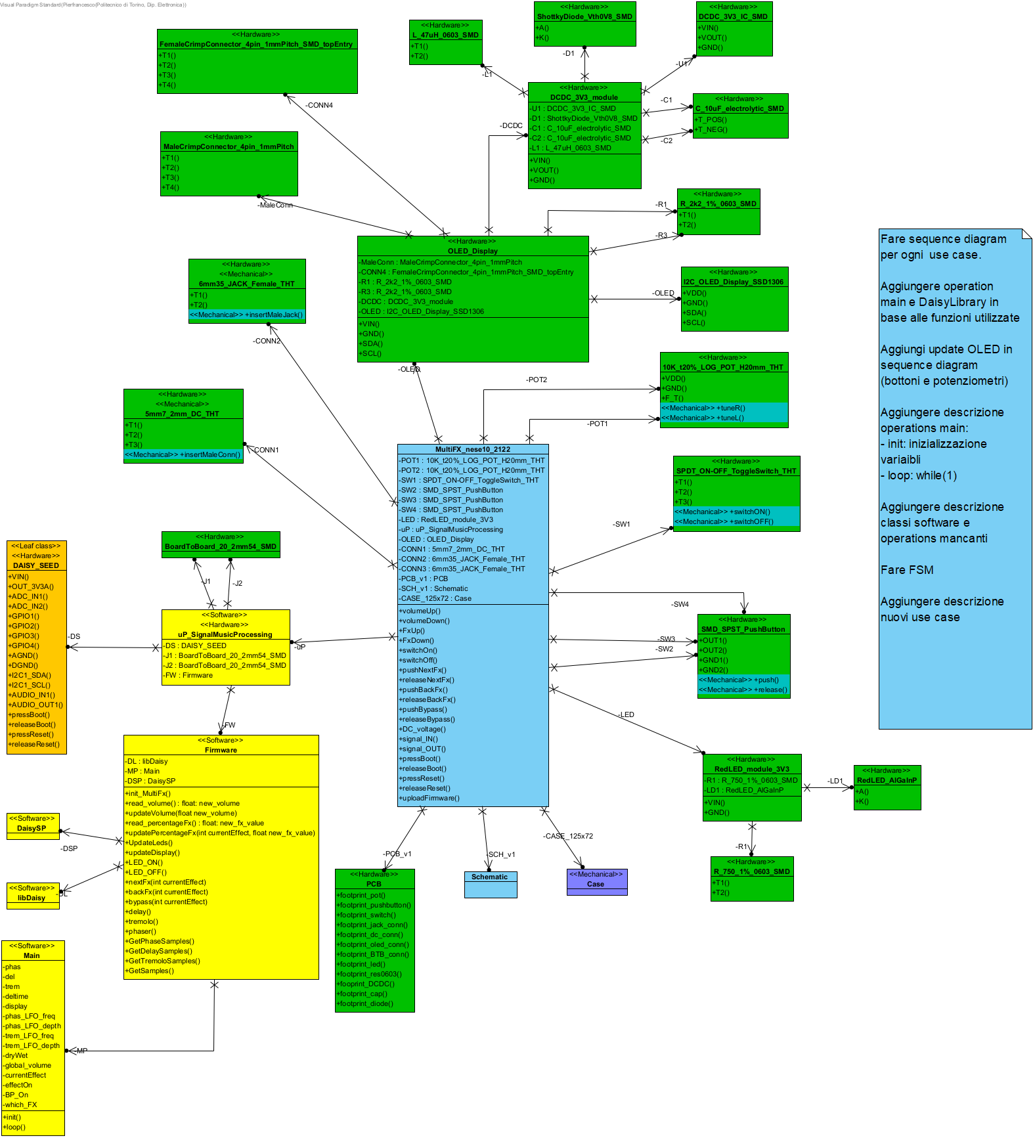

## Image7.png L_47uH_0603_SMD

Name: L_47uH_0603_SMD

Surface mount inductor.

**Electrical characteristics:**

- Inductance: 47uH

- Tolerance: +/-20%

**Mechanical characteristics:**

- Length: 1.6mm

- Width: 0.8mm

- Height: 0.8mm

Operations

## Image8.png T1

Name: T1

Pin 1 inductor.

**Coding:** voltage

**Periodicity:** continuous

## Image8.png T2

Name: T2

Pin 2 inductor.

**Coding:** voltage

**Periodicity:** continuous

## Image7.png DCDC_3V3_IC_SMD

Name: DCDC_3V3_IC_SMD

It is a DCDC converter that allows to provide a stable DC voltage.

It takes as input a DC voltage inside a range from 4.5V to 22V, in order to have a stable 3.3V DC voltage at the output.

To avoid noise on the output a decoupling capacitor can be needed, depending on the application.

**Electrical characteristics:**

- Max input DC voltage: 24V

- Output DC voltage: 3.3V

- Max output current: 2A

- Min efficiency: 75%

Operations

## Image8.png VIN

Name: VIN

This is the positive input supply for the IC switching regulator. A suitable input bypass capacitor must be presented at this pin to minimize voltage transients and to supply the switching currents required by the regulator.

**Coding:** voltage, from 4.5V to 22V

**Periodicity:** continuous

## Image8.png VOUT

Name: VOUT

Output voltage fixed to 3.3V.

The voltage at this pin switches between approximately VIN() and -0.5V with a duty cycle of approximately VOUT()/VIN().

To minimize coupling to sensitive circuitry, the PCB copper area connected to this pin should be minimized.

**Coding:** voltage, 3.3V

**Periodicity:** continuous

## Image8.png GND

Name: GND

Reference ground voltage.

**Coding:** voltage

**Periodicity:** continuous

## Image7.png RedLED_AlGaInP

Name: RedLED_AlGaInP

When a voltage drop larger than Vth is applied to terminals of the LED, it turns ON and emits red light (625nm), otherwise it is turned OFF.

**Electrical characteristics:**

- Vth = 1.8V

- Max DC forward current: 30mA

- Max Reverse Voltage: 5V

- Viewing angle: 120°

Operations

## Image8.png A

Name: A

Anode connected to the higher potential.

When voltage drop (model element not found) - (model element not found) > 1.8V (threshold voltage of red LED) LED turns on.

A resistor can be needed in order to limit the current that flows in the LED.

**Coding:** voltage

**Periodicity:** continuous

## Image8.png K

Name: K

Cathode connected to the lower potential (ground).

Anode connected to the higher potential.

When voltage drop (model element not found) - (model element not found) > 1.8V (threshold voltage of red LED) LED turns on.

A resistor can be needed in order to limit the current that flows in the LED.

**Coding:** voltage

**Periodicity:** continuous

## Image7.png I2C_OLED_Display_SSD1306

Name: I2C_OLED_Display_SSD1306

The display exploits the I2C protocol to communicate, so only 4 pins are needed. Two pull-up resistors are needed: one for SDA (Serial DAta) line and the other for SCL (Serial CLock) line.

Pins must be connected to a male connector having a pitch equal to 1mm.

**Basic specifications:**

- Size: 0.96''

- Supply voltage: [3, 5]V

- I2C interface

- Max module length: 40mm

- Max module width: 40mm

- 128x64 pixel

- Display size: 0.96"

- Display width: 10.86mm

- Display length: 21.74mm

Operations

## Image8.png VDD

Name: VDD

Voltage supply pin.

A DC voltage 3.3V is require to supply the OLED display.

**Coding:** voltage, 3.3V

**Periodicity:** continuous

## Image8.png GND

Name: GND

Reference ground pin.

**Coding:** voltage

**Periodicity:** continuous

## Image8.png SDA

Name: SDA

Serial DAta pin: data are sent and received in a serial way using this pin.

**Coding**: I2C

* Input logic levels:
  + '0': DGND() - 0.99V
  + '1': 2.31V - 3.3V
* Output logic levels:
  + '0': DGND() - 0.4V
  + '1': 2.9V - 3.3V

**Periodicity**: continuous

## Image8.png SCL

Name: SCL

Serial CLock pin: a synchronous signal is connected to this pin in order to synchronize Master and Slave.

**Coding**: I2C

* Input logic levels:
  + '0': DGND() - 0.99V
  + '1': 2.31V - 3.3V
* Output logic levels:
  + '0': DGND() - 0.4V
  + '1': 2.9V - 3.3V

**Periodicity**: continuous

## Image7.png C_10uF_electrolytic_SMD

Name: C_10uF_electrolytic_SMD

Surface mount electrolytic capacitor.

**Electrical characteristics:**

- Capacitance: 10uF

- Max DC voltage: 25V

- Max ESR: 35mOhm

- Max leakage current: 125uA

**Mechanical characteristics:**

- Diameter: 8mm

- Height: 7mm

Operations

## Image8.png T_POS

Name: T_POS

Electrolytic capacitor terminal to connect to higher voltage.

**Coding:** voltage

**Periodicity:** continuous

## Image8.png T_NEG

Name: T_NEG

Electrolytic capacitor terminal to connect to lower voltage.

**Coding:** voltage

**Periodicity:** continuous

## Image7.png ShottkyDiode_Vth0V8_SMD

Name: ShottkyDiode_Vth0V8_SMD

When a voltage drop larger than Vth is applied to terminals of the LED, it turns ON and allows current to flow from anode (A()) to cathode (K()).

**Electrical characteristics:**

- Vth = 0.8V

- Forward current: 0.5A

- Max DC forward current: 30mA

- Max Reverse Voltage: 80V

- Max RMS forward voltage: 56V

Operations

## Image8.png A

Name: A

Anode connected to the higher potential.

When voltage drop (model element not found) - (model element not found) > 0.8V (threshold voltage of diode) diode turns on.

**Coding:** voltage

**Periodicity:** continuous

## Image8.png K

Name: K

Cathode connected to the lower potential (ground).

Anode connected to the higher potential.

When voltage drop (model element not found) - (model element not found) > 0.8V (threshold voltage of diode) diode turns on.

**Coding:** voltage

**Periodicity:** continuous

## Image7.png DCDC_3V3_module

Name: DCDC_3V3_module

It is a DCDC converter that allows to provide a stable DC voltage.

It takes as input a DC voltage inside a range from 4.5V to 22V, in order to have a stable 3.3V DC voltage at the output.

To avoid noise on the output a decoupling capacitor can be needed, depending on the application.

**Electrical characteristics:**

- Max input DC voltage: 24V

- Output DC voltage: 3.3V

- Max output current: 2A

- Min efficiency: 75%

Attributes

## Image9.png U1

Name: U1

## Image9.png D1

Name: D1

A diode can be needed to clamp the VOUT().

## Image9.png C1

Name: C1

Bypass capacitor connected at VIN() pin of DCDC_3V3_IC_SMD. It allows to filter out noise on power line in order to minimize voltage transient at the input of DCDC_3V3_IC_SMD.

This capacitor must be placed as close as possible to VIN() pin.

The T_POS() pin must be connected to VIN(), instead the T_NEG() pin to GND().

## Image9.png C2

Name: C2

Decoupling capacitor connected at the VOUT() pin of DCDC_3V3_IC_SMD in order to maintain stable the output voltage at 3.3V.

The T_POS() pin must be connected to VOUT(), instead the T_NEG() pin to GND().

## Image9.png L1

Name: L1

Operations

## Image8.png VIN

Name: VIN

It is the positive input supply. The DCDC_3V3_module can accept an input voltage between 4.5V and 22V. It is connected to the VIN() pin on DCDC_3V3_IC_SMD.

A suitable input bypass capacitor must be presented at this pin to minimize voltage transients and to supply the switching currents required by the regulator.

**Coding:** voltage, 4.5V - 22V

**Periodicity:** continuous

## Image8.png VOUT

Name: VOUT

Output voltage fixed to 3.3V.

It is connected to VOUT() pin of DCDC_3V3_IC_SMD.

**Coding:** voltage, 3.3V

**Periodicity:** continuous

## Image8.png GND

Name: GND

Reference ground voltage.

**Coding:** voltage

**Periodicity:** continuous

## Image7.png DaisySP

Name: DaisySP

Set of functions to implement digital audio processing algorithms, available in Electrosmith's repository (<https://github.com/electro-smith/DaisySP>).

## Image7.png R_2k2_1%_0603_SMD

Name: R_2k2_1%_0603_SMD

Surface mount resistor, it is a linear passive component.

**Electrical characteristics:**

- Resistance: 2.2kOhm

- Tolerance: +/-1%

- Max power: 0.1W

- Max voltage: 75V

- Temperature coefficient: +/-200ppm/°C

**Mechanical characteristics:**

- Length: 1.55mm

- Width: 0.8mm

- Height: 0.45mm

Operations

## Image8.png T1

Name: T1

Pin 1 resistor.

Max current: 1A

**Coding:** voltage

**Periodicity:** continuous

## Image8.png T2

Name: T2

Pin 2 resistor.

Max current: 1A

**Coding:** voltage

**Periodicity:** continuous

## Image7.png R_750_1%_0603_SMD

Name: R_750_1%_0603_SMD

Surface mount resistor, it is a linear passive component.

**Electrical characteristics:**

- Resistance: 750 Ohm

- Tolerance: +/-1%

- Max power: 0.1W

- Max voltage: 75V

- Temperature coefficient: +/-200ppm/°C

**Mechanical characteristics:**

- Length: 1.55mm

- Width: 0.8mm

- Height: 0.45mm

Operations

## Image8.png T1

Name: T1

Pin 1 resistor.

Max current: 1A

**Coding:** voltage

**Periodicity:** continuous

## Image8.png T2

Name: T2

Pin 2 resistor.

Max current: 1A

**Coding:** voltage

**Periodicity:** continuous

## Image7.png Main

Name: Main

Main program in which all the functions to process audio signal are called.

Attributes

## Image9.png phas

Name: phas

## Image9.png del

Name: del

## Image9.png trem

Name: trem

## Image9.png deltime

Name: deltime

## Image9.png display

Name: display

## Image9.png phas_LFO_freq

Name: phas_LFO_freq

## Image9.png phas_LFO_depth

Name: phas_LFO_depth

## Image9.png trem_LFO_freq

Name: trem_LFO_freq

## Image9.png trem_LFO_depth

Name: trem_LFO_depth

## Image9.png dryWet

Name: dryWet

## Image9.png global_volume

Name: global_volume

## Image9.png currentEffect

Name: currentEffect

## Image9.png effectOn

Name: effectOn

## Image9.png BP_On

Name: BP_On

## Image9.png which_FX

Name: which_FX

Operations

## Image8.png init

Name: init

## Image8.png loop

Name: loop

## Image7.png libDaisy

Name: libDaisy

Set of functions to manage Daisy seed hardware, available in Electrosmith's repository (<https://github.com/electro-smith/libDaisy>).

## Image7.png Firmware

Name: Firmware

Attributes

## Image9.png DL

Name: DL

## Image9.png MP

Name: MP

## Image9.png DSP

Name: DSP

Operations

## Image8.png init_MultiFx

Name: init_MultiFx

When MultiFX_nese10_2122 is switched ON (switchON()), the default effect is delay. updateDisplay() shows the current effect, volume and effect value on OLED_Display.

**Coding:** bit, interrupt

**Periodicity:** occasional (event driven)

## Image8.png read_volume

Name: read_volume

The voltage sampled by the ADC_IN1() is read from the register, corresponding to the new value of volume.

The latter is compared with the previous value of volume:

- same volume, nothing happened

- different volume, the position of POT1: 10K_t20%_LOG_POT_H20mm_THT is changed. In this case, the input audio signal is processed in order to updateVolume(float new_volume).

Then the OLED_Display must be updated (updateDisplay()) in order to show the new value of volume.

**Coding:** int, integer variable to store the sampled value of volume

**Periodicity:** periodic (main loop delay)

## Image8.png updateVolume

Name: updateVolume

The magnitude of the input audio signal is adjusted in order to be proportional to the sampled volume (read_volume(): float: new_volume).

## Image8.png read_percentageFx

Name: read_percentageFx

The voltage sampled by the ADC_IN2() is read from the register, corresponding to the new effect percentage.

The latter is compared with the previous effect percentage:

- same percentage, nothing happened

- different percentage, the position of POT2: 10K_t20%_LOG_POT_H20mm_THT is changed. In this case, the input audio signal is processed in order to updatePercentageFx(int currentEffect, float new_fx_value).

Then the OLED_Display must be updated (updateDisplay()) in order to show the new effect percentage.

**Coding:** int, integer variable storing the effect percentage

**Periodicity:** periodic (main loop delay)

## Image8.png updatePercentageFx

Name: updatePercentageFx

Based on the current effect and sampled parameter value (read_percentageFx(): float: new_fx_value) the input audio signal is adjusted in a different way:

- delay(): delay time between original audio signal and the delayed one is changed

- tremolo(): modulation frequency is changed

- phaser(): phase shift applied to the input audio signal is changed

## Image8.png UpdateLeds

Name: UpdateLeds

## Image8.png updateDisplay

Name: updateDisplay

The OLED_Display must be updated showing the current:

- effect name

- effect percentage

- volume percentage

**Coding:** bit, interrupt

**Periodicity:** occasional (event driven)

## Image8.png LED_ON

Name: LED_ON

Voltage at pin GPIO4() becomes 3.3V (logic level '1') in order to turn ON the LED: RedLED_module_3V3.

**Coding:** bit

**Periodicity:** occasional (event driven)

## Image8.png LED_OFF

Name: LED_OFF

Voltage at pin GPIO4() becomes 0V (logic level '0') in order to turn OFF the LED: RedLED_module_3V3.

**Coding:** bit

**Periodicity:** occasional (event driven)

## Image8.png nextFx

Name: nextFx

Status of SW3: SMD_SPST_PushButton is read from GPIO1(). Whenever a '0' logic level is read the next effect must be applied:

- delay()->tremolo()

- tremolo()->phaser()

- phaser()->delay()

Then the OLED_Display is updated (updateDisplay()). The value of volume and effect remain the same of previous effect, based on the position of POT1: 10K_t20%_LOG_POT_H20mm_THT and POT2: 10K_t20%_LOG_POT_H20mm_THT respectively.

Before release(), even if a '0' logic level is read, the effect is not switched.

**Coding:** boolean

**Periodicity:** occasional (event driven)

## Image8.png backFx

Name: backFx

Status of SW2: SMD_SPST_PushButton is read from GPIO2(). Whenever a '0' logic level is read the previous effect must be applied:

- delay()->phaser()

- phaser()->tremolo()

- tremolo()->delay()

Then the OLED_Display is updated (updateDisplay()). The value of volume and effect remain the same of previous effect, based on the position of POT1: 10K_t20%_LOG_POT_H20mm_THT and POT2: 10K_t20%_LOG_POT_H20mm_THT respectively.

Before release(), even if a '0' logic level is read, the effect is not switched.

**Coding:** boolean

**Periodicity:** occasional (event driven)

## Image8.png bypass

Name: bypass

Status of SW4: SMD_SPST_PushButton is read from GPIO3(). Whenever a '0' logic level is read bypass value is toggled.

If bypass is OFF, it turns ON, and vice versa. When bypass turns ON, LED_ON(), otherwise LED_OFF().

The OLED_Display is updated (updateDisplay()) in order to show that the input signal is not modified.

Before release(), even if a '0' logic level is read, the effect is not switched.

**Coding:** boolean

**Periodicity:** occasional (event driven)

## Image8.png delay

Name: delay

Delay effect stores a copy of the input signal and applies a temporal delay to it. Then, the delayed signal is added to the input signal and this process can be replicated with a lowering amplitude of the reproduced replica.

There are two user-tunable parameters:

-Time delay: which sets the delay between the original signal and the copies;

-Decay: which sets decay trend for the amplitude of the replicas;

**Coding**: int, integer variable that corresponds to the delay effect (int currentEffect = 0)

**Periodicity**: occasional (event driven), when nextFx(int currentEffect) or backFx(int currentEffect) and effect variable is equal to the number that corresponds to delay effect

## Image8.png tremolo

Name: tremolo

The tremolo effect applies a little amplitude modulation to the input signal, by means of a Low Frequency Oscillator (LFO).

There are two user-tunable parameters:

-Frequency: which sets the frequency of the LFO;

-Depth: which sets the amplitude of the LFO;

**Coding**: int, integer variable that corresponds to the tremolo effect (int currentEffect = 1)

**Periodicity**: occasional (event driven), when nextFx(int currentEffect) or backFx(int currentEffect) and effect variable is equal to the number that corresponds to tremolo effect

## Image8.png phaser

Name: phaser

Phaser effect applies a phase shift to the input signal controlled by a Low Frequency Oscillator and then adds back the processed signal inverted by 180° with the original input signal.

The effect of this processing for the listener is a slow modulation of the signal.

There are two user-tunable parameters:

-Frequency: which sets the frequency of the LFO;

-Depth: which sets the amplitude of the LFO;

**Coding**: int, integer variable that corresponds to the phaser effect (int currentEffect = 2)

**Periodicity**: occasional (event driven), when nextFx(int currentEffect) or backFx(int currentEffect) and effect variable is equal to the number that corresponds to phaser effect

## Image8.png GetPhaseSamples

Name: GetPhaseSamples

## Image8.png GetDelaySamples

Name: GetDelaySamples

## Image8.png GetTremoloSamples

Name: GetTremoloSamples

## Image8.png GetSamples

Name: GetSamples

## Image7.png FemaleCrimpConnector_4pin_1mmPitch_SMD_topEntry

Name: FemaleCrimpConnector_4pin_1mmPitch_SMD_topEntry

Crimp style female connector that allows to connect a MaleCrimpConnector_4pin_1mmPitch from the top side. So it allows to connect 4 wires to a board, having 4 pins 1 mm pitch.

FemaleCrimpConnector_4pin_1mmPitch_SMD_topEntry must be similar to the following one:

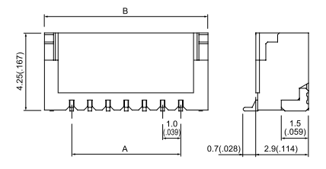

Looking at the side in which there are surface mount pins, the first pin (T1()) is the first one starting from the right.

**Specifications:**

- Max contact resistance: 20mOhm

- Min insulation resistance: 100MOhm

- Max current: 0.7A

- Max DC voltage: 50V

- Height: 4.25mm

- External thickness: 2.9mm

- Width: 6mm

Operations

## Image8.png T1

Name: T1

Pin 1

**Coding:** voltage

**Periodicity:** continuous

## Image8.png T2

Name: T2

Pin 2

**Coding:** voltage

**Periodicity:** continuous

## Image8.png T3

Name: T3

Pin 3

**Coding:** voltage

**Periodicity:** continuous

## Image8.png T4

Name: T4

Pin 4

**Coding:** voltage

**Periodicity:** continuous

## Image7.png MaleCrimpConnector_4pin_1mmPitch

Name: MaleCrimpConnector_4pin_1mmPitch

Crimp style male connector. It has 4 pins 1mm pitch.

It is used to terminate 4 wires in order to connect them to a board, avoiding soldering them. For this purpose a FemaleCrimpConnector_4pin_1mmPitch_SMD_topEntry is needed on the board.

MaleCrimpConnector_4pin_1mmPitch must be similar to the following one:

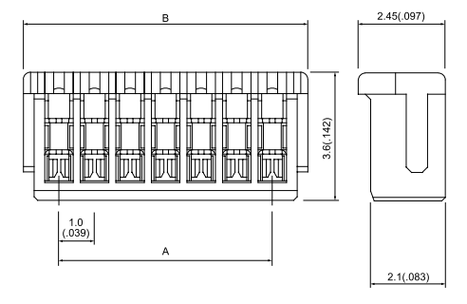

**Specifications:**

- Max contact resistance: 20mOhm

- Min insulation resistance: 100MOhm

- Max current: 0.7A

- Max DC voltage: 50V

- Height: 3.6mm

- Thickness: 2.1mm

- Width: 5mm

Operations

## Image8.png T1

Name: T1

Pin 1.

It must be connected to T1() of FemaleCrimpConnector_4pin_1mmPitch_SMD_topEntry.

**Coding:** voltage

**Periodicity:** continuous

## Image8.png T2

Name: T2

Pin 2.

It must be connected to T2() of FemaleCrimpConnector_4pin_1mmPitch_SMD_topEntry.

**Coding:** voltage

**Periodicity:** continuous

## Image8.png T3

Name: T3

Pin 3.

It must be connected to T3() of FemaleCrimpConnector_4pin_1mmPitch_SMD_topEntry.

**Coding:** voltage

**Periodicity:** continuous

## Image8.png T4

Name: T4

Pin 4.

It must be connected to T4() of FemaleCrimpConnector_4pin_1mmPitch_SMD_topEntry.

**Coding:** voltage

**Periodicity:** continuous

## Image7.png BoardToBoard_20_2mm54_SMD

Name: BoardToBoard_20_2mm54_SMD

Surface mount socket to connect another board to the PCB on which circuit is implemented.

20 inputs are aligned on a single row, with a pitch of 2.54mm.

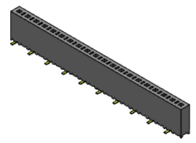

## Image7.png Schematic

Name: Schematic

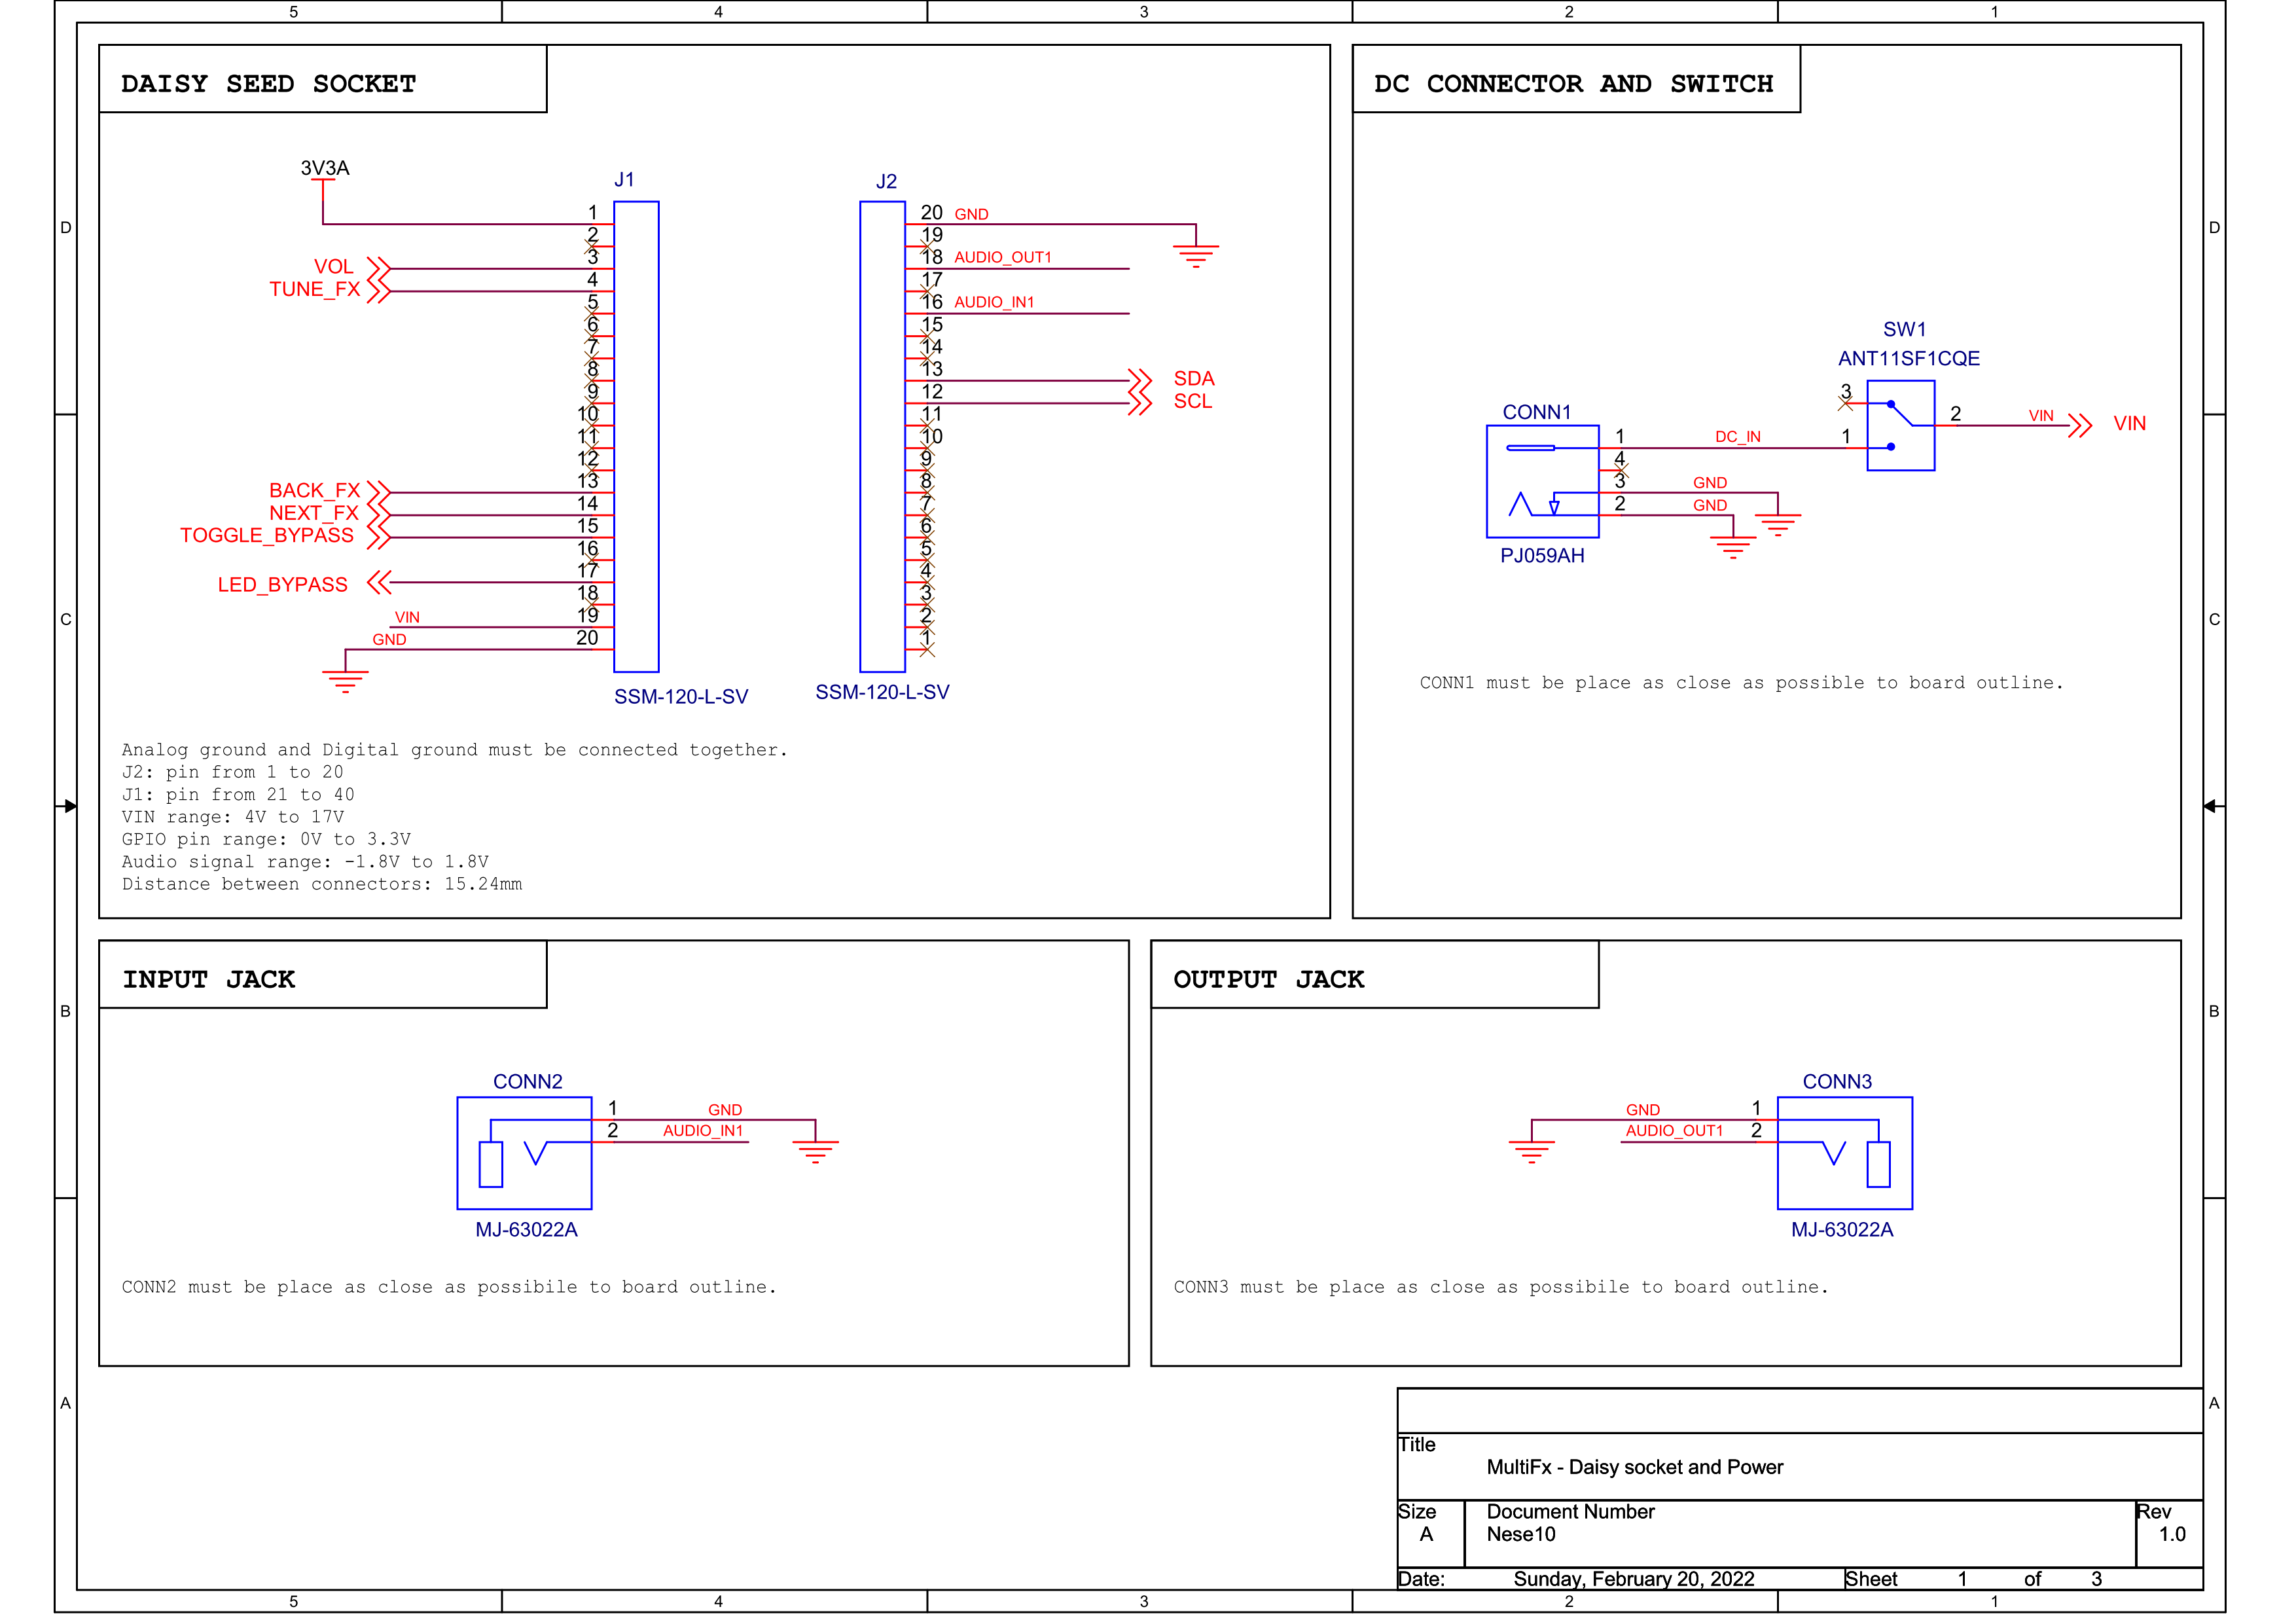

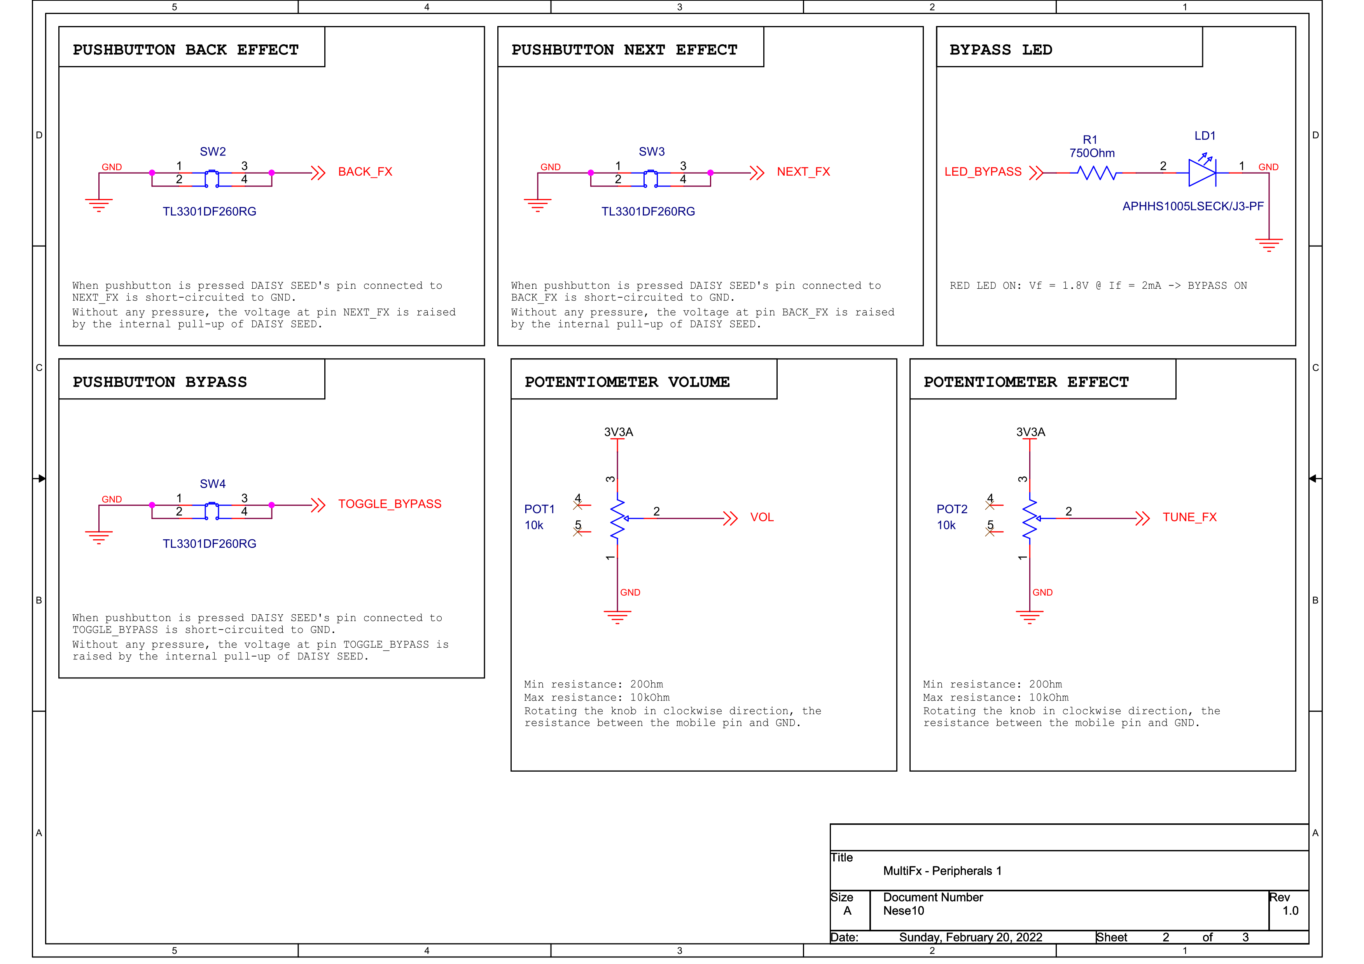

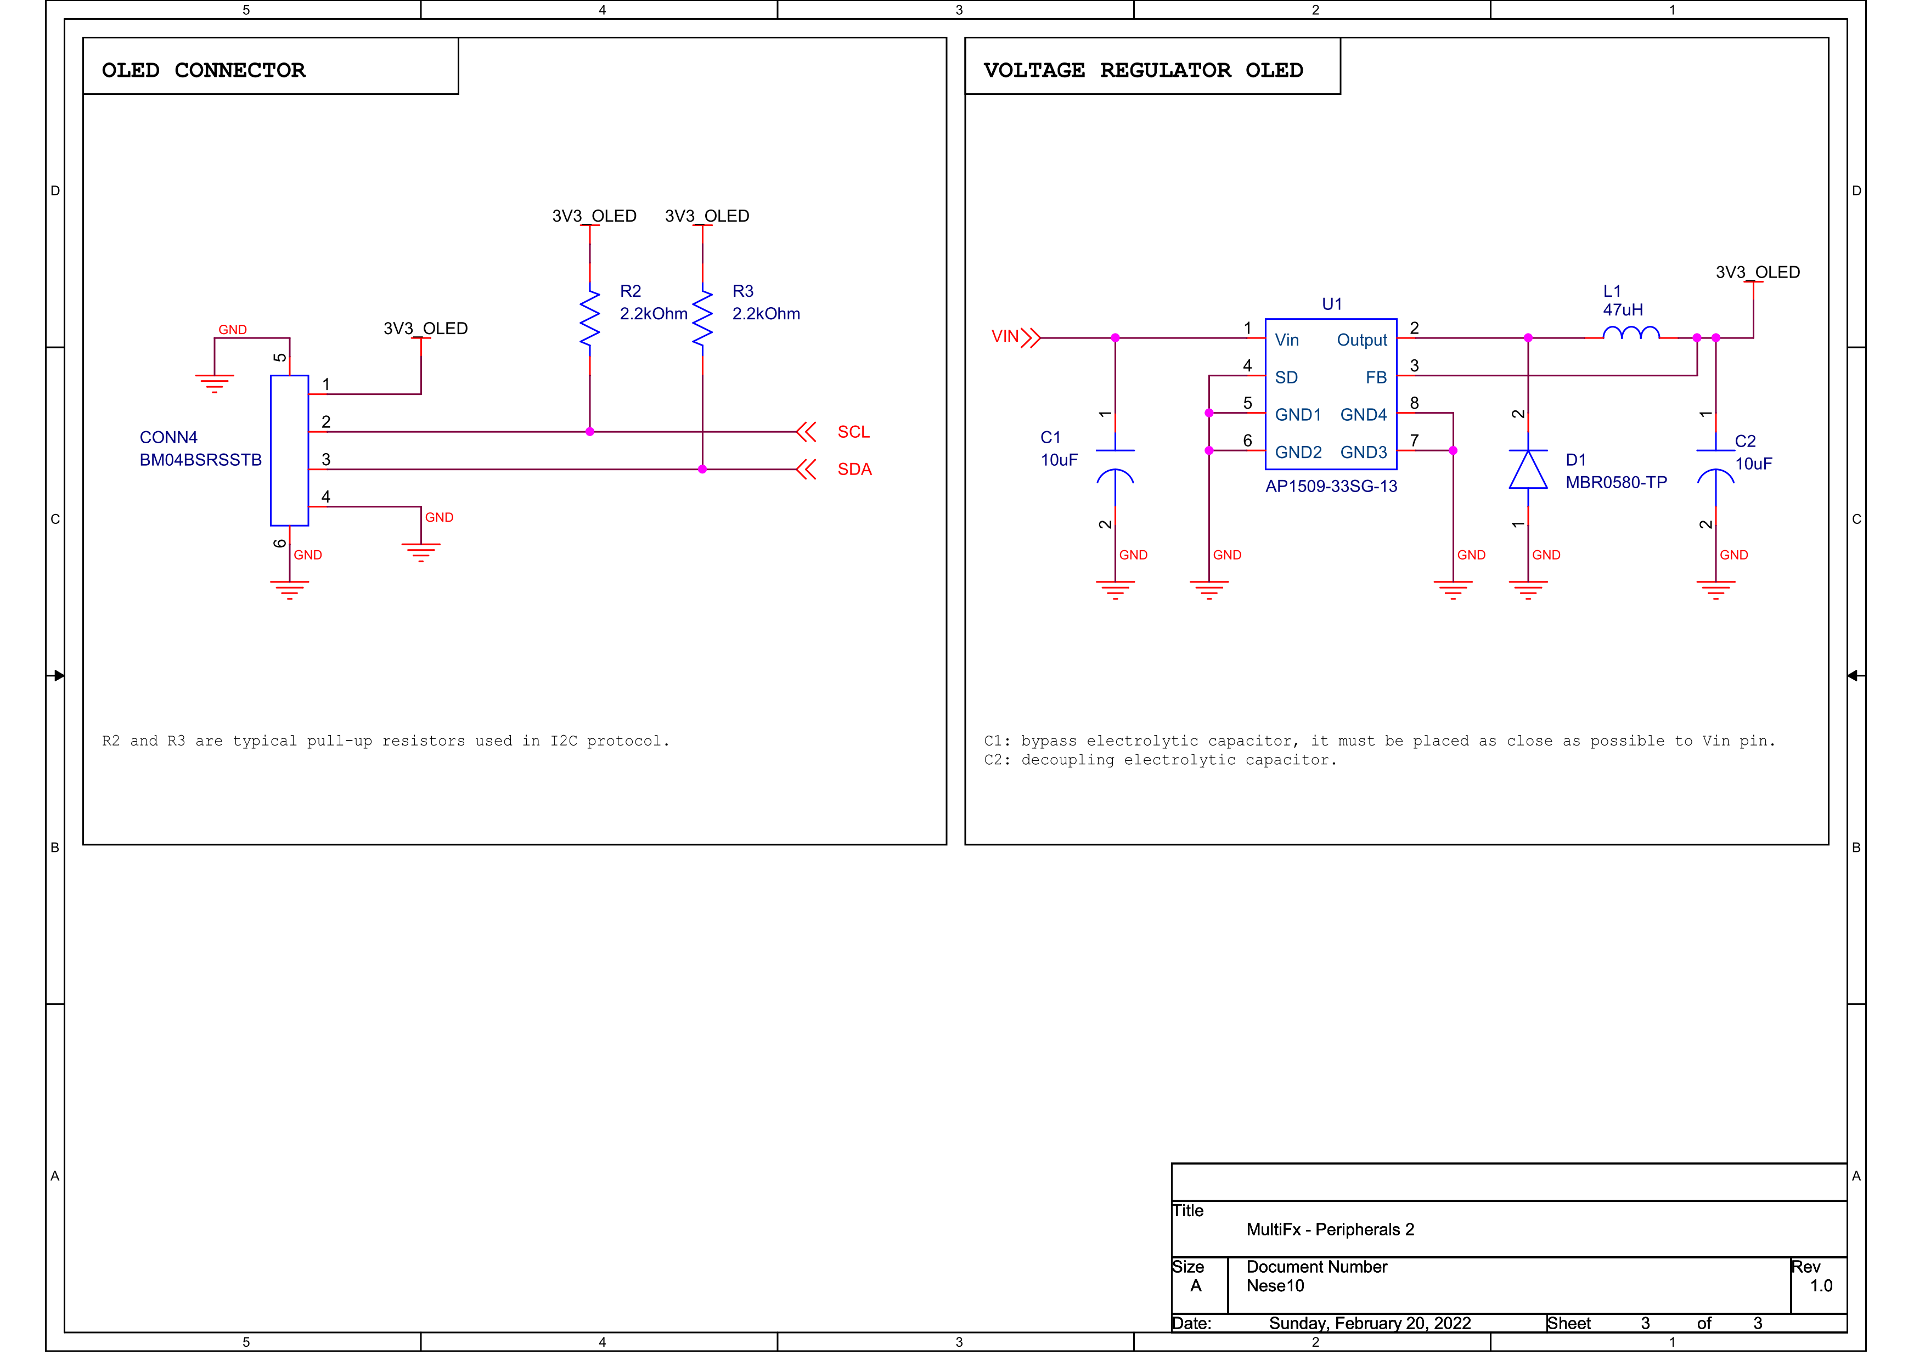

## Image7.png DAISY_SEED

Name: DAISY_SEED

DAISY_SEED is an embedded platform for music. It features everything you need for creating high fidelity audio hardware devices. It integrates:

- SDRAM 64MB

- ARM Cortex-M7 MCU, running at 480MHz

- 31 GPIO

- 12 bit ADC

**Absolute maximum ratings:**

- Vin: [4, 17] V

- GPIO: [0, 5] V

- Audio inputs: [-1.8, 1.8] V

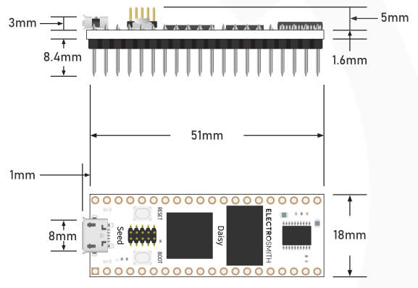

Operations

## Image8.png VIN

Name: VIN

Voltage supply (DC) input terminal of DAISY_SEED board. It is pin 39.

VIN: 4V to 17V

**Coding:** voltage, 4V - 17V

**Periodicity:** continuous

## Image8.png OUT_3V3A

Name: OUT_3V3A

Output DC voltage 3.3V provided by DAISY_SEED. It can be used to supply other components. It corresponds to pin 21.

Maximum available current: 150mA.

**Coding:** voltage, 3.3V

**Periodicity:** continuous

## Image8.png ADC_IN1

Name: ADC_IN1

Input ADC. An analog signal can be connected to this input in order to be converted in digital (12 bit resolution).

Input voltage can be in the range from 0V to 3.3V.

**Coding:** voltage, 0V - 3.3V

**Periodicity:** continuous

## Image8.png ADC_IN2

Name: ADC_IN2

Input ADC. An analog signal can be connected to this input in order to be converted in digital (12 bit resolution).

Input voltage can be in the range from 0V to 3.3V.

**Coding:** voltage, 0V - 3.3V

**Periodicity:** continuous

## Image8.png GPIO1

Name: GPIO1

GPIO pin: 0V to 3.3V

When configured as input each pin can configure an internal pull-up, pull-down, or no pull resistor.

When configured as an output each pin can be configured for push-pull or open-drain configuration.

**Coding**: digital voltage

* Input logic levels:
  + '0': DGND() - 0.99V
  + '1': 2.31V - 3.3V
* Output logic levels:
  + '0': DGND() - 0.4V
  + '1': 2.9V - 3.3V

**Periodicity**: continuous

## Image8.png GPIO2

Name: GPIO2

GPIO pin: 0V to 3.3V

When configured as input each pin can configure an internal pull-up, pull-down, or no pull resistor.

When configured as an output each pin can be configured for push-pull or open-drain configuration.

**Coding**: digital voltage

* Input logic levels:
  + '0': DGND() - 0.99V
  + '1': 2.31V - 3.3V
* Output logic levels:
  + '0': DGND() - 0.4V
  + '1': 2.9V - 3.3V

**Periodicity**: continuous

## Image8.png GPIO3

Name: GPIO3

GPIO pin: 0V to 3.3V

When configured as input each pin can configure an internal pull-up, pull-down, or no pull resistor.

When configured as an output each pin can be configured for push-pull or open-drain configuration.

**Coding**: digital voltage

* Input logic levels:
  + '0': DGND() - 0.99V
  + '1': 2.31V - 3.3V
* Output logic levels:
  + '0': DGND() - 0.4V
  + '1': 2.9V - 3.3V

**Periodicity**: continuous

## Image8.png GPIO4

Name: GPIO4

GPIO pin: 0V to 3.3V

When configured as input each pin can configure an internal pull-up, pull-down, or no pull resistor.

When configured as an output each pin can be configured for push-pull or open-drain configuration.

**Coding**: digital voltage

* Input logic levels:
  + '0': DGND() - 0.99V
  + '1': 2.31V - 3.3V
* Output logic levels:
  + '0': DGND() - 0.4V
  + '1': 2.9V - 3.3V

**Periodicity**: continuous

## Image8.png AGND

Name: AGND

Analog ground reference voltage of DAISY_SEED board. It corresponds to pin 20.

AGND()must be shorted to DGND().

**Coding:** voltage, 0V - 3.3V

**Periodicity:** continuous

## Image8.png DGND

Name: DGND

Digital ground reference voltage of DAISY_SEED board. It corresponds to pin 40.

DGND() must be shorted to AGND().

**Coding:** voltage

**Periodicity:** continuous

## Image8.png I2C1_SDA

Name: I2C1_SDA

GPIO pin dedicated for I2C Serial DAta line (SDA).

Input voltage can be in the range from 0V to 3.3V.

**Coding**: I2C

* Input logic levels:
  + '0': DGND() - 0.99V
  + '1': 2.31V - 3.3V
* Output logic levels:
  + '0': DGND() - 0.4V
  + '1': 2.9V - 3.3V

**Periodicity**: continuous

## Image8.png I2C1_SCL

Name: I2C1_SCL

GPIO pin dedicated for I2C Serial CLock line (SCL).

Input voltage can be in the range from 0V to 3.3V.

**Coding**: I2C

* Input logic levels:
  + '0': DGND() - 0.99V
  + '1': 2.31V - 3.3V
* Output logic levels:
  + '0': DGND() - 0.4V
  + '1': 2.9V - 3.3V

**Periodicity**: continuous

## Image8.png AUDIO_IN1

Name: AUDIO_IN1

Line Level, AC Coupled analog audio

Audio will begin to clip when input or output signal approach 3Vpp

For line level audio, the pins can be connected directly to jacks, etc.

**Coding:** voltage, -1.8V - 1.8V

**Periodicity:** continuous

## Image8.png AUDIO_OUT1

Name: AUDIO_OUT1

Line Level, AC Coupled analog audio

Audio will begin to clip when input or output signal approach 3Vpp

For line level audio, the pins can be connected directly to jacks, etc.

**Coding:** voltage, -1.8V - 1.8V

**Periodicity:** continuous

## Image8.png pressBoot

Name: pressBoot

Boot pushbutton on DAISY_SEED board is pressed. It can be useful to flash uP: uP_SignalMusicProcessing.

## Image8.png releaseBoot

Name: releaseBoot

Boot pushbutton on DAISY_SEED board is released.

## Image8.png pressReset

Name: pressReset

Reset pushbutton on DAISY_SEED board is pressed. It allows to reset the DAISY_SEED board and can be useful to flash uP: uP_SignalMusicProcessing.

## Image8.png releaseReset

Name: releaseReset

Reset pushbutton on DAISY_SEED board is released.

## Image7.png Case

Name: Case

Plastic black case to protect the PCB on which the circuit is assembled.

Since DAISY_SEED board height is approximately 15mm, we need a Case height at least equal to 20mm.

A break in the case 10.86mm x 21.74mm is needed for the OLED_Display.

On the top side of the case there are:

- 5 circular holes with a 9mm diameter

- 1 circular holes with a 5.72 diameter

- 1 rectangular hole 10.86mm x 21.74mm

On the left lateral side there is a circular hole with a 10.8mm diameter.

On the right lateral side there are:

- 1 circular hole with a 10.8mm diameter

- 1 hole for micro USB 2.0 connector

Finally, on the lateral bottom side there is a rectangular hole 9.2mm x 11.2mm

**Specifications:**

- Thickness: 3mm

- Width: 72mm

- Length: 125.5mm

Aggiungi LED, spazio per bottoni su daisy e vista da sotto

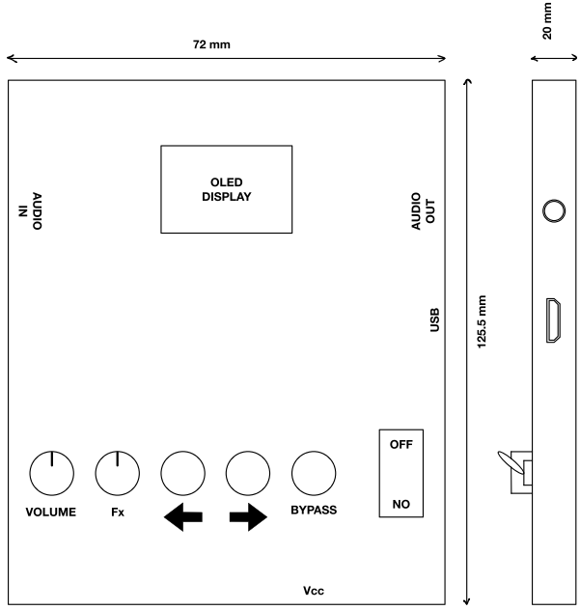

## Image7.png PCB

Name: PCB

Printed Circuit Board to assembly all the components. It is a double layer PCB. A ground plane on the bottom layer is required to minimize the trace inductance.

DAISY_SEED board must be positioned as close as possible to the outline of the board so that the USB connector can be reached from the outside.

Components accessible from the outside must be Through-Hole devices (THT) because they provide a better mechanical attach to the board. Instead, for all the other components Surface Mount Technology (SMT) can be more useful in case of high speed signals.

The PCB must have 4 holes to be fixed to the case. Hole diameter must be 5mm. the holes centers coordinates in mm (origin in the bottom left corner of the PCB):

- 5,5

- 100.5, 5

- 64, 5

- 100.5, 64.5

No components in the next 5mm around these holes.

A couple of BoardToBoard_20_2mm54_SMD useful to connect the DAISY_SEED must be placed in the middle of PCB, parallel to the shortest side of the board.

Then components that allows User to provide input must be placed on the left side. The OLED_Display, instead, must be placed on the right. As far as connectors, they must be placed in order to have the entry oriented towards the outside:

- 5mm7_2mm_DC_THT for the Power_supply and cable, on the left, having the entry exposed on the shorter side of the board

- 6mm35_JACK_Female_THT for the Jack_IN, on the right, having the entry exposed on the longest side of the board (left, looking at the board top layer)

- 6mm35_JACK_Female_THT for the Jack_OUT, on the right, having the entry exposed on the longest side of the board (right, looking at the board top layer)

**Specifications:**

- Width: 69mm

- Length: 105.5mm

- Core material: FR-4

- Board thickness: 1.6mm

- Material TG: 145-150°C

- Copper thickness: 0.035mm

**Top view**

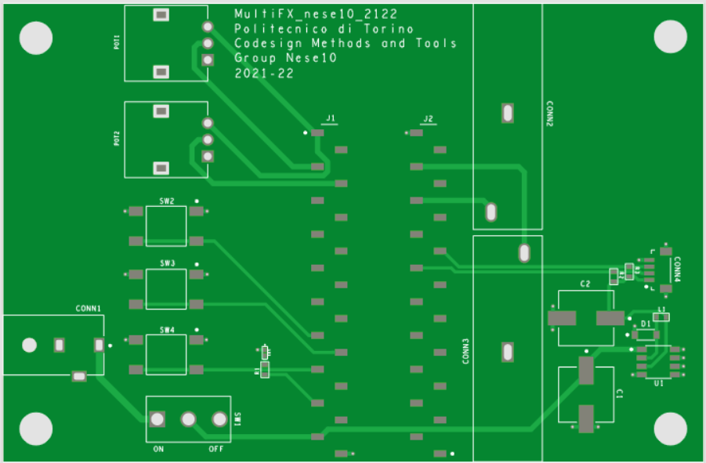

**Bottom view**

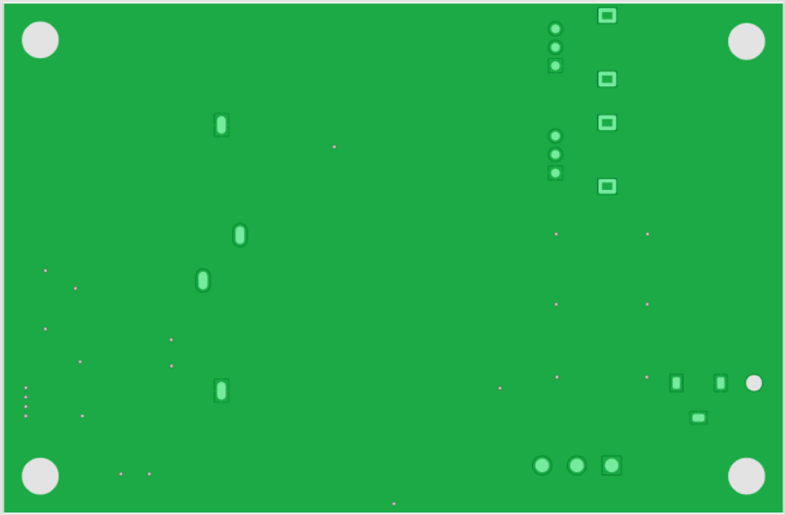

Operations

## Image8.png footprint_pot

Name: footprint_pot

Footprint of 10K_t20%_LOG_POT_H20mm_THT.

Since it is a through-hole component, 3 plated circular holes are required (diameter = 1.2mm), and 2 mechanical rectangular holes (2.4mm x 4.3mm) are required in order to have a better attach to the board.

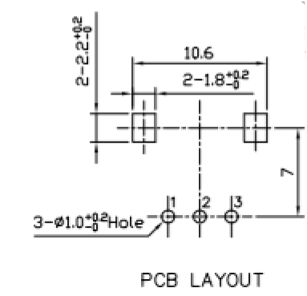

## Image8.png footprint_pushbutton

Name: footprint_pushbutton

Footprint of SMD_SPST_PushButton.

Since it is a surface mount component, 4 copper rectangular exposed pads are required (2.1mm x 1.4mm).

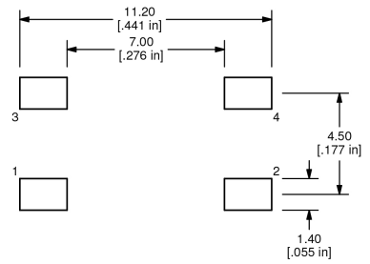

## Image8.png footprint_switch

Name: footprint_switch

Footprint of SPDT_ON-OFF_ToggleSwitch_THT.

Since it is a through-hole component, 3 plated circular holes are required (diameter = 1.85mm).

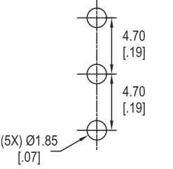

## Image8.png footprint_jack_conn

Name: footprint_jack_conn

Footprint of 6mm35_JACK_Female_THT.

Since it is a through-hole component, 2 plated oval holes are required (1.2mm x 2.4mm).

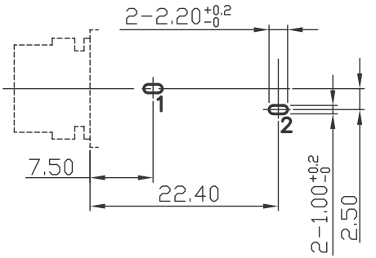

## Image8.png footprint_dc_conn

Name: footprint_dc_conn

Footprint of 5mm7_2mm_DC_THT.

Since it is a through-hole component, 3 plated rectangular holes are required (1.6mm x 1mm), and 1 mechanical circular hole (diameter = 2.2mm) is required in order to have a better attach to the board.

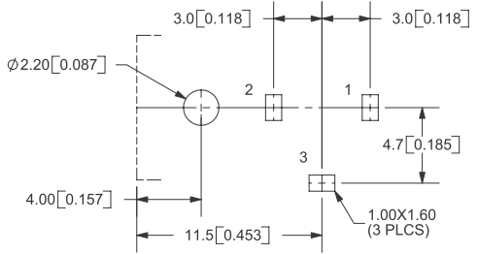

## Image8.png footprint_oled_conn

Name: footprint_oled_conn

Footprint of FemaleCrimpConnector_4pin_1mmPitch_SMD_topEntry.

Since it is a surface mount component:

- 4 rectangular exposed copper pads (0.65mm x 1.55mm) are required for pins

- 4 rectangular exposed copper pads (1.3mm x 1.9mm) are required for mechanical connection to the board

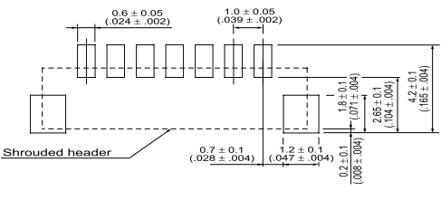

## Image8.png footprint_BTB_conn

Name: footprint_BTB_conn

Footprint of BoardToBoard_20_2mm54_SMD.

Since it is a surface mount component, 20 exposed rectangular copper pads (1.02mm x 1.975mm).

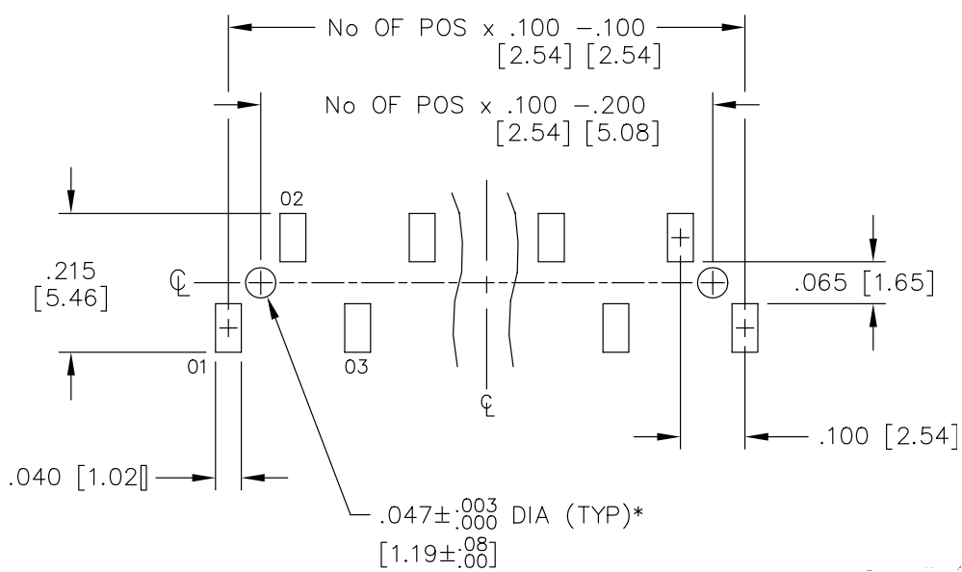

## Image8.png footprint_led

Name: footprint_led

Footprint of RedLED_module_3V3.

Since it is a surface mount component, 2 exposed rectangular copper pads (0.5mm x 0.7mm) are required.

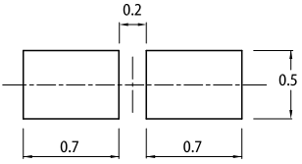

## Image8.png footprint_res0603

Name: footprint_res0603

Footprint for 0603 resistors.

Since surface mount resistors are used, 2 copper rectangular exposed pads are required (0.9mm x 0.65mm).

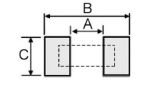

Image29.png

## Image8.png fooprint_DCDC

Name: fooprint_DCDC

Footprint of DCDC_3V3_IC_SMD.

Since it is a surface mount component, 8 copper rectangular exposed pads are required (0.802mm x 1.505mm).

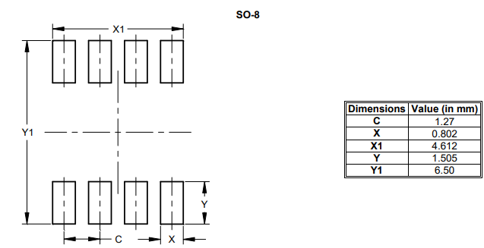

## Image8.png footprint_cap

Name: footprint_cap

Footprint of C_10uF_electrolytic_SMD.

Since it is a surface mount component, 2 copper rectangular exposed pads are required (2.2mm x 4.2mm).

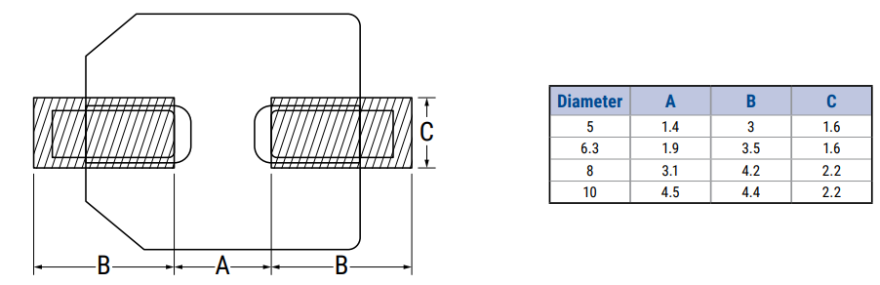

## Image8.png footprint_diode

Name: footprint_diode

Footprint of SMD_SPST_PushButton.

Since it is a surface mount component, 2 copper rectangular exposed pads are required (1.22mm x 0.91mm).

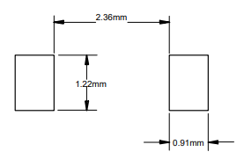

## Image7.png 5mm7_2mm_DC_THT

Name: 5mm7_2mm_DC_THT

Female Jack connector for DC voltage.

The positive DC voltage is received at the core of the connector, instead the external metal cylinder provides the reference voltage.

On the pin T1() there is the DC voltage to supply the circuit. Instead pin T2() and T3() provide the reference ground.

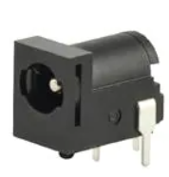

**Basic characteristics:**

- External contact diameter: 5.7mm

- Internal contact diameter: 2mm

- Max voltage: 24V

- Max current: 5A

- 5000 cycles

- Through hole technology

Operations

## Image8.png T1

Name: T1

Terminal connected to the core of 5mm7_2mm_DC_THT connector.

It receives the positive DC supply voltage.

Max voltage: 24V

**Coding**: voltage

**Periodicity**: continuous

## Image8.png T2

Name: T2

Terminal connected to the external metallic cylinder of 5mm7_2mm_DC_THT connector.

It receives the ground reference.

**Coding**: voltage

**Periodicity**: continuous

## Image8.png T3

Name: T3

Terminal connected to the external metallic shell of 5mm7_2mm_DC_THT connector.

It receives the ground reference.

**Coding**: voltage

**Periodicity**: continuous

## Image8.png insertMaleConn

Name: insertMaleConn

Male connector is inserted inside 5mm7_2mm_DC_THT.

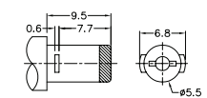

**Coding**: inserted/non-inserted

**Periodicity**: occasional

## Image7.png 6mm35_JACK_Female_THT

Name: 6mm35_JACK_Female_THT

Female Jack connector for Jack mono 6.35mm.

Signal is received from tip of male Jack mono connector 6.35mm, and it is made available at pin T2(). Instead the ground reference is on the sleeve.

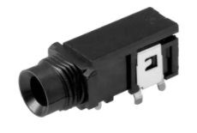

**Basic characteristics:**

- Hole diameter: 6.4mm

- Max voltage: 12V

- Max current: 1A

- Max contact resistance: 30mOhm

- 5000 cycles

- Through hole technology

Operations

## Image8.png T1

Name: T1

Terminal connected to ground reference.

**Coding**: voltage

**Periodicity**: continuous

## Image8.png T2

Name: T2

Terminal that receives the input signal.

**Coding**: voltage

**Periodicity**: continuous

## Image8.png insertMaleJack

Name: insertMaleJack

Male Jack connector is inserted inside 6mm35_JACK_Female_THT.

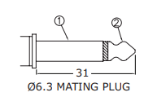

**Coding**: inserted/non-inserted

**Periodicity**: occasional

## Image7.png SPDT_ON-OFF_ToggleSwitch_THT

Name: SPDT_ON-OFF_ToggleSwitch_THT

The switch is an ON-OFF switch. There is a lever that can be in two different positions. When position of lever is modified, it remains in that position until lever is moved in the opposite one.

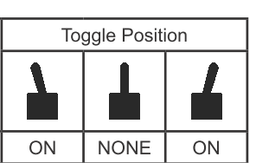

So it can be in two states:

- ON: circuit is connected to voltage supply

- OFF: circuit is not supplied

The switch remains in a state until the lever is moved in the opposite position.

This switch is a SPDT (Single Pole Double Throw) with a common pin (T2()) that can be shorted to T1() or T3().

Body must be higher approximately 20mm in order to guarantee that the lever is outside the Case.

In the following image is reported an example of toggle switch.

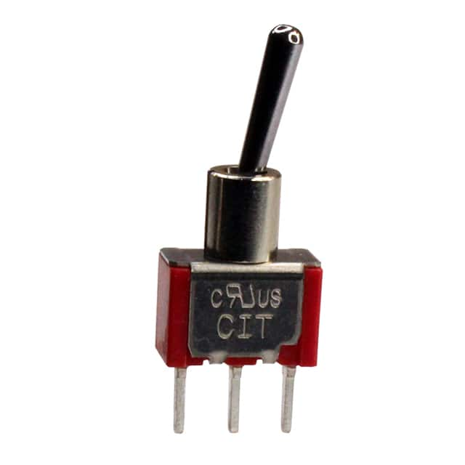

**Electrical characteristics:**

- Insulation resistance: more than 1000MOhm

- Contact resistance: less than 20mOhm

- Maximum current: 5A

**Mechanical characteristics:**

- Through-hole technology

- 50000 cycles

- Total height (without considering lever): at least 2cm

- Circular diameter: 5.72mm

Operations

## Image8.png T1

Name: T1

Terminal connected to the voltage supply.

**Coding:** voltage

**Periodicity:** continuous

## Image8.png T2

Name: T2

Terminal connected to the circuit (common pin).

**Coding:** voltage

**Periodicity:** continuous

## Image8.png T3

Name: T3

Terminal non-connected.

**Coding:** voltage

**Periodicity:** continuous

## Image8.png switchON

Name: switchON

The lever is moved in ON position (towards the "ON" label) in order to connect T1() and T2().

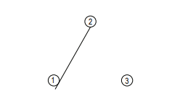

**Coding:** force

**Periodicity:** occasional

## Image8.png switchOFF

Name: switchOFF

The lever is moved in OFF position (towards the "OFF" label) in order to connect T3() and T2().

**Coding:** voltage

**Periodicity:** occasional

## Image7.png RedLED_module_3V3

Name: RedLED_module_3V3

Red LED module that allows to have a bright indication on the circuit.

A SMD LED will require a guide in order to propagate the light until the surface of the package.

In order to limit the current flows in the LED a resistor is required.

A 3.3V DC voltage must be applied to VIN() pin in order to switch on the LED.

Attributes

## Image9.png R1

Name: R1

This resistor allows to limit the current that flows through the RedLED_AlGaInP up to 2mA, considering that VIN() = 3.3V when RedLED_AlGaInP must be switched ON.

The T1() pin must be connected to VIN() pin of RedLED_module_3V3, instead the T2() pin must be connected to A() pin of LD1: RedLED_AlGaInP.

## Image9.png LD1

Name: LD1

Red LED that switches ON when a voltage larger than 1.8V drops on it.

The anode A() must be connected to T2() pin of R1: R_750_1%_0603_SMD, instead the cathode K() must be connected to GND().

Operations

## Image8.png VIN

Name: VIN

Positive voltage pin.

**Coding:** voltage:

- 0V -> switched OFF

- 3.3V -> switched ON

**Periodicity:** continuous

## Image8.png GND

Name: GND

Reference ground pin.

**Coding:** voltage

**Periodicity:** continuous

## Image7.png SMD_SPST_PushButton

Name: SMD_SPST_PushButton

It is a tactile (ON)-OFF switch. There is a button that can be pushed, for an arbitrary long time interval. When it is released it comes back in its original position.

Most of time it is in OFF position, it means that it sends a '1' logic level on OUT2() pin (external pull-up can be required). Instead when button is pressed it sends a '0' logic level on OUT2() pin.

**Basic characteristics:**

- Max contact resistance: 10mOhm

- Min insulation resistance: 100MOhm

- SPST (Single Pole Single Throw)

- Actuation force: 260gf

Operations

## Image8.png OUT1

Name: OUT1

This terminal provides the state of SMD_SPST_PushButton:

- pressed: '0' logic level

- non-pressed: '1' logic level

It must be shortcircuited to OUT2().

**Coding:** voltage

**Periodicity:** continuous

## Image8.png OUT2

Name: OUT2

This terminal provides the state of SMD_SPST_PushButton:

- pressed: '0' logic level

- non-pressed: '1' logic level

It must be shortcircuited to OUT1().

**Coding:** voltage

**Periodicity:** continuous

## Image8.png GND1

Name: GND1

Terminal connected to ground reference voltage.

It must be shortcircuited to GND2().

**Coding:** voltage

**Periodicity:** continuous

## Image8.png GND2

Name: GND2

Terminal connected to ground reference voltage.

It must be shortcircuited to GND1().

**Coding:** voltage

**Periodicity:** continuous

## Image8.png push

Name: push

When button is pressed the OUT1() and OUT2() terminal are shortcircuited to GND1() and GND2().

**Coding:** force

**Periodicity:** occasional

## Image8.png release

Name: release

When button is not pressed OUT1() and OUT2() pins are float.

**Coding:** voltage

**Periodicity:** occasional

## Image7.png 10K_t20%_LOG_POT_H20mm_THT

Name: 10K_t20%_LOG_POT_H20mm_THT

The potentiometer 10K_t20%_LOG_POT_H20mm_THT is a logarithmic potentiometer that allows to have a variable resistance. The resistance value depends on the position of the knob, that can be rotated in clockwise and counterclockwise direction. Since VDD() must be connected to a voltage supply, the variable resistance allows to tune the voltage at pin F_T().

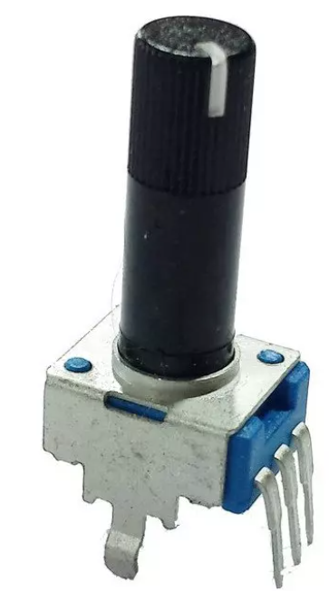

**Electrical characteristics:**

- Minimum resistance: 20Ohm

- Maximum resistance: 10KOhm

- Tolerance: +/-20%

- Maximum voltage: 50V

**Mechanical characteristics:**

- Knob diameter: 6mm

- Total height: 20mm

- Total rotation: 280°

- 100000 cycles

- Through-hole technology

Operations

## Image8.png VDD

Name: VDD

Voltage supply pin.

Max voltage: 50V

**Coding:** voltage

**Periodicity:** continuous

## Image8.png GND

Name: GND

Reference ground pin.

**Coding:** voltage

**Periodicity:** continuous

## Image8.png F_T

Name: F_T

Terminal at which the variable voltage can be read. Voltage at this pin can vary in the range from F_T() = 20/10k * VDD() = 2*10^-3*VDD() (due to the minimum resistance of potentiometer) to F_T() = VDD().

**Coding:** voltage

**Periodicity:** continuous

## Image8.png tuneR

Name: tuneR

Knob is rotated in clockwise direction: voltage at pin F_T()increases, so resistance is higher

**Coding:** force

**Periodicity:** occasional

## Image8.png tuneL

Name: tuneL

Knob is rotated in counterclockwise direction: voltage at pin F_T() decreases, so resistance is lower

**Coding:** force

**Periodicity:** occasional

## Image7.png OLED_Display

Name: OLED_Display

OLED display module.

A DC voltage between 4.5V and 22V is required to supply this module.

The I2C protocol is exploited to establish a communication with the remaining part of the circuit.

Attributes

## Image9.png MaleConn

Name: MaleConn

The 4 wire starting from the OLED_Display pins end in the MaleCrimpConnector_4pin_1mmPitch.

This male connector will be inserted inside the CONN4: FemaleCrimpConnector_4pin_1mmPitch_SMD_topEntry, so that there is a direct mapping between pins of both connectors:

- T4() -> GND()

- T3() -> SDA()

- T2() -> SCL()

- T1() -> VOUT()

## Image9.png CONN4

Name: CONN4

Female crimp style connector on the board that allows to connect OLED_Display to the circuit. Pins of connector must be mapped in the following way:

- T4() -> GND()

- T3() -> SDA()

- T2() -> SCL()

- T1() -> VOUT()

## Image9.png R1

Name: R1

Pull-up resistor to rise the SCL() line.

## Image9.png R3

Name: R3

Pull-up resistor to rise the SDA() line.

## Image9.png DCDC

Name: DCDC

A DCDC regulator is used to supply the OLED_Display in order to isolate it from the power supply of uP: uP_SignalMusicProcessing.

Therefore DCDC: DCDC_3V3_module provide the positive supply voltage to OLED_Display. In fact, VIN() pin of DCDC: DCDC_3V3_module receives the DC voltage from T1() of 5mm7_2mm_DC_THT and provides on VOUT() pin a suitable supply voltage for OLED_Display.

## Image9.png OLED

Name: OLED

OLED display that exploits the I2C protocol to communicate.

Operations

## Image8.png VIN

Name: VIN

Voltage supply pin of OLED display module.

A supply voltage from 4.5V to 22V can be applied.

**Coding:** voltage, 4.5V - 22V

**Periodicity:** continuous

## Image8.png GND

Name: GND

Reference ground pin.

**Coding:** voltage

**Periodicity:** continuous

## Image8.png SDA

Name: SDA

Serial DAta pin: data are sent and received in a serial way using this pin.

**Coding**: I2C

* Input logic levels:
  + '0': DGND() - 0.99V
  + '1': 2.31V - 3.3V
* Output logic levels:
  + '0': DGND() - 0.4V
  + '1': 2.9V - 3.3V

**Periodicity**: continuous

## Image8.png SCL

Name: SCL

Serial CLock pin: a synchronous signal is connected to this pin in order to synchronize Master and Slave.

**Coding**: I2C

* Input logic levels:
  + '0': DGND() - 0.99V
  + '1': 2.31V - 3.3V
* Output logic levels:
  + '0': DGND() - 0.4V
  + '1': 2.9V - 3.3V

**Periodicity**: continuous

## Image7.png uP_SignalMusicProcessing

Name: uP_SignalMusicProcessing

It is the microprocessor module must be able to process the input signal received by means of Jack_IN.

It exploits the DAISY_SEED board, available on the market.

Some digital signal processing algorithm are implemented in order to apply effects to the input signal.

Attributes

## Image9.png DS

Name: DS

## Image9.png J1

Name: J1

Model: **SSM-120-L-SV**

## Image9.png J2

Name: J2

Model: **SSM-120-L-SV**

## Image9.png FW

Name: FW

## Image7.png MultiFX_nese10_2122

Name: MultiFX_nese10_2122

MultiFX_nese10_2122 is a system that allows to apply some effects to an input audio signal, so that a new audio signal can be provided as output.

The User can easily interface with the system using the knobs and pushbuttons on the top side of the MultiFX_nese10_2122. Furthermore an OLED display allows to understand what is the current effect applied on the input audio signal, the parameter value of that effect and the volume.

Attributes

## Image9.png POT1

Name: POT1

This 10K_t20%_LOG_POT_H20mm_THT allows to tuneR() the volume of the input signal processed by uP: uP_SignalMusicProcessing.

The pin VDD() must be connected to OUT_3V3A() pin of DAISY_SEED.

The pin F_T() must be connected to ADC_IN1(). Due to the connection to OUT_3V3A() the voltage at this pin can be tuned in the voltage range between 6.6mV (minimum volume) and 3.3V (maximum volume).

Finally, the pin GND() will be connected to ground reference provided by CONN1: 5mm7_2mm_DC_THT.

## Image9.png POT2

Name: POT2

This 10K_t20%_LOG_POT_H20mm_THT allows to tuneR() the volume of the input signal processed by uP: uP_SignalMusicProcessing.

The pin VDD() must be connected to OUT_3V3A() pin of DAISY_SEED.

The pin F_T() must be connected to ADC_IN2().

Due to the connection to OUT_3V3A() the voltage at this pin can be tuned in the voltage range between 6.6mV (minimum volume) and 3.3V (maximum volume).

Finally, the pin GND() will be connected to ground reference provided by CONN1: 5mm7_2mm_DC_THT.

## Image9.png SW1

Name: SW1

This SPDT_ON-OFF_ToggleSwitch_THT is used to turn ON/OFF the device.

When device is turned ON (switchON()) the whole circuit is supplied, otherwise (switchOFF()) it is not connected to supply voltage.

## Image9.png SW2

Name: SW2

This SMD_SPST_PushButton that allows to switch to the previous effect.

When button is pressed (push()), there is a commutation ('1' -> '0') on OUT1() and OUT2() pins, that indicate the previous effect must be applied.

Pins OUT1() and OUT2() must be connected to GPIO2().

## Image9.png SW3

Name: SW3

This SMD_SPST_PushButton that allows to switch to the next effect.

When button is pressed (push()), there is a commutation ('1' -> '0') on OUT1() and OUT2() pins, that indicate the next effect must be applied.

Pins OUT1() and OUT2() must be connected to GPIO1().

## Image9.png SW4

Name: SW4

This SMD_SPST_PushButton that allows to switch ON bypass: the input output signal is not processed.

When button is pressed (push()), there is a commutation ('1' -> '0') on OUT1() and OUT2() pins, so it is possible to toggle between bypass ON and OFF, and vice versa.

Pins OUT1() and OUT2() must be connected to GPIO3().

## Image9.png LED

Name: LED

This LED provides a luminous indication about the bypass:

- LED is ON: input signal is bypassed without any processing

- LED is OFF: an effect in applied to input signal

The VIN() pin must be connected to GPIO3().

The GND() pin must be connected to the reference ground voltage provided by CONN1: 5mm7_2mm_DC_THT.

## Image9.png uP

Name: uP

The uP_SignalMusicProcessing module exploits the DAISY_SEED board to process input signal.

## Image9.png OLED

Name: OLED

The OLED: OLED_Display is used to show:

- Current effect

- Bypass status

- Volume percentage

- Effect percentage

It communicates with the uP: uP_SignalMusicProcessing, that provides also the required supply voltage:

- VIN(): T1() of 5mm7_2mm_DC_THT

- GND(): AGND()

- SDA(): I2C1_SDA()

- SCL(): I2C1_SCL()

## Image9.png CONN1

Name: CONN1

Connector that receives the voltage supply from Power_supply and cable in order to supply the whole circuit.

## Image9.png CONN2

Name: CONN2

Connector that receives the signal from Jack_IN(tip of male Jack connector 6.35mm) and send it to uP: uP_SignalMusicProcessing at pin AUDIO_IN1().

## Image9.png CONN3

Name: CONN3

Connector that allows to send the processed audio signal, provided by uP: uP_SignalMusicProcessing at pin AUDIO_OUT1(), to Jack_OUT.

## Image9.png PCB_v1

Name: PCB_v1

## Image9.png SCH_v1

Name: SCH_v1

## Image9.png CASE_125x72

Name: CASE_125x72

Operations

## Image8.png volumeUp

Name: volumeUp

The knob of POT1: 10K_t20%_LOG_POT_H20mm_THT is rotated in clockwise direction (tuneR()). In this way, an higher voltage value will be sampled by DAISY_SEED at ADC_IN1() pin, so it is possible to increase the volume (magnitude) of audio signal processed by uP: uP_SignalMusicProcessing.

## Image8.png volumeDown

Name: volumeDown

The knob of POT1: 10K_t20%_LOG_POT_H20mm_THT is rotated in counterclockwise direction (tuneL()). In this way, a lower voltage value will be sampled by DAISY_SEED at ADC_IN1() pin, so it is possible to decrease the volume (magnitude) of audio signal processed by uP: uP_SignalMusicProcessing.

## Image8.png FxUp

Name: FxUp

The knob of POT2: 10K_t20%_LOG_POT_H20mm_THT is rotated in clockwise direction (tuneR()). In this way, an higher voltage value will be sampled by DAISY_SEED at ADC_IN2() pin, so it is possible to increase the way in which the effect affect the audio signal processed by uP: uP_SignalMusicProcessing.

## Image8.png FxDown

Name: FxDown

The knob of POT2: 10K_t20%_LOG_POT_H20mm_THT is rotated in clockwise direction (tuneR()). In this way, a lower voltage value will be sampled by DAISY_SEED at ADC_IN2() pin, so it is possible to decrease the way in which the effect affect the audio signal processed by uP: uP_SignalMusicProcessing.

## Image8.png switchOn

Name: switchOn

The lever is moved in ON position (towards the "ON" label) in order to switchON() the circuit. In this way the circuit is supplied.

## Image8.png switchOff

Name: switchOff

The lever is moved in OFF position (towards the "OFF" label) in order to switchOFF() the circuit. In this way the circuit is not connected to any voltage supply.

## Image8.png pushNextFx

Name: pushNextFx

When User push() the SW3: SMD_SPST_PushButton the next effect is applied to the audio signal processed by uP: uP_SignalMusicProcessing. In particular, variation of voltage at GPIO1() pin is read like a request (nextFx(int currentEffect)) to switch to the next effect.

One switch per each pressure, until release() of SW3: SMD_SPST_PushButton.

## Image8.png releaseNextFx

Name: releaseNextFx

The User release() the SW3: SMD_SPST_PushButton, so the voltage value become again equal to the quiescent value ('1'). Only now a new pushNextFx() can lead to another effect switch.

## Image8.png pushBackFx

Name: pushBackFx

When User push() the SW2: SMD_SPST_PushButton the previous effect is applied to the audio signal processed by uP: uP_SignalMusicProcessing. In particular, variation of voltage at GPIO2() pin is read like a request (backFx(int currentEffect)) to switch to the next effect.

One switch per each pressure, until release() of SW2: SMD_SPST_PushButton.

## Image8.png releaseBackFx

Name: releaseBackFx

The User release() the SW2: SMD_SPST_PushButton, so the voltage value become again equal to the quiescent value ('1'). Only now a new pushBackFx() can lead to another effect switch.

## Image8.png pushBypass

Name: pushBypass

When User push() the SW4: SMD_SPST_PushButton the next effect is applied to the audio signal processed by uP: uP_SignalMusicProcessing. In particular, variation of voltage at GPIO3() pin is read like a request (bypass(int currentEffect)) to switch to the next effect.

One switch per each pressure, until release() of SW4: SMD_SPST_PushButton.

## Image8.png releaseBypass

Name: releaseBypass

The User release() the SW4: SMD_SPST_PushButton, so the voltage value become again equal to the quiescent value ('1'). Only now a new pushBypass() can lead to another effect switch.

## Image8.png DC_voltage

Name: DC_voltage

DC voltage between 4V and 17V

## Image8.png signal_IN

Name: signal_IN

Input audio signal provided by Jack_IN.

Nominal input level: −20dBm.

## Image8.png signal_OUT

Name: signal_OUT

Processed output audio signal provided to Jack_OUT.

Max output level: Line +5dBm (with output load 10 kΩ or more).

## Image8.png pressBoot

Name: pressBoot

Boot pushbutton on DAISY_SEED board is pressed. It can be useful to flash uP: uP_SignalMusicProcessing.

## Image8.png releaseBoot

Name: releaseBoot

Boot pushbutton on DAISY_SEED board is released.

## Image8.png pressReset

Name: pressReset

Reset pushbutton on DAISY_SEED board is pressed. It allows to reset the DAISY_SEED board and can be useful to flash uP: uP_SignalMusicProcessing.

## Image8.png releaseReset

Name: releaseReset

Reset pushbutton on DAISY_SEED board is released.

## Image8.png uploadFirmware

Name: uploadFirmware

Connecting the USB_cable to DAISY_SEED it is possible to upload a new firmware.

Component Diagram

# Components_multiFx

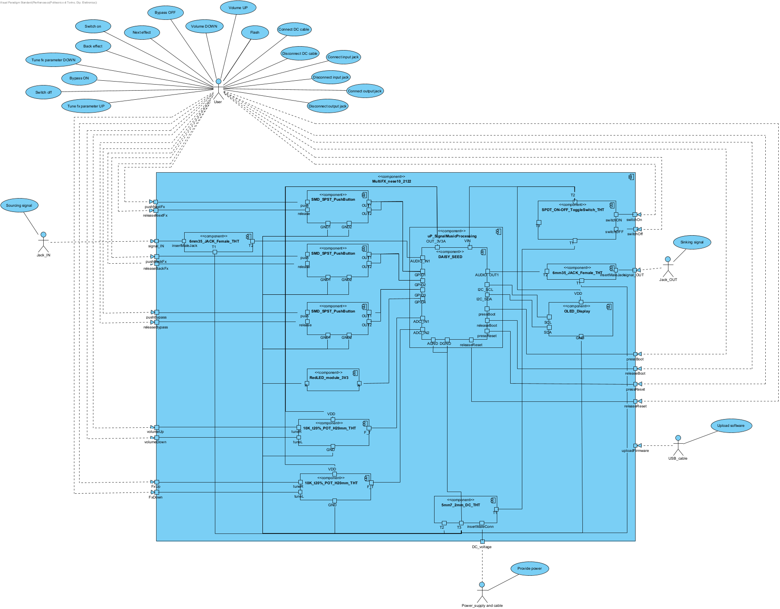

Sequence Diagram

# PowerWindow_CloseRightWindow

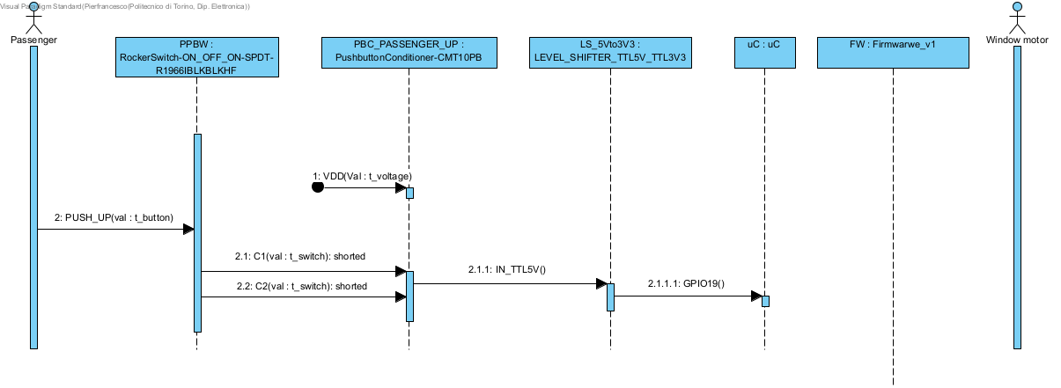

Sequence Diagram

# TuneVolumeUp

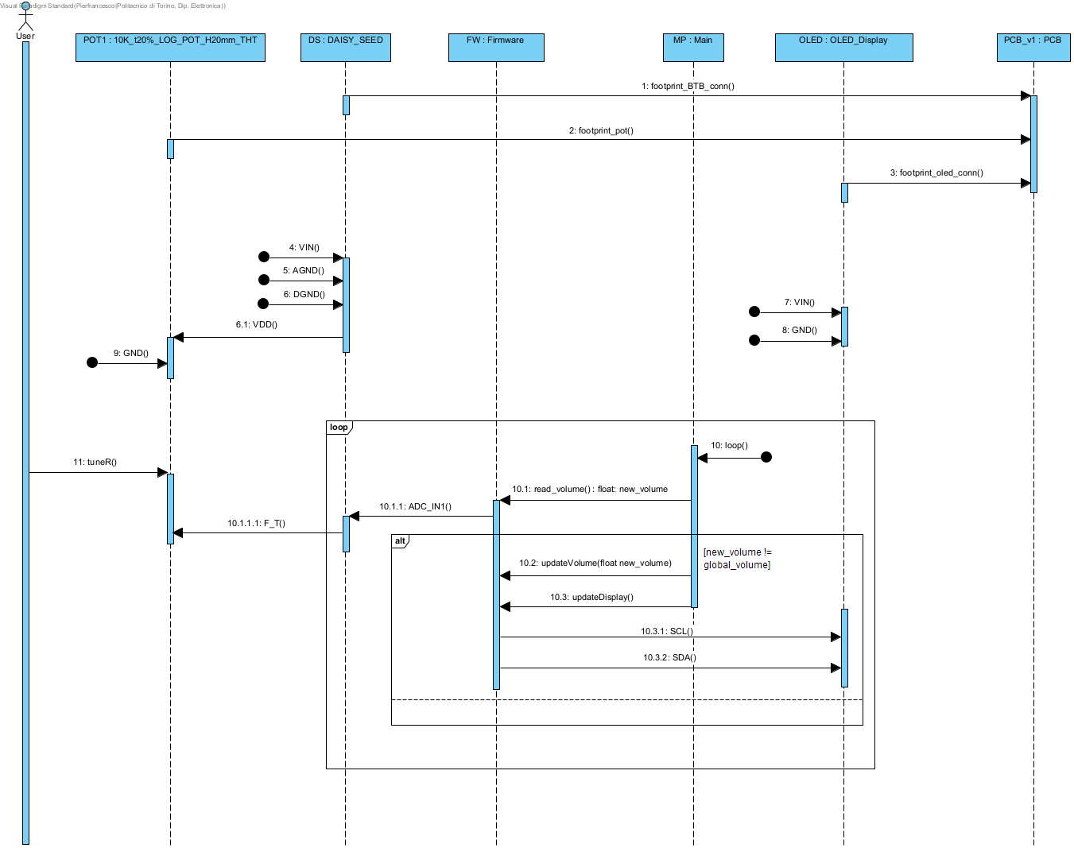

Sequence Diagram

# TuneVolumeDown

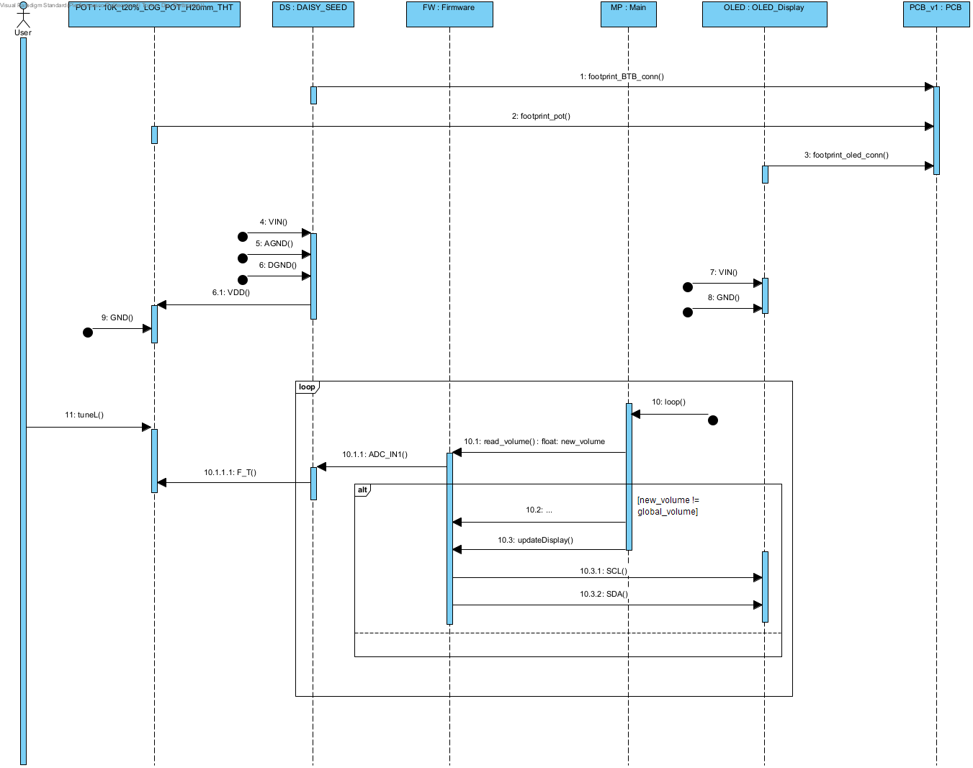

Sequence Diagram

# TuneParameterFxUp

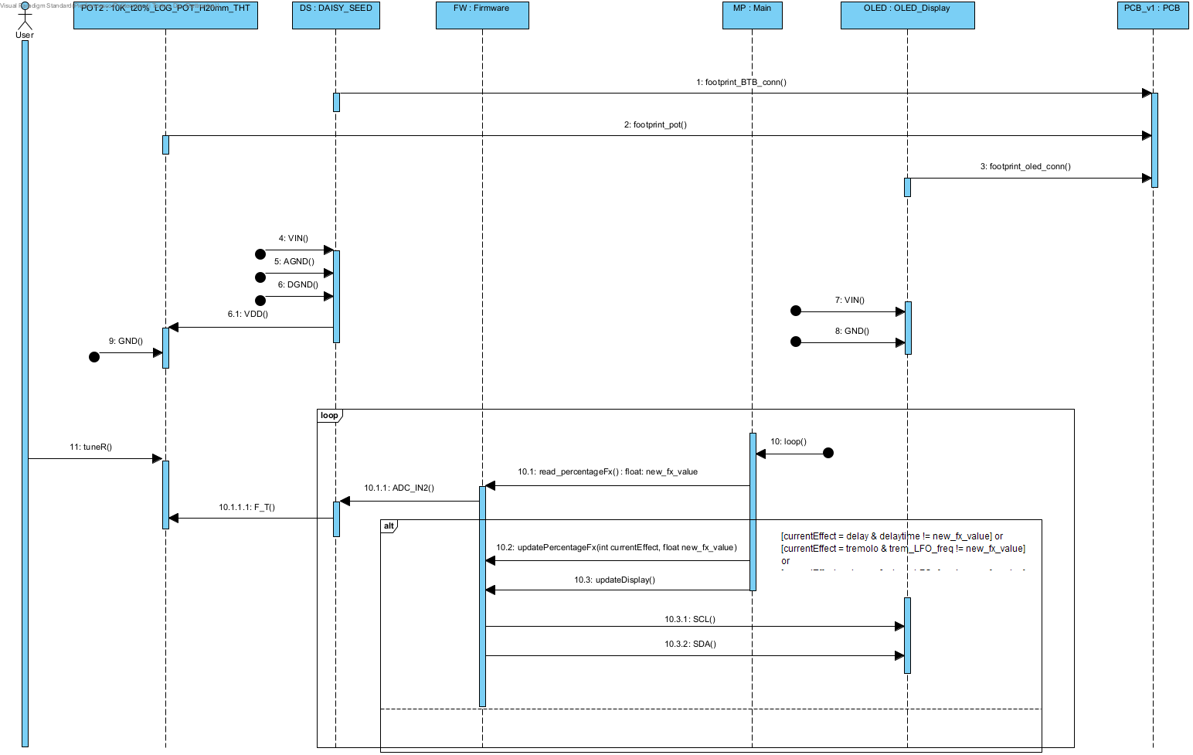

Sequence Diagram

# TuneParameterFxDown

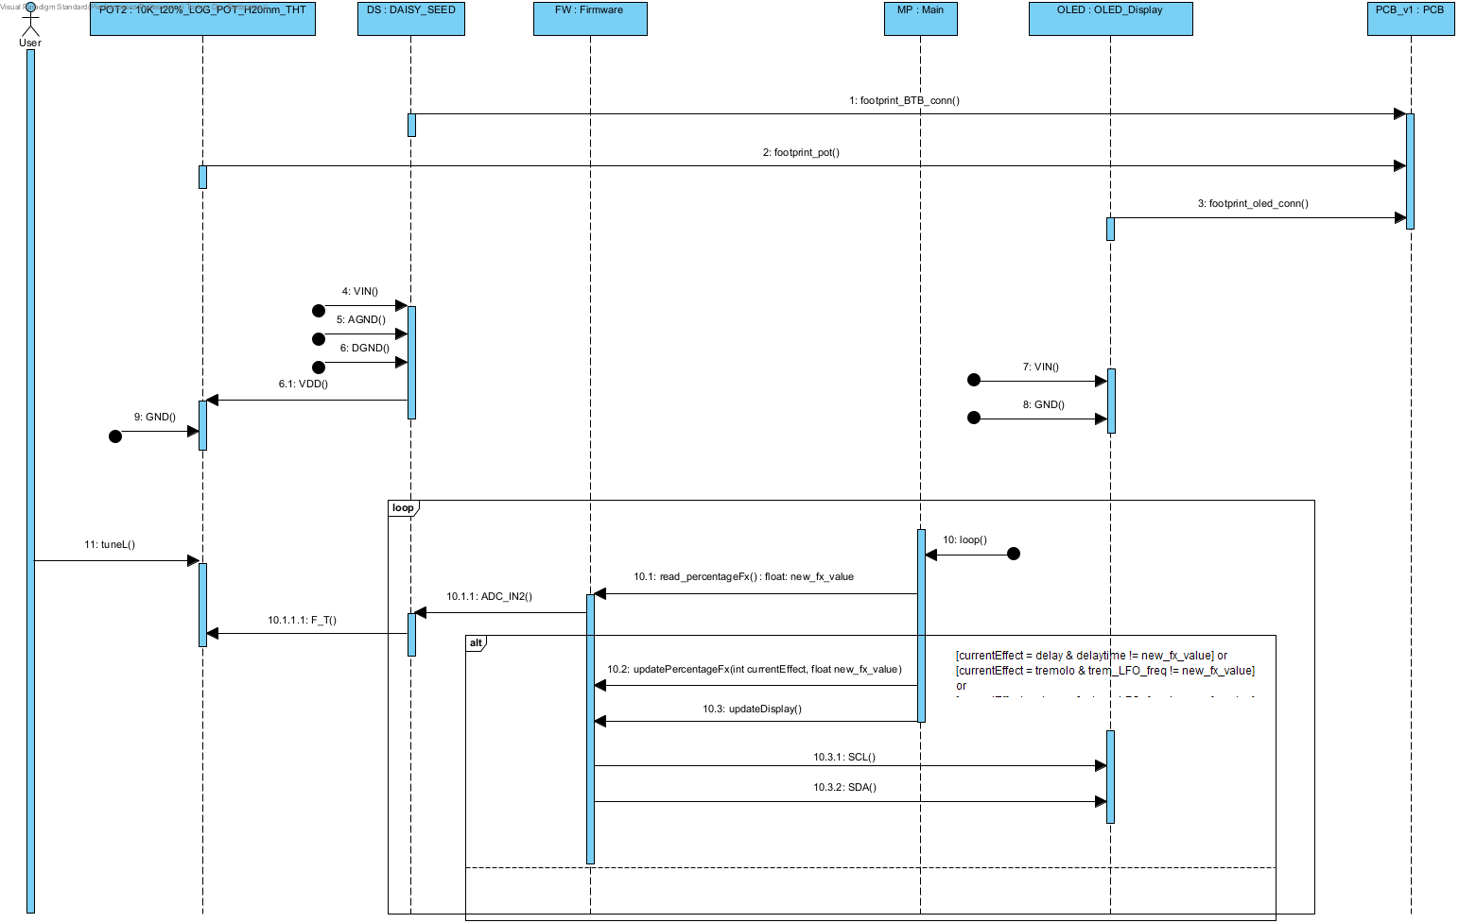

Sequence Diagram

# NextEffect

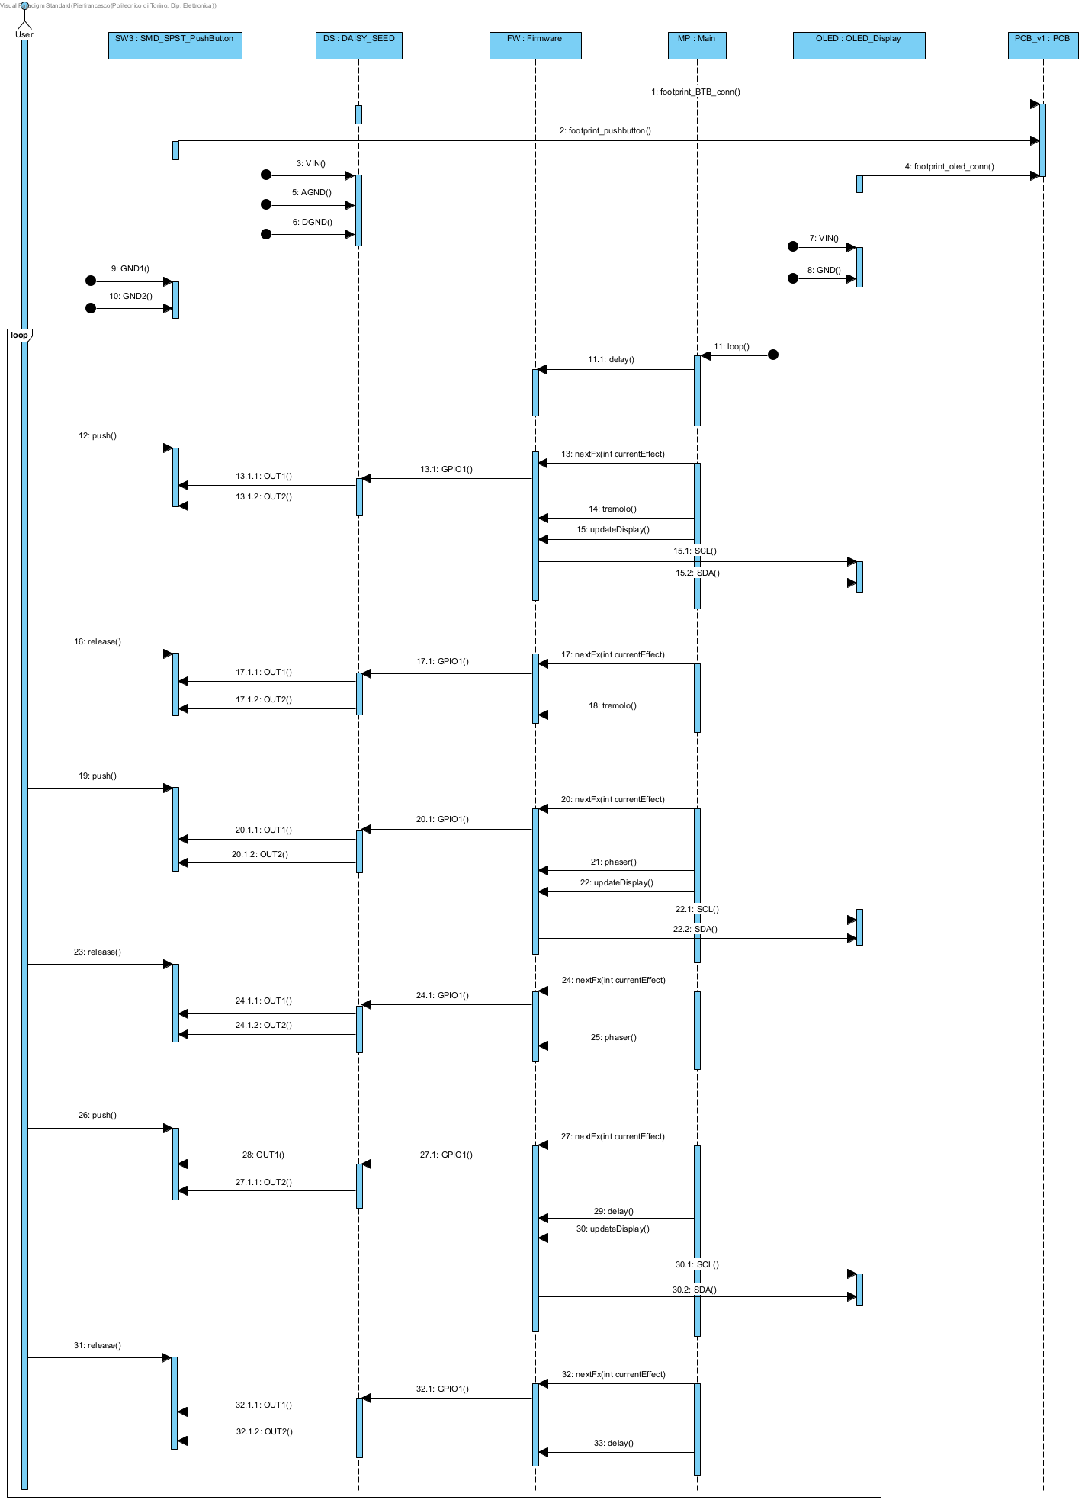

Sequence Diagram

# BackFx

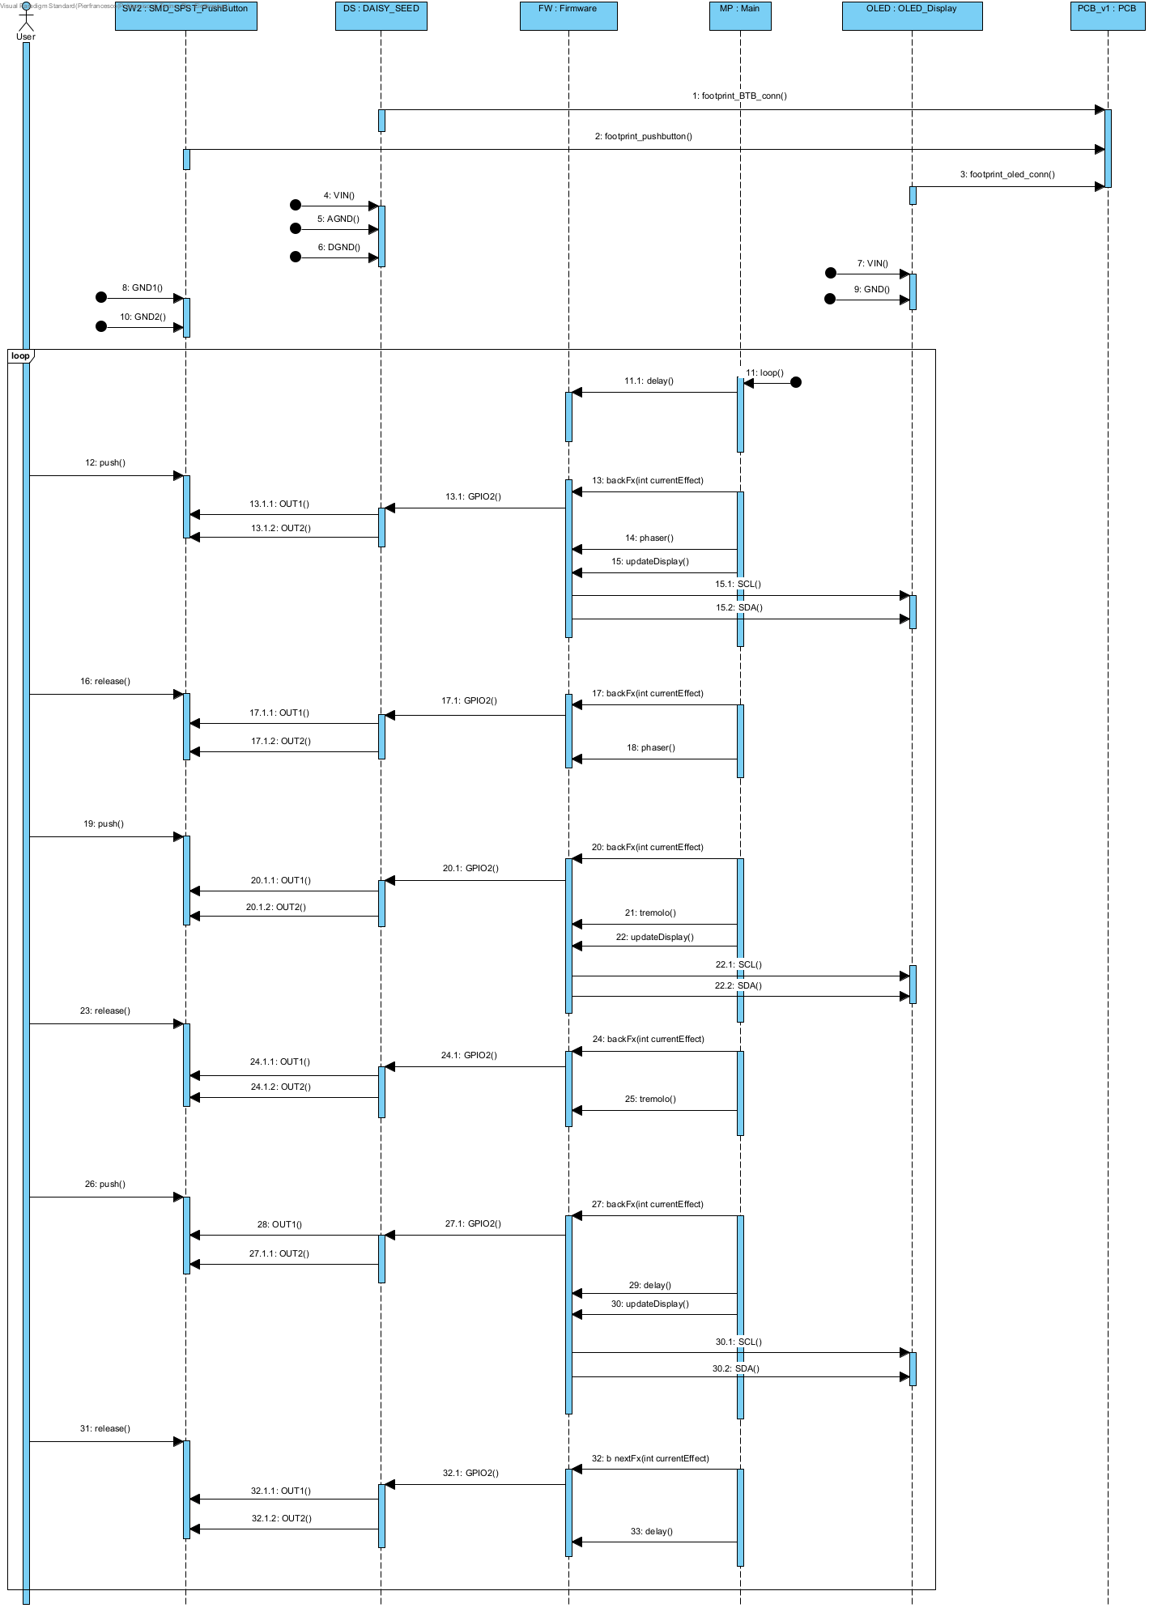

Sequence Diagram

# Bypass

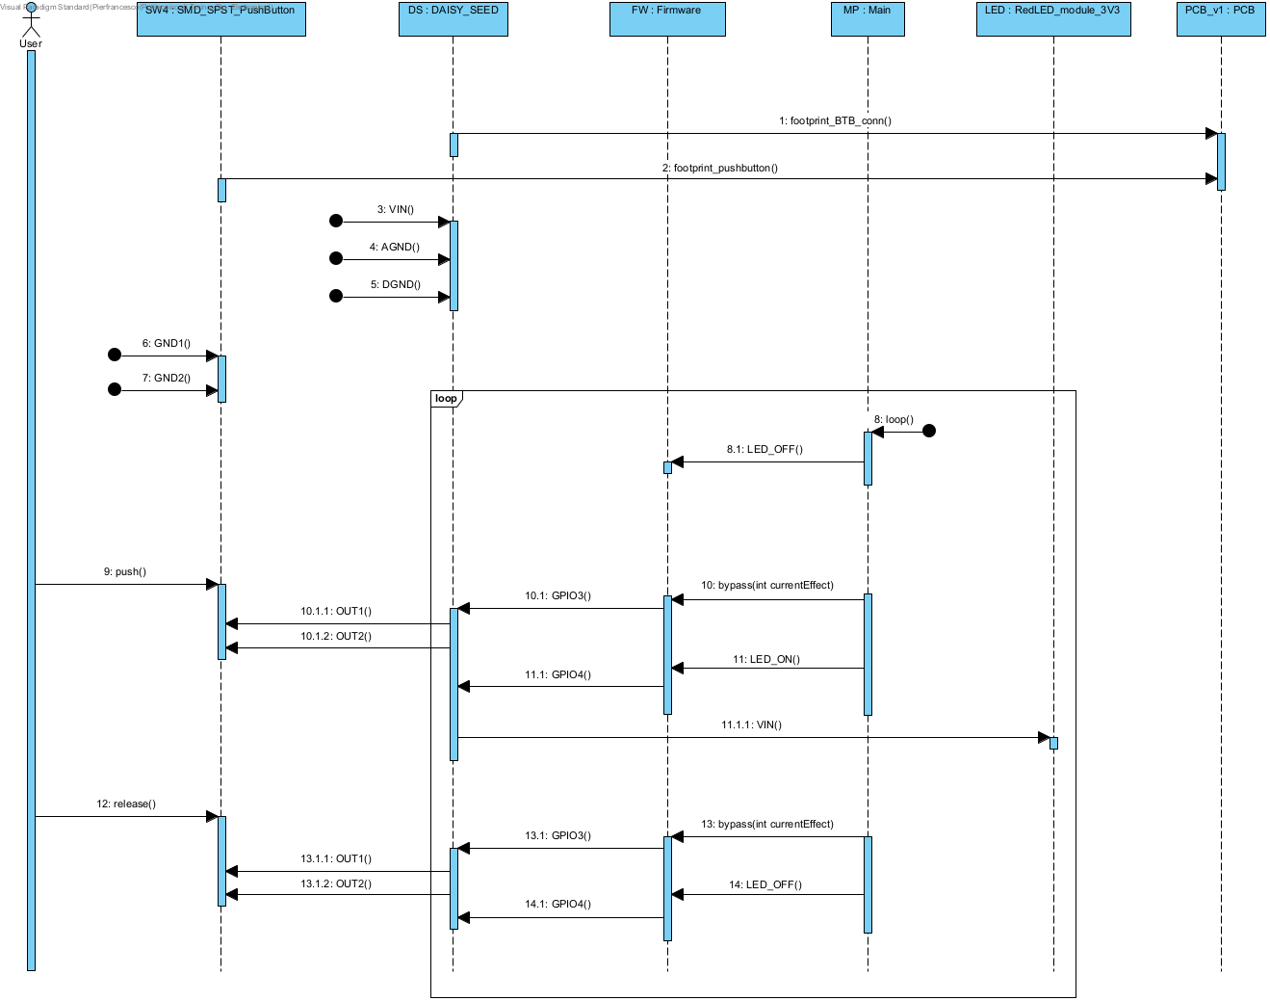

Sequence Diagram

# Switch_ON

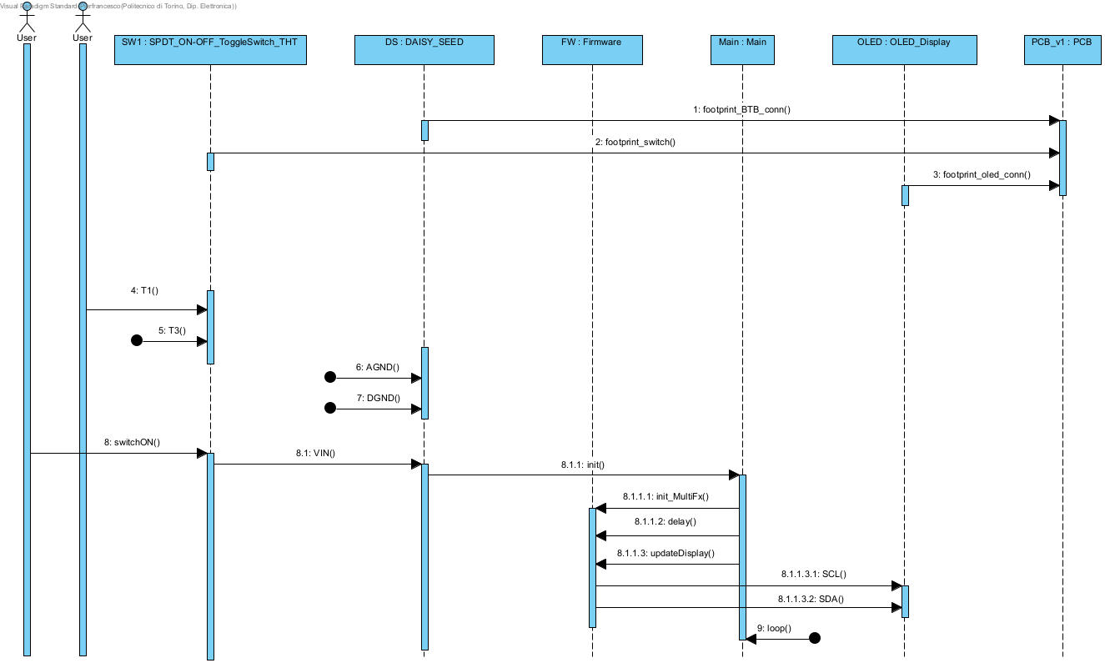

Sequence Diagram

# Switch_OFF

