Beer Guidebook
For a Belgian citizen it is almost a part of the DNA to drink Belgian beer. Because the range of national beers is very large, this piece of work takes the opportunity to set up an application that covers the idea of a personal beer guidebook. Every time a user enjoys a beer, the guidebook should be expanded by simply inserting new information into the application (which is connected to a csv file). A new entry consists of a key (name and alcohol level of the beer) and a value section. The value section contains the following information: Feature/Feeling of the taste, region of origin, city of origin and rating score. Beside inserting new entries, in starting the app the user can also choose to delete, sort or search for existing entries.
The main data structure (the guidebook) uses a (python) dictionary (Python Software Foundation, 09/21). The key is characterized by an immutable tuple (name and alcohol level) whereas the value section uses a mutable list of three strings (feature, region, city) and one floating point number (score). The choice of this set-up can be explained with regard to three dimensions:
- Running Time:
Because of the built-in hash function that Python dictionaries uses, this data structure should lead to constant running time (i.e. does not directly depend on the number of data points) for insertion, deletion and searching. Furthermore, sorting can also be done in less than quadradic time, using for example Timsort (MIT OpenCourseWare, 2013).

- Memory Space:
Memory space can be an issue if there are relatively few entries compared to the size of the dictionary (i.e. number of buckets). But as the number of keys get close to the number of buckets, the space issue in using a dictionary becomes less significant while comparing it to other data structures such as an array, a linked lists or a binary search tree. The appendix contains (A1: Overview: Data Structures and Memory Space) an overview of the main advantages and disadvantages with respect to memory allocation for the different data structures (Brookshear & Brylow, 2018) (CS50, 2020) (PyCon 2017, 2017).
- Developer Time:
The Python dictionary is a built-in data structure and is very user friendly. It has built-in functions for deletion (“pop” or “del”), searching (“==” or “in”) and sorting (“sorted”) (Python Software Foundation, 09/21).
Taking these three criteria into account, the decision in using a python dictionary data structure is mainly related to the great advantages in running and developer time whereas space issues only seem to be temporarily (when resizing is required).
Looking to the application as a whole, Figure 1 depicts the structure quite sufficiently.
Figure 1: Main structure of the beer guidebook algorithm
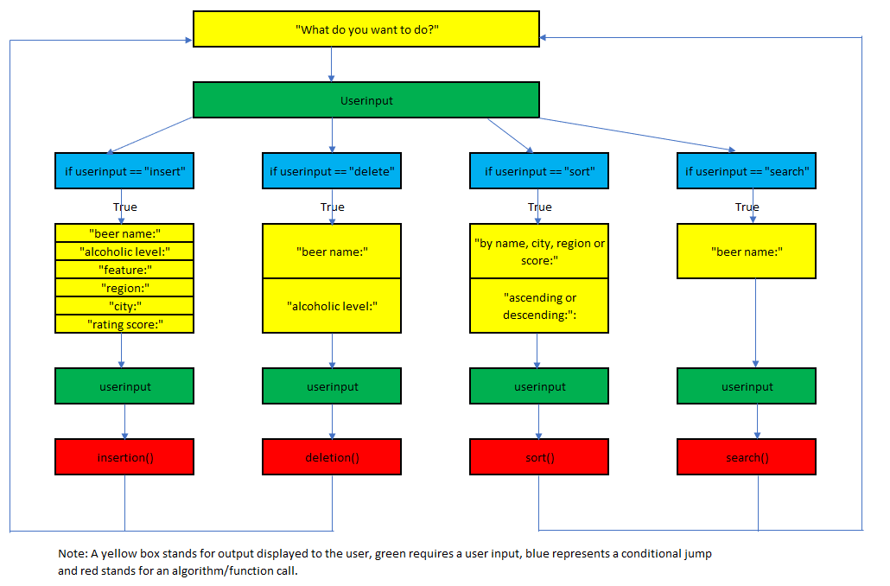
The user will first be asked to enter what he wants to do: insert, delete, search or sort? After providing the desired action by the user, the application goes into a conditional jump:
- “insert” requires that the user provides information about the name and alcohol level, taste features, region, city and a personal rating score.
- “delete” only asks the name and the alcohol level of the beer brand.
- “search” behaves almost similarly in asking the user to provide a beer name.
- “sort” sends additional queries for 1) by name, region, city or rating 2) ascending or descending.
Following these additional information, the application can then call one of the functions: insertion, deletion, sort, search. In general, the whole process from the beginning to the end can be repeatedly done (see the loop arrows at the end which go back to the beginning).
Looking to the pseudocodes of each function (Figure 2), one can distinguish between two groups. Insertion and deletion work in a similar way in the sense that a csv file will be opened/loaded. After opening the file, in calling insertion or deletion the dictionary will be resized and therefore the csv file will be expanded/overwritten. On the other side, sort and search only work with an existing dictionary without changing the data structure itself.
Figure 2: Pseudocode for insertion, deletion, sort and search algorithms
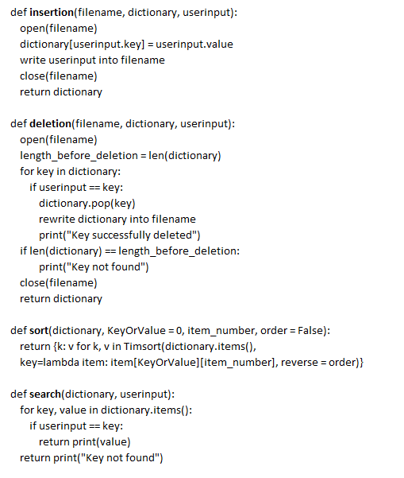
The final step then still consists of testing the reliability of the program. This part is divided into a built-in analysis and a final test data check. The built-in analysis uses small checkpoints while building the application (in mostly running the “print” function). Checkpoints will be included to test for the following questions:
- Are there differences in using capital or small letters when asking the user for input (Boolean test: Are the inputs equal?).
- After every successful deletion, became the length of the dictionary smaller by one unit?
- Will multiple insertion be correctly applied?
The final check then still consists of testing multiple dictionaries which already have existing data (using a csv file where some datasets are artificially generated and others are created by the developer itself). The application can then be tested with respect to 6 checkpoints in running a program “testing.py” ((1) Test for immutability of key, (2) - (5) test for correct use of inserting, deletion, searching, sorting, (6) test for spelling errors). The result of testing.py should lead to 100 % of correct answers (Haas, 2022).
Beer Guidebook (README file)
This piece of work takes the opportunity to set up an application that covers the idea of a personal beer guidebook. The guidebook can be run in typing into a python command line "python guidebook.py". The application itself is divided into two python files, functions.py and guidebook.py.
The functions.py contains all the main actions that the application can take. These are:
- load_csv: Handles the mapping of the data from the CSV file to a python dictionary where the key of the dictionary is a tuple of size “length_key” and the value section is a list of values of size "length_value".
- insertion: Is a function that takes a user input, inserts this as a new key and a new value in a dictionary and then writes this new entry as a new row into CSV file (in append modus, no cancellation of the old entries).
- deletion: It is quite different compared to insertion because it first searches for a tuple as a key in the dictionary. If there is a key that is equal to the tuple, then it removes this key from the dictionary and prints "Key successfully deleted". Though, the important change is that the csv file will be completely overwritten by the adapted (new) dictionary (no append modus). If they Key wasn’t found at all, then an error message appears (“Key not found”). Finally, the new dictionary will be returned.
- search: Is very simple because it only takes two arguments, a dictionary and a beer_name and then checks if the name is a part of a key in the dictionary. If it is, it prints out the value section of all keys that are found, otherwise it prints (“No Key found”).
- sort: It takes four arguments: a dictionary, a boolean to differ between sorting by key or value, an item number for within key/within value sorting and an order category to sort in ascending or descendig modus. Hence, this can lead to different sorting requirements. For sorting itself, it uses the python sorted function which can iterate over a dictionary and can sort it in different ways based on the Timsort algorithm (Python Software Foundation, 06/2020).
The guidebook.py file depicts the main program and therefore includes the user. The main idea is that the program should run infinitely and it therefore constantly listens to the user whether he wants to create or work with an existing guidebook (a CSV file). After the user has provided a name for his guidebook, the selection of one action begins. Here, the user will be asked what he wants to do, insert, delete, search or sort? (Note: If he creates a new notebook, the user automatically goes into insert because there are no existing entries) After selecting one of the four actions, the program always asks the user to provide more information. These are for:
- insert: beer name, alcoholic level, feature 1, feature 2, feature 3, city, region, rating score.
- delete: beer name, alcoholic level
- search: beer name (No alcoholic level is required because it should allow the user to be less precise although this can lead to more than one value sections. On the other side, deletion needs to be precise because it has direct consequences).
- sort: category (beer name, region, city, rating), order (ascending, descending)
Getting the information of one action, the program then calls the equivalent function above and displays in some cases an output. Because the program runs continuously, the program starts again from the beginning after this last step.
Beside functions.py and guidebook.py, the program also includes a file called testing.py which simply tests an existing csv file with respect to 6 dimensions ((1) Test for immutability of key, (2) - (5) test for correct use of inserting, deletion, searching, sorting, (6) test for spelling errors). This application test can be run in typing into the command line ‘python testing.py filename’ where filename is only the name of the csv file (without the ending of ‘.csv’) and then presents an output for every test.
Finally, the zip package also includes 3 testdata csv files which include some duplicates and whitespace errors. Furthermore, testdata2.csv is an artificially generated data set which has been evaluated by running the datacreation.py file (python code ‘python datacreation.py’). This python file allows for randomly generated csv files of different size (5,10,50 or 100 rows) which have the same format as the guidebook.
In general, the application has the following limitations:
- No handling of spelling errors aside from upper/lower case and whitespace issues (for example stopwords) because efficiency in running time is given more priority.
- No class is involved for the guidebook because the application is too specific (no intention to use it for another application). Similar books such as a contact book seem to give more incentive to work with classes.
Appendix
A1) Overview: Data Structures and Memory Space
Linked List |  | Pro: | Resizing flexible
 |  | Con: | Every entry requires space
 |  |  | for value and space for next pointer
Array |  | Pro: | Every entry requires only space
 |  |  | for value (no pointer necessary because contiguous structure)
 |  | Con: | Resizing inflexible because of contiguous structure
Binary Search tree |  | Pro: | Resizing flexible
 |  | Con: | Every entry requires space
 |  |  | for value and space for two next pointers
 |  |  | (left and right child)
Dictionary |  | Pro: | Every entry requires only space
 |  |  | for value (no pointer included)
 |  | Con: | Resizing expensive because a set of buckets will
 |  |  | be allocated. The larger the number of unused buckets, the higher the cost.

Reference List:
Brookshear, J. & Brylow, D. (2018) Computer Science: An Overview. 13th ed. London: Pearson Education Limited.
CS50 2020 (2020) Lecture 5 – Data Structures. Available from: https://www.youtube.com/watch?v=2T-A_GFuoTo&t=6012s [Accessed 10 December 2021]
Haas N. (2022) Beer Guidebook. Essex: Essex University
MIT OpenCourseWare (2013) Hashing with Chaining. Available from: https://www.youtube.com/watch?v=0M_kIqhwbFo [Accessed 07 December 2021]
Python Software Foundation (Latest update 06/20) 3.7.18 Documentation – Sorting HOW TO Available from: https://docs.python.org/2.7/howto/sorting.html [Accessed 02 January 2022]
Python Software Foundation (Latest update 09/21) 3.6.15 Documentation – 4.10. Mapping Types-dict. Available from: https://docs.python.org/3.6/library/stdtypes.html#typesmapping [Accessed 12 December 2021]
PyCon 2017 (2017) Raymond Hettinger Modern Python Dictionaries A confluence of a dozen great ideas PyCon 2017. Available from: https://www.youtube.com/watch?v=npw4s1QTmPg&t=1s [Accessed 07 December 2021]

