Belgian eGovernment: How to improve it?
This essay discusses the digital transformation in the public sector, including a particular analysis of the Belgian Federal Government. Because the expression alone (digital transformation of the public sector) leads to different views of connected terms, this analysis relates it to the field of eGovernment. After introducing the term itself (literature review), the investigation tries to look into a framework (European Interoperability Framework) which implies eGovernment suggestions and relates it to the Belgian State. While looking into the country specific implementation of Belgium, the essay focuses on one key indicator (Digital Post) which can be improved in the future and possible solutions will be depicted. The essay ends with a concluding part where future developments will be discussed.
The introduction already mentioned that it is for this essay of huge importance to shrink the scope in the field of digital transformation of the public sector. There are certainly other fields such as knowledge management, smart cities or cybersecurity which also make a huge part of the pie and could also be worth to discuss. Though, the choice to look deeper into the eGovernment perspective should not be regarded as a personal choice rather than to see the country-specific relationship to Belgium where still one key enabler (Digital Post) can be improved. Hence, describing eGovernment, it is a (digital) transformation to more efficiency & quality, to more customer-centricity and to more democracy-focus in terms of providing online information and services (Fischer, Heuberger, Heine, 2021) (Sorum, 2014) (Lemke, Ehrhardt, Popelynshyn, 2021). More Efficiency & quality refers to better performance of the products that the government provides (better functionality) but also better performance of internal processes (more efficient in the sense that the governments works faster and/or uses fewer inputs). Customer-focus should oblige the government to change the view from working for the state as a whole to focusing on one general user while necessary differentiation between for example elder and younger people can still be incorporated. The democracy focus is based on the principal of transparency. The government should reach more out to people in providing information. This should be done in a direct way (for example sending information about Covid 19 by email to organisations and citizens) and in an indirect way (for example government data and statistics don’t have to be sent to the user explicitly. This could be published on a web page).
Moving forward, the eGovernment strategy of Belgium is strongly related to the European Interoperability Framework (EIF) which was set in 2017 by the European Commission. The more generic sense of the framework is to provide states of the European Union with recommendations (47 in total) how to set up an effective, efficient and trustful eGovernment (Publications Office of the European Union, 2017). For evaluating the performance of one country, the European Commission (in cooperation with an external evaluator “Wavestone”) uses different performance measures across different policies, compares every measure to its EU-average value and publishes the results in an annual report by country (Wavestone, 2021b). For Belgium, 2021 the table is shown below (Figure 1):
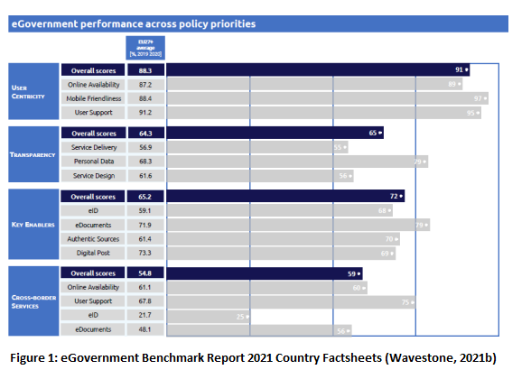
Noticing, the figures on the most left side represent the EU average and the row bar lines represent the outcome for Belgium. In general, the country performs quite well with some weaknesses in Digital Post. The category of digital post refers to direct communication of public actors with citizens and how well this is done digitally. For Belgium, this measure points out two of the major problems that the country is currently facing. Firstly, the number of unfilled job vacancies in the IT sector is generally quite high (Agoria, 2021). Secondly, a European problem, there is strong evidence for a currently existing skills gap between the public and private sector whereas the former is lagging behind (McKinsey & Company, 2020). To understand the Digital Post issue much better in relation to the skills gap, we can take a second figure which shows the user abilities in using digital resources provided by the government.

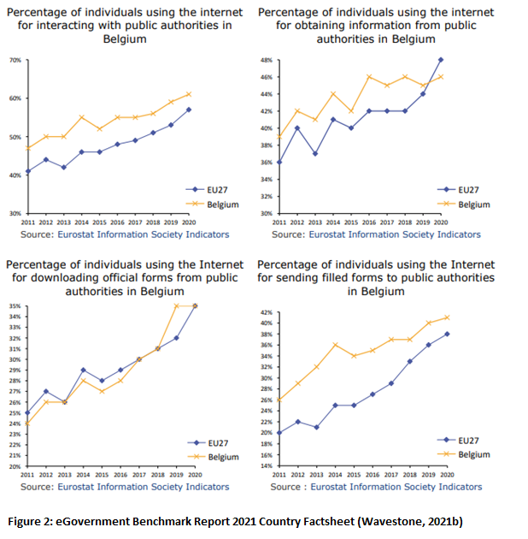
These four graphs of Figure 2 clearly show that a user faces fewer problems to interact digitally with the government. Roughly speaking, the “Belgian user” overall stands above the “EU27 user”.
With these insides in mind, it is not surprising that the Belgian Government settled the new law of “eBox” in 2019 which enables the public sector to communicate much simpler with citizens and companies (Service Public Fédérale Belge, N.D.). Thus, private partners (Doccle, bPost bank, etc.) have been found which have useful information about citizens and enterprises (for example metadata about IDs and addresses) and which are also able to set-up a user-friendly electronic mailbox, which the government itself then can use to reach out to their customers. Despite the existence of such a new digital platform (eBox) which allows interacting with customers, public actors are not obliged to communicate explicitly digitally. Taking for example Denmark as counterexample for a digital advanced EU country, the “digital-only” way to communicate with citizens and companies is almost mandatory. In only few cases (person with handicap for instance) an exception is applicable. This Danish strategy led to the fact that Denmark already surpassed the line of 90 % digital communication in the public sector (Agency of Digitisation, Ministry of Finance, N.D.). Another example, less rigorous but with the same target, is Austria. Instead of compulsory asking public employees to engage electronically with the public, the Austrian strategy gives the user much more rights compared to public actors. In other words, quoting the last Digital Public Administration Factsheet of Austria.
Wavestone (2021a: 18):
“On 1 January 2020 the right to electronic correspondence with authorities entered into force. Citizens now have the opportunity to handle their contacts with the authorities entirely electronically. This also means a further essential step towards a user-centric, modern eGovernment.”
This stands much more in accordance with the user-centricity principle of the EIF and sounds less rigorous. The result of both strategies (mandatory communication of public sector or the right to send digitally by the private sector) is also reflected in the Digital Post score of both countries. Both countries have a Digital Post score of 100/100 (Wavestone, 2021a) (Wavestone, 2021c).
While looking for improvements for the Belgian eBox strategy, possible solutions should be divided into technical and political ones. Starting with the latter, the eBox law should be adapted from time to time and should enforce the use of the application itself. If this will finally lead to more obligations on the provider side (public sector) or to more rights on the user side (citizens) should not be discussed here. The two examples of Denmark and Austria seem to be both effective when looking to their recent report results.
Beside political solutions, the more interesting part is certainly to improve the technological capacity of the public sector in the next few years. Technological capacity firstly means to improve the skills set and the know-how of public employees but this can be a long-term process. This requires reskilling/adapting of knowledge to new technologies but also upskilling public actors with know-how that wasn’t present before such as in depth-skills in data analysis, blockchain management, cybersecurity, etc. (McKinsey & Company, 2020). Apart from this fact, there will be a transition period which probably occurs because of the reason that people still don’t have the skills at the present time or in the near future (1-2 years). Therefore, public employees need also be practically supported to use the eBox system continuously more often. One way could be to think about a virtual environment included into eBox that reflects an application similar to the professional mail box system of every public employee. Figure 3 represents this idea and therefore reflects the Front-End interface.
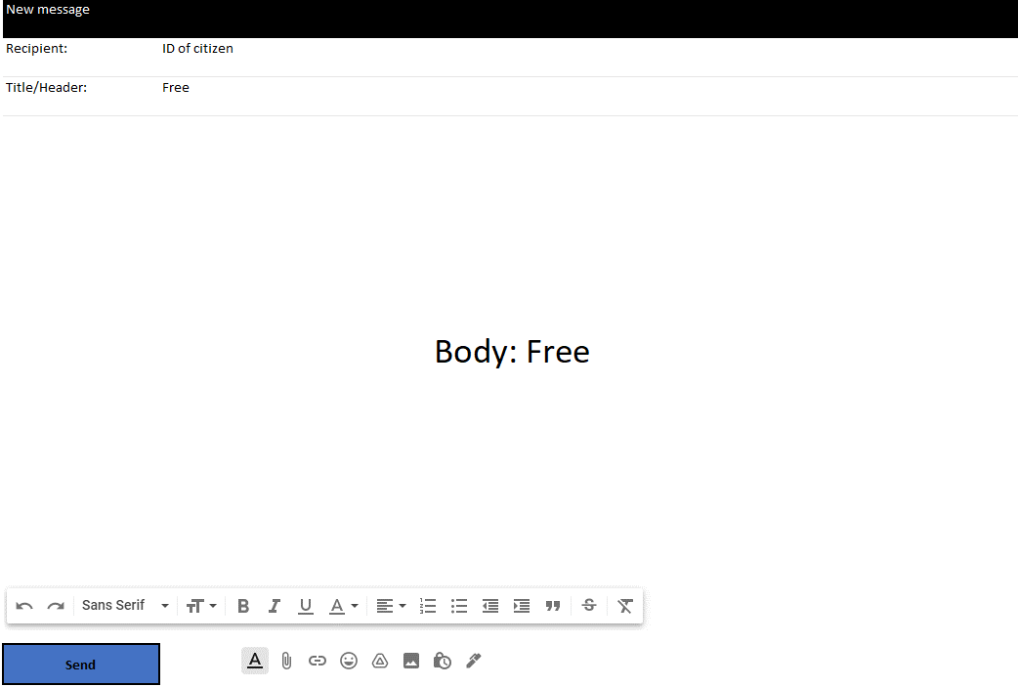
Figure 3: Example of a Customized Mail in eBox (Front-End Interface).
Foremost, the user of this API should probably also be restricted depending on the responsibility level of the employee and therefore there should be a username and password check at the beginning. When getting access, the interface enables the user to give a public document, similar to a simple Html file, its own title/header, content, signature and some basic structure (bolt, italics, paragraphs, etc.) (Appendix I is also useful to see the difference between existing and expected outcome). Furthermore, previous emails and attempts should be able to save in local storage and the recipient field could be incorporated in using an event listener (with AJAX in Javascript for example). For example, while typing into the recipient field the national ID of a citizen, the front-end directly connects to the database of the back-end (= database of eBox) and checks if the ID is registered or not (Douzis et al., 2018) (Konstantopoulos et al., 2018). Figure 4 should help to understand the overall architecture.
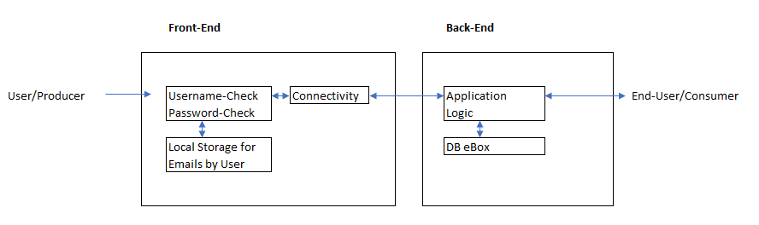Figure 4: Connection between Virtual Environment and eBox
Explaining Figure 4, when a user tries to write a customized email, he first has to get access to the Front-End in typing in his username and his password. If he is authorized, he can use a virtual environment similar to Figure 3. He also has the possibility to save locally email attempts or search for existing email that he wrote himself over this interface. Additionally, only in typing into the recipient field a valid ID of a citizen, the application connects the current email to the Back-End where the eBox system itself has some checkpoints (= Application Logic) before it finally connects to the database (DB) of eBox (Douzis et al., 2018) (Konstantopoulos et al., 2018). At the end, the consumer/citizen has the possibility to always get access to eBox in using his own access-code (this can be a successful ID read or something else).
This idea, to include a flexible part into eBox, should overlap with the increasing need and desire of public actors for “informal Formalizations” which has been introduced by Albert Jacob Meijer while analysing the Dutch public administration and its bureaucratic future outlook. This paper is from 2008, and it depicts in an understandable way that the product of email has first been used by public administrations in such a way that it is conform with its desired formal and hierarchical structure (i.e. restricted use). Though, after some time, the public sector itself was influenced by this medium of email in the way that private actors use it to communicate with public ones (For example using the given name instead of the last name in the beginning of a message). All this process led to “informal Formalizations” which stands for formalization on the content part but informal welcome and ending messages and therefore represents a need to support public actors to continue on this way (Meijer, 2008).
Before summarizing the insights, it should be mentioned that this analysis doesn’t take into account the existing IT infrastructure of the Belgian governmental entities and therefore only analysis the eBox law in terms of an external investigator. Furthermore, important questions related to feasibility and privacy concerns will not be discussed here but they will be at the base in adapting the law itself and also the functionality of eBox. For example, questions such as “does the Belgian government want that eBox becomes the general mail box for communication between public and private sectors?” If so, “what is about accessibility of documents by different entities for the same eBox-subject?” “Does every entity have unrestricted rights to all public documents?” All these questions haven’t been included in the scope of the analysis.
To conclude, the report started from the generic sense of eGovernment and related it to the Belgian State. From there on, the investigation has already been restricted to look deeper into one key factor: Digital Post. Further readings suggested, that the Belgian digital post delay in the public sector is mainly driven by a lack of skills on the provider side (i.e. the public sector itself). The analysis was then divided into a political and a technical part. The political part was worried about the law itself and introduced two proposals to adapt it. Both ideas were related to other countries which seem to be European leaders in terms of Digital Post and an adaptation in this respect should lead to increasing willingness by the public sector to use eBox more often. The technical recommendation is built on interests of public actors to interact more personally with private ones. Hence, the eBox application should be enriched in the way that it should easily allow a public employee to send a customized email over eBox to a citizen. Thus, a concrete example has been presented (Figure 3) which had the main structure of a Html file at its root and seems to be comparable to the email interface of common email providers such as Gmail, hotmail, etc.. The investigation only took an external viewpoint (No details about IT infrastructure of Belgian public sector known) and didn’t question important issues related to feasibility and privacy.

Appendix:
- Existing Outcome (Left) vs. Expected Outcome (Right) of an eBox Letter
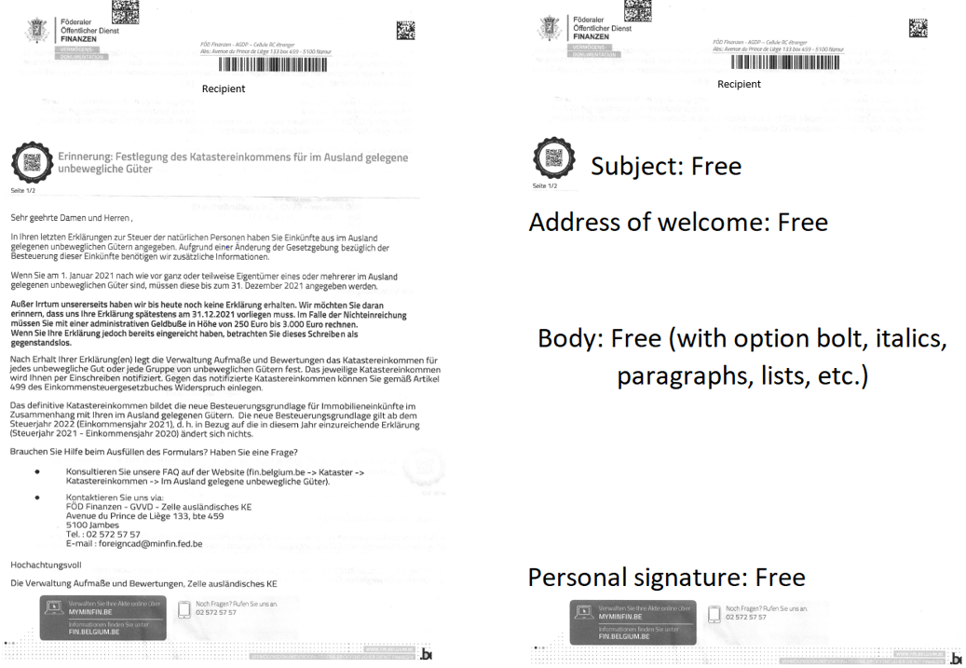

Reference List:
Agency of Digitisation, Ministry of Finance (N. D.) Mandatory Digital Post from public authorities. Available from: https://en.digst.dk/policy-and-strategy/mandatory-digitisation/digital-post/ [Accessed 30 December 2021]
Agoria (2021) Digiskills Belgium tackles the digitalskills gap for all citizens. Available from: https://www.agoria.be/en/human-capital-education/lifelong-learning-careers/skills-development-and-talent-management/digiskills-belgium-tackles-the-digital-skills-gap-for-all-citizens [Accessed 29 December 2021]
Douzis, K., Sotiriadis, S., Petrakis, E.G.M. & Amza, C. (2018) Modular and generic IoT management on the cloud. Future Generation Computer Systems 78(1): 369-378.
Fischer, C., Heuberger, M. & Heine, M. (2021) The impact of digitalization in the public sector: A systematic literature review. Dms – der moderene Staat - Zeitschrift für Public Policy, Recht und Management 14(1): 3–23.
Konstantopoulos, P.; Petrakis, E.G.M.; Sotiriadis, S. (2018) INaaS: Indoors navigation as a service on the cloud and smartphone application. In Proceedings of the 2018 IEEE 39th Sarnoff Symposium, Sarnoff 2018, Newark, NJ, USA, 24–25 September 2018; pp. 1–6.
Lemke, F., Ehrhardt, K. & Popelynshyn, O. (2021) Support and resistance of public officials towards current eGovernment initiatives – A case study on Ukraine and Germany. dms – der moderne Staat - Zeitschrift für Public Policy, Recht und Management 14(1): 61-80.
McKinsey & Company (2020) The future is now: Closing the skills gap in Europe’s public sector. Available from: https://www.mckinsey.com/industries/public-and-social-sector/our-insights/the-future-is-now-closing-the-skills-gap-in-europes-public-sector [Accessed 01 January 2022]
Meijer, A. (2008) E-mail in government: Not post-bureaucratic but late-bureaucratic organizations. Government Information Quarterly. 25(2008): 429-447.
Publications Office of the European Union (2017) New European Interoperability Framework, Promoting seamless services and data flows for European public administrations. Available from: https://ec.europa.eu/isa2/sites/default/files/eif_brochure_final.pdf [Accessed 08. December 2021]
Service Public Fédérale Belge (N.D.) eBox, tous vos documents officiels en un seul endroit. Available from: https://www.belgium.be/fr/services_en_ligne/app_ebox_social_security [Accessed 06. December 2021]
Sorum H. (2014) ‘E-mail Inquiries to the public Sector: Response, Impacts, and Importance’ in Cunningham P. & Cunningham M. (eds) eChallenges e-2014 Conference Proceedings. Institute of Electrical and Electronics Engineers.
Wavestone (2021) Digital Public Administration factsheet 2021 Austria. Available from: https://joinup.ec.europa.eu/sites/default/files/inline-files/DPA_Factsheets_2021_Austria_vFINAL.pdf [Accessed 21. January 2022]
Wavestone (2021) Digital Public Administration factsheet 2021 Belgium. Available from: https://joinup.ec.europa.eu/sites/default/files/inline-files/DPA_Factsheets_2021_Belgium_vFINAL.pdf [Accessed 27. December 2021]
Wavestone (2021) Digital Public Administration factsheet 2021 Denmark. Available from: https://joinup.ec.europa.eu/sites/default/files/inline-files/DPA_Factsheets_2021_Denmark_vFINAL.pdf [Accessed 21. January 2022]

Inputs can be labour but also physical goods such as technological devices (for example fax, telephone, printer, scanner can be replaced by one optimal organized computer).

