Performance:!

step – num batches processed per epoch
steps per epoch = num batches = epoch size/ batch size – as weights udpated after every batch

Batch size – how many samples are processed before updating weights. So num batches = epoch size/batch size

epoch size – total num of training samples available for that epoch – we define this as dataloader generates pairs
An epoch is one complete pass through the entire dataset during training

The DataLoader fetches data from the ProgressionDataset by calling the __getitem__() method for each batch. In train mode, it generates pairs dynamically, and in validation/test mode, it uses predefined image pairs. The transformation applied to images allows for preprocessing, and the DataLoader handles batching, shuffling, and multi-threaded data loading for efficient training.

code tests – TESTS ARE WRONG BECAUSE WE WERE VALIDATING ON TEST DATA NOT VALIDATION DATA :( check pg 8 for correct results
test: batch size = 32, lr = 3*10e-4, epochs = 10, epoch size = 1400,
accuracy = 33.33

decrease lr and epoch size to train more quickly and not overfit
test: batch size = 32, lr = 1e-4, epochs = 15, epoch size = 600,
accuracy = 37.76

Writing logs to logs/siamese_CNN/CNN_bn_bs=32_lr=0.0001_run_2
validation loss: 1.19051, accuracy: 33.33
epoch: [1], step: [0/19], batch loss: 1.17777, batch accuracy: 25.00, data load time: 0.56330, step time: 0.67404
validation loss: 1.16058, accuracy: 33.53
epoch: [2], step: [1/19], batch loss: 1.07334, batch accuracy: 31.25, data load time: 0.00177, step time: 0.65290
validation loss: 1.13395, accuracy: 29.29
epoch: [3], step: [2/19], batch loss: 1.01910, batch accuracy: 43.75, data load time: 0.00171, step time: 0.64469
validation loss: 1.14598, accuracy: 31.98
epoch: [4], step: [3/19], batch loss: 0.95153, batch accuracy: 62.50, data load time: 0.00176, step time: 0.64847
validation loss: 1.13978, accuracy: 29.48
epoch: [5], step: [4/19], batch loss: 0.94743, batch accuracy: 56.25, data load time: 0.00177, step time: 0.65615
validation loss: 1.14148, accuracy: 31.41
epoch: [6], step: [5/19], batch loss: 0.90943, batch accuracy: 59.38, data load time: 0.00174, step time: 0.68756
validation loss: 1.16048, accuracy: 30.44
epoch: [7], step: [6/19], batch loss: 0.96255, batch accuracy: 40.62, data load time: 0.00187, step time: 0.67713
validation loss: 1.16732, accuracy: 30.64
epoch: [8], step: [7/19], batch loss: 1.00024, batch accuracy: 53.12, data load time: 0.00189, step time: 0.68301
validation loss: 1.15687, accuracy: 28.90
epoch: [9], step: [8/19], batch loss: 0.95278, batch accuracy: 37.50, data load time: 0.00172, step time: 0.67437
validation loss: 1.13905, accuracy: 34.30
epoch: [10], step: [9/19], batch loss: 0.84881, batch accuracy: 53.12, data load time: 0.00201, step time: 0.67651
validation loss: 1.16519, accuracy: 31.41
epoch: [11], step: [10/19], batch loss: 0.81845, batch accuracy: 50.00, data load time: 0.00173, step time: 0.67626
validation loss: 1.20926, accuracy: 32.95
epoch: [12], step: [11/19], batch loss: 0.85016, batch accuracy: 59.38, data load time: 0.00186, step time: 0.68190
validation loss: 1.20609, accuracy: 36.42
epoch: [13], step: [12/19], batch loss: 0.82434, batch accuracy: 62.50, data load time: 0.00186, step time: 0.69571
validation loss: 1.20952, accuracy: 40.85
epoch: [14], step: [13/19], batch loss: 0.84874, batch accuracy: 65.62, data load time: 0.00187, step time: 0.67053
validation loss: 1.21976, accuracy: 37.76

validation loss increasing too much – model is too confident and being penalized for wrong guesses on unseen data

sixth test: batch size = 32, lr = 1e-4, epochs = 20, epoch size = 750,
accuracy = 35.84
validation loss: 1.50351, accuracy: 38.54
epoch: [17], step: [11/24], batch loss: 0.50499, batch accuracy: 87.50, data load time: 0.00183, step time: 0.70229
validation loss: 1.30109, accuracy: 36.03
epoch: [18], step: [7/24], batch loss: 0.48777, batch accuracy: 84.38, data load time: 0.00175, step time: 0.71768
validation loss: 1.57919, accuracy: 33.33
epoch: [19], step: [3/24], batch loss: 0.46496, batch accuracy: 90.62, data load time: 0.00189, step time: 0.71587
epoch: [19], step: [23/24], batch loss: 0.70489, batch accuracy: 78.57, data load time: 0.00081, step time: 0.30641
validation loss: 1.53623, accuracy: 35.84

so reduce epoch size
test: batch size = 32, lr = 1e-4, epochs = 20, epoch size = 300,
accuracy low, too low epoch size

test:batch size = 32, lr = 1e-4, epochs = 15, epoch size = 500

validation loss: 1.12017, accuracy: 33.33
epoch: [1], step: [3/16], batch loss: 0.95792, batch accuracy: 59.38, data load time: 0.00171, step time: 0.64628
validation loss: 1.24966, accuracy: 33.53
epoch: [2], step: [7/16], batch loss: 1.06836, batch accuracy: 43.75, data load time: 0.00177, step time: 0.66963
validation loss: 1.28311, accuracy: 32.95
epoch: [3], step: [11/16], batch loss: 1.05969, batch accuracy: 37.50, data load time: 0.00182, step time: 0.66068
validation loss: 1.20472, accuracy: 29.09
epoch: [4], step: [15/16], batch loss: 1.02285, batch accuracy: 45.00, data load time: 0.00114, step time: 0.41021
validation loss: 1.15446, accuracy: 31.60
validation loss: 1.18173, accuracy: 34.68
epoch: [6], step: [3/16], batch loss: 0.97248, batch accuracy: 43.75, data load time: 0.00176, step time: 0.68991
validation loss: 1.14268, accuracy: 32.76
epoch: [7], step: [7/16], batch loss: 0.98467, batch accuracy: 53.12, data load time: 0.00190, step time: 0.67923
validation loss: 1.16864, accuracy: 31.79
epoch: [8], step: [11/16], batch loss: 1.02814, batch accuracy: 43.75, data load time: 0.00174, step time: 0.67085
validation loss: 1.18494, accuracy: 34.30
epoch: [9], step: [15/16], batch loss: 1.00842, batch accuracy: 50.00, data load time: 0.00140, step time: 0.42279
validation loss: 1.14245, accuracy: 31.41
validation loss: 1.16788, accuracy: 34.87
epoch: [11], step: [3/16], batch loss: 0.78987, batch accuracy: 65.62, data load time: 0.00184, step time: 0.67323
validation loss: 1.21694, accuracy: 33.72
epoch: [12], step: [7/16], batch loss: 0.89617, batch accuracy: 59.38, data load time: 0.00173, step time: 0.67297
validation loss: 1.15034, accuracy: 36.42
epoch: [13], step: [11/16], batch loss: 0.79509, batch accuracy: 71.88, data load time: 0.00182, step time: 0.67381
validation loss: 1.22231, accuracy: 40.27
epoch: [14], step: [15/16], batch loss: 0.83300, batch accuracy: 65.00, data load time: 0.00111, step time: 0.42229
validation loss: 1.27643, accuracy: 34.10

increase num epochs to reach better convergence and slightly increase epoch size without overfitting
test: batch size = 32, lr = 1e-4, epochs = 30, epoch size = 500,

Writing logs to logs/siamese_CNN/CNN_bn_bs=32_lr=0.0001_run_8
validation loss: 1.15470, accuracy: 33.53
epoch: [1], step: [3/16], batch loss: 1.04375, batch accuracy: 34.38, data load time: 0.00208, step time: 0.68505
validation loss: 1.15764, accuracy: 31.79
epoch: [2], step: [7/16], batch loss: 1.02141, batch accuracy: 53.12, data load time: 0.00200, step time: 0.66838
validation loss: 1.24180, accuracy: 31.60
epoch: [3], step: [11/16], batch loss: 1.00315, batch accuracy: 43.75, data load time: 0.00200, step time: 0.67515
validation loss: 1.25680, accuracy: 31.79
epoch: [4], step: [15/16], batch loss: 0.99756, batch accuracy: 55.00, data load time: 0.00116, step time: 0.41863
validation loss: 1.12759, accuracy: 32.56
validation loss: 1.17765, accuracy: 30.64
epoch: [6], step: [3/16], batch loss: 1.00170, batch accuracy: 46.88, data load time: 0.00175, step time: 0.66951
validation loss: 1.15966, accuracy: 30.25
epoch: [7], step: [7/16], batch loss: 0.95360, batch accuracy: 46.88, data load time: 0.00174, step time: 0.67143
validation loss: 1.16977, accuracy: 30.06
epoch: [8], step: [11/16], batch loss: 0.97784, batch accuracy: 46.88, data load time: 0.00173, step time: 0.67286
validation loss: 1.14570, accuracy: 28.13
epoch: [9], step: [15/16], batch loss: 0.83999, batch accuracy: 60.00, data load time: 0.00111, step time: 0.42212
validation loss: 1.16638, accuracy: 35.07
validation loss: 1.17397, accuracy: 33.33
epoch: [11], step: [3/16], batch loss: 1.07352, batch accuracy: 46.88, data load time: 0.00169, step time: 0.67556
validation loss: 1.15111, accuracy: 37.38
epoch: [12], step: [7/16], batch loss: 0.85000, batch accuracy: 56.25, data load time: 0.00185, step time: 0.67599
validation loss: 1.17617, accuracy: 32.95
epoch: [13], step: [11/16], batch loss: 0.89588, batch accuracy: 62.50, data load time: 0.00175, step time: 0.67668
validation loss: 1.16188, accuracy: 39.50
epoch: [14], step: [15/16], batch loss: 0.94509, batch accuracy: 45.00, data load time: 0.00112, step time: 0.42001
validation loss: 1.17106, accuracy: 36.80
validation loss: 1.22989, accuracy: 35.65
epoch: [16], step: [3/16], batch loss: 0.92088, batch accuracy: 53.12, data load time: 0.00177, step time: 0.67624
validation loss: 1.23316, accuracy: 33.53
epoch: [17], step: [7/16], batch loss: 0.85154, batch accuracy: 53.12, data load time: 0.00175, step time: 0.68208
validation loss: 1.13860, accuracy: 37.38
epoch: [18], step: [11/16], batch loss: 0.82831, batch accuracy: 65.62, data load time: 0.00172, step time: 0.67534
validation loss: 1.23901, accuracy: 31.21
epoch: [19], step: [15/16], batch loss: 0.71435, batch accuracy: 70.00, data load time: 0.00112, step time: 0.42102
validation loss: 1.20723, accuracy: 39.11
validation loss: 1.25716, accuracy: 35.45
epoch: [21], step: [3/16], batch loss: 0.77720, batch accuracy: 68.75, data load time: 0.00172, step time: 0.67651
validation loss: 1.25079, accuracy: 37.76
epoch: [22], step: [7/16], batch loss: 0.69805, batch accuracy: 65.62, data load time: 0.00185, step time: 0.67701
validation loss: 1.39751, accuracy: 35.26
epoch: [23], step: [11/16], batch loss: 0.90977, batch accuracy: 56.25, data load time: 0.00186, step time: 0.67508
validation loss: 1.19806, accuracy: 40.08
epoch: [24], step: [15/16], batch loss: 0.90660, batch accuracy: 75.00, data load time: 0.00112, step time: 0.42292
validation loss: 1.33547, accuracy: 39.50
validation loss: 1.21577, accuracy: 37.96
epoch: [26], step: [3/16], batch loss: 0.54127, batch accuracy: 81.25, data load time: 0.00174, step time: 0.67606
validation loss: 1.36794, accuracy: 35.65
epoch: [27], step: [7/16], batch loss: 0.54732, batch accuracy: 75.00, data load time: 0.00177, step time: 0.67873
validation loss: 1.25940, accuracy: 41.62
epoch: [28], step: [11/16], batch loss: 0.67900, batch accuracy: 75.00, data load time: 0.00199, step time: 0.67877
validation loss: 1.31521, accuracy: 32.18
epoch: [29], step: [15/16], batch loss: 0.74221, batch accuracy: 65.00, data load time: 0.00109, step time: 0.42311
validation loss: 1.31157, accuracy: 36.42

reduce learning rate slightly
test: batch size = 32, lr = 1e-5, epochs = 30, epoch size = 500 → not learning anything meaningful, lr too low

test: batch size = 32, lr = 1e-3, epochs = 30, epoch size = 1000 → high test accuracy, very low and random validation accuracy. Between 31 and 33

around 1e-4 is where the model trains best
test: batch size = 32, lr = 2e-4, epochs = 30, epoch size = 1000
final validation accuracy = 42.39
epoch: [0], step: [19/32], batch loss: 1.07487, batch accuracy: 37.50, data load time: 0.00169, step time: 0.69147
validation loss: 1.27549, accuracy: 33.33
epoch: [1], step: [7/32], batch loss: 1.11681, batch accuracy: 43.75, data load time: 0.00188, step time: 0.63248
epoch: [1], step: [27/32], batch loss: 1.05159, batch accuracy: 34.38, data load time: 0.00166, step time: 0.63464
validation loss: 1.12080, accuracy: 30.25
epoch: [2], step: [15/32], batch loss: 1.05260, batch accuracy: 34.38, data load time: 0.00165, step time: 0.63808
validation loss: 1.12394, accuracy: 32.95
epoch: [3], step: [3/32], batch loss: 1.04293, batch accuracy: 40.62, data load time: 0.00195, step time: 0.64331
epoch: [3], step: [23/32], batch loss: 0.95843, batch accuracy: 50.00, data load time: 0.00165, step time: 0.64278
validation loss: 1.17979, accuracy: 36.42
epoch: [4], step: [11/32], batch loss: 1.04327, batch accuracy: 46.88, data load time: 0.00166, step time: 0.64317
epoch: [4], step: [31/32], batch loss: 1.08222, batch accuracy: 50.00, data load time: 0.00048, step time: 0.16829
validation loss: 1.25717, accuracy: 34.87
epoch: [5], step: [19/32], batch loss: 0.87668, batch accuracy: 59.38, data load time: 0.00167, step time: 0.64624
validation loss: 1.27464, accuracy: 32.95
epoch: [6], step: [7/32], batch loss: 0.87257, batch accuracy: 56.25, data load time: 0.00170, step time: 0.64662
epoch: [6], step: [27/32], batch loss: 0.74086, batch accuracy: 65.62, data load time: 0.00170, step time: 0.64731
validation loss: 1.29817, accuracy: 39.88
epoch: [7], step: [15/32], batch loss: 1.05012, batch accuracy: 50.00, data load time: 0.00171, step time: 0.64691
validation loss: 1.25331, accuracy: 31.41
epoch: [8], step: [3/32], batch loss: 0.85299, batch accuracy: 62.50, data load time: 0.00174, step time: 0.64839
epoch: [8], step: [23/32], batch loss: 0.83783, batch accuracy: 50.00, data load time: 0.00166, step time: 0.64875
validation loss: 1.17110, accuracy: 33.91
epoch: [9], step: [11/32], batch loss: 0.89543, batch accuracy: 59.38, data load time: 0.00165, step time: 0.64928
epoch: [9], step: [31/32], batch loss: 1.21718, batch accuracy: 50.00, data load time: 0.00047, step time: 0.17032
validation loss: 1.29158, accuracy: 39.31
epoch: [10], step: [19/32], batch loss: 1.00534, batch accuracy: 53.12, data load time: 0.00167, step time: 0.64853
validation loss: 1.23344, accuracy: 38.15
epoch: [11], step: [7/32], batch loss: 0.92996, batch accuracy: 50.00, data load time: 0.00167, step time: 0.65014
epoch: [11], step: [27/32], batch loss: 0.82043, batch accuracy: 62.50, data load time: 0.00165, step time: 0.65061
validation loss: 1.16214, accuracy: 43.55
epoch: [12], step: [15/32], batch loss: 0.60850, batch accuracy: 81.25, data load time: 0.00169, step time: 0.64974
validation loss: 1.21218, accuracy: 40.27
epoch: [13], step: [3/32], batch loss: 0.76389, batch accuracy: 59.38, data load time: 0.00172, step time: 0.64969
epoch: [13], step: [23/32], batch loss: 0.95925, batch accuracy: 53.12, data load time: 0.00172, step time: 0.64920
validation loss: 1.76791, accuracy: 40.46
epoch: [14], step: [11/32], batch loss: 0.80488, batch accuracy: 71.88, data load time: 0.00166, step time: 0.65468
epoch: [14], step: [31/32], batch loss: 0.76993, batch accuracy: 62.50, data load time: 0.00047, step time: 0.16989
validation loss: 1.51866, accuracy: 38.34
epoch: [15], step: [19/32], batch loss: 0.80005, batch accuracy: 65.62, data load time: 0.00169, step time: 0.65102
validation loss: 1.56566, accuracy: 38.92
epoch: [16], step: [7/32], batch loss: 0.58435, batch accuracy: 65.62, data load time: 0.00167, step time: 0.64730
epoch: [16], step: [27/32], batch loss: 0.75345, batch accuracy: 65.62, data load time: 0.00166, step time: 0.64850
validation loss: 1.31405, accuracy: 42.77
epoch: [17], step: [15/32], batch loss: 0.77402, batch accuracy: 56.25, data load time: 0.00167, step time: 0.65433
validation loss: 1.40594, accuracy: 41.23
epoch: [18], step: [3/32], batch loss: 0.97678, batch accuracy: 50.00, data load time: 0.00171, step time: 0.64889
epoch: [18], step: [23/32], batch loss: 0.81303, batch accuracy: 75.00, data load time: 0.00166, step time: 0.64876
validation loss: 1.45235, accuracy: 39.11
epoch: [19], step: [11/32], batch loss: 0.51847, batch accuracy: 87.50, data load time: 0.00169, step time: 0.65010
epoch: [19], step: [31/32], batch loss: 0.73163, batch accuracy: 50.00, data load time: 0.00072, step time: 0.17344
validation loss: 1.53615, accuracy: 38.92
epoch: [20], step: [19/32], batch loss: 0.40782, batch accuracy: 90.62, data load time: 0.00168, step time: 0.65164
validation loss: 1.47745, accuracy: 39.11
epoch: [21], step: [7/32], batch loss: 0.83470, batch accuracy: 65.62, data load time: 0.00168, step time: 0.64930
epoch: [21], step: [27/32], batch loss: 0.50086, batch accuracy: 81.25, data load time: 0.00169, step time: 0.67061
validation loss: 1.71780, accuracy: 43.35
epoch: [22], step: [15/32], batch loss: 0.72022, batch accuracy: 62.50, data load time: 0.00183, step time: 0.66389
validation loss: 1.69822, accuracy: 42.00
epoch: [23], step: [3/32], batch loss: 0.74994, batch accuracy: 75.00, data load time: 0.00172, step time: 0.65395
epoch: [23], step: [23/32], batch loss: 0.70489, batch accuracy: 75.00, data load time: 0.00169, step time: 0.65576
validation loss: 1.60603, accuracy: 41.62
epoch: [24], step: [11/32], batch loss: 0.75348, batch accuracy: 71.88, data load time: 0.00170, step time: 0.66219
epoch: [24], step: [31/32], batch loss: 0.94940, batch accuracy: 62.50, data load time: 0.00047, step time: 0.16985
validation loss: 1.62710, accuracy: 46.44
epoch: [25], step: [19/32], batch loss: 0.70735, batch accuracy: 68.75, data load time: 0.00169, step time: 0.65686
validation loss: 1.29486, accuracy: 49.52
epoch: [26], step: [7/32], batch loss: 0.48991, batch accuracy: 81.25, data load time: 0.00168, step time: 0.65829
epoch: [26], step: [27/32], batch loss: 0.40873, batch accuracy: 87.50, data load time: 0.00169, step time: 0.65837
validation loss: 1.27496, accuracy: 46.82
epoch: [27], step: [15/32], batch loss: 0.45811, batch accuracy: 78.12, data load time: 0.00172, step time: 0.64968
validation loss: 1.38423, accuracy: 46.82
epoch: [28], step: [3/32], batch loss: 0.25083, batch accuracy: 93.75, data load time: 0.00169, step time: 0.64993
epoch: [28], step: [23/32], batch loss: 0.30023, batch accuracy: 93.75, data load time: 0.00166, step time: 0.65078
validation loss: 1.70075, accuracy: 39.31
epoch: [29], step: [11/32], batch loss: 0.82911, batch accuracy: 68.75, data load time: 0.00173, step time: 0.64824
epoch: [29], step: [31/32], batch loss: 0.33633, batch accuracy: 87.50, data load time: 0.00049, step time: 0.16871
validation loss: 1.50723, accuracy: 42.39

USING VALIDATION AS VALIDATION SET NOT TESTING SET (SO CORRECT WAY)

test: batch size = 32, lr = 3e-4, epochs = 60, epoch size = 1000

*at 30 epochs, validation accuracy is 46.82 so this lr is already better than previous

final validation accuracy = 53.76
final test accuracy =
Test Loss: 1.74963, Test Accuracy: 45.66

-failed to generalize to new images

batch accuracy on average = 84-90 – super high - overfitting

PROBLEM HERE – validation loss increases too quickly and optimal validation loss is found at maybe epoch 3. Meaning that we must decrease our learning rate in order to not early stop this early.
Over fitting – when validation loss begins a sustained increase while the training loss continues to drop

reduce lr and epoch num
test: batch size = 32, lr = 1e-4, epochs = 30, epoch size = 1000
leave epoch size as is

Test Loss: 1.63916, Test Accuracy: 39.50%

test: implement early stopping – maybe after 15 epochs if validation loss hasn’t decreased then stop and use the weights recorded there
batch size = 32, lr = 5e-5, epochs = 30, epoch size = 1000

Test Loss: 1.15237, Test Accuracy: 31.21% - stopping way too early, decrease lr (this was when we early stopped at lowest test loss)

test: batch size = 32, lr = 5e-5, epochs = 30, epoch size = 1000
FINAL TEST RESULTS** (Using Best Saved Model)
Test Loss: 1.14234, Test Accuracy: 30.64% (when we early stopped at lowest test loss)

me: 0.00170, step time: 0.65331
epoch: [18], step: [23/32], batch loss: 0.50344, batch accuracy: 81.25, data load time: 0.00202, step time: 0.65523
validation loss: 1.40039, accuracy: 36.56
Validation loss did not improve. Patience: 11/20
epoch: [19], step: [11/32], batch loss: 0.66545, batch accuracy: 75.00, data load time: 0.00176, step time: 0.64964
epoch: [19], step: [31/32], batch loss: 0.79864, batch accuracy: 62.50, data load time: 0.00048, step time: 0.16965
validation loss: 1.17703, accuracy: 44.62
Validation loss did not improve. Patience: 12/20
epoch: [20], step: [19/32], batch loss: 0.40043, batch accuracy: 87.50, data load time: 0.00171, step time: 0.65221
validation loss: 1.41267, accuracy: 39.25
Validation loss did not improve. Patience: 13/20
epoch: [21], step: [7/32], batch loss: 0.53898, batch accuracy: 81.25, data load time: 0.00175, step time: 0.65026
epoch: [21], step: [27/32], batch loss: 0.59741, batch accuracy: 75.00, data load time: 0.00173, step time: 0.64957
validation loss: 1.63086, accuracy: 45.70
Validation loss did not improve. Patience: 14/20
epoch: [22], step: [15/32], batch loss: 0.38759, batch accuracy: 87.50, data load time: 0.00167, step time: 0.65161
validation loss: 1.21927, accuracy: 43.55
Validation loss did not improve. Patience: 15/20
epoch: [23], step: [3/32], batch loss: 0.58743, batch accuracy: 71.88, data load time: 0.00205, step time: 0.65267
epoch: [23], step: [23/32], batch loss: 0.47444, batch accuracy: 87.50, data load time: 0.00172, step time: 0.65106
validation loss: 1.13833, accuracy: 48.92
Validation loss did not improve. Patience: 16/20
epoch: [24], step: [11/32], batch loss: 0.41455, batch accuracy: 81.25, data load time: 0.00167, step time: 0.65117
epoch: [24], step: [31/32], batch loss: 0.71018, batch accuracy: 62.50, data load time: 0.00048, step time: 0.17009
validation loss: 1.37015, accuracy: 34.41
Validation loss did not improve. Patience: 17/20
epoch: [25], step: [19/32], batch loss: 0.33077, batch accuracy: 93.75, data load time: 0.00169, step time: 0.65693
validation loss: 1.26540, accuracy: 49.46
Validation loss did not improve. Patience: 18/20
epoch: [26], step: [7/32], batch loss: 0.50855, batch accuracy: 75.00, data load time: 0.00168, step time: 0.65054
epoch: [26], step: [27/32], batch loss: 0.38504, batch accuracy: 93.75, data load time: 0.00170, step time: 0.65305
validation loss: 1.33501, accuracy: 49.46
Validation loss did not improve. Patience: 19/20
epoch: [27], step: [15/32], batch loss: 0.29987, batch accuracy: 90.62, data load time: 0.00174, step time: 0.65172
validation loss: 1.42222, accuracy: 50.54
Validation loss did not improve. Patience: 20/20

***NOTE – CLOSE TERMINAL BEFORE RUNNING EVERYTIME AS SOMETIMES THIS WORKS BEST
get rid of early stopping with validation loss – (maybe add validation accuracy later as low validation loss seems to correlate with higher validation accuracy)

test: batch size = 32, lr = 5e-5, epochs = 30, epoch size = 1000

1, step time: 0.65320
validation loss: 0.97175, accuracy: 50.00
epoch: [21], step: [7/32], batch loss: 0.43932, batch accuracy: 84.38, data load time: 0.00193, step time: 0.66241
epoch: [21], step: [27/32], batch loss: 0.39000, batch accuracy: 84.38, data load time: 0.00176, step time: 0.67212
validation loss: 0.90525, accuracy: 59.68
epoch: [22], step: [15/32], batch loss: 0.35827, batch accuracy: 90.62, data load time: 0.00170, step time: 0.66049
validation loss: 1.14546, accuracy: 53.23
epoch: [23], step: [3/32], batch loss: 0.44849, batch accuracy: 81.25, data load time: 0.00171, step time: 0.65231
epoch: [23], step: [23/32], batch loss: 0.51052, batch accuracy: 87.50, data load time: 0.00170, step time: 0.65328
validation loss: 0.97917, accuracy: 52.69
epoch: [24], step: [11/32], batch loss: 0.51106, batch accuracy: 81.25, data load time: 0.00170, step time: 0.65278
epoch: [24], step: [31/32], batch loss: 0.71374, batch accuracy: 62.50, data load time: 0.00057, step time: 0.16943
validation loss: 1.06478, accuracy: 47.85
epoch: [25], step: [19/32], batch loss: 0.40304, batch accuracy: 87.50, data load time: 0.00171, step time: 0.65589
validation loss: 1.16376, accuracy: 46.77
epoch: [26], step: [7/32], batch loss: 0.51138, batch accuracy: 81.25, data load time: 0.00170, step time: 0.65310
epoch: [26], step: [27/32], batch loss: 0.56851, batch accuracy: 75.00, data load time: 0.00166, step time: 0.65351
validation loss: 1.50865, accuracy: 40.32
epoch: [27], step: [15/32], batch loss: 0.48039, batch accuracy: 87.50, data load time: 0.00167, step time: 0.65429
validation loss: 1.23510, accuracy: 50.54
epoch: [28], step: [3/32], batch loss: 0.22565, batch accuracy: 93.75, data load time: 0.00168, step time: 0.65213
epoch: [28], step: [23/32], batch loss: 0.34969, batch accuracy: 90.62, data load time: 0.00169, step time: 0.65387
validation loss: 1.15204, accuracy: 48.92
epoch: [29], step: [11/32], batch loss: 0.35298, batch accuracy: 87.50, data load time: 0.00167, step time: 0.65480
epoch: [29], step: [31/32], batch loss: 0.67753, batch accuracy: 62.50, data load time: 0.00048, step time: 0.16827
validation loss: 1.00687, accuracy: 52.15

training well on validation set but not on training set
Test Loss: 1.47916, Test Accuracy: 38.15%

test:
lr above too weak so increase
epoch: [0], step: [19/32], batch loss: 1.10918, batch accuracy: 40.62, data load time: 0.00171, step time: 0.62296
validation loss: 1.16473, accuracy: 36.02
epoch: [1], step: [7/32], batch loss: 1.13757, batch accuracy: 37.50, data load time: 0.00168, step time: 0.62883
epoch: [1], step: [27/32], batch loss: 1.19089, batch accuracy: 34.38, data load time: 0.00165, step time: 0.62907
validation loss: 1.09034, accuracy: 39.78
epoch: [2], step: [15/32], batch loss: 1.03491, batch accuracy: 40.62, data load time: 0.00171, step time: 0.63531
validation loss: 1.07486, accuracy: 39.25
epoch: [3], step: [3/32], batch loss: 1.04004, batch accuracy: 46.88, data load time: 0.00168, step time: 0.63745
epoch: [3], step: [23/32], batch loss: 1.00066, batch accuracy: 43.75, data load time: 0.00170, step time: 0.63666
validation loss: 1.03655, accuracy: 43.55
epoch: [4], step: [11/32], batch loss: 0.83315, batch accuracy: 71.88, data load time: 0.00177, step time: 0.64054
epoch: [4], step: [31/32], batch loss: 1.13022, batch accuracy: 37.50, data load time: 0.00048, step time: 0.16871
validation loss: 1.02115, accuracy: 49.46
epoch: [5], step: [19/32], batch loss: 0.94502, batch accuracy: 62.50, data load time: 0.00166, step time: 0.64332
validation loss: 0.97061, accuracy: 55.38
epoch: [6], step: [7/32], batch loss: 0.88467, batch accuracy: 59.38, data load time: 0.00169, step time: 0.64534
epoch: [6], step: [27/32], batch loss: 0.87244, batch accuracy: 46.88, data load time: 0.00165, step time: 0.65034
validation loss: 0.99059, accuracy: 43.55
epoch: [7], step: [15/32], batch loss: 0.81600, batch accuracy: 56.25, data load time: 0.00167, step time: 0.64811
validation loss: 1.10137, accuracy: 46.77
epoch: [8], step: [3/32], batch loss: 0.89022, batch accuracy: 56.25, data load time: 0.00171, step time: 0.64684
epoch: [8], step: [23/32], batch loss: 0.79039, batch accuracy: 62.50, data load time: 0.00169, step time: 0.64533
validation loss: 1.00455, accuracy: 43.55
epoch: [9], step: [11/32], batch loss: 0.70700, batch accuracy: 75.00, data load time: 0.00174, step time: 0.65118
epoch: [9], step: [31/32], batch loss: 0.78778, batch accuracy: 37.50, data load time: 0.00047, step time: 0.17009
validation loss: 1.06281, accuracy: 45.16
epoch: [10], step: [19/32], batch loss: 0.90589, batch accuracy: 50.00, data load time: 0.00167, step time: 0.65036
validation loss: 1.17742, accuracy: 45.16
epoch: [11], step: [7/32], batch loss: 0.67412, batch accuracy: 68.75, data load time: 0.00169, step time: 0.64970
epoch: [11], step: [27/32], batch loss: 0.78957, batch accuracy: 59.38, data load time: 0.00169, step time: 0.65028
validation loss: 1.13499, accuracy: 43.01
epoch: [12], step: [15/32], batch loss: 0.95915, batch accuracy: 50.00, data load time: 0.00170, step time: 0.64882
validation loss: 1.01110, accuracy: 48.92
epoch: [13], step: [3/32], batch loss: 0.89339, batch accuracy: 59.38, data load time: 0.00170, step time: 0.66395
epoch: [13], step: [23/32], batch loss: 0.69119, batch accuracy: 71.88, data load time: 0.00169, step time: 0.65104
validation loss: 1.24595, accuracy: 51.08
epoch: [14], step: [11/32], batch loss: 0.70873, batch accuracy: 75.00, data load time: 0.00174, step time: 0.65031
epoch: [14], step: [31/32], batch loss: 0.80142, batch accuracy: 62.50, data load time: 0.00047, step time: 0.16957
validation loss: 1.22314, accuracy: 41.94
epoch: [15], step: [19/32], batch loss: 0.66108, batch accuracy: 68.75, data load time: 0.00166, step time: 0.64920
validation loss: 1.17298, accuracy: 45.70
epoch: [16], step: [7/32], batch loss: 0.79649, batch accuracy: 62.50, data load time: 0.00170, step time: 0.65022
epoch: [16], step: [27/32], batch loss: 0.73438, batch accuracy: 65.62, data load time: 0.00167, step time: 0.64863
validation loss: 1.22591, accuracy: 50.54
epoch: [17], step: [15/32], batch loss: 0.56891, batch accuracy: 81.25, data load time: 0.00169, step time: 0.64944
validation loss: 0.99659, accuracy: 48.92
epoch: [18], step: [3/32], batch loss: 0.74209, batch accuracy: 65.62, data load time: 0.00175, step time: 0.64888
epoch: [18], step: [23/32], batch loss: 0.76945, batch accuracy: 75.00, data load time: 0.00168, step time: 0.64845
validation loss: 1.09104, accuracy: 44.62
epoch: [19], step: [11/32], batch loss: 0.63300, batch accuracy: 71.88, data load time: 0.00166, step time: 0.65090
epoch: [19], step: [31/32], batch loss: 0.46509, batch accuracy: 87.50, data load time: 0.00049, step time: 0.16926
validation loss: 1.17015, accuracy: 51.61
epoch: [20], step: [19/32], batch loss: 0.64685, batch accuracy: 81.25, data load time: 0.00168, step time: 0.64803
validation loss: 1.17653, accuracy: 53.76
epoch: [21], step: [7/32], batch loss: 0.77731, batch accuracy: 62.50, data load time: 0.00168, step time: 0.65075
epoch: [21], step: [27/32], batch loss: 0.58595, batch accuracy: 68.75, data load time: 0.00172, step time: 0.65476
validation loss: 1.38207, accuracy: 46.77
epoch: [22], step: [15/32], batch loss: 0.67418, batch accuracy: 65.62, data load time: 0.00166, step time: 0.64959
validation loss: 1.25210, accuracy: 48.39
epoch: [23], step: [3/32], batch loss: 0.71384, batch accuracy: 71.88, data load time: 0.00171, step time: 0.64768
epoch: [23], step: [23/32], batch loss: 0.37094, batch accuracy: 90.62, data load time: 0.00171, step time: 0.64785
validation loss: 1.32483, accuracy: 50.00
epoch: [24], step: [11/32], batch loss: 0.51529, batch accuracy: 78.12, data load time: 0.00174, step time: 0.64757
epoch: [24], step: [31/32], batch loss: 0.40852, batch accuracy: 87.50, data load time: 0.00052, step time: 0.16971
validation loss: 1.48185, accuracy: 45.70
epoch: [25], step: [19/32], batch loss: 0.50805, batch accuracy: 87.50, data load time: 0.00168, step time: 0.64706
validation loss: 1.20926, accuracy: 43.01
epoch: [26], step: [7/32], batch loss: 0.87137, batch accuracy: 65.62, data load time: 0.00170, step time: 0.64895
epoch: [26], step: [27/32], batch loss: 0.41262, batch accuracy: 84.38, data load time: 0.00180, step time: 0.66243
validation loss: 1.22330, accuracy: 51.61
epoch: [27], step: [15/32], batch loss: 0.68898, batch accuracy: 68.75, data load time: 0.00175, step time: 0.64700
validation loss: 1.17338, accuracy: 58.60
epoch: [28], step: [3/32], batch loss: 0.56035, batch accuracy: 81.25, data load time: 0.00172, step time: 0.64636
epoch: [28], step: [23/32], batch loss: 0.50765, batch accuracy: 78.12, data load time: 0.00168, step time: 0.64479
validation loss: 1.54211, accuracy: 50.00
epoch: [29], step: [11/32], batch loss: 0.45012, batch accuracy: 84.38, data load time: 0.00170, step time: 0.64970
epoch: [29], step: [31/32], batch loss: 0.54829, batch accuracy: 87.50, data load time: 0.00048, step time: 0.16887
validation loss: 1.17160, accuracy: 53.23

Test Loss: 1.41067, Test Accuracy: 40.85%

TEST:
epochs = 30, lr= 3e-4, batch size = 32, epoch size = 1000
DOES NOT SEEM TO BE OVER FITTING THE TEST DATA. SO BATCH ACCURACY IN RANGE OF 60-75

test accuracy = 41.04 percent

increase num epochs and lr a bit

AT LR = 3e-4, we had same test accuracy
TEST
epochs = 60, lr = 4e-4, batch size = 32, epoch size = 1000

towards end of epochs, batch accuracies between 70-90 which suggests some over fitting. Batch loss generally decreases as well over the 60 epochs – model learning training data effectively but overfitting so decrease num epochs

test accuracy: 45.66

so lr not a limiting factor, lets change some other hyperparameters
TEST
-decrease num epochs
-add weight decay (penalises large weights) = 1e-4
- use lr = 3e-4

epochs = 20, lr = 3e-4, batch size = 32, epoch size = 1000

batch accuracies between 40 and 60 percent so defo less over fitting

test accuracy = 41.81 %

TEST
-increase num epochs
- weight decay = 1e-4
- use lr = 3e-4

epochs = 50, lr = 3e-4, batch size = 32, epoch size = 1000
overfit the batch too much

test accuracy = 40.66 %

TEST – reduce epoch size
epochs = 50, lr = 4e-4, batch size = 32, epoch size = 800
remove weight decay

*when batch accuracy gets higher, validation accuracy tends to decrease slightly
post epoch 40 – batch accuracies tend to increase a lot more

test accuracy = 45.86 %

reduce epoch size by half and increase lr slightly
TEST
epochs = 25, lr = 5e-4, batch size = 32, epoch size = 800

Test accuracy = 33.14 %

TEST
INCREASE EPOCH SIZE – to increase generalization = 1600
go back down to lr = 4e-4
epochs = 45
batch size = 32

test accuracy = 40.66 %

TEST
epochs = 50, lr = 4e-4, batch size = 32, epoch size = 1000

test accuracy: 47.59 %

SET RANDOM SEED THE SAME EVERY TIME TO ACTUALLY BE ABLE TO TEST PARAMETERS!!!

TEST
epochs = 50, lr = 4e-4, batch size = 32, epoch size = 1000 again to see if we get similar results

RESULT:
36.03

INCREASE EPOCH SIZE FOR NEXT TEST and decrease LR TO NOT OVERFIT
TEST
epochs = 50, lr = 2e-4, batch size = 32, epoch size = 1500
RESULT: 47.59%

INCREASE EPOCH SIZE AGAIN
TEST
epochs = 50, lr = 1.5e-4, batch size = 32, epoch size = 2000
RESULT: 46.66%

TEST
epochs = 50, lr = 2.5e-4, batch size = 32, epoch size = 2000
RESULT: 50.67 %
train accuracy – 95-100 percent in final epochs
val/test accuracy – 50-60 percent in final epochs

TEST
epochs = 50, lr = 2.5e-4, batch size = 32, epoch size = 2000

add data normalization and weight decay (penalise larger weights that could fit training noise perfectly)
weight decay = 1e-4

RESULT: 46.82 %

TEST
epochs = 50, lr = 2.5e-4, batch size = 32, epoch size = 2000

add data normalization and weight decay (penalise larger weights that could fit training noise perfectly)
weight decay = 1e-5

RESULT: 47.98 %

TEST
remove weight decay and add more data augmentation

epochs = 50, lr = 2.5e-4, batch size = 32, epoch size = 2000

RESULT: 45.28%

TEST
epochs = 50, lr = 3e-4, batch size = 32, epoch size = 3000
weight_Decay = 1e-5

RESULT: 46.82 %

optimal parameters are
epochs = 50, lr = 2.5e-4, batch size = 32, epoch size = 2000
RESULT: 50.67 %

TEST:
epochs = 50, lr = 2.5e-4, batch size = 32, epoch size = 2000

ADD DROPOUT WITHIN CNN LAYERS (OVERFITTING MORE COMMON IN LAST LAYERS) NOT 1ST FULLY CONNECTED LAYER
ADD 5X5 FOR FIRST KERNEL SIZE – want to extract large scale structures to start off with

https://dl.acm.org/doi/pdf/10.1145/3324921.3328781

You compare two images to decide:
- Same recipe
- Which comes first
- Different recipe
In cooking progression datasets, important differences are often global:
- Ingredients appearing/disappearing
- Amount of cooking (color changes, browning)
- Mixing, kneading, forming steps
- Bowl contents changing shape
So larger kernels can help capture global texture & color change patterns earlier in the network.

TEST:
ADD CROPPING FOR DATA AUGMENTATION ON TOP OF PREVIOUS TEST
with dropout within CNNlayers
with first kernel size = 5x5
test set:38 percent

TEST:
USE CROPPING FOR DATA AUGMENTATION ON TOP OF PREVIOUS TEST
with one dropout in final CNN layer
with first kernel size = 5x5

test set: 46 percent

TEST: REPEAT IT TAKE PIC OF GRAPH AND CONFUSION MATRIX
USE CROPPING FOR DATA AUGMENTATION ON TOP OF PREVIOUS TEST
with one dropout in final CNN layer
with first kernel size = 5x5
+ DILATION in receptive field without increasing parameters for conv layer 3
just RELU
epochs – 35
currently running

test set:
37.57

TEST – REPEAT IT TAKE PIC OF GRAPH AND CONFUSION MATRIX
USE CROPPING FOR DATA AUGMENTATION ON TOP OF PREVIOUS TEST
with one dropout in final CNN layer
with first kernel size = 5x5
+ DILATION in receptive field without increasing parameters for conv layer 3
add in leaky RELU
epochs = 50
38.34

Confusion Matrix (val):
[[34 24 4]
[23 37 2]
[15 12 35]]

TEST:
USE CROPPING FOR DATA AUGMENTATION ON TOP OF PREVIOUS TEST
with one dropout in final CNN layer
with first kernel size = 3x3

test set: 47.01

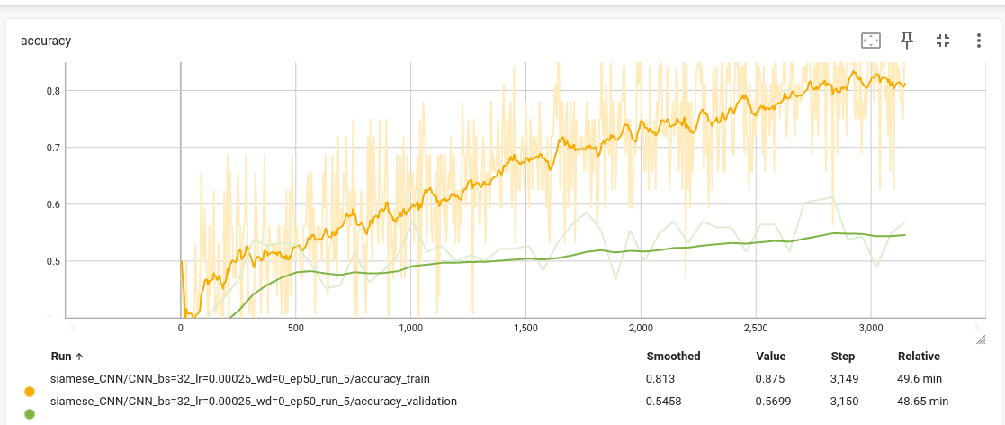

from transforms.CenterCrop(400), # remove edges + kitchen background transforms.RandomResizedCrop(224, scale=(0.8, 1.0)), # random zoom + crop transforms.ColorJitter( brightness=0.2, contrast=0.2, saturation=0.1, hue=0.02 ),

TEST:
change transformations from cropping because sometimes person cooking at bottom of screen :

try:
train_transform = transforms.Compose([
transforms.RandomResizedCrop(224),
transforms.ColorJitter(0.3,0.3,0.2,0.02),
transforms.RandomHorizontalFlip(),
transforms.GaussianBlur(3),
transforms.ToTensor(), # Convert to tensor HERE
transforms.RandomErasing(p=0.3) # Now this works
])

did not work
test accuracy: 34.49%

TEST:
leaky relu
use transforms.ColorJitter( brightness=0.2, contrast=0.2, saturation=0.1, hue=0.02 ) as data augmentations
test accuracy:

TEST:
epochs = 50, lr = 2.5e-4, batch size = 32, epoch size = 2000
ADD DROPOUT TO THIS
AND LEAKY RELU
45.47%
very overfitting to training set

NO AUGMENTATION

TEST:
applied cropping to bottom half of image as noticed that in training set a lot of the steps are focused on bottom half
luminance as some of training set is dark

includes

at validation epoch 40: we have val accuracy 60.22
and Confusion Matrix (val):
[[43 15 4]
[22 37 3]
[19 11 32]]

Final validation matrix
Confusion Matrix (val):
[[39 19 4]
[26 32 4]
[17 10 35]]

Test Accuracy: 49.33%
Confusion Matrix on Test Set:
[[128 35 10]
[ 44 116 13]
[ 88 73 12]]

get graph for this too:

TEST: EPOCHS TO 40

Test Accuracy: 40.46%
Confusion Matrix on Test Set:
[[122 44 7]
[ 76 86 11]
[103 68 2]]

TEST: ADD GRAY SCALE
NIC HAS GRAPH AND CONFUSION MATRIX
TEST ACCURACY: 48.33

CONFUSION MATRIX – VERY LOW FOR CLASS 2 TEST ACCURACY – ADD IN CLASS WEIGHTING

TEST:ting logs to logs/siamese_CNN/CNN_bs=32_lr=0.00025_wd=0_ep50_run_24
JUST BASIC HYPER-PARAMETERS -

FINAL TEST RESULTS
Test Accuracy: 50.87%
Confusion Matrix on Test Set:
[[131 40 2]
[ 48 121 4]
[ 87 74 12]]
-----------------------

TEST: BASE MODEL + transforms: lowers it to 47 percent – maybe its the cropping that does this

run: writing logs to logs/siamese_CNN/CNN_bs=32_lr=0.00025_wd=0_ep50_run_25
test accuracy: 47.59

[[128 45 0]
[ 54 119 0]
[ 91 82 0]]
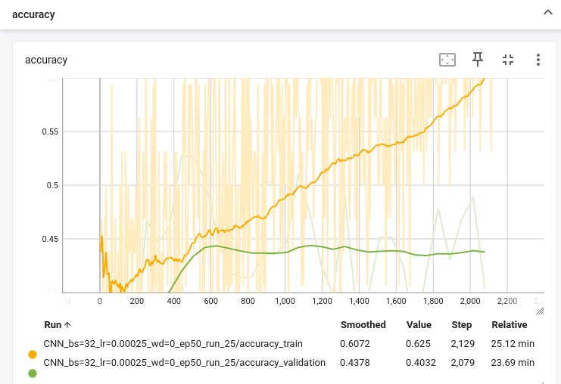
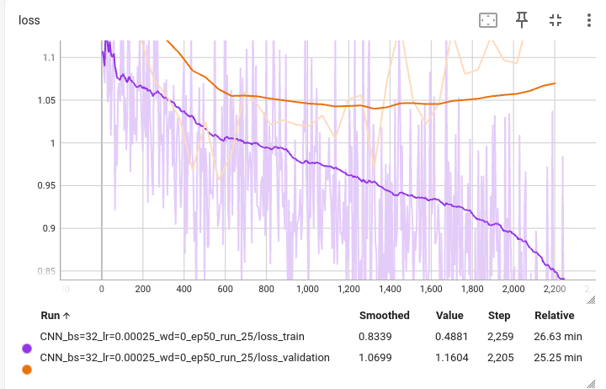

TEST: BASE MODEL + leaky RELU: ups test accuracy
[[133 34 6]
[ 47 120 6]
[ 80 66 27]]

Test Accuracy: 53.95%
logs/siamese_CNN/CNN_bs=32_lr=0.00025_wd=0_ep50_run_27
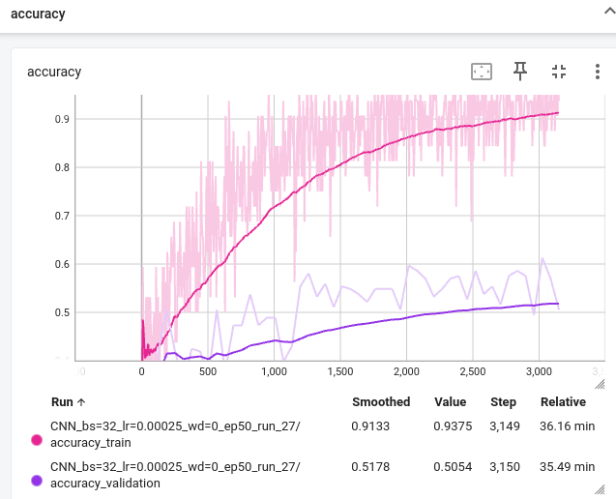

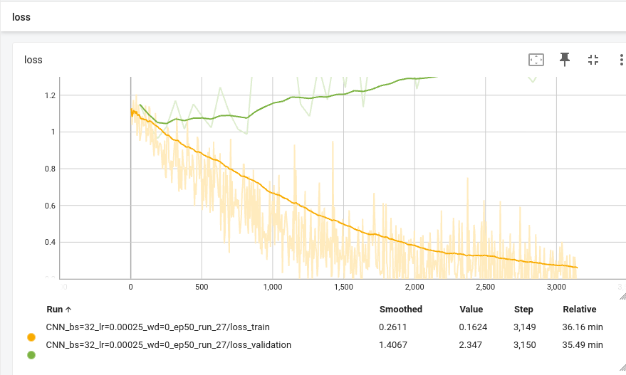

test: above + grayscale
logs/siamese_CNN/CNN_bs=32_lr=0.00025_wd=0_ep50_run_31

does not look great and hella overfitting
– try rotation as augmentation because test images sometimes rotated

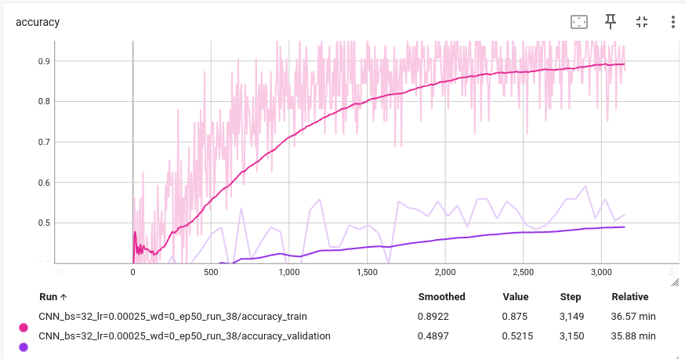
Test Accuracy: 50.10%
Confusion Matrix on Test Set:
[[113 25 35]
[ 52 85 36]
[ 68 43 62]]

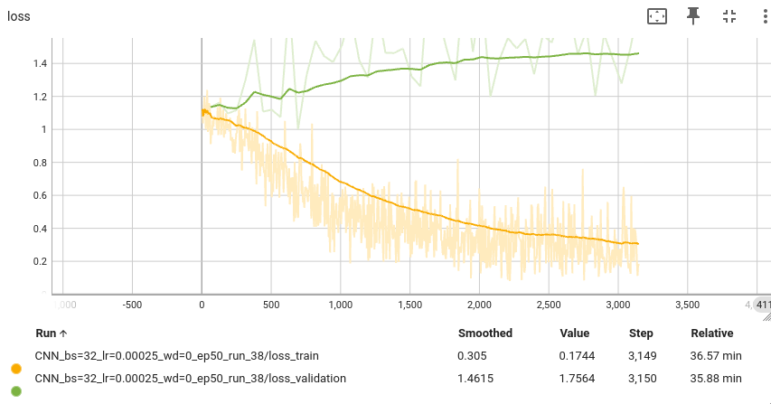

improvement on confusion matrix with class 2

test: above + increase first receptive field to 5x5 + reduce epoch number to 40

looks like its less overfitting, higher validation accuracy overall and better per class matrix on class 2

test accuracy:

EXTENSIONS
- different loss estimates
- more dropout between conv layers – spatial dropout
- early stopping?
- data augmentation – BLUR, NOISE
- nesterov momentum
- activation functions – preReLU and leaky ReLU
- distance based loss functions : contrastive, triplet, magnet, center loss

data augmentation fucks up the confusion matrix

implemented preprocessing to training dataset

* Small batches (8-16) lead to noisy gradients, contributing to the high batch accuracy variance. A larger batch size stabilizes training.

