CELL COUNT.

Mallassez cell:

- Dilute cells in 3.7% Formaldehyde in PBS.

- Count the cells in 10 squares of the cell like RM.

- Calculate the average cell number per square.

- The number of cells per mL is:

Average cell number per square x 10⁵ x F

10⁵ is the factor to have the result per milliliter (because RM = 0.01μL)
F is the dilution factor = 1/d.
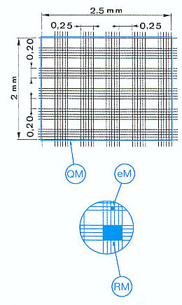
Quick-Read Precision Cell :

- Dilute cells in 3.7% Formaldehyde in PBS.

- Count the cells in 9 circles of the cell.

- The number of cells per mL is:

Cell number in 9 circles x 10⁴ x F x ½

or simplified : Cell number in 9 circles 5x10³ x F

10⁴ is the factor to have the result per milliliter (because 9 circles = 0.1μL)
F is the dilution factor = 1/d.
½ corresponds to a factor determinates by comparaison between Mallassez cell (reference) and this cell.

