ImageJ

This is a short protocol to make overlays from Metamorph or Metavue without saving them in a specific format (such as color combine)…not an ImageJ course.
Avoid saving as color combine since color combine is an 8 bits final file from 12 bits photos (you loose information which is crucial is you want to do some quantification).

You can download freely the ImageJ software here :

http://rsbweb.nih.gov/ij/
Download

Open ImageJ

Drag your metamorph/metavue files into ImageJ.

Overlay.
Image (or stacks)
Color
Merge channels: assign the colors to your files (I will see how we can add channels). Tick Create composite (as well as Keep source images if you want to keep the original files open).

Modify the layers of the overlay.
Once you have your composite, you can modify each layer individually. You will need two small windows
To know on which layer you are, move the curser right and left. The frame of the photo is changing color.

Image
Color
Channel tools : you can select the layer (or channel) you want to modify.

Then

Image
Adjust
Brightness/contrast (for example !) : If you are on the red channel, the diagram is red. Set your modification. If you click on apply, I think it applies it to all channels (but you can play and test… !).

If you want to save your overlay save the composite as .Tiff.

Scale bar
You will need to know the pixel size: on metamorph (or metavue for the old microscope), go to measure -> Calibrate distance. In this menu, the pixel size has already been calibrated for the different objectives.

But, since I know we are all leasy, here are the values:

Since both microscopes (AxioImager Z1 and AxioPlan) have the same cameras and that the pixel size is 6.45 um, you have to use the corresponding values:

objective 100x → 0.0645 um/pixel
objective 63x → 0.10238 um/pixel
objective 40x → 0.1615 um/pixel
objective 25x → 0.2580 um/pixel
objective 20x → 0.3225 um/pixel
objective 10x → 0.645 um/pixel
objective 4x → 0.16125 um/pixel

Now, open your image (single plane or stacks) in ImageJ
Go to Image → Properties you see this panel: It will adjust the number of channels and slices corresponding to your file.
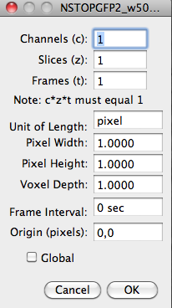

Enter the same pixel value in pixel width and pixel height (pixels are square) as well as the name of the unit (such as um):
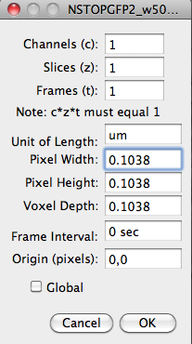

Now, go to Analyze → Tools → Scale bar.

