Deconvolution using Deconvolution lab / ImageJ

In a manuscript, you will have to specify that you used the ImageJ Deconvolution Lab plugin (cite the corresponding paper) with a synthetic PSF (cite the corresponding paper) and the algorithm with the number of iterations;

**Install PSF generator (Plugin for Icy/ImageJ/Fiji)** from <http://bigwww.epfl.ch/algorithms/psfgenerator/>  
extention: .jar

Cite : H. Kirshner, F. Aguet, D. Sage, M. Unser, 3-D PSF Fitting for Fluorescence Microscopy: Implementation and Localization Application, Journal of Microscopy, vol. 249, no. 1, 2013.

**Install Deconvolution Lab** from <http://bigwww.epfl.ch/algorithms/deconvolutionlab/>

Cite : C. Vonesch and M. Unser, “A Fast Thresholded Landweber Algorithm for Wavelet-Regularized Multidimensional Deconvolution,” *IEEE Transactions on Image Processing: A Publication of the IEEE Signal Processing Society* 17, no. 4 (April 2008): 539–49, doi:10.1109/TIP.2008.917103.

**1. Generate your synthetic PSF (one PSF for each wavelength).**

(when giving numbers, you may have to test “.” or “,” depending how your computer is set up).

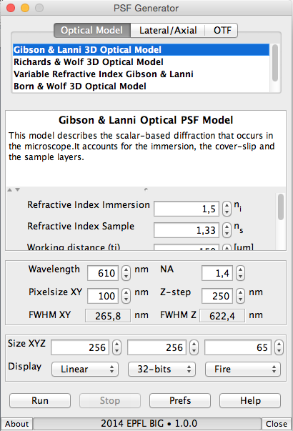

Recommended is Gibson and Lanni

- Refractive Index immersion ex 1.518 for Zeiss immersion oil

- Refractive Index sample (Prolong is 1.47, Slowfade is 1,42)

- Working distance (specific of your objective. On the Imager Z1 Zeiss microscope   
working distance is 190 um for the x63 and 170 um for the x100).

-Particle position Z (for cells onto coverslips which are upside down a glass slide, Z=0um, for trypanosomes on Teflon glass slides, Z=**20**-40um 🡪 20000 nm).

-Accuracy “Good”

-Wavelength (write the emission wavelength)

-N.A is specific to your objective (1.4 for our x100 and x63)

-Pixel size depends on the objectif (x100: 64.5 nm, x63: 102.38 nm/pixel, x40: 161.5 nm/pixel)

-Z-step: depends on your acquisition parameters

-size XYZ 256 (or 512…) 256 (or 512…) 64

(this must be smaller than your original image size, and the voxel size a multiple of the power of 2*)

-Display linear 32bits Fire  
  
to set the size: Edit 🡪 Selection 🡪 Specify 🡪 512 x 512 or…

**2. Deconvolution Lab**

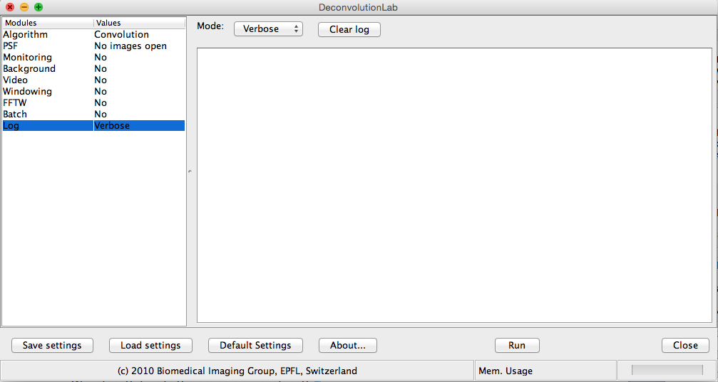

-Log: verbose (the program will write EVERYTHING it is doing)

-Batch.

If you want to run a batch, you need to create a specific folder with only the corresponding files (acquisition for 1 color only).

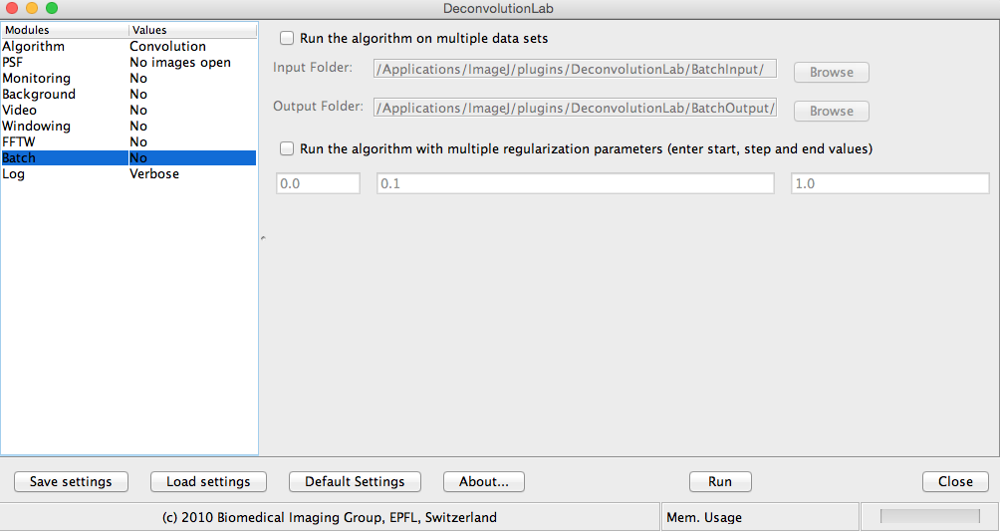

-FFTW is recommended as faster

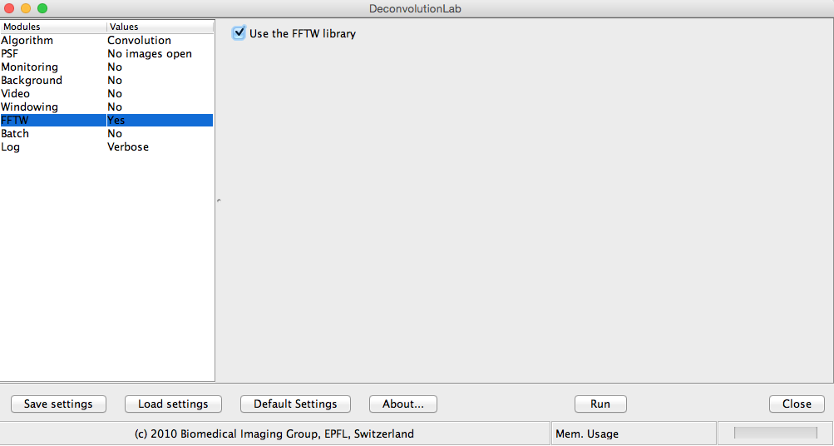

-Windowing: No (but make your own crop before starting the entire process)

- Video: Can be useful to follow if it went too far or not far enough for the iteration number. It takes one picture for every iteration, and then you can go back and see the good number of iterations needed for your specific image.

- Background: your choice to remove background, but if images are clean, not necessary.

- Monitoring: No need. Used only for generated images.

- PSF: your generated PSF file must be open. Tick normalize PSF and Flip PSF quadrants. Ev. Refresh and select

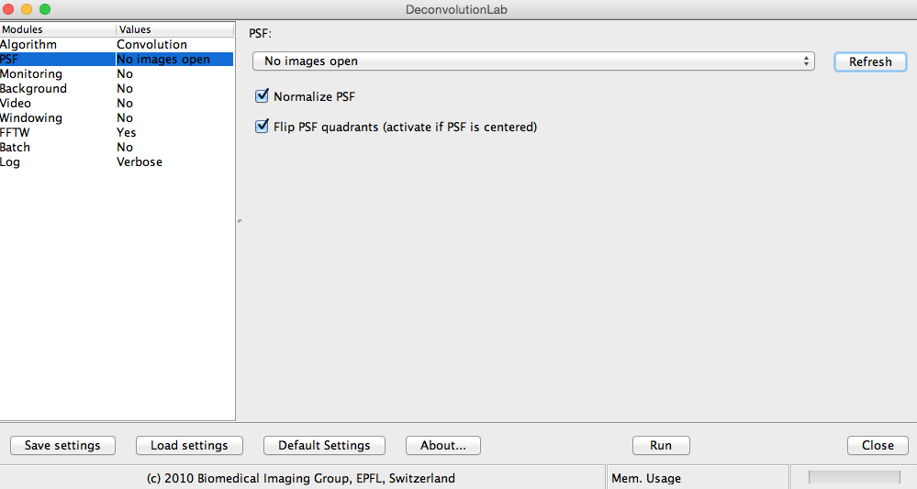

- Algorithm: Richardson and Lucy. Start with an iteration number of 200.

Activate the image you want to deconvolve (otherwise you will deconvolve your PSF…).

Then Run.

- Image 🡪 Lookup Tables 🡪 Fire  
  
- to open a video:  
File 🡪 import 🡪 image sequence 🡪 OK  
  
- to separate stacks from iterations (f. ex in a video):  
Image 🡪 hyperstacks 🡪 stack to hyperstack 🡪

Channel: 1

Slices: # of stacks  
Frames: # of iterations  
  
- to ?  
line on one of your structures🡪 analize 🡪 pot profile 🡪 live