# SDM79 from PAA company

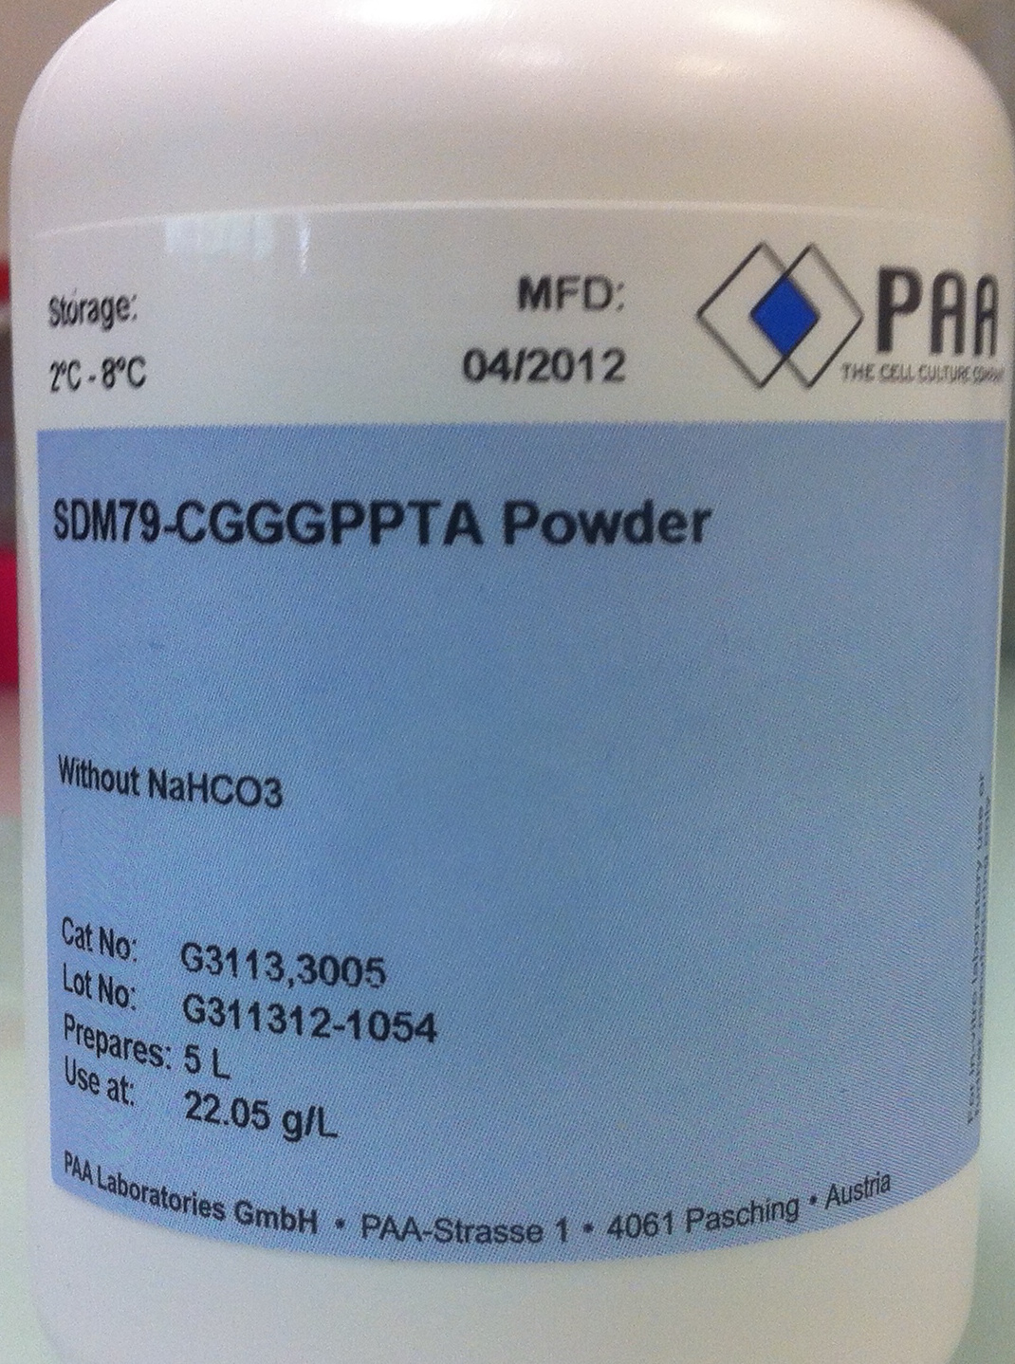

## Material :

* Medium from PAA : SDM79 – CGGGPPTA (Cat No : G3113,3005 Batch : #G311312-1054)
* 2 washed and autoclaved bottles (5 liters each).
* 5 Aguettant water bottles. (ref:3195085) (store room)
* 1 Nalgene 0.2 μm filter (500 mL).
* 10 bottles (500 mL) washed and autoclaved.
* 10 N NaOH in mQ water to adjust the pH.
* 500 mL of Foetal bovine serum (GE ref A15-101 Batch #A10111-0906).
* 25 mL of 2 mg/ml Hemin (Sigma H-5533) in 0,05N NaOH.
* A stirrer.
* Parafilm.
* Following Components :

|  |  |  |
| --- | --- | --- |
| **Components** | **Weight** | **Final concentrations** |
| NaHCO3 (Sigma #S-6014) | 11 g | 2,2 g/L |
| D-Glucose (Euromedex #UG3050) | 9,3 g | 10 mM |
| L-Glutamine (Sigma #G-8540) | 2,6 g | 3,5 mM |
| L-Proline (Sigma # P-5607) | 3,1 g | 5,3 mM |
| Sodium Pyruvate (Sigma #P-3662) | 0,45 g | 0,9 mM |
| L-Thréonine (Sigma #T-8441) | 2 g | 3,4 mM |
| Acide glutamique (Sigma #G-5889) | 0,11 g | 0,15 mM |
| Sodium Acetate (Euromedex #EU0310-B) | 0,051 g | 0,12 mM |

## Procedure :

Mix all the powders in a 5L bottle with 4 L of Aguettant water.

When the powders are dissolved, adjust the pH to 7.4 with 10N NaOH (10 mL approx.).

Complete with the Aguettant water to 4.5 L.

Add 500 mL of Fetal Bovine Serum heated at 56 °C for 30 minutes

Add 25 mL of 2mg/ml Hemin (Sigma H-5533) in 0,05N NaOH

Under a flow hood , filter the media through a 0.2 μm Nalgene filter (500 mL) in 10 bottles of 500 mL.

Store the media at +4°C.