COMP3702 Artificial Intelligence (Semester 2, 2024)
Assignment 3: Reinforcement Learning
Name:
Student ID:
Student email:
Note: Please edit the name, student ID number and student email to reflect your identity. When submitting to Gradescope, ensure you mark the start of each question.
Question 1 (Complete your full answer to Question 1 on the remainder of page 1)

A)
Both methods use Markov Decision Process as it allows the models to make decisions based on the states, actions, transition probabilities and rewards. They both also iteratively find the optimal reward for each state through repeated updates as they receive new information about the rewards and transitions. This process allows them to converge on the optimal policy that maximizes the total reward.

B)
VI calculates the expected value for each state using a transition function and requires full knowledge of the state space, including transition probabilities and rewards. Because of this knowledge, VI does not need to explore the environment. In contrast, Q-learning learns through exploring the environment, updating its value estimates based on the rewards received for actions taken. Q-learning does not require prior knowledge of transition probabilities.

Question 2 (Complete your full answer to Question 2 on page 2)
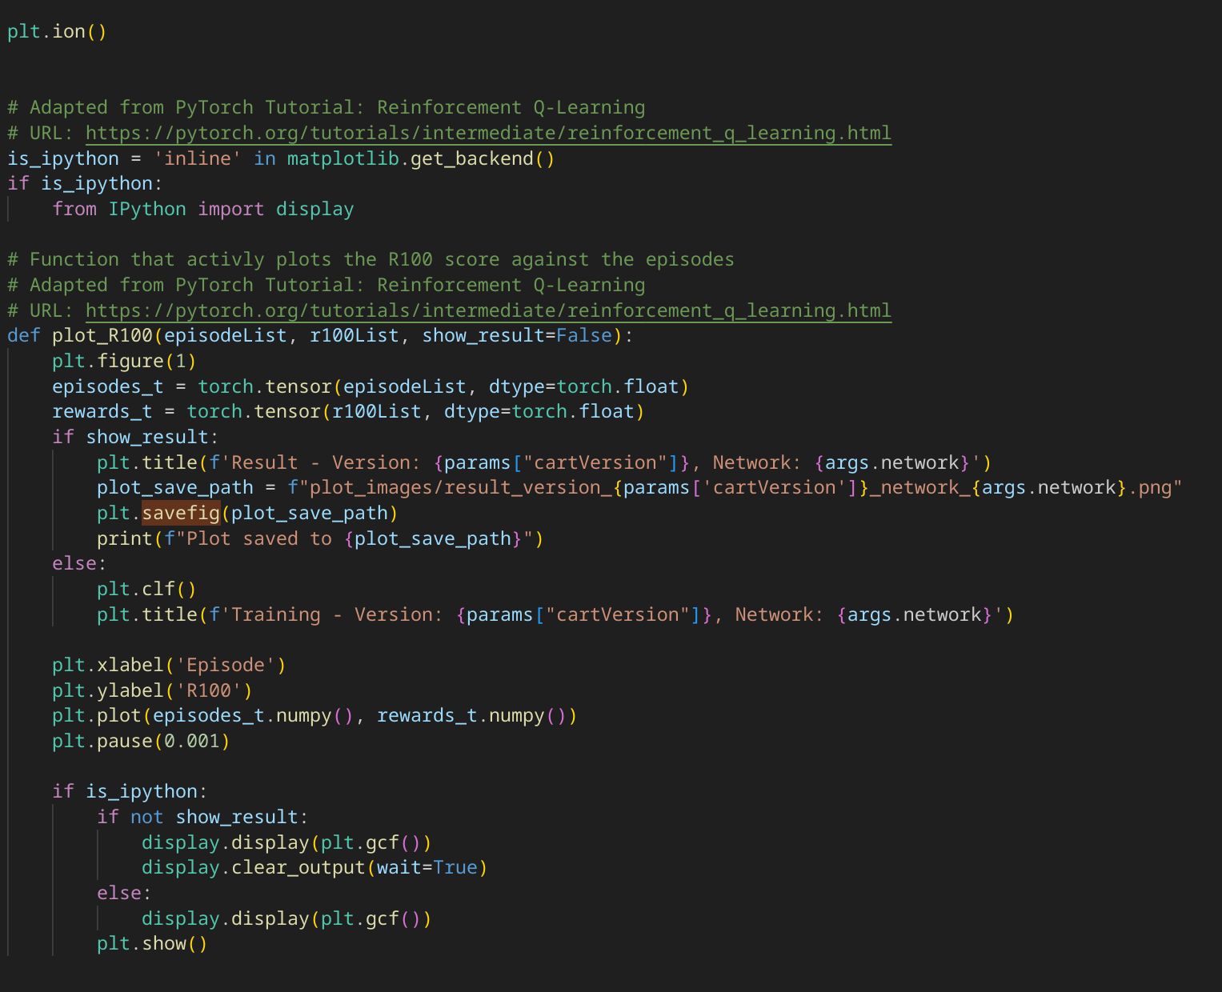
A)

B)
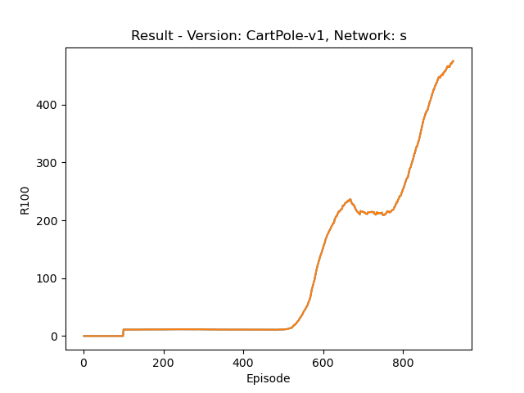Figure 2: CartPole-V1 Result
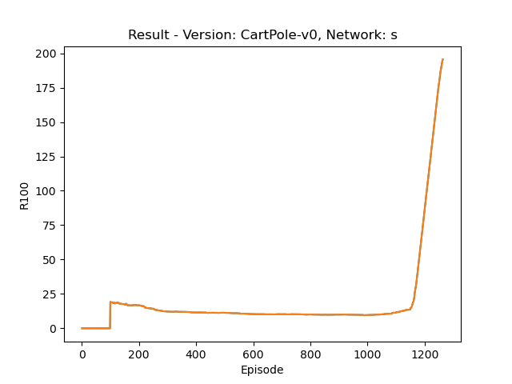Figure 1: CartPole-V0 result

C)
When looking at the learnt policy of CartPole-v0 it has an R100 value of around 25 at 100 episodes, the R100 value then decreases to around 20 and then has a sharp increase just before 1200 episodes, it then reaches the threshhold just after 1200 episodes.
In comarrison to CartPole-V1, the R100 value also starts off around 20 and doesnt change until 500 episodes, it sharply increases to an R100 value of 250 and then slightly plateaus, it then sharply increases all the way to the threshhold at 900 episodes
Question 3 (Complete your full answer to Question 3 on page 3)

Question 4 (Complete your full answer to Question 4 on page 4)
A)
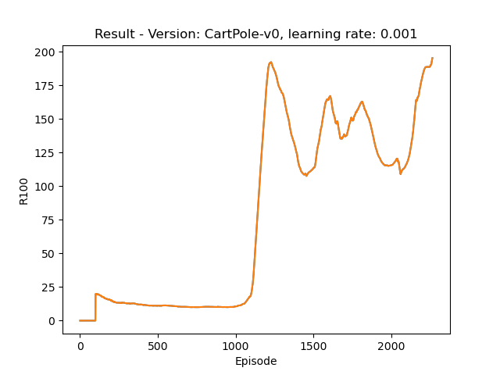Figure 3: CartPole-V0 with learning rate 0.001

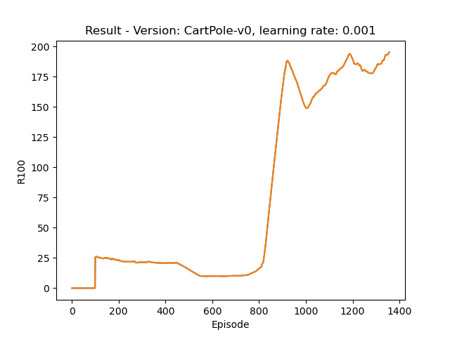Figure 4: CartPole-V0 with learning rate 0.01

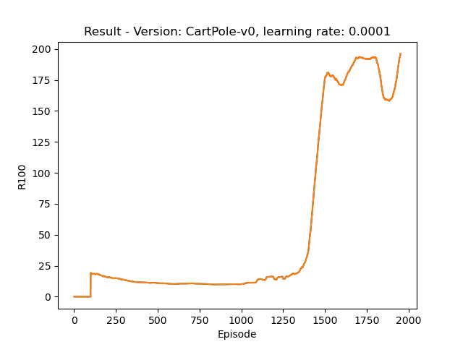Figure 5: CartPole-V0 with learning rate 0.001
Question 4 (Complete your full answer to Question 4 on page 4)
B)
A large learning rate (0.01) can lead to quicker convergence as it makes larger steps; however, due to these larger steps, it can also be unstable and struggle to find the optimal solution. This can be seen in Figure 4, where the R100 score nearly converges around 1200 episodes, but due to the large learning rate, it significantly drops and rises multiple times before finding the solution. Because of this, it converges slower than the other two learning rates at nearly 3000 episodes.
A small learning rate (0.0001) will lead to slow but very stable convergence. This can be seen in Figure 5. Once the R100 score starts increasing, it only slightly drops twice before converging just before 2000 episodes.
A learning rate in between the two (0.001) will lead to the fastest convergence, as it doesn’t take too large of steps but also not too small. It can be seen to have a large rise and then a slight fall before gradually converging just before 1400 episodes.
C)
In the image above it can be seen that too high of a learning rate makes too large of updates and therefore can struggle to find the optimal solution.
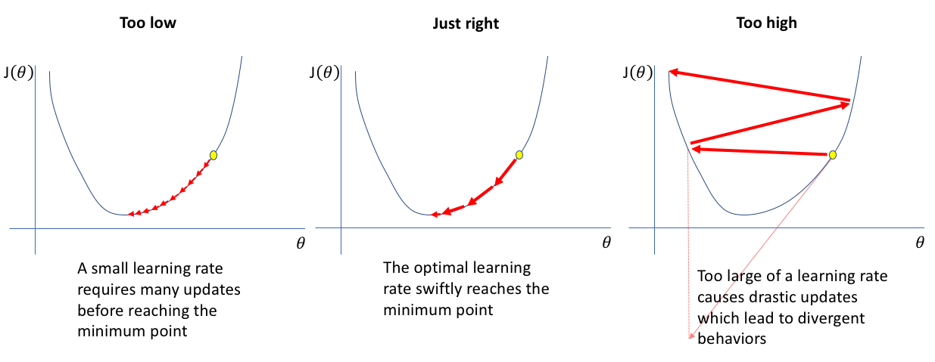Figure 6: Learning rate diagram (Jordan, J. (n.d.). Learning rate in neural networks.)
Question 5 (Complete your full answer to Question 5 on page 5)
A)
The epsilon hyperparameter is very important to the DQN model as it dictates the models next move. This hyperparameter does this by influencing whether the model should explore the state space by trying new actions or to exploit its prior knowledge of expected rewards found by exploration. As more actions are taken and the agent learns, it builds a Q value function that estimates the expected rewards for specific state spaces. When the model exploits it uses the prior knowledge and selects the action with the largest Q value as it believes that it will yeild the largest reward. When the model explores it takes a random action from the list of possible actions as this might give a better Q value function.
Question 6 (Complete your full answer to Question 6 on page 6)

Question 7 (Complete your full answer to Question 7 on page 7)

Appendix/References (Include references and usage of Generative AI on the last page)
Figure 6: Learning rate graph. Source: Jordan, J. (n.d.). Learning rate in neural networks. Retrieved from https://www.jeremyjordan.me/nn-learning-rate/

