COMP3702 Artificial Intelligence (Semester 2, 2024)
Assignment 3: Reinforcement Learning
Name:
Student ID:
Student email:
Note: Please edit the name, student ID number and student email to reflect your identity. When submitting to Gradescope, ensure you mark the start of each question.
Question 1 (Complete your full answer to Question 1 on the remainder of page 1)
A)
Both methods use Markov Decision Process as it allows both methods to make decisions based on the states, actions, transition probabilities and rewards. They both also iteratively find the optimal reward for each state through repeated updates as they receive new information about the rewards and transitions. This process allows them to converge on the optimal policy that maximizes the total reward.

B)
VI calculates the expected value for each state using a transition function and requires full knowledge of the state space, including transition probabilities and rewards. Because of this knowledge, VI does not need to explore the environment. In contrast, Q-learning learns through exploring the environment, updating its value estimates based on the rewards received for actions taken. Q-learning does not require prior knowledge of transition probabilities.

Question 2 (Complete your full answer to Question 2 on page 2)
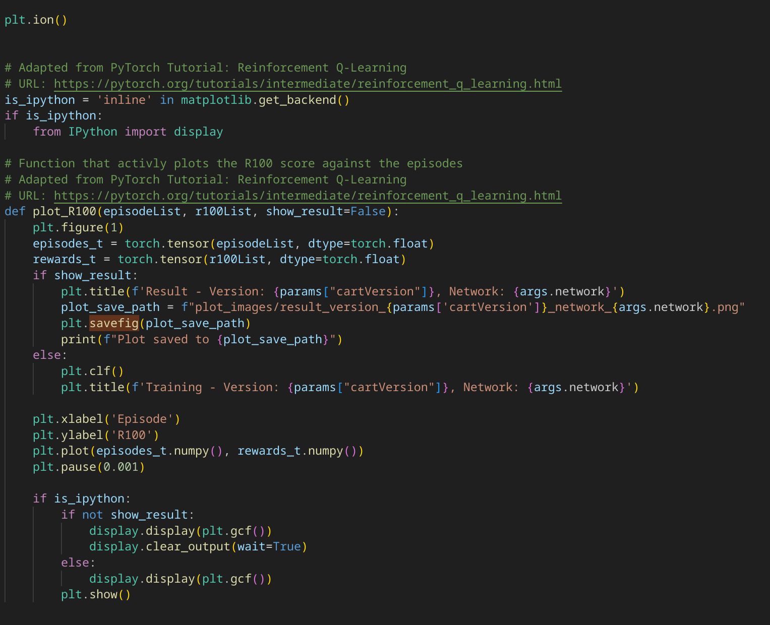
A)

B)
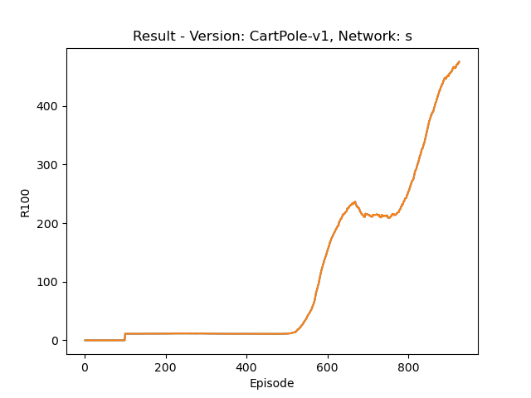Figure 2: CartPole-V1 Result
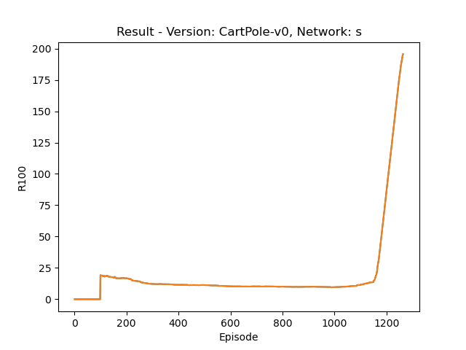Figure 1: CartPole-V0 result

C)
When looking at the learnt policy of CartPole-v0 it has an R100 value of around 25 at 100 episodes, the R100 value then decreases to around 20 and then has a sharp increase just before 1200 episodes, it then reaches the threshhold just after 1200 episodes.
In comarrison to CartPole-V1, the R100 value also starts off around 20 and doesnt change until 500 episodes, it sharply increases to an R100 value of 250 and then slightly plateaus, it then sharply increases all the way to the threshhold at 900 episodes
Question 3 (Complete your full answer to Question 3 on page 3)
A)
With reference to TD-learning, describe the loss function used to train the neural network in DQN. Use equations and highlight the components corresponding to the “target value” and the neural network’s current state-action value predictions.
B)
expected_state_action_values represents the target values, it is calculated using the line
expected_state_action_values = rewards_v + next_state_values.detach() * params['gamma'] * (1 – dones_v)
state_action_values represents the state-action value predictions/estimates. Is t is calculated by
state_action_values = Q_s.gather(1, actions_v.type(torch.int64).unsqueeze(-1)).squeeze(-1)
C)
A second target network is important as it gives multiple benefits. Firstly if only one network were used and high inaccurate Q-value estimates were generated, these incorrect estimates could be amplified in the next learning step as they would be used during the calculation of the target values. A seperate target network prevents this as it is the network that is used to give the new Q-value estimates. This target network does not have the same issues as it is updated less frequently and therefore makes it more consistent as it maintains a stable set of target values as the infrequent updates can help remove any errors in predictions, causing a smoother learning process.
D)
When comparing the performance of periodic syncing of the target network vs soft updates, it can be seen that soft updates result in a faster convergence for Cartpole-V0 (figure 3 and figure 4). Both models start off very similar until just before 500 episodes. The soft updates then has a steady increase and reaches convergence at an R100 value of 195 in around 100 episodes. Periodic syncing however has the same R100 value till just before 1200 episodes where is has a slightly sharper increase then the soft updates as it reaches the convergence of 195 at around 1250 episodes.
This most likely occurred as the soft updates allowed for a smoother learning process and being less affected by any large changes in the Q-Value resulting in a faster convergence.
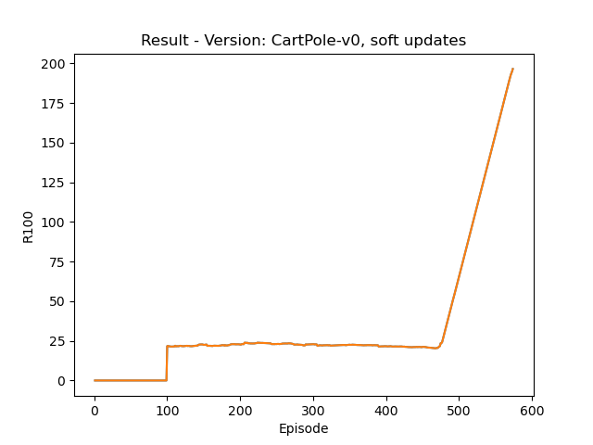Figure 3: CartPole-V0 Soft updates
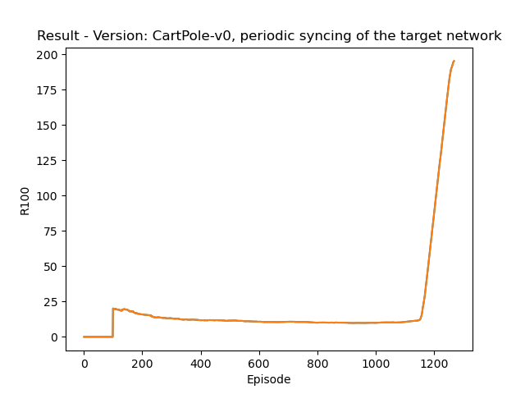Figure 4: CartPole-V0 Periodic syncing of the target network
Question 4 (Complete your full answer to Question 4 on page 4)
A)
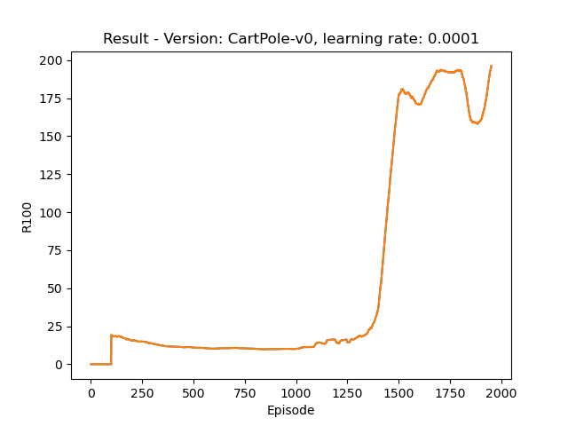Figure 7: CartPole-V0 with learning rate 0.0001
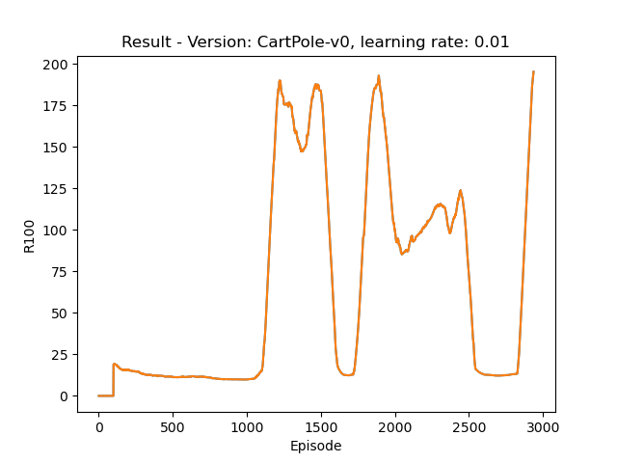Figure 5: CartPole-V0 with learning rate 0.01

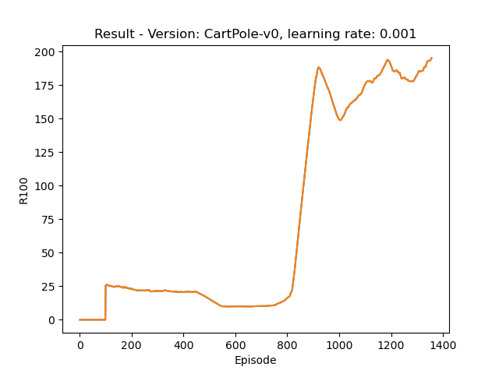Figure 6: CartPole-V0 with learning rate 0.001

B)
A large learning rate (0.01) can lead to quicker convergence as it makes larger steps; however, due to these larger steps, it can also be unstable and struggle to find the optimal solution. This can be seen in Figure 4, where the R100 score nearly converges around 1200 episodes, but due to the large learning rate, it significantly drops and rises multiple times before finding the solution. Because of this, it converges slower than the other two learning rates at nearly 3000 episodes.
A small learning rate (0.0001) will lead to slow but very stable convergence. This can be seen in Figure 5. Once the R100 score starts increasing, it only slightly drops twice before converging just before 2000 episodes.
A learning rate in between the two (0.001) will lead to the fastest convergence, as it doesn’t take too large of steps but also not too small. It can be seen to have a large rise and then a slight fall before gradually converging just before 1400 episodes.
C)
In the image above it can be seen that too high of a learning rate makes too large of updates and therefore can struggle to find the optimal solution. This can be seen in the plots from question 4A. The low learning rate has many small incremental updates and converges somewhat slowly. The middle learning rate converges faster than the low and high learning rate. Finally the model with the high learning rate struggles to converge and takes the longest time as its updates are too large.
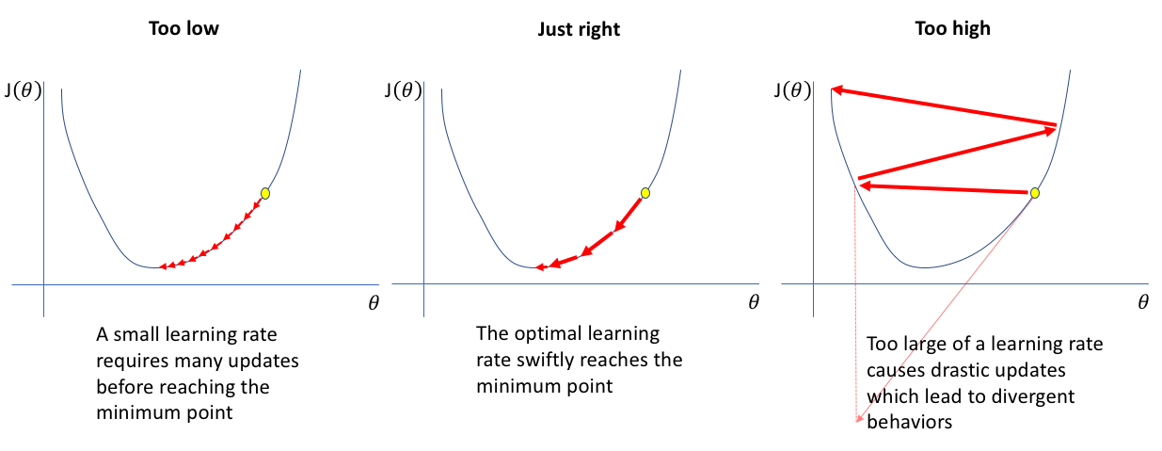Figure 8: Learning rate diagram (Jordan, J. (n.d.). Learning rate in neural networks.)
Question 5 (Complete your full answer to Question 5 on page 5)
A)
The epsilon hyperparameter is very important to the DQN model as it dictates the models next move. This hyperparameter does this by influencing whether the model should explore the state space by trying new actions or to exploit its prior knowledge of expected rewards found by exploration. As more actions are taken and the agent learns, it builds a Q value function that estimates the expected rewards for specific state spaces. When the model exploits it uses the prior knowledge and selects the action with the largest Q value as it believes that it will yeild the largest reward. When the model explores it takes a random action from the list of possible actions as this might give a better Q value function. Over time the model will tend to eploit rather than explore as the epsilon value will decrease from is starting value to its final value. The model randomly picks a number, if it is smaller than the epsilon the model will explore however if its larger it will exploit.
B)
Epsilon start represents the highest starting rate that dictates the models liklyhood to explore. A high starting rate (1.0) forces the model to explore a lot more at the start of the training, because of this it will learn a lot through experience rather than through exploitation, this is more beneficial as the model doesnt have a good understanding of the state space. A lower value (0.5) will mean the model is equally likely to initially explore as it is to exploit, the lower the value the more the model becomes prone to exploiting earlier in the training.
Epsilon final is the lowest that the epsilon value can get to. A low value (0.1) means that the model will reach a point where it is unlikly that the model will explore more and it will exploit its learned knowledge of the state space. This is beneficial as later in training the model will have a better understanding of the expected rewards. Having a high value (0.5) means that the model will only ever reach a point where eploitation and exploration are equally likely, this may be bad as later in the training phase your model might have sufficently learned the state space and estimated rewards.
Epsilon decay represents the speed at how fast the epsilon value decreases from the start to the final. The type of function that calculates the decay also affects the speed of decrese however they act in a similar manor (linear, exponential etc). A large epsilon value means a slower decay and a longer period that the model explores for. A smaller epsilon value means that the agent will use its prior gained knowledge sooner and will start to exploit.
Question 6 (Complete your full answer to Question 6 on page 6)

“”””””
DQN suffers from the problem of overestimation bias, which occurs because the same neural network is used for both selecting actions and evaluating their Q-values. This can lead to inflated value estimates for certain actions, resulting in suboptimal decision-making. As the network becomes overly optimistic about specific actions, it may prioritize them, even when they do not yield the best long-term rewards. This overestimation can slow down convergence to an optimal policy and cause the agent to learn inefficiently.
Double DQN improves upon this by adding a second network architecture. Specifically, it decouples action selection and evaluation: the main network is used to determine which action to take in a given state, while a separate target network is employed to evaluate the Q-value of that selected action. By using the target network to compute the Q-value for the action chosen by the main network, DDQN mitigates the overestimation bias inherent in standard DQN.
This separation of roles leads to more accurate Q-value updates, as the target network’s estimates are more stable due to being updated less frequently. Consequently, DDQN not only reduces the likelihood of overoptimistic value estimates but also enhances the overall stability of the learning process. As a result, agents trained with DDQN often converge more quickly and perform better in complex environments, ultimately leading to more effective and reliable decision-making.
From gpt
“”””””
Question 7 (Complete your full answer to Question 7 on page 7)

Appendix/References (Include references and usage of Generative AI on the last page)
Figure 6: Learning rate graph. Source: Jordan, J. (n.d.). Learning rate in neural networks. Retrieved from https://www.jeremyjordan.me/nn-learning-rate/

