Huffman Coding Implementation - Report

What was Built

What is Huffman’s Algorithm?
Huffman coding is a lossless compression algorithm that assigns shorter binary codes to more frequent characters and longer codes to the less frequent ones and is built by merging the two least frequent nodes using a min-heap priority_queue to build a binary tree until one root remains

Why it works
The reasons why this algorithm works is because how greedy it is. Fixed-width Encodings like ASCII give every character a 1 byte of space. However, Huffman’s algorithm uses a greedy approach by ensuring that the most frequent characters receive the shortest code so character that appear the most cost the fewest bits per occurrence as seen from Figure 1. Also, the Huffman tree also guarantees that no code is a prefix of any other code. This means when the program runs, it just must traverse down the tree either going left (‘0’) or right (‘1’) until there is no child leaves as it knows that there is no other valid code that could be used

Figure 1
frequency table and Huffman tree
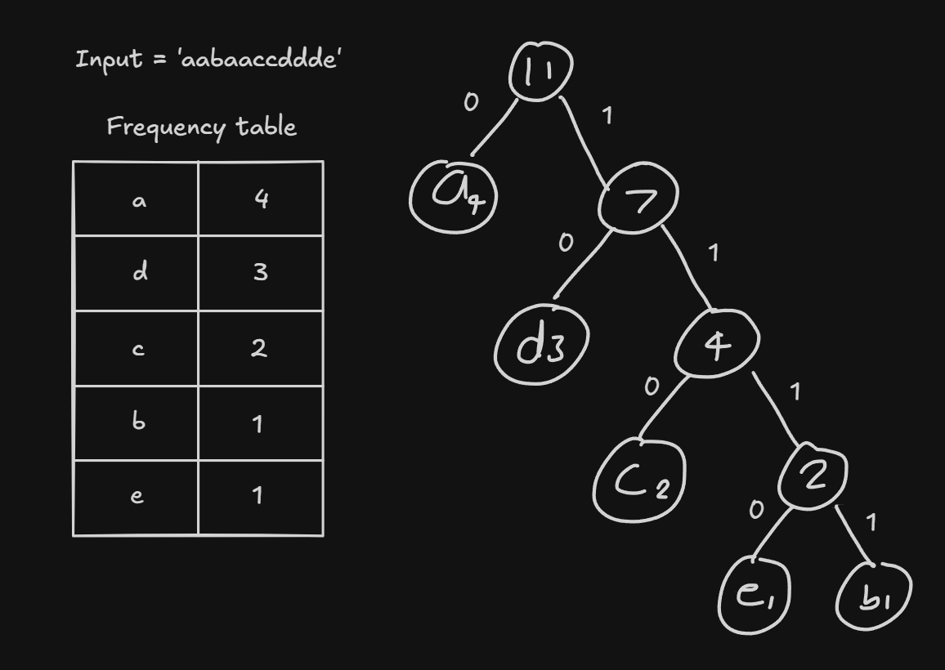
Note. Shows the frequency table and Huffman tree drawn out for an input. Created by author

Implementation of the huffman_tree
This algorithm was implemented to compare its effectiveness of compressing files against gzip (a built in Linux compressor).

frequency_data | This method is used to build the character frequency table using an unordered_map<char, int>. The way it works is by looping over the input and updating the value for each key
build_huffman_tree | This method builds the tree using a priority_queue using a min heap order for the frequency so whenever you call pq.top(), it retrieves the lowest frequency node currently in the queue then the loop pops two of these at a time, merges them, and pushes the result back until one node remains. After one node is remaining it sets that Node to the root of the tree.  Leaves are sorted by character before being pushed into the priority_queue, so that equal frequency nodes are always pushed in the same order, regardless of the frequency table's original order
huffman_codes | This method walks down the tree assigning ‘0’ or ‘1’ to each branch. For inputs with only 1 distinct character, it will assign it ‘0’.
encode / decode | These methods were used to turn the input into bitstring and vice versa
pack / unpack | These methods pack the bitstrings into uint8_t bytes by tracking a bit count and pushing them into a vector<uint8_t>. Any remaining bitstring without a total of 8 is pushed in with padding
write_frequency_table | This method was used to write the information needed into a file so that it could be decompressed later which allowed the CLI to work. The format that it was written in was count of total characters (32 bit), character (8 bit) and then its frequency (32 bit)
read_frequency_table | This method was used to read the information produced by the write_frequency_table, so that it could be decompressed.
compress_to_file | This method is the one that is called during compression for the CLI. It writes the frequency table (via write_frequency_table), padding info, and packed bytes to a binary file.
decompress_from_file | This method just decompresses the files, it uses read_frequency_table to get the characters and frequency count, rebuilds the tree and retrieves the total bytes from the saved file. It doesn’t need to create the codes again as it just must walk down the tree with the bitstring that was retrieved

The tool
For the design, the compressed files need enough information for a separate run of the program to rebuild the same tree. Instead of adding the whole tree to the binary file, I relied on the build_huffman_tree. This works because build_huffman_tree is deterministic which means that the same frequency table always produces the same tree, since leaves are sorted by character before being pushed into the priority_queue. This means that when it comes to characters with the same frequencies, it would always push in the same order, regardless of the frequency table's original order. The character sort wasn't part of the original design. It was added after encountering a bug where same frequency characters could be pushed into the priority_queue in a different order during compress and decompression which produced different tree shapes and corrupted the output. The information was formatted as below:

uint32_t | number of symbols
n * [char , uint32_t] | n * symbol & frequency
uint8_t | valid bits in the last byte
uint32_t | number of packed bytes (m)
m * uint8_t | Packed bytes

I decided to leave the root as public rather than private. Usually, it should be protected as the program relies on it either being nullptr or representing a fully built tree. However, the root is touched internally by the class’s own methods so there isn’t much risk, but If I decide to further improve this project, I will make it private to improve encapsulation and prevent external code from accidentally modifying the tree

Initially, when I was developing the code for this project, I separated every function into different methods so I could work on it step by step without having to fix multiple things within a single method. In hindsight this turned out to be useful later in development as I was able to debug my code relatively easily because I knew exactly where to look and which method was responsible for a particular operation. This design choice, although initially made for convenience, resulted in a cleaner and more maintainable codebase. It also made individual methods easier to test and modify without unintentionally affecting unrelated parts of the program.

On top of huffman_tree, main.cpp provides a CLI with three subcommands that handle file I/O and arguments parsing, while all compression logic stays inside the huffman_tree struct with compress_to_file and decompress_from_file being the bridge communication between main.cpp and huffman.cpp. The design choice for this was that I just wanted a simple interface, so I decided to stick with the subcommands as it was simple to navigate through and use.

Figure 2
CLI subcommand lines
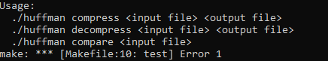
Note. Image of three subcommand lines options (compress, decompress, compare). Created by Author.

What compare does is that it runs the Huffman compression and gzip via a command-line prompt ‘gzip -k -f …’ for the same file and compares the byte size of both files as seen below:

Figure 3
Compare subcommand in use
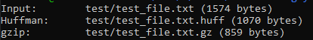
Note. Created by Author.

Figure 4
Three CLI subcommands in use
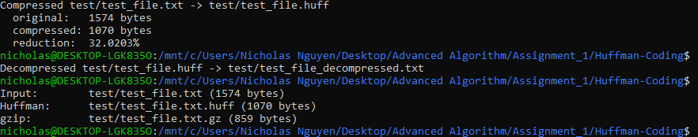
Note. Created by Author

As it shows, gzip compresses information better than Huffman’s Algorithm as it is a ‘dual staged’ process called DEFLATE that uses Huffman’s Algorithm and LZ77 Algorithm.

What was learnt
Decoding single-character input
Getting the decoding to work correctly for a single repeated character took a while to understand. In my earlier version, the code would try to traverse down the tree regardless of whether children existed or not, so current would just become nullptr as it was going off the tree and pointing to nothing and dereferencing a nullptr is undefined behaviour. I fixed this by adding a guard that checks current == nullptr; if true, it resets current back to root and appends the root's symbol to the result before continuing.

Handling empty input
I ran into a crash when building the tree for an empty input. build_huffman_tree had no guard checking whether the frequency table was empty before pushing into the priority queue, so calling pq.top() on an empty queue was undefined behaviour and because of this it crashed the program. I fixed this by adding an early check that checked if the frequency table is empty. If it was it would return immediately without touching the priority queue.

Memory leaks
I learned that every new Node needs a matching delete, or it leaks. Specifically, reassigning root without first freeing the tree it used to point to which made the old memory unreachable hence causing the memory leak. To fix this, I implemented a destroy method that frees a tree. This method is called in two different places. Once in the build_huffman_tree for whenever this method is called more than once so that the old one can be freed before its replaced. The other is once in the destructor ~huffman_tree() for when objects go out of scope or when the program ends

Non-deterministic tree shape for same frequencies
When building the tree, I found that characters with equal frequency weren't always merged in the same order between compression and decompression, producing different tree shapes on each side. This came from the frequency table being stored in an unordered_map(), which gives no guarantee about iteration order. This meant that the order in which the leaves were pushed into the priority queue could differ between the two runs, even with identical frequency data. I fixed this by sorting the frequency table by character before pushing leaves into the priority queue, making the push order deterministic regardless of the map's original layout.
Implementing the algorithm is not the same as building the tool
I initially thought I was finished once encode/decode worked correctly. I hadn't accounted for the fact that a bitstring of '0'/'1' characters is still one byte per bit in memory which meant that the compressed output would be larger than the original file unless I packed those bits into real uint8_t bytes eight at a time.

Smaller files can get bigger after compression
When it came to smaller files with many distinct characters, compressed output could end up larger than the original. This is because the header holds a total of 9 fixed bytes, plus 5 bytes per distinct character. This means Huffman's algorithm only pays off if the savings from compressing repeated content outweigh that overhead. Compared to gzip, which has a fixed 18-byte overhead (10 byte header + 8 byte footer) regardless of file content, Huffman's fixed overhead is smaller on its own compared to gzip. Huffman's overhead scales linearly with the number of distinct characters so it can quickly exceed gzip's fixed cost once a file has a few distinct characters.

How binary files are read to return information
I learnt for binary files, it cannot distinguish what information is what. Whenever something is put into a binary file, it must be predetermined so that it can be read and written in the same order. This means that both write_frequency_table and read_frequency_table must have the same order of content or else it would produce the wrong information

Huffman vs gzip
I learnt that gzip uses two compression algorithms, LZ77 and Huffman, combined into a process called DEFLATE. The way it works is that LZ77 finds and replaces repeated sequences of characters with reference back to earlier occurrences in the file. After that, huffman’s algorithm is then applied on top of that already reduced data. Since my compressor only uses Huffman, it cannot reduce repeated substrings like gzip hence why gzip compresses files more efficiently.

How AI was used

Which tool was used?
I used Claude heavily for the implementation and overall project

What were they used for?
I used Claude heavily throughout the development of this project to assist with the implementation, structure, understanding of the algorithm, debugging and drafting the report. When I was unsure about how a particular part of the algorithm should work, I would ask Claude to explain the process and check whether my implementation followed the correct logic. This allowed me to identify mistakes and better understand the reasoning behind each step rather than simply relying on the code produced Claude.

Two specific examples of where AI wasn’t helpful
Rebuilding the tree from the binary file
Initially when I was designing the binary file format, Claude told me that recreating the tree would always produce the same tree, “same frequencies in -> same tree out”. I questioned this, since I used an unordered_map() for the frequency table which provided no guarantee to a specific iteration order meaning that the tree could be built for characters with the same frequencies depending on the order they were pushed into the priority_queue. This turned out to be misleading information from Claude as without the frequency data sorted order, the output would be wrong. However, this issue was fixed later by sorting the unordered_map() before pushing it into the priority_queue.

Assigning binary file variable with wrong type
When creating the binary file format, the count for total number of characters, Claude suggested uint8_t (0-255), however there was a max count of 256 for all characters. Which meant that it would not fit in the uint8_t that was suggested as value 256 would silently overflow to 0. I decided to keep the count as uint32_t instead to avoid the risk entirely although it takes up more space than necessary.

Overhead size for gzip & Huffman
I asked Claude to explain why smaller files became larger after compression for Huffman but not so much for gzip. Claude's first explanation said gzip has "the same kind of overhead too," implying the two were roughly comparable. That confused me, since gzip's actual overhead is a small, fixed 18 bytes regardless of file content, while my format's overhead (9 bytes + 5 bytes per distinct character) scales linearly with the number of distinct characters when I did some research into it. This meant that although Huffman’s overhead started off smaller, it quickly exceeded gzip's fixed cost as soon as a file has more than a couple of distinct characters.

What you understood vs what you took on trust
I understood how the Huffman algorithm works with the help of Claude and why the frequency table alone is enough to rebuild an identical tree, this is because with the tree the program just follows the bitstring '0' for left '1' for right and no code is a prefix of another code so whenever it reaches a leaf node with no children it knows that it has found the character for that code. I also understood that the binary data for read/write must be the exact same, the reason for this is because binary files cannot distinguish between what data is for what. When it came to the casting at first, I didn't understand how reinterpret_cast and static_cast worked. However, after this project, I understood that static_cast is used to convert types while reinterpret_cast is used to relabel the pointer type of a variable so that it can be cast in different method/functions

However, what I took more on trust initially was why specific type widths were chosen (e.g. uint32_t vs uint8_t for different fields). I've since worked through the reasoning but didn't have that intuition upfront. I'm still less confident I could design a binary file format like this entirely from scratch on a new project myself.

Also, I understood that main.cpp's functions calls into my huffman_tree struct, but I took more on trust from Claude about the surrounding C++ standard library code such as:
- std::ofstream/std::ifstream (file stream objects for reading/writing)
- std::cerr (a separate output stream for error messages)
- uintmax_t (a large unsigned type used for file sizes)
- std::system (runs a shell command)
- std::filesystem::path (represents a file/directory path)
- std::filesystem::exists (check whether a file/directory exist)
I understand some parts of it however not confidently. The overall structure of main.cpp was something I was given rather than something I designed myself.

