**Generic Evolutionary Algorithms Programming Library (2003)**

->freeware nicht mehr runterladbar

**Evolutionary Algorithm Sandbox (2009)**

Kein Produkt gefunden, lediglich Paper

<https://www.researchgate.net/publication/224086909_Evolutionary_Algorithm_Sandbox_A_Web-Based_Graphical_User_Interface_for_Evolutionary_Algorithms>

**An Educational Genetic Algorithms Learning Tool**

<https://ewh.ieee.org/soc/es/May2001/14/Begin.htm>

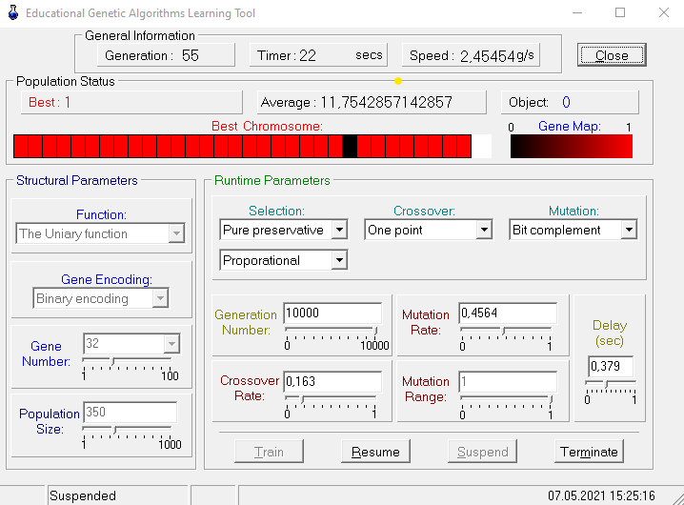

# GEATbx - The Genetic and Evolutionary Algorithm Toolbox for Matlab

# Kosten: 476€ (100% Geld-zurück-Garantie)

# Dokumentation für umsonst: <http://geatbx.com/download.html>

Besser zusammengefasst in Nicas Dokument